This is a work in progress. There are some deviations from published material where I had something I liked better. Otherwise I have been developing the knights and nobles of Karameikos and elsewhere for my Mystara. Names/titles with no arms pictured still remain undetermined. Others have arms depicted without final names being determined

Grand Duchy of Karameikos
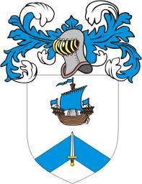

Stefan Karameikos III | Olivia Prothemian Karameikos | Personal Seal of Olivia Prothemian Karameikos
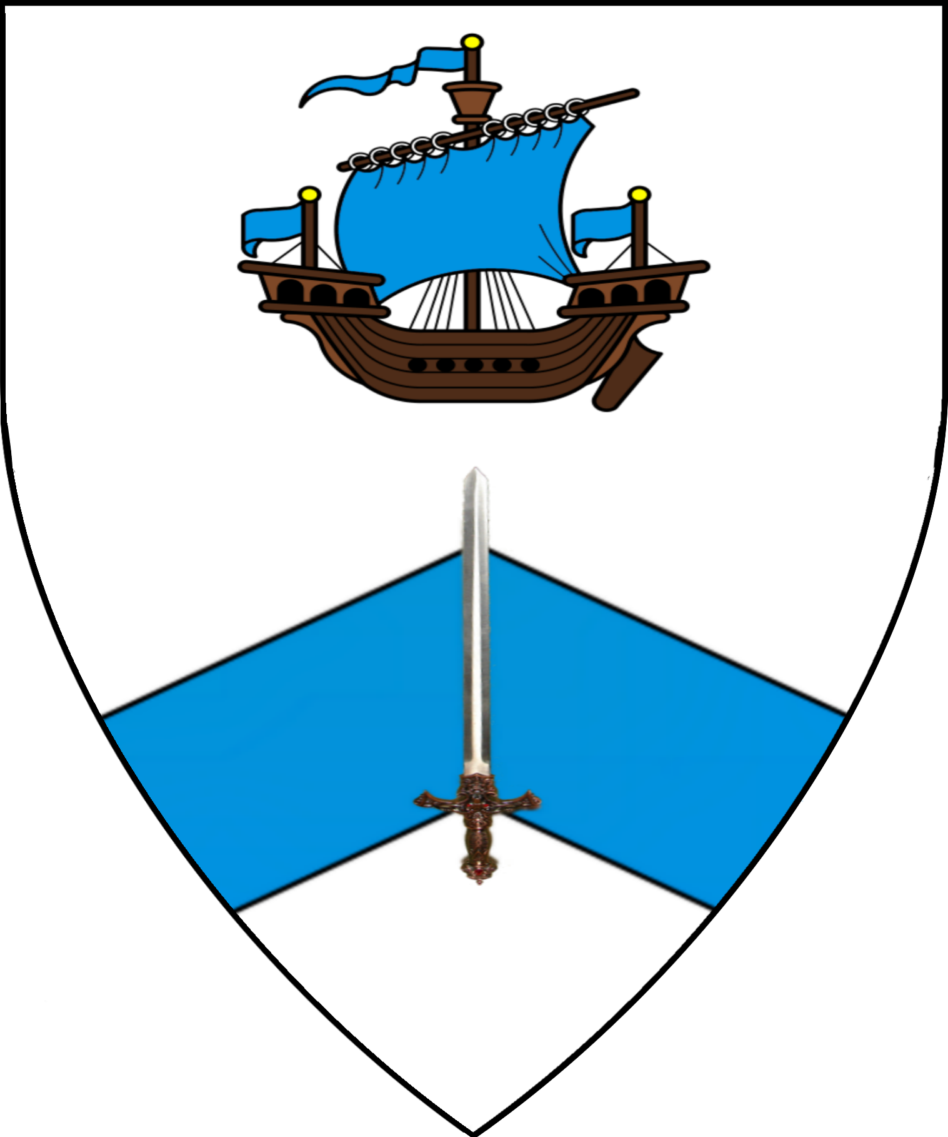 | 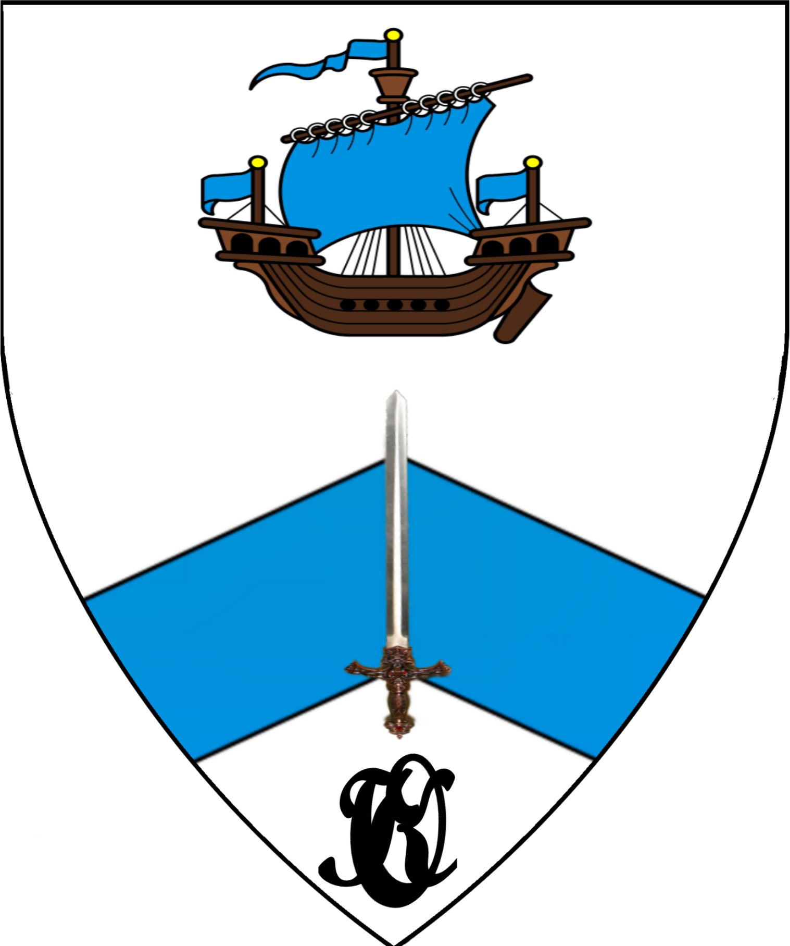 | 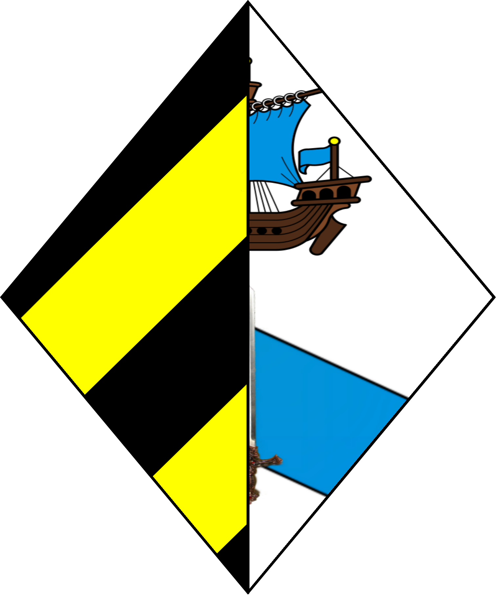
Adriana Karameikos | Justin Karameikos | Valen Karameikos
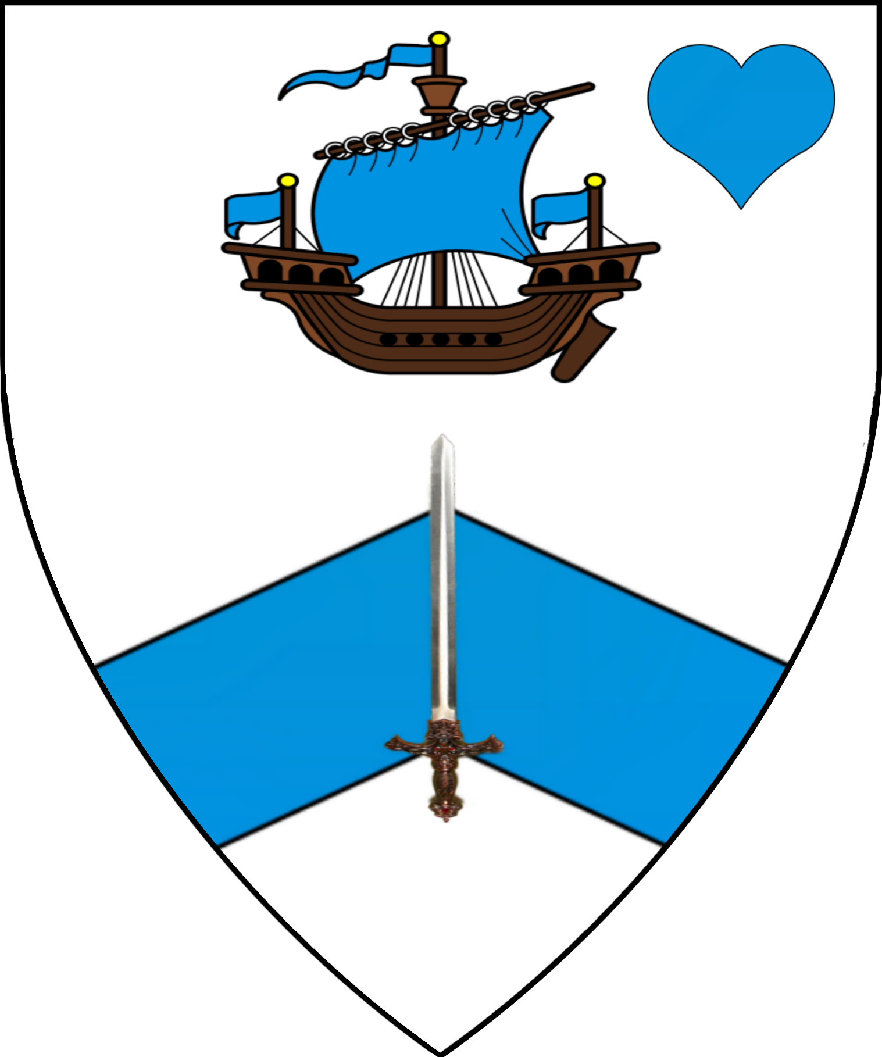 | 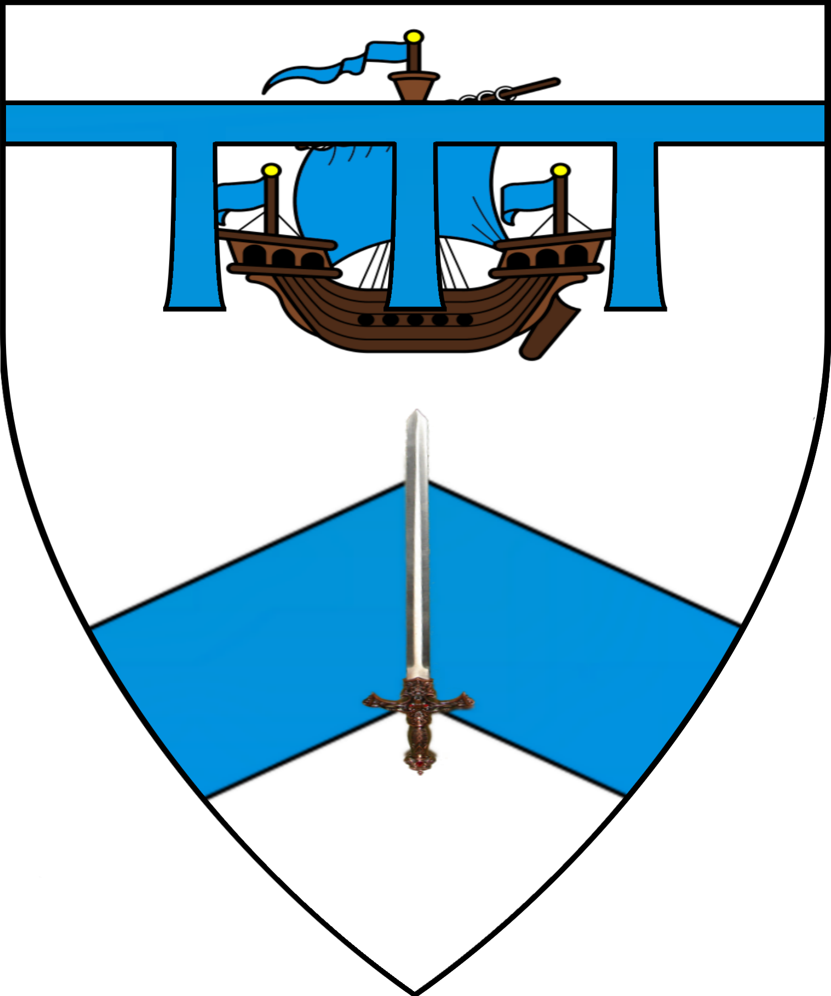 | 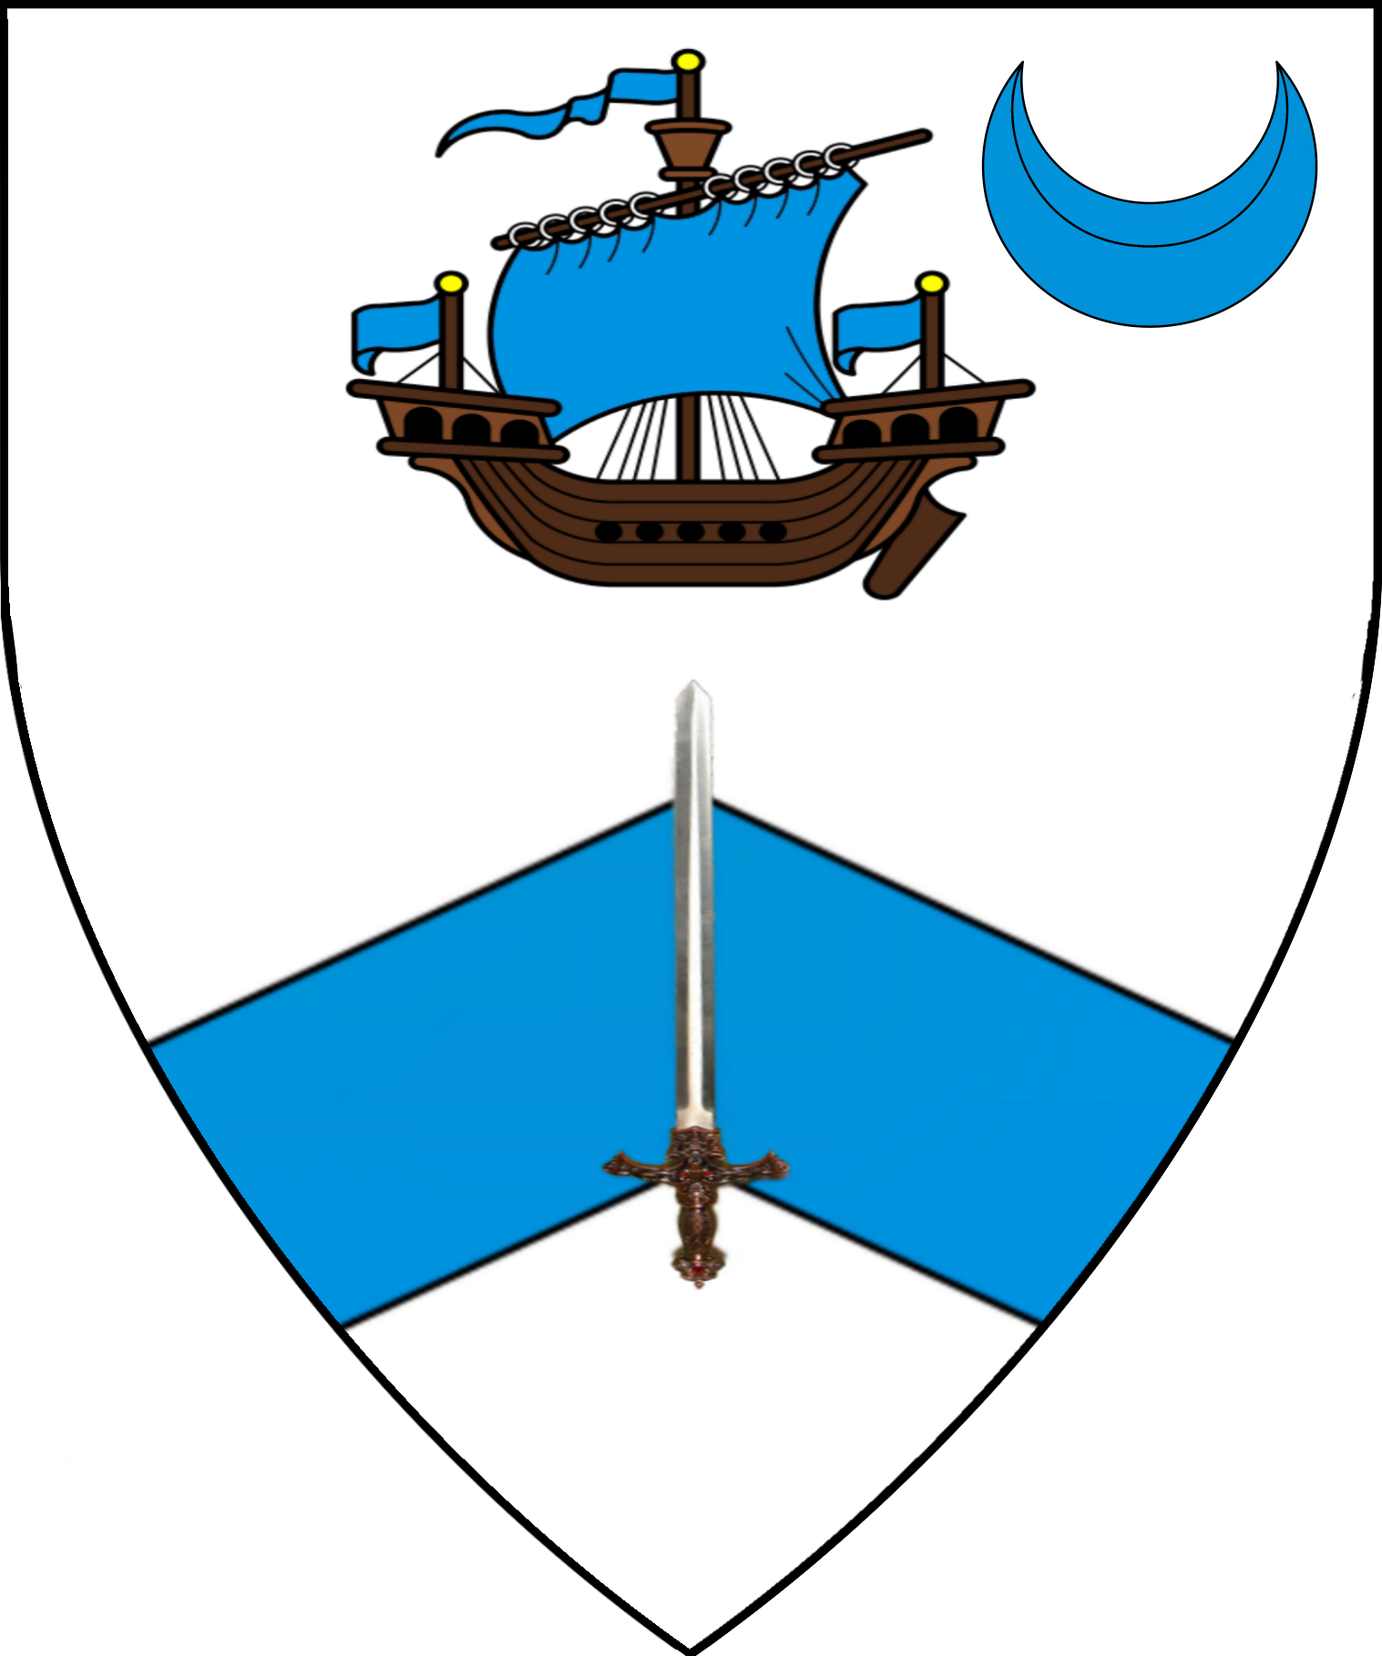

Knightly Orders
Order Karameikos
Sit Hamlet | Dame Anastasia Bloodfang | Sir Lionel Telemachus | Dame Hannah Bracegirtle | Sir Robert Tepes
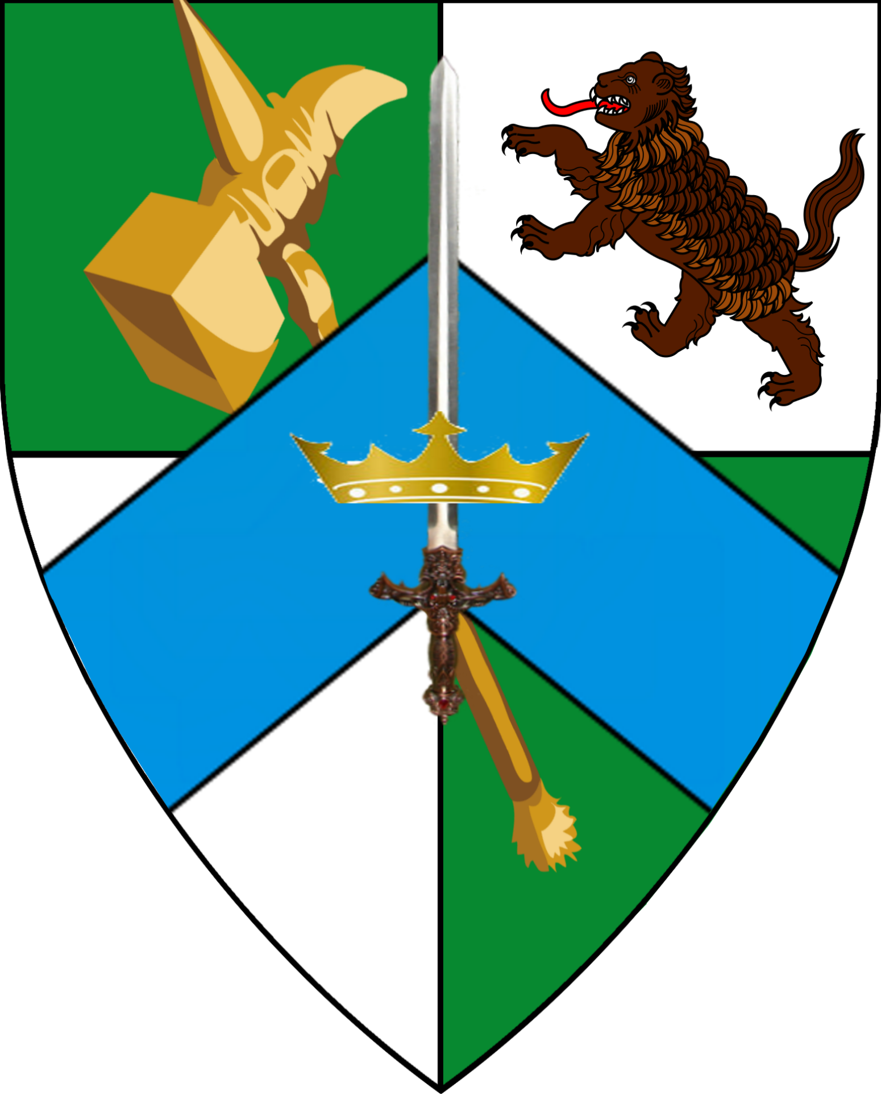 | 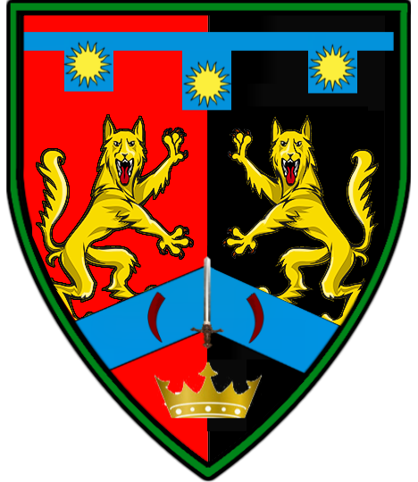 | 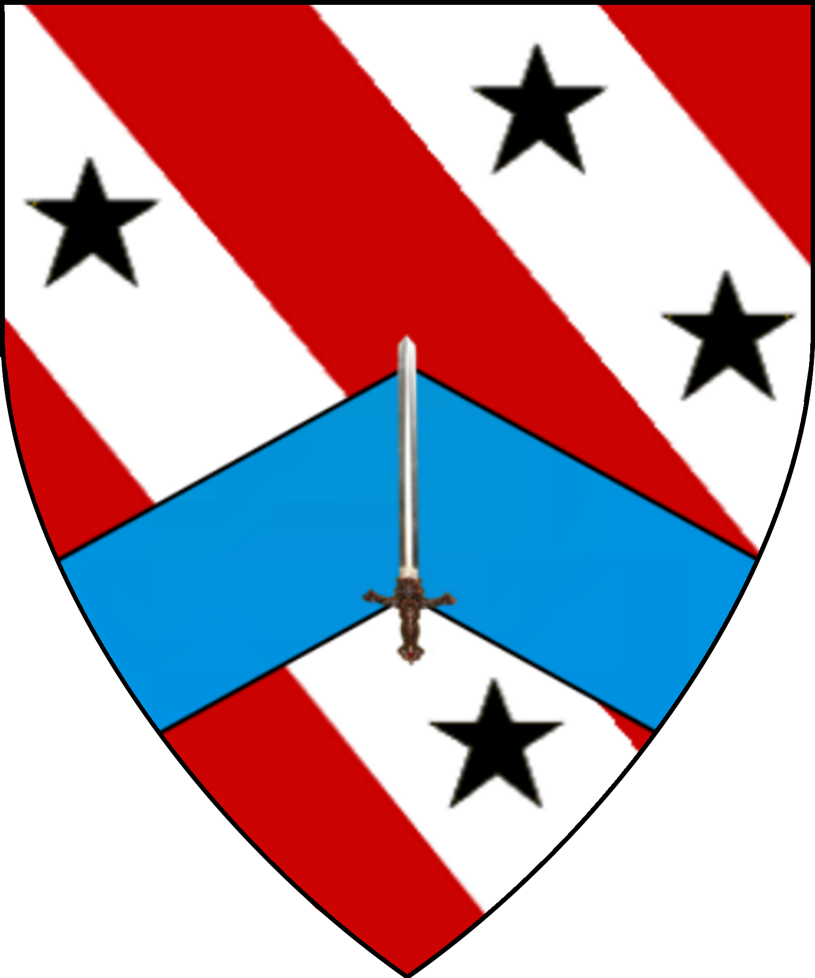 | 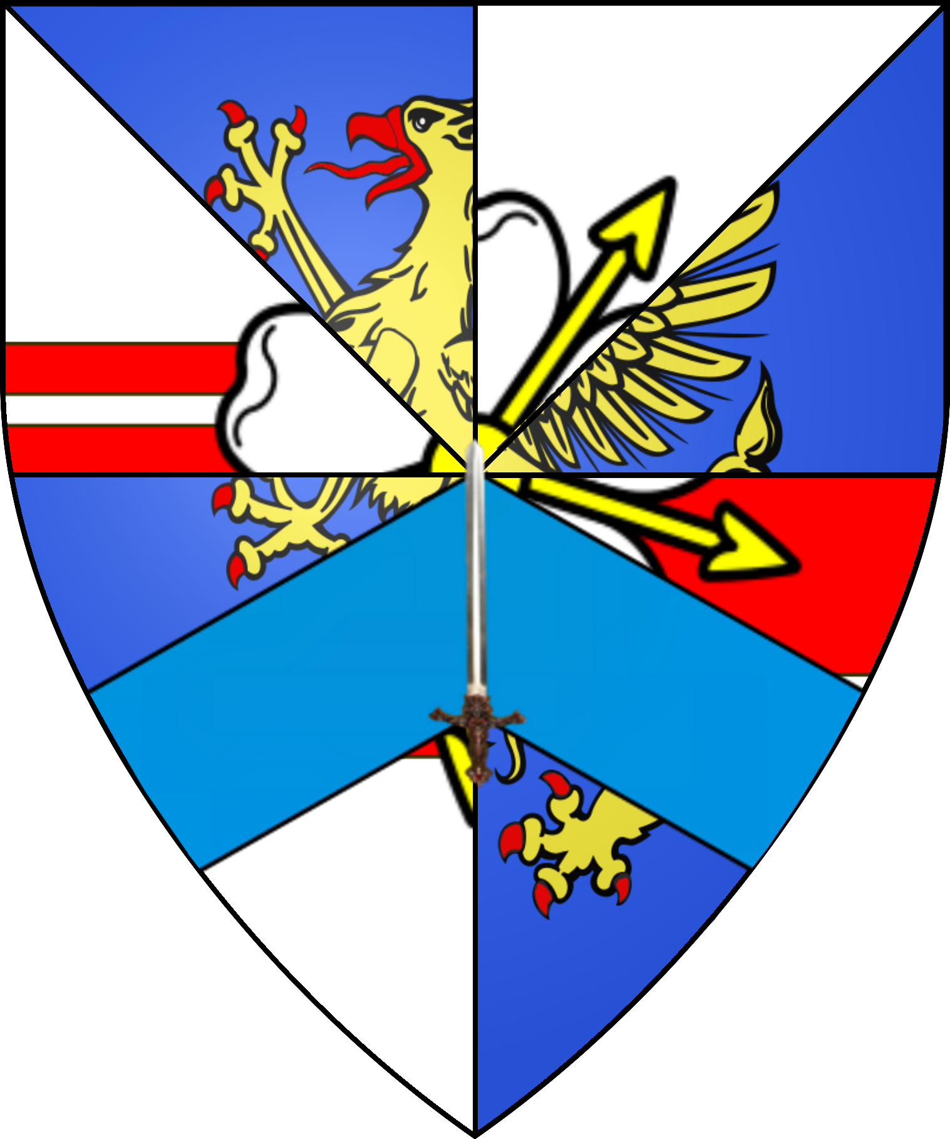 | 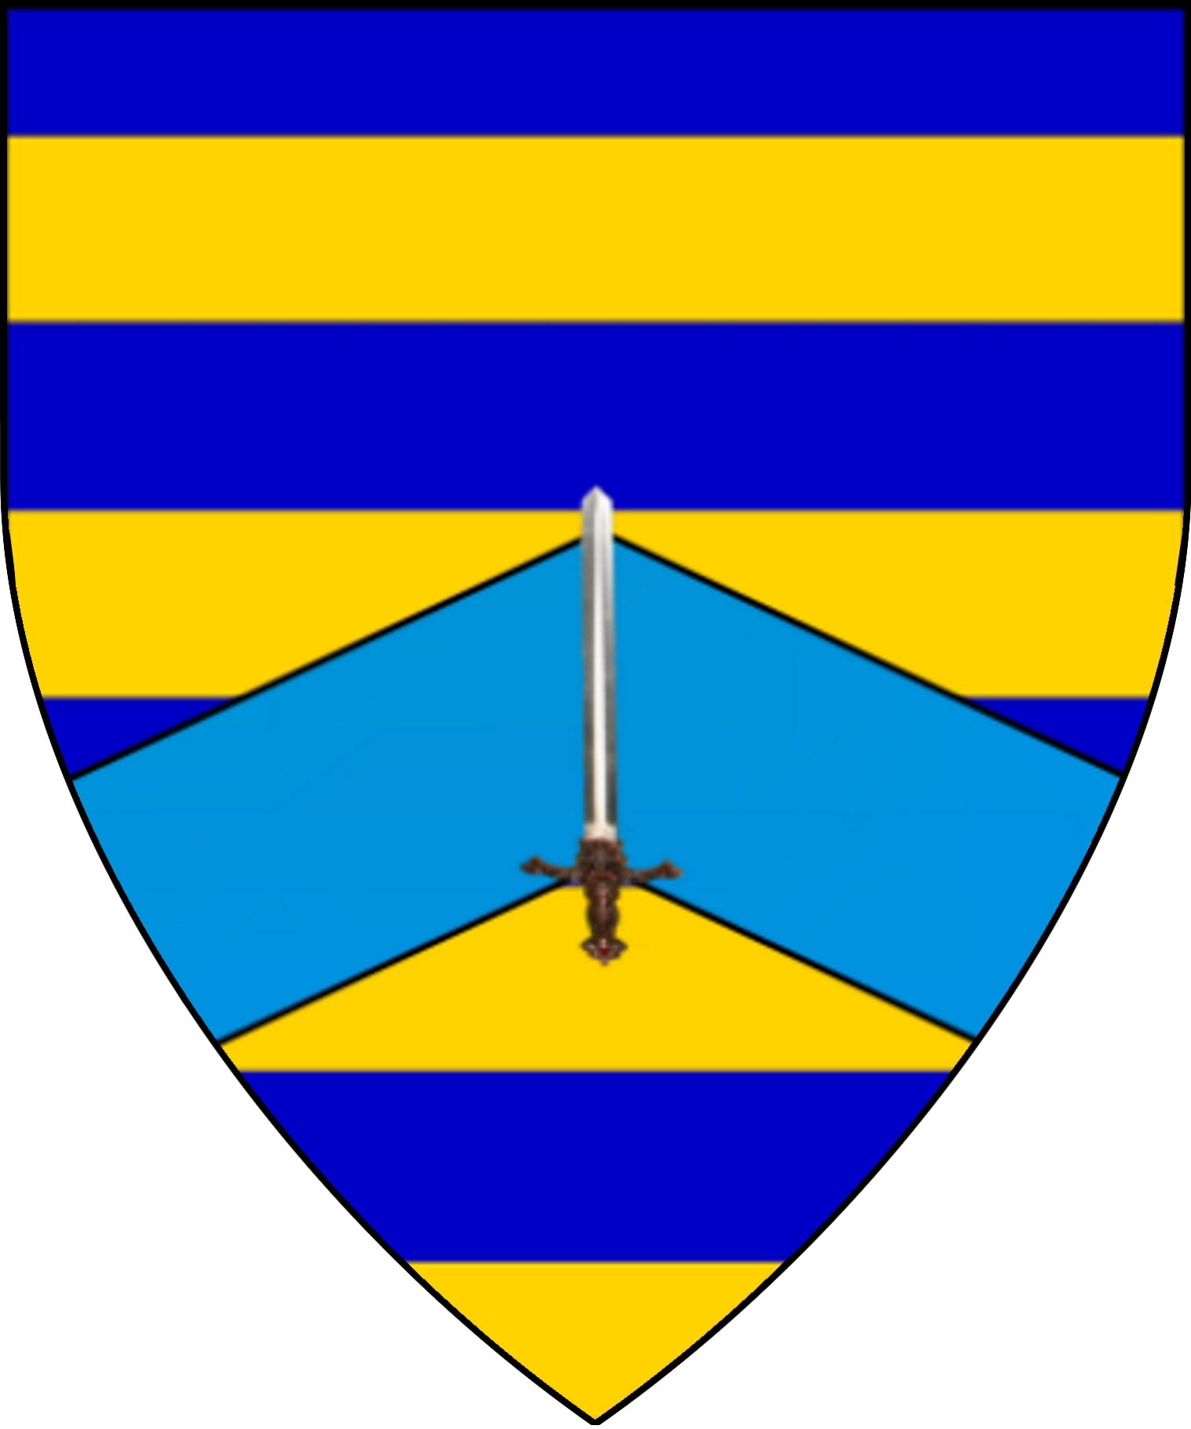
Order of the Griffon
Arms of the Order | Master Jowett
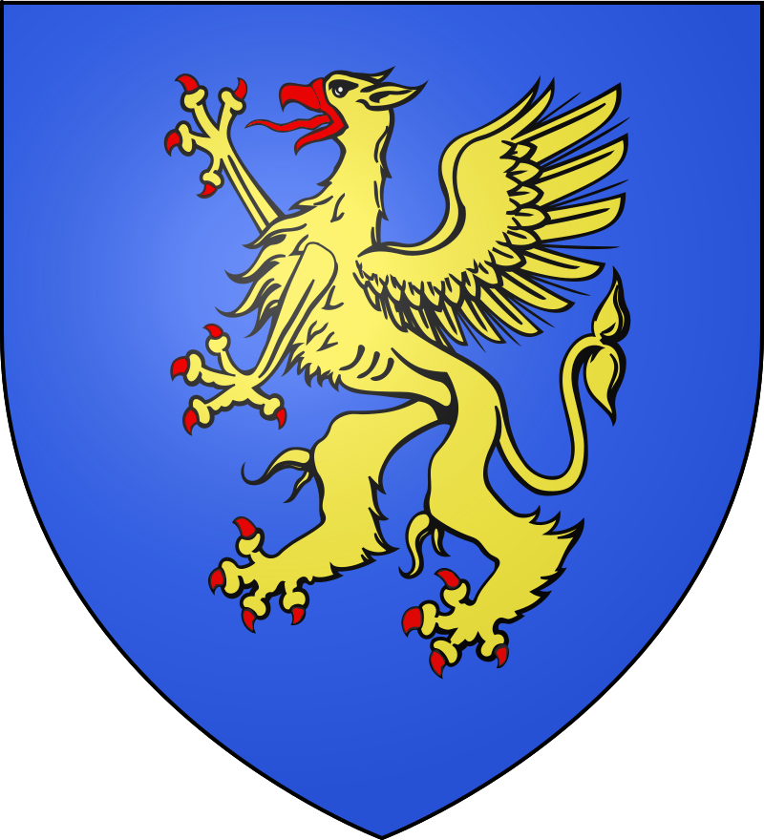 | 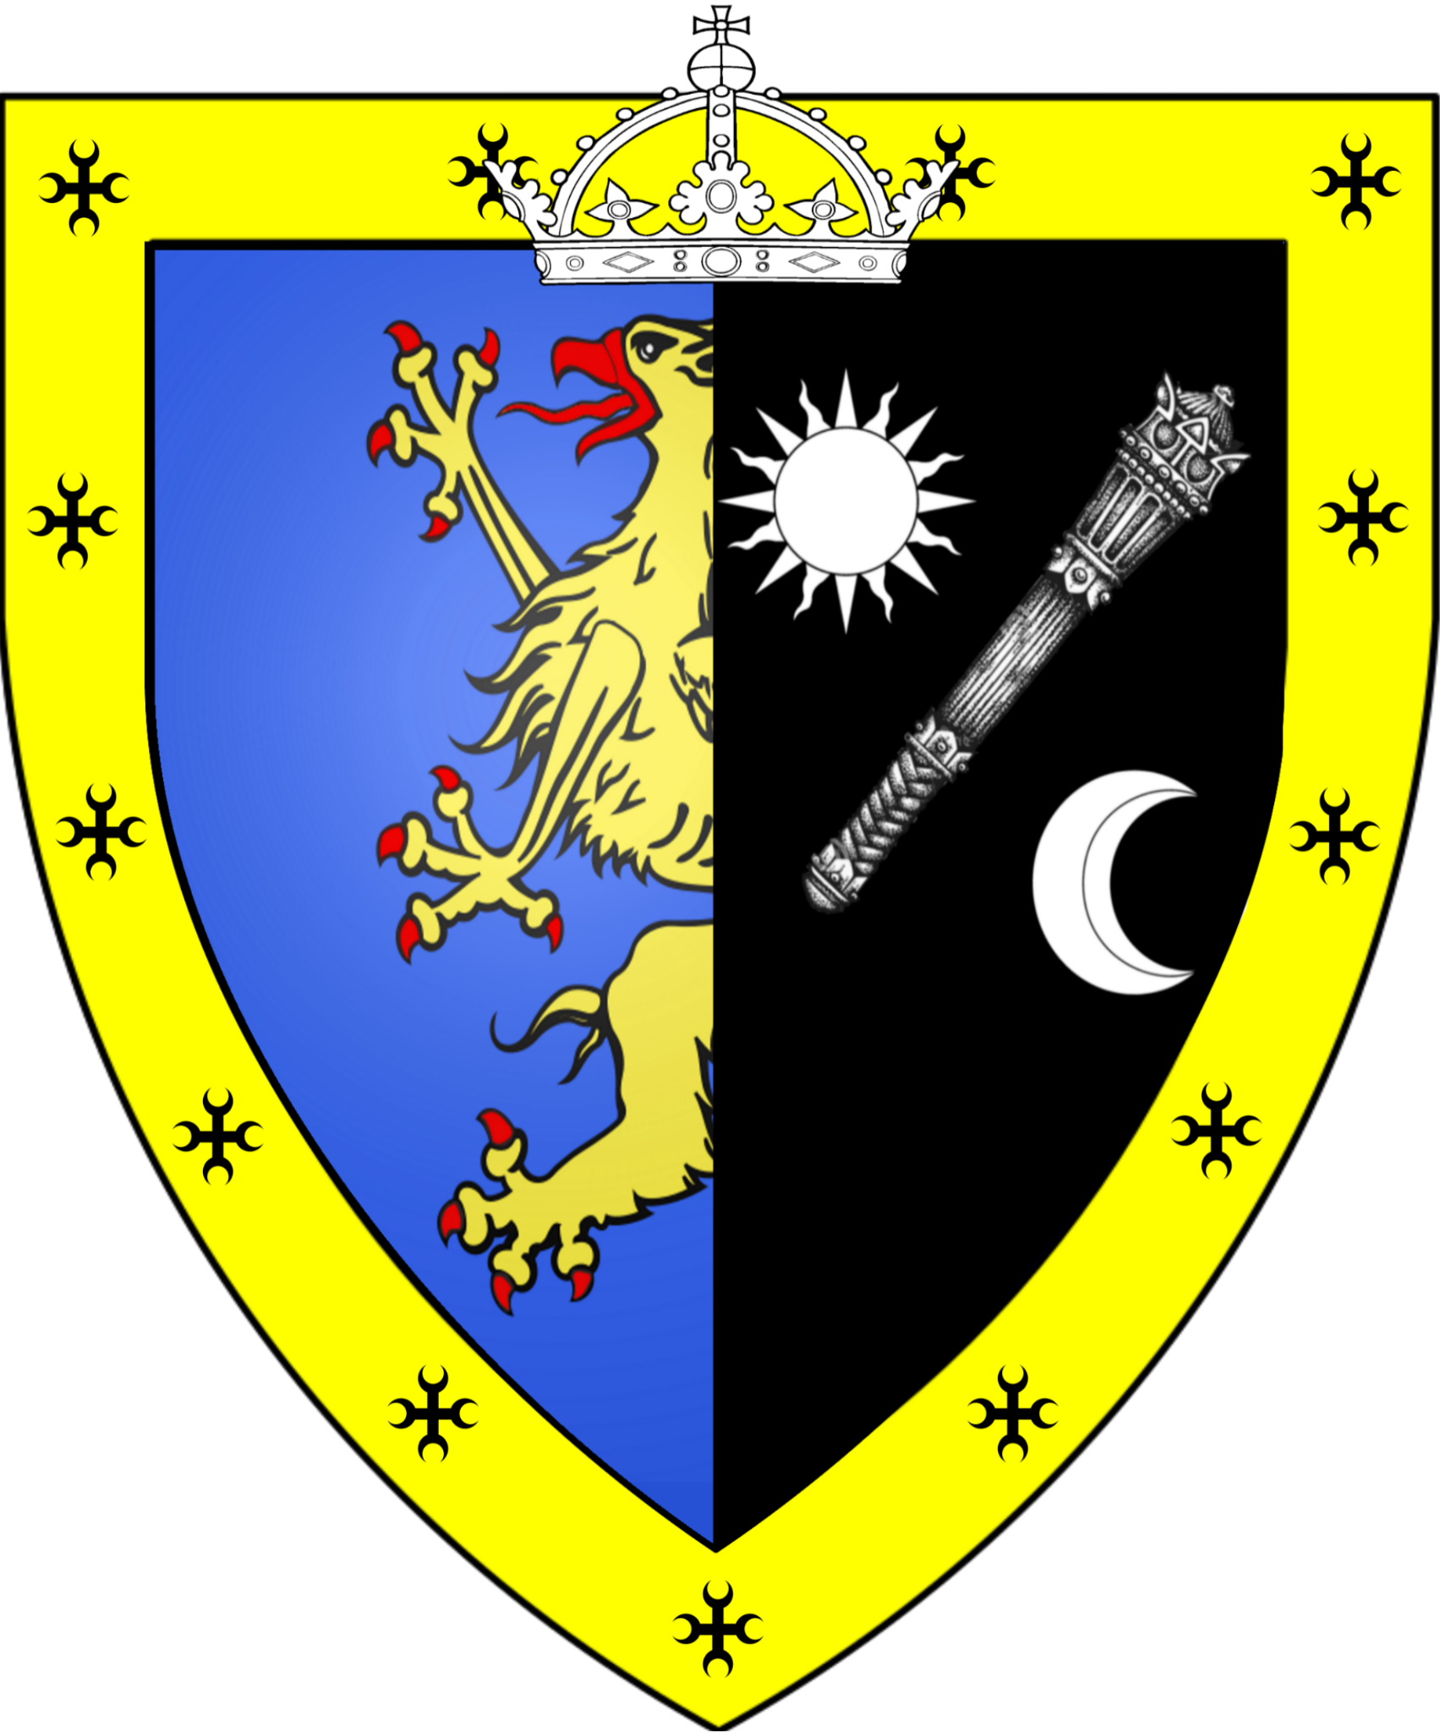
Marshals of the Order
Marshal Sir Vespasian | Marshal Baron Desmond Kelvin II | Marshal Dame Anielle Halaran
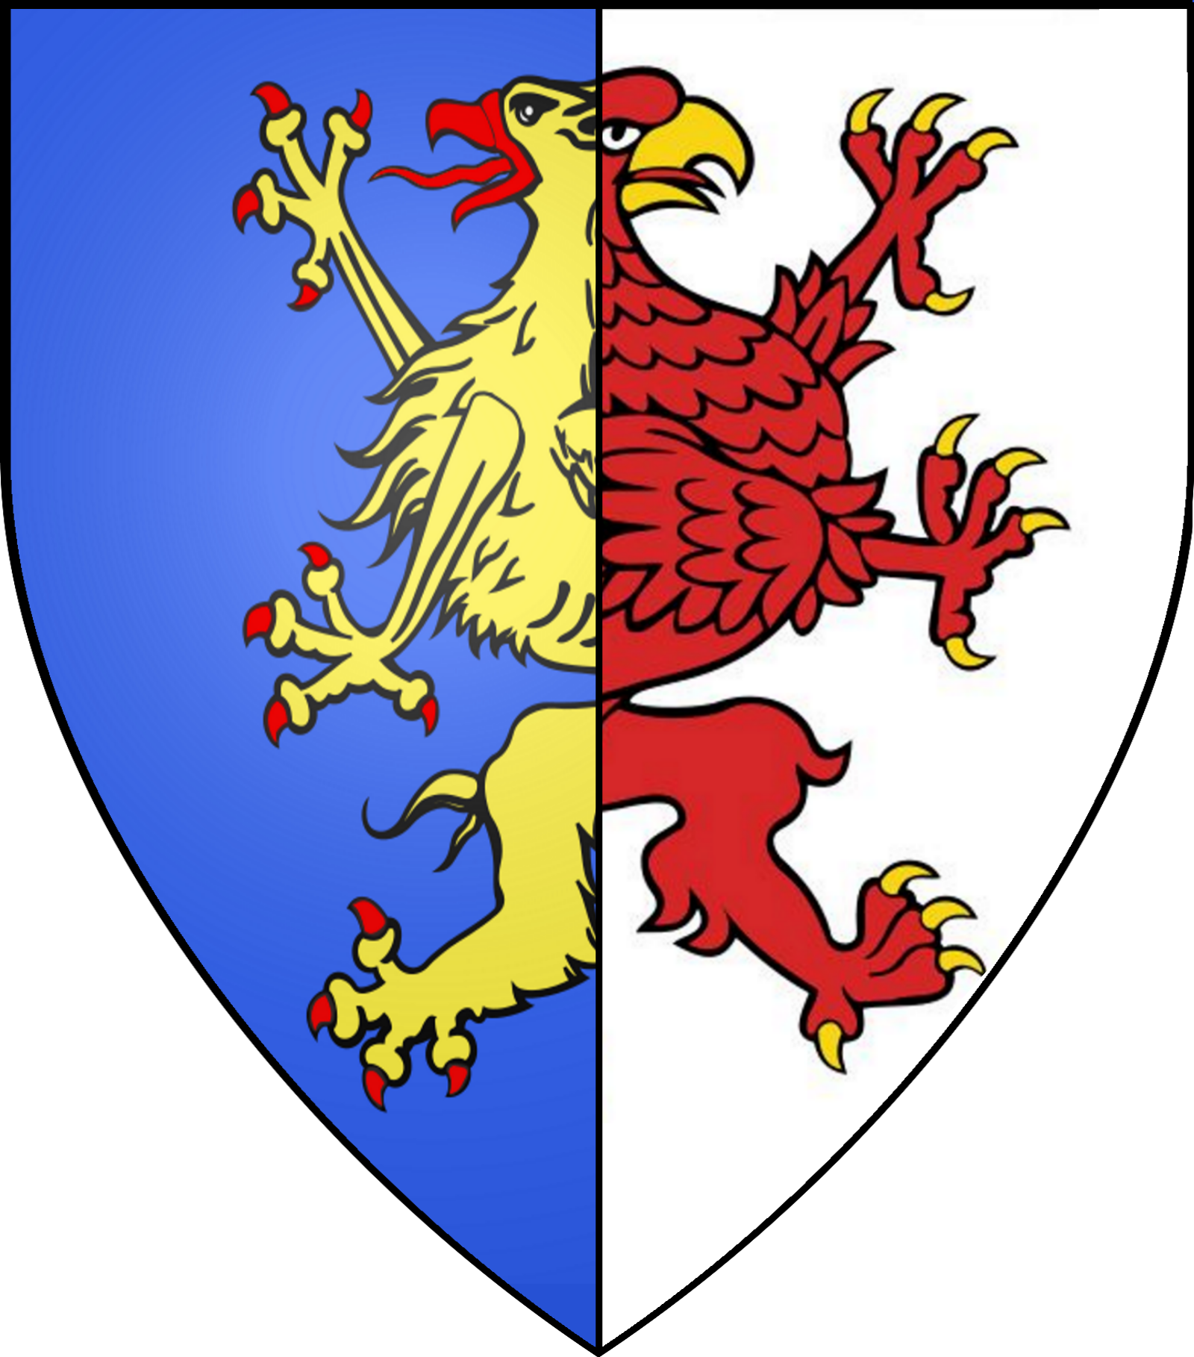 | 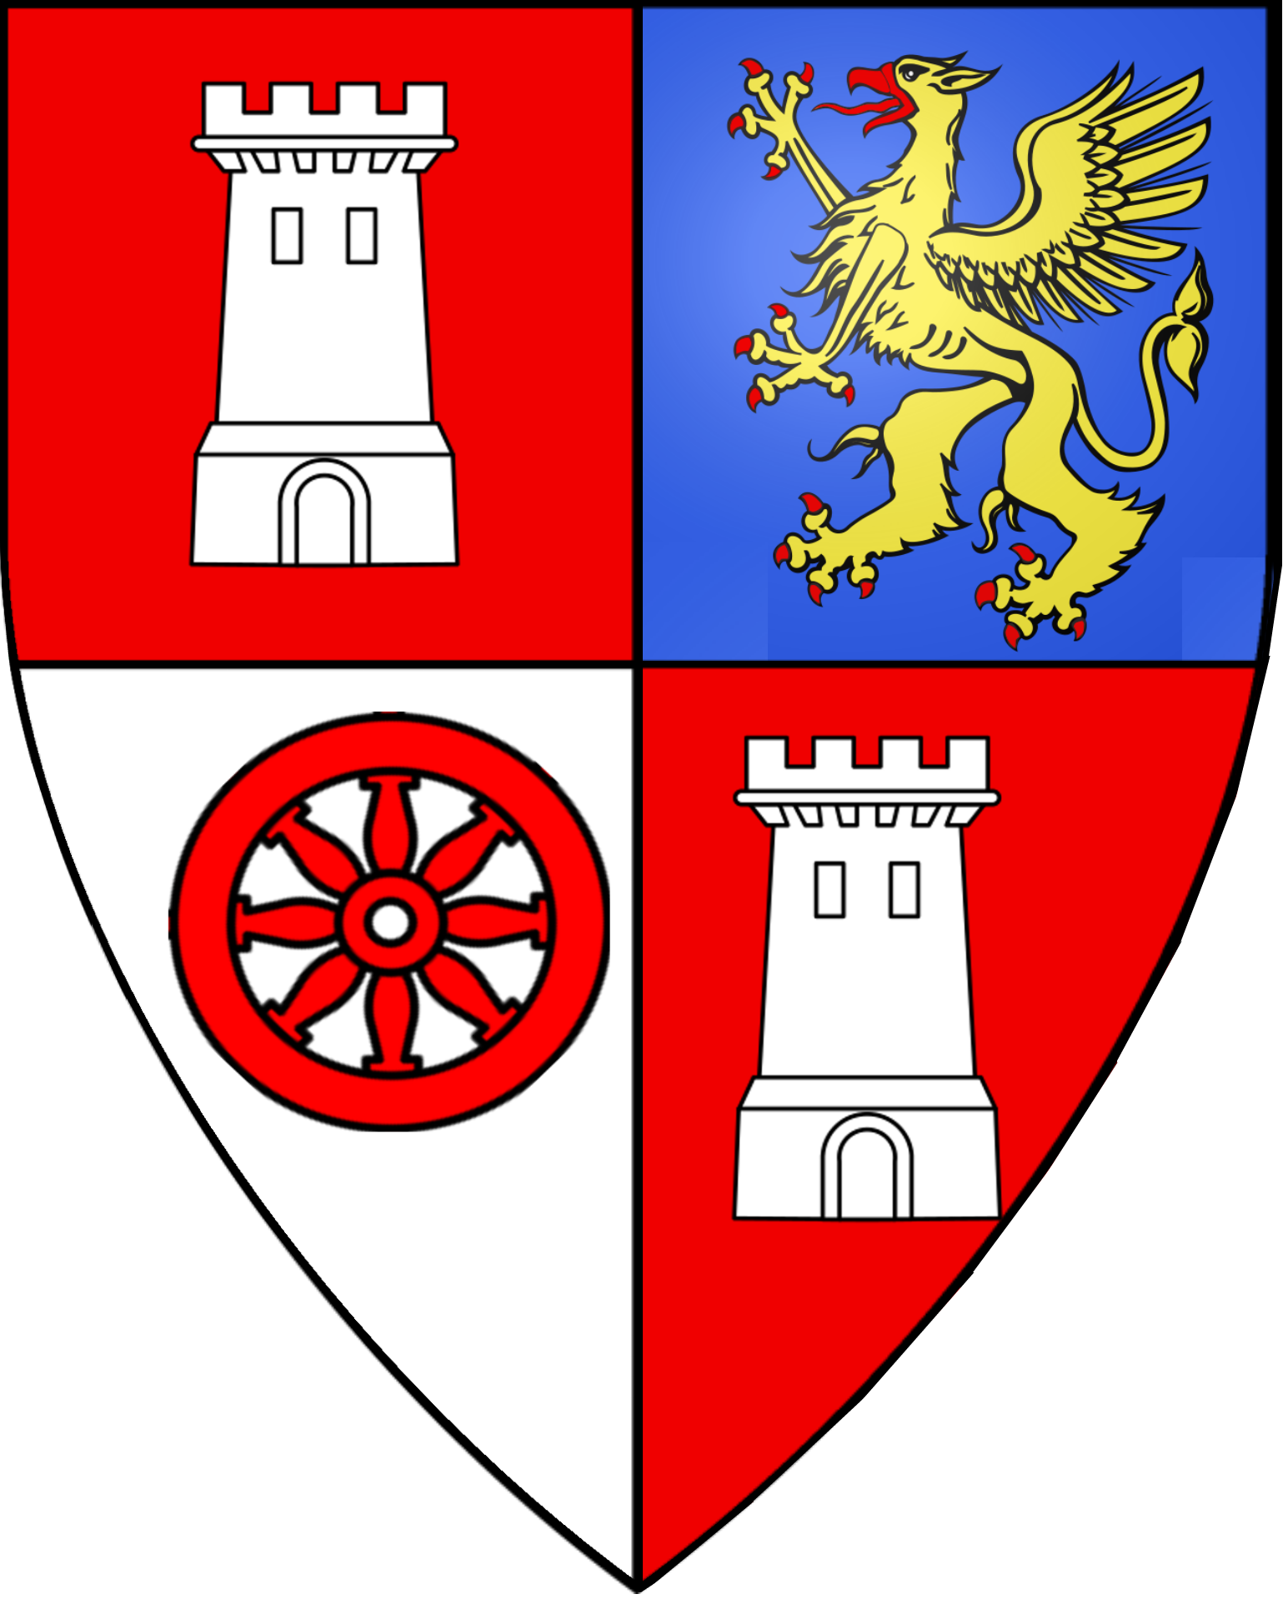 | 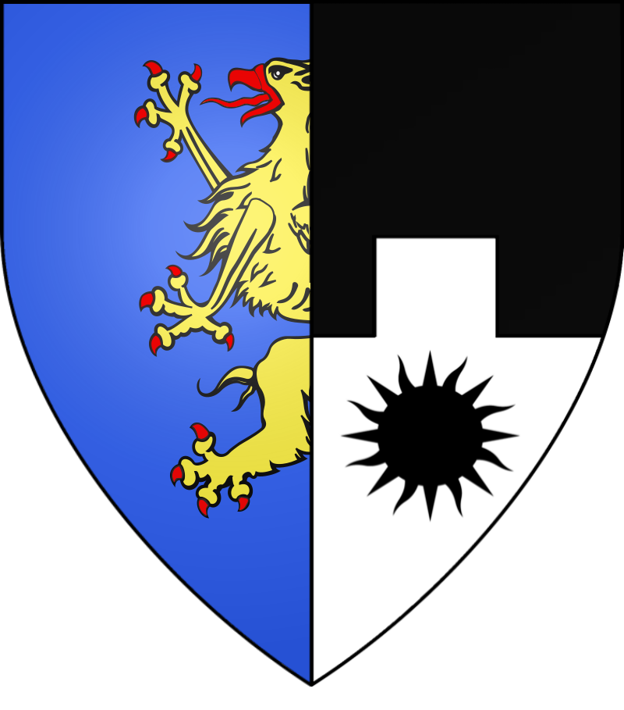
Knight Commanders
Sir Dormer Kendall
Knight Commander
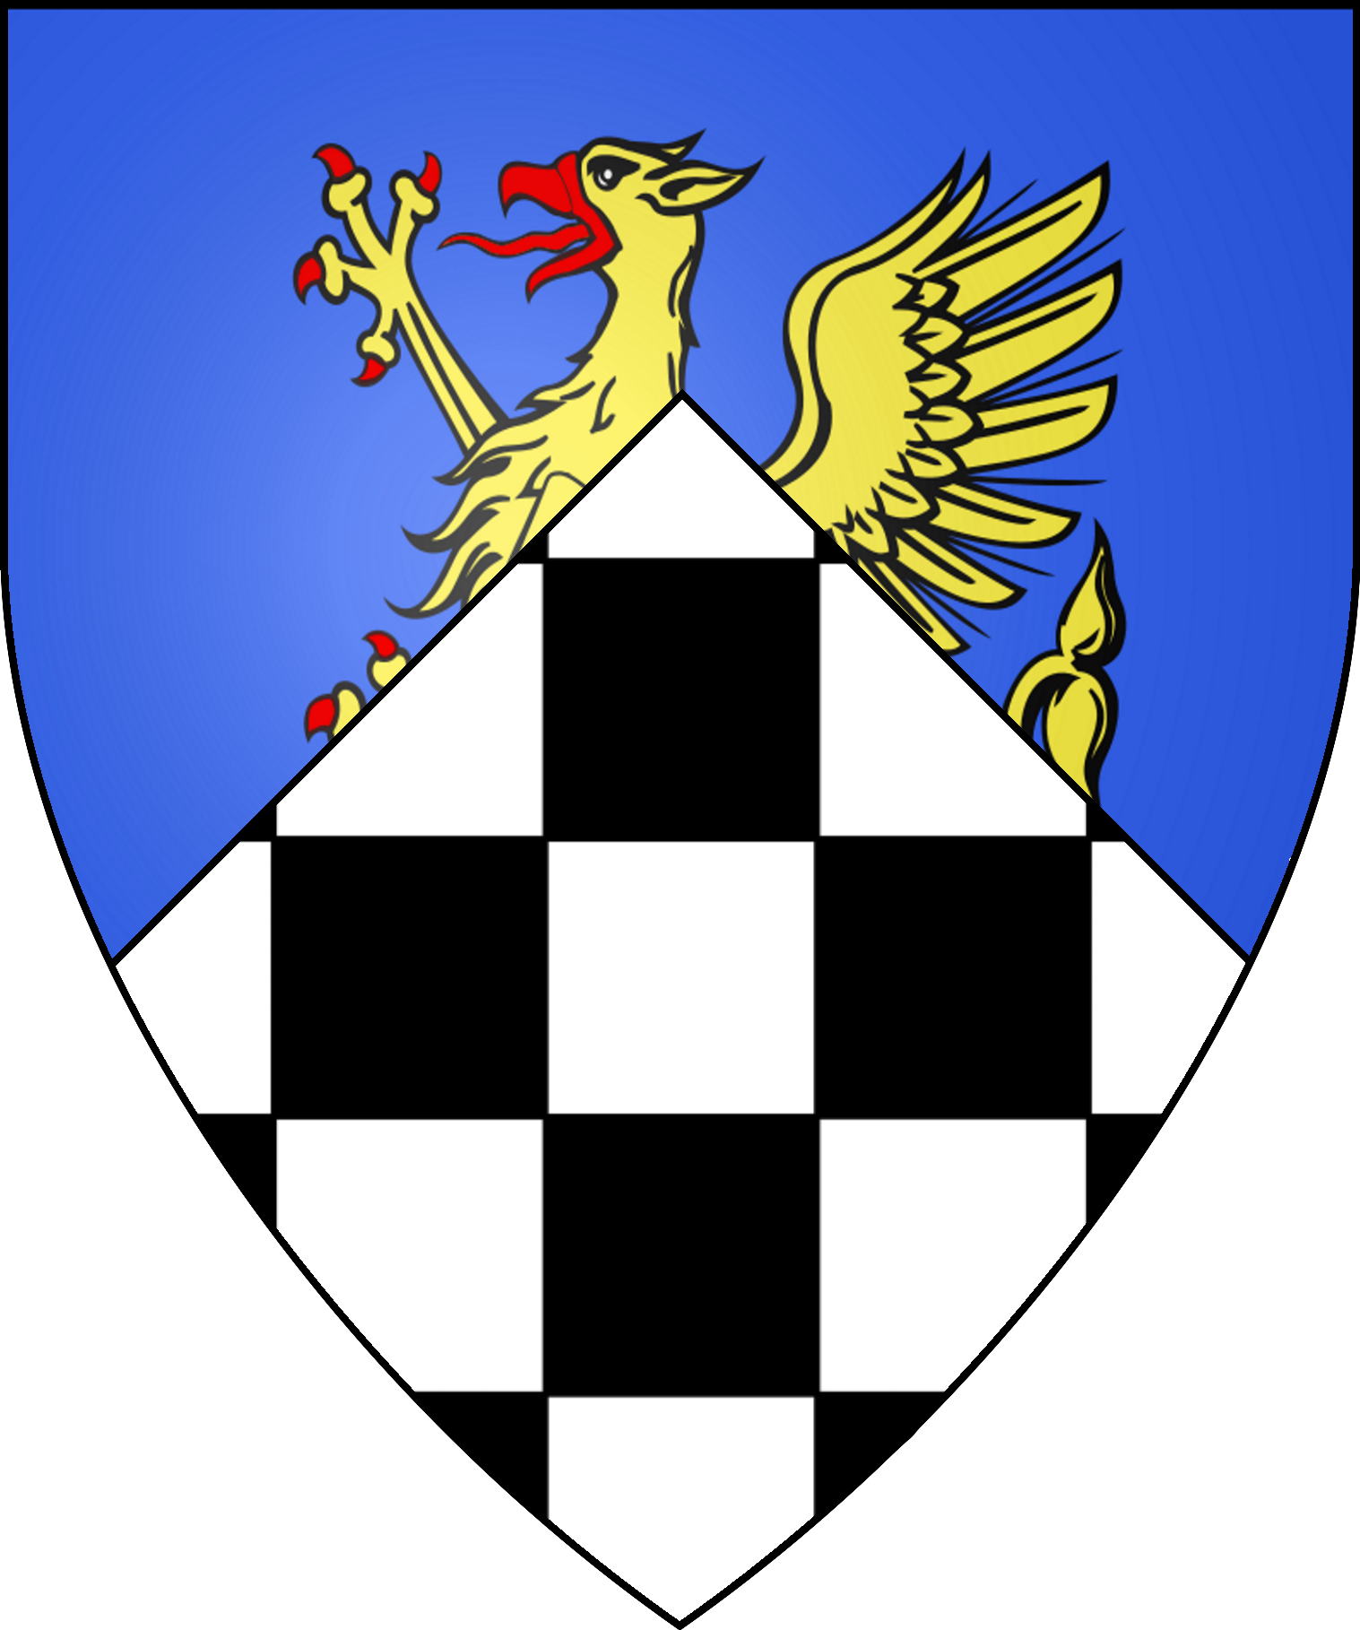
Knights Brother/Sister
Dame Hannah Bracegirtle
Order of the Three Suns
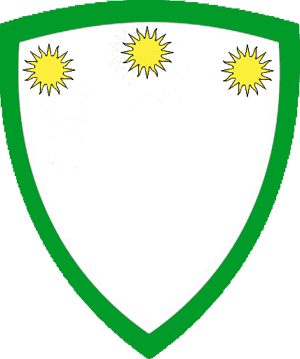
Knight Masters
Grandmaster | Hospitaler | Treasurer
Sir Gryndyr “the Strong” Bloodfang | Sir Lyle Graybow, the “Shovel Knight” | Sir Parsifail Gower
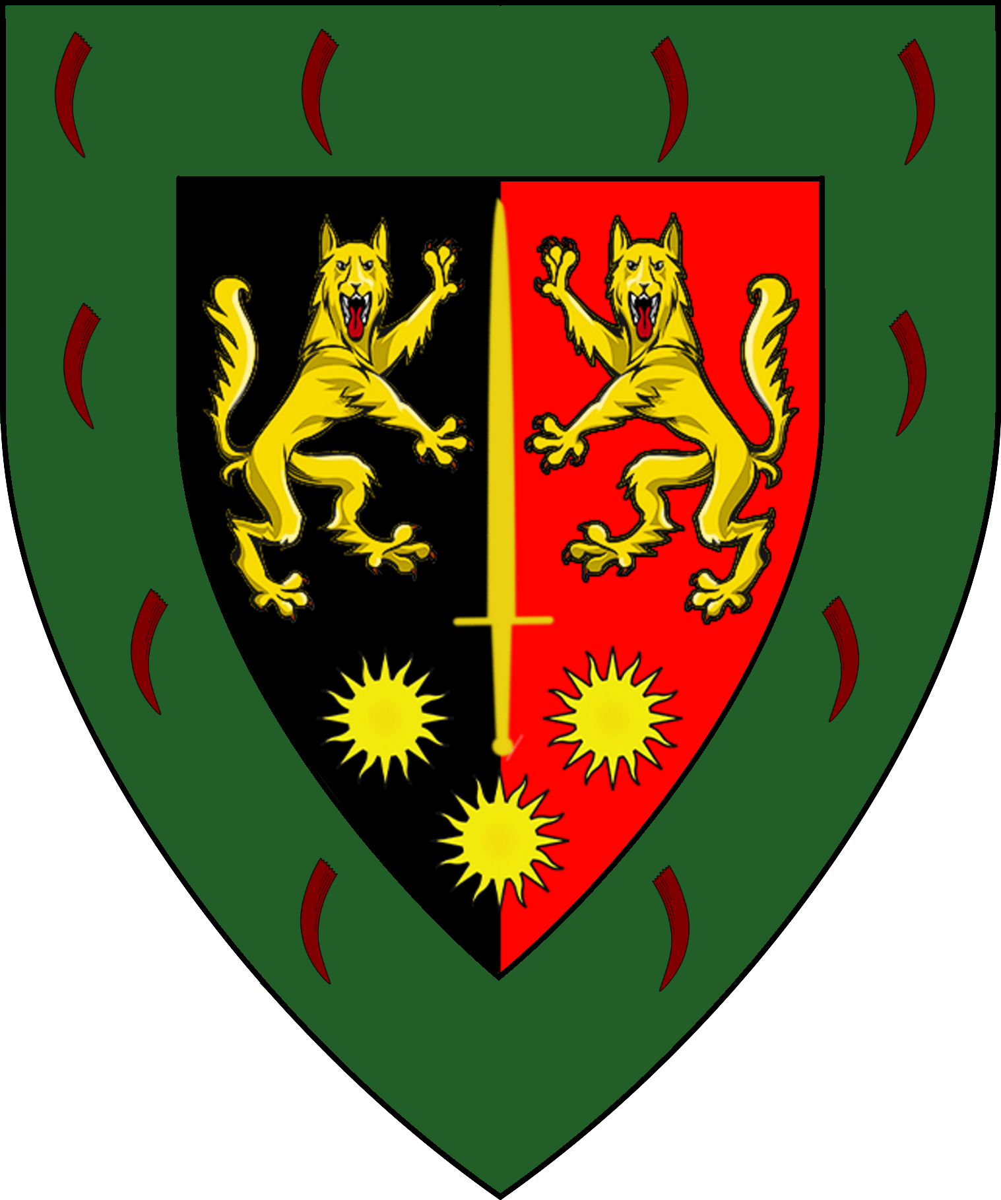 | 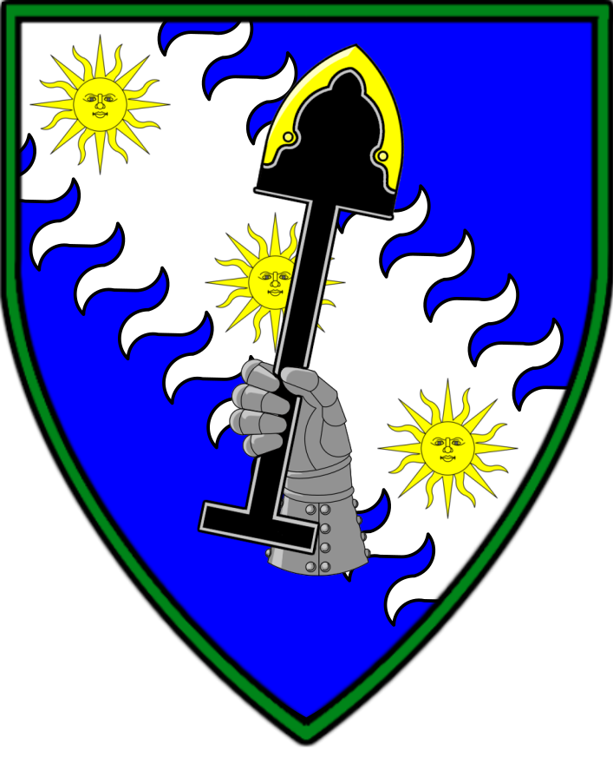 | 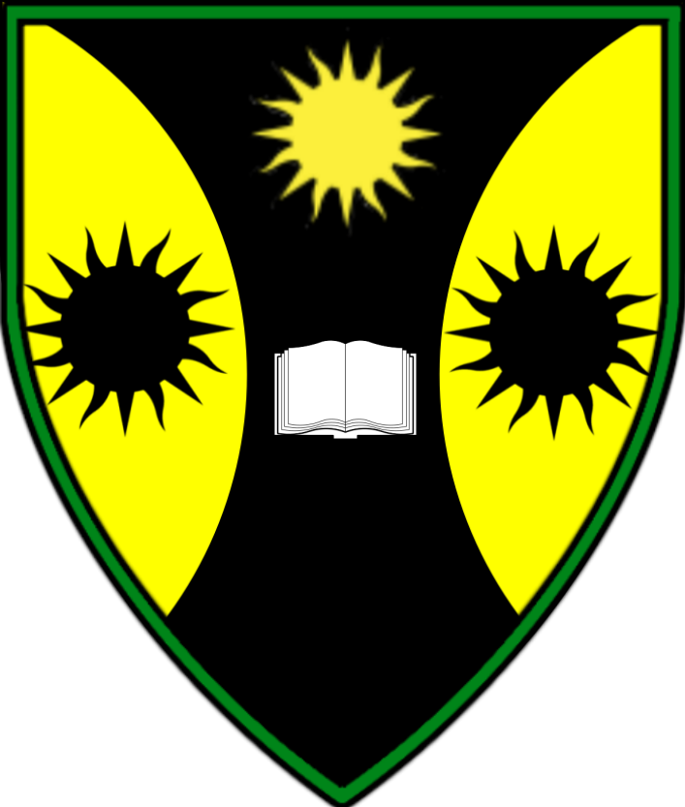
Knight Commanders
Baroness Arteris ”Fang-Riven” Penhaligon | Sir Pontius “Coldheart” Severingin | Sir Marin “Trollbreaker” Rothswayne | Lord Trebor “Blackhawk” Marchant | Captain Sir Algernon Courde
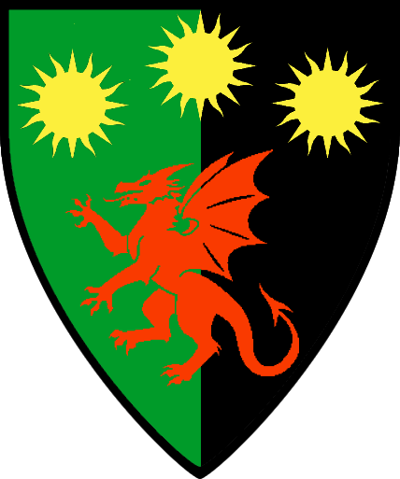 | 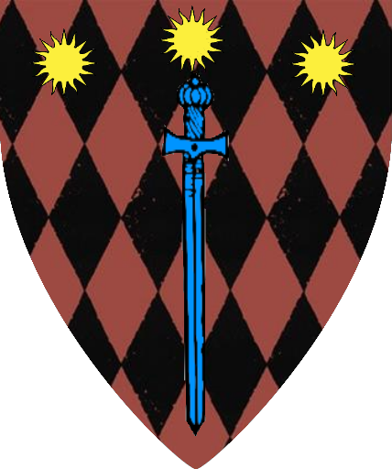 | 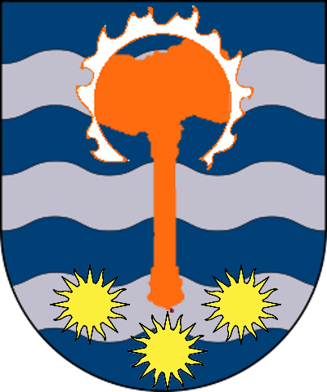 | 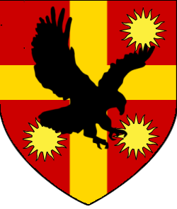 | 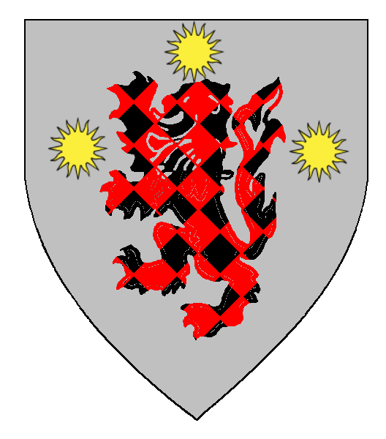
Sir Kel of Loxado | Captain Sir Heinrich Wolf
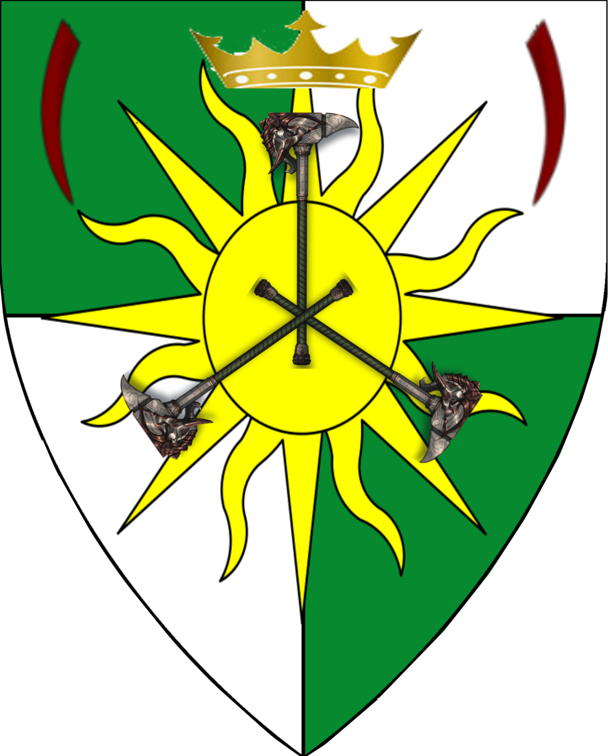 | 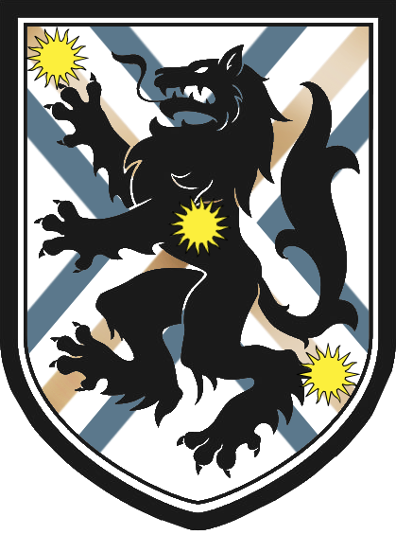
Knights
Sir Axel Flynn | Sir Dantalos Posdione | Sir Cristofor Shchurov | Sir Linnaeus Octus | Sir Kaerin Pehaligon
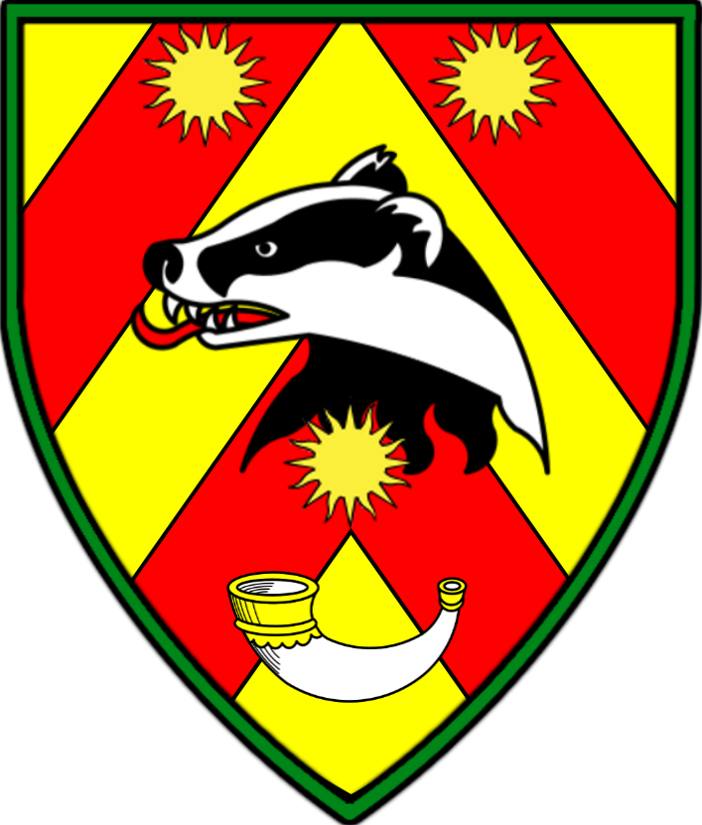 | 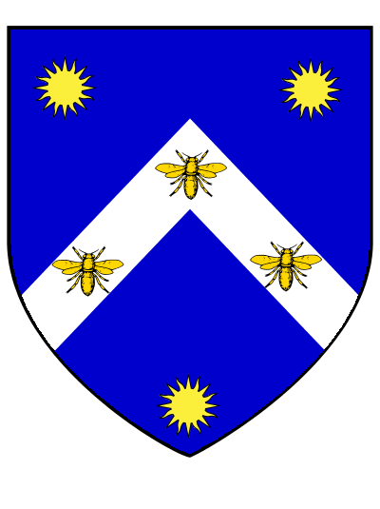 | 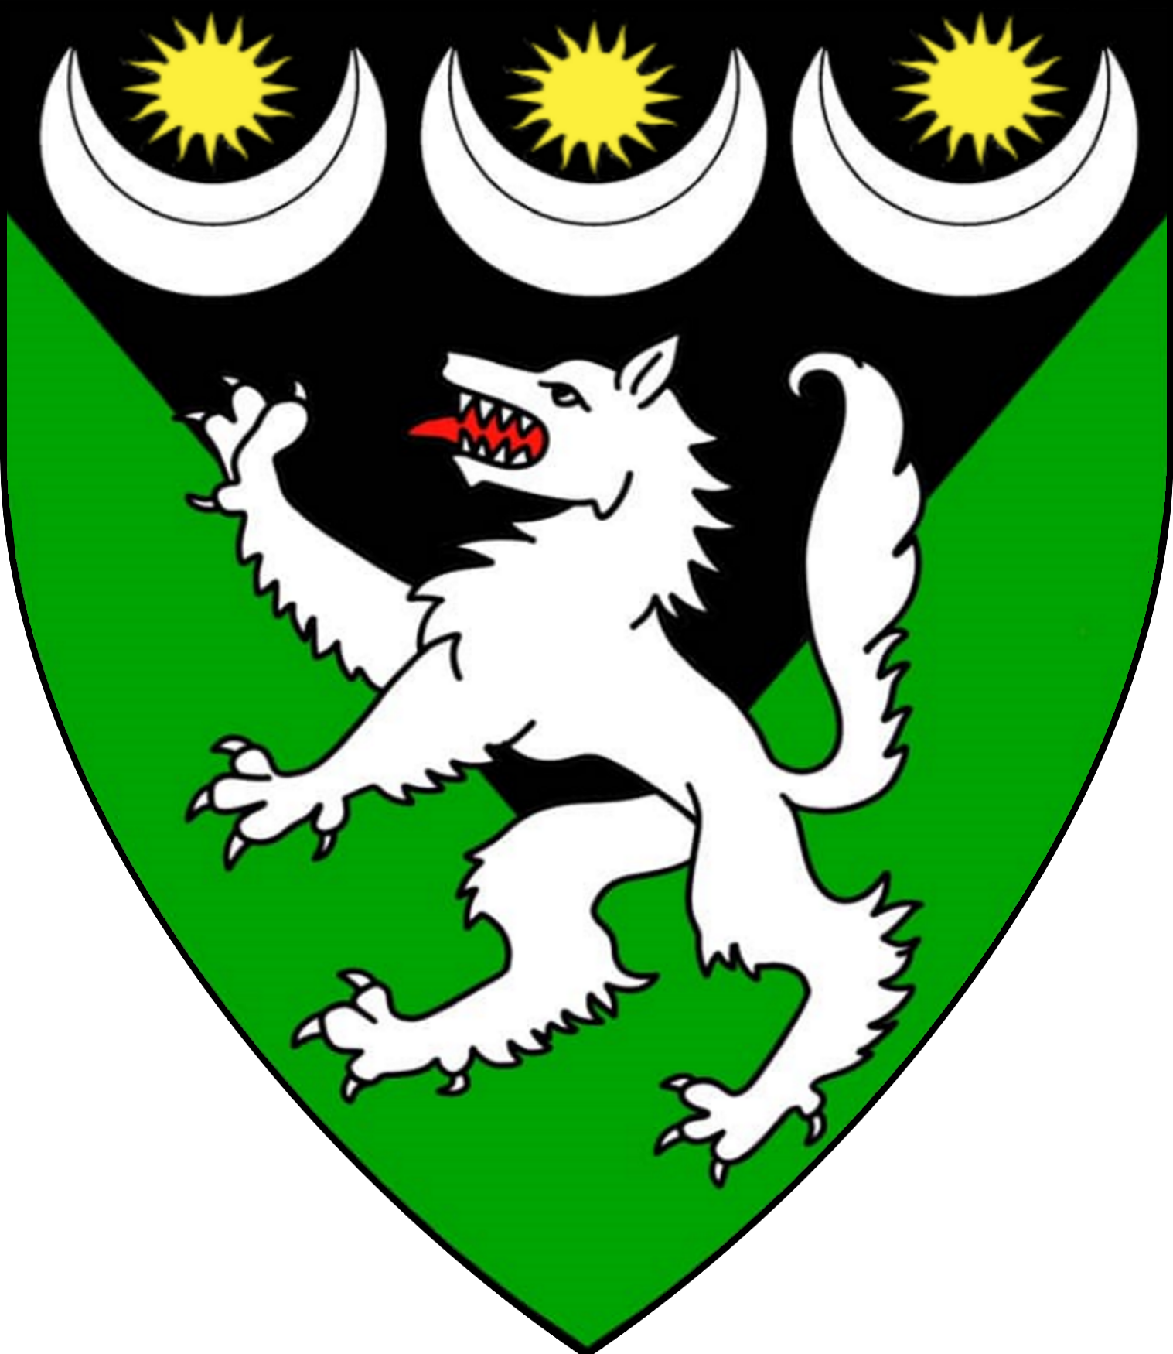 | 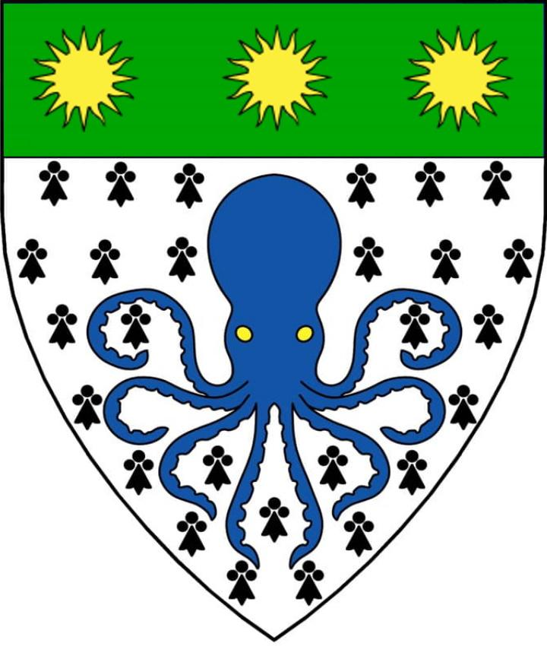 | 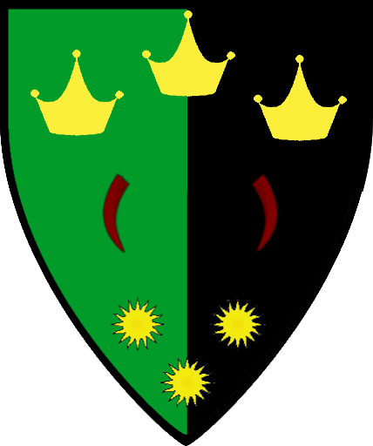
Sir Rajiff Al’Nouri | Osiric Maldiv | Leon Cenerian | Sven Ranulfsen | Sergi Tolanov
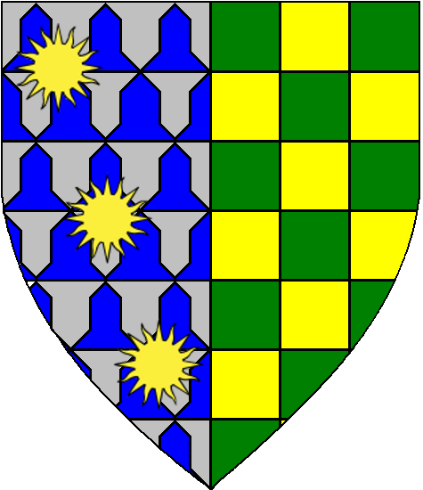 | 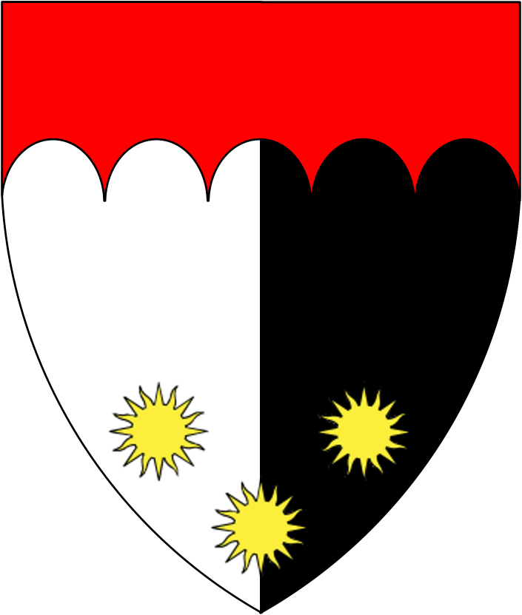 | 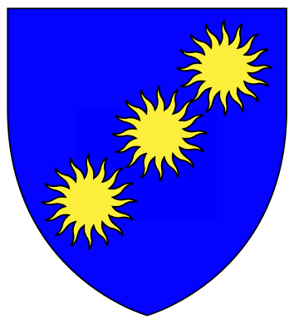 | 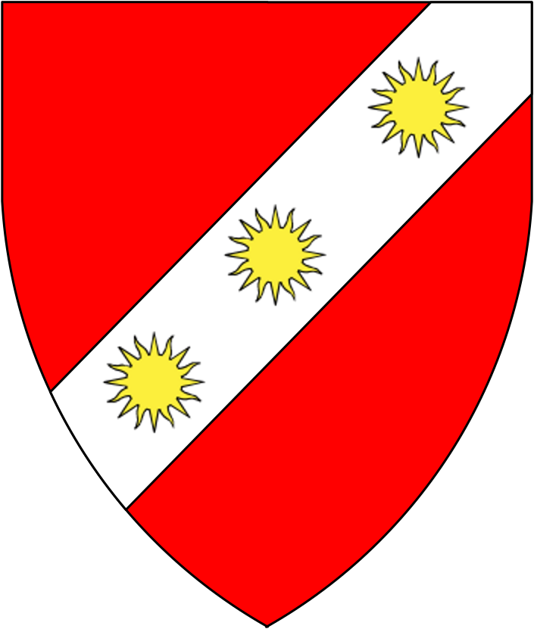 | 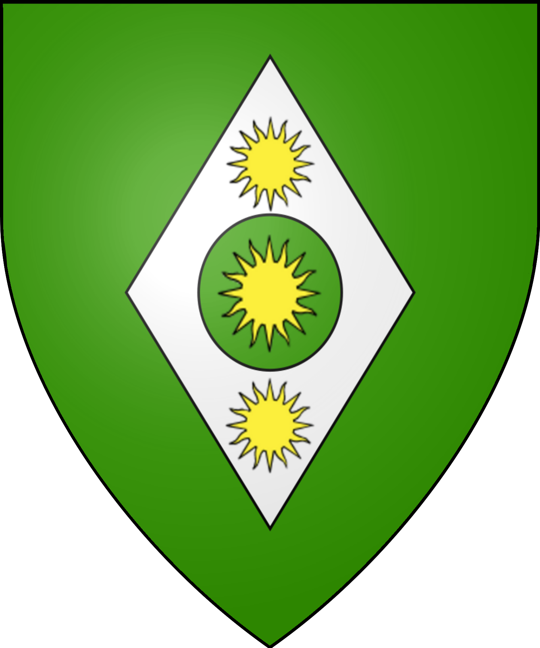
Dame Anastasia Bloodfang | Sir Theodocius Caravel | Sir Yakov Strausse | Constantin Zandrov | Erik Revenmar
 | 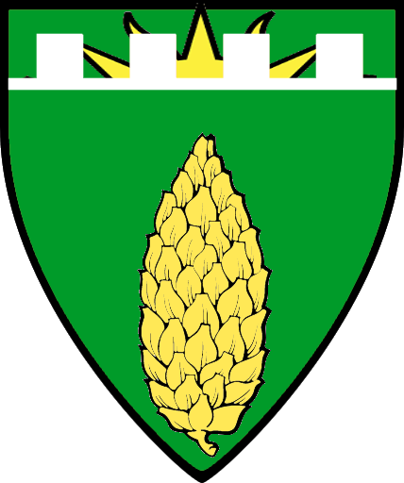 | 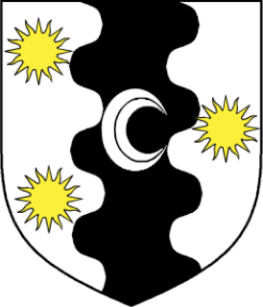 | 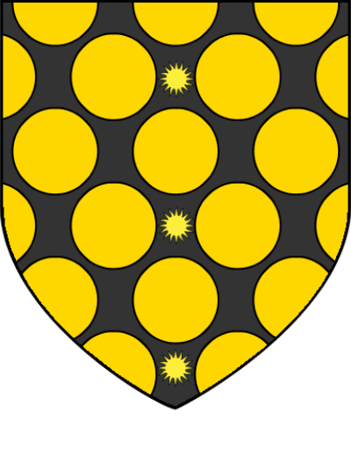 | 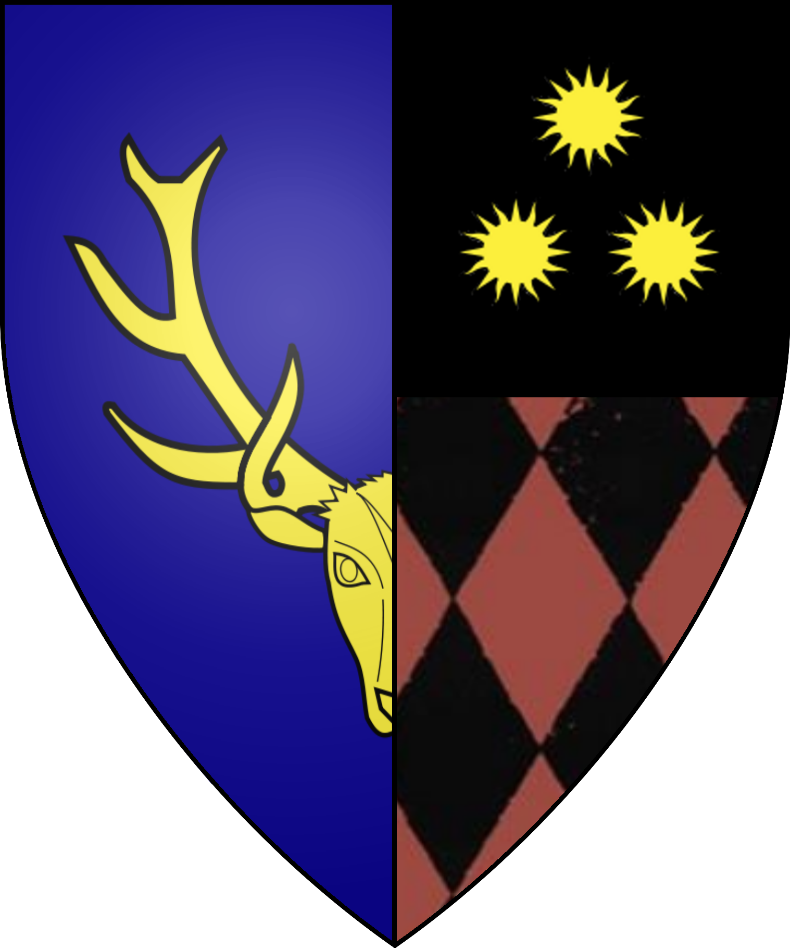
Sir Julian Bouras | Sir Pertonus Alston | Sir Jonathan Drake | Sir Alonzo Voet Giamatti | Sir Clemont Bostwick
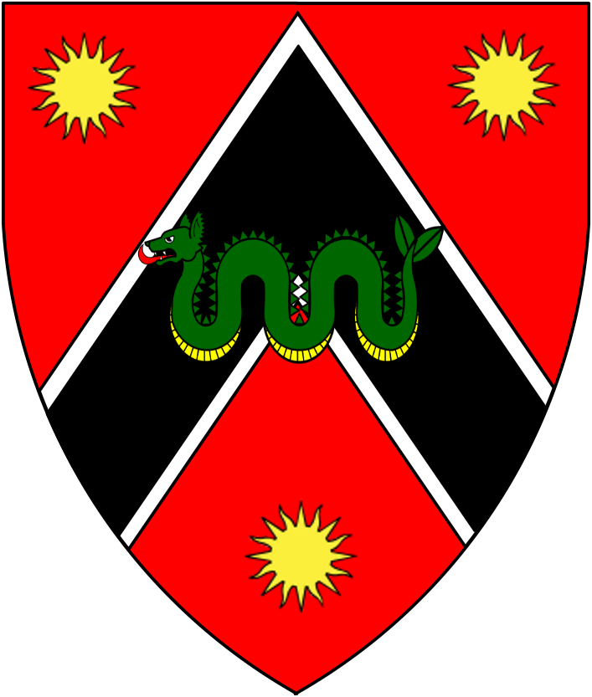 | 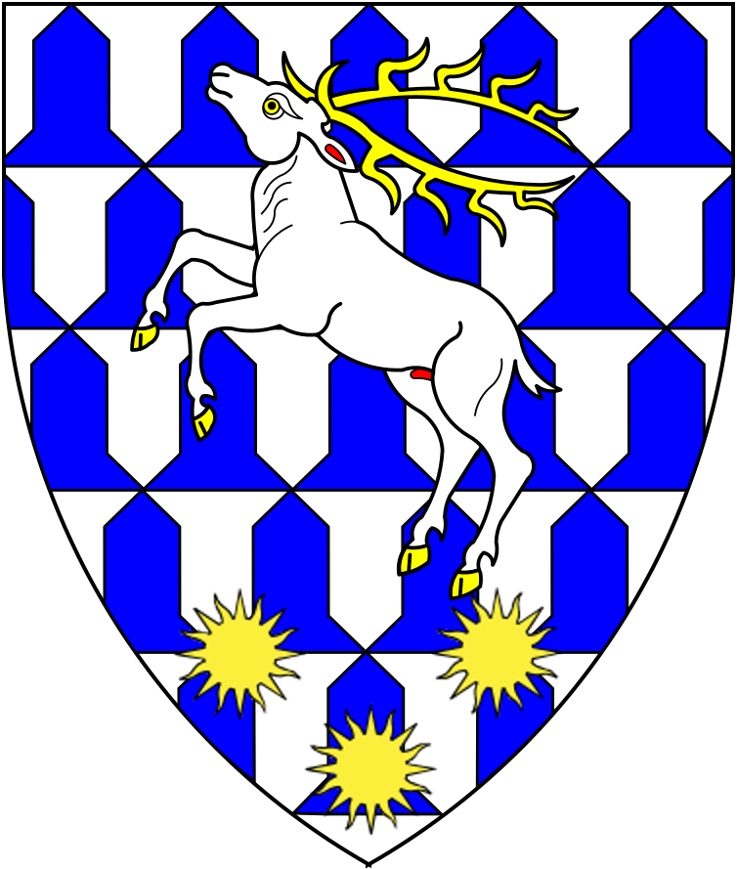 | 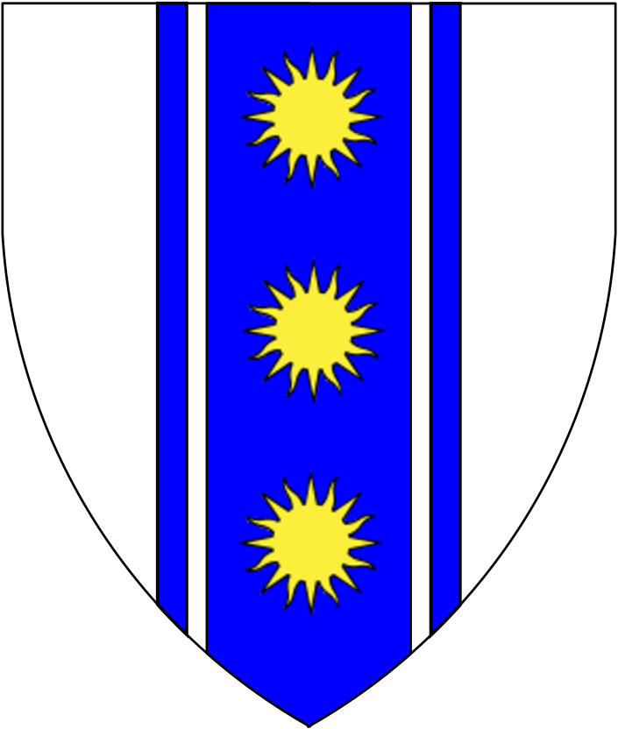 | 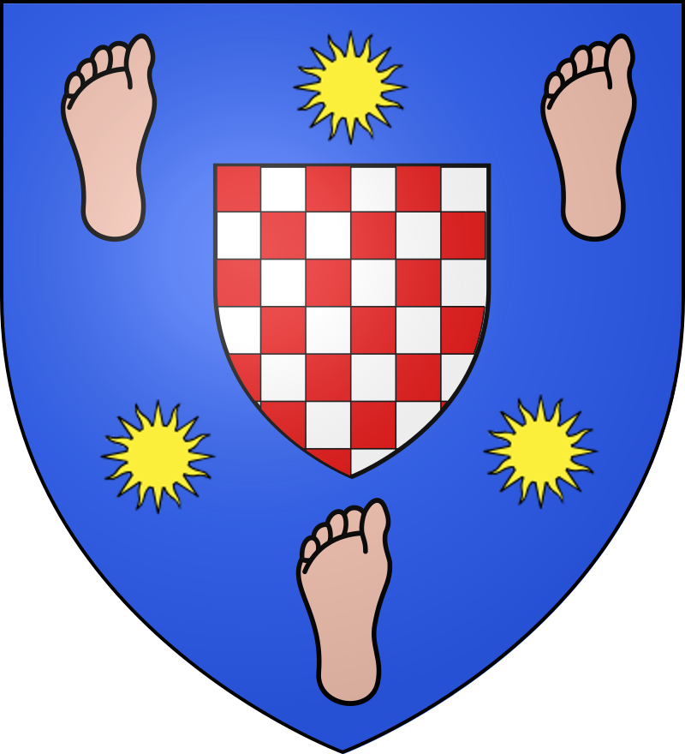 | 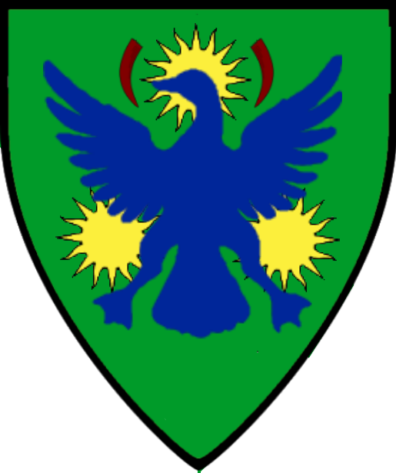
Sir Titus Anaerius | Sir Ayden “Odinsworn” Sylvoril | Antillar Courde | Yelchin Voss | Sir Decimos Meridian
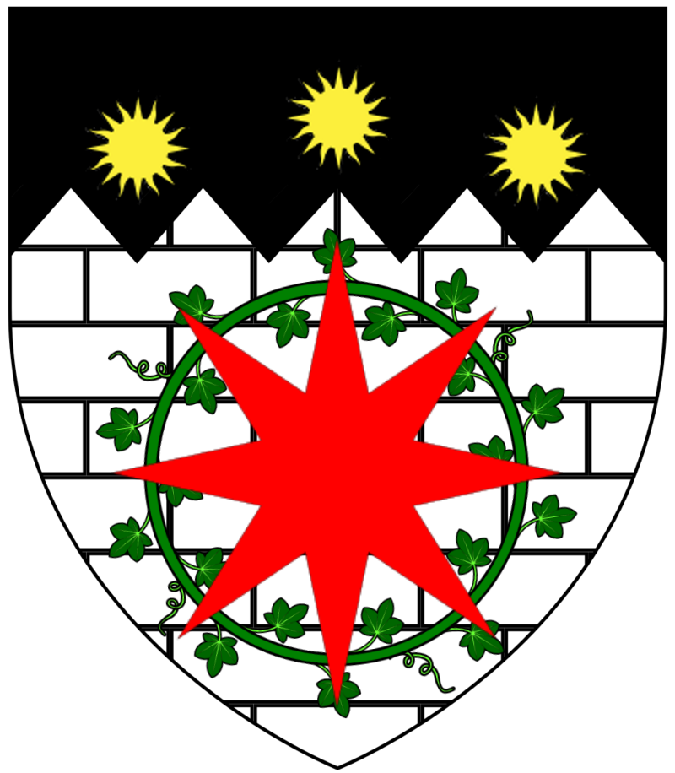 | 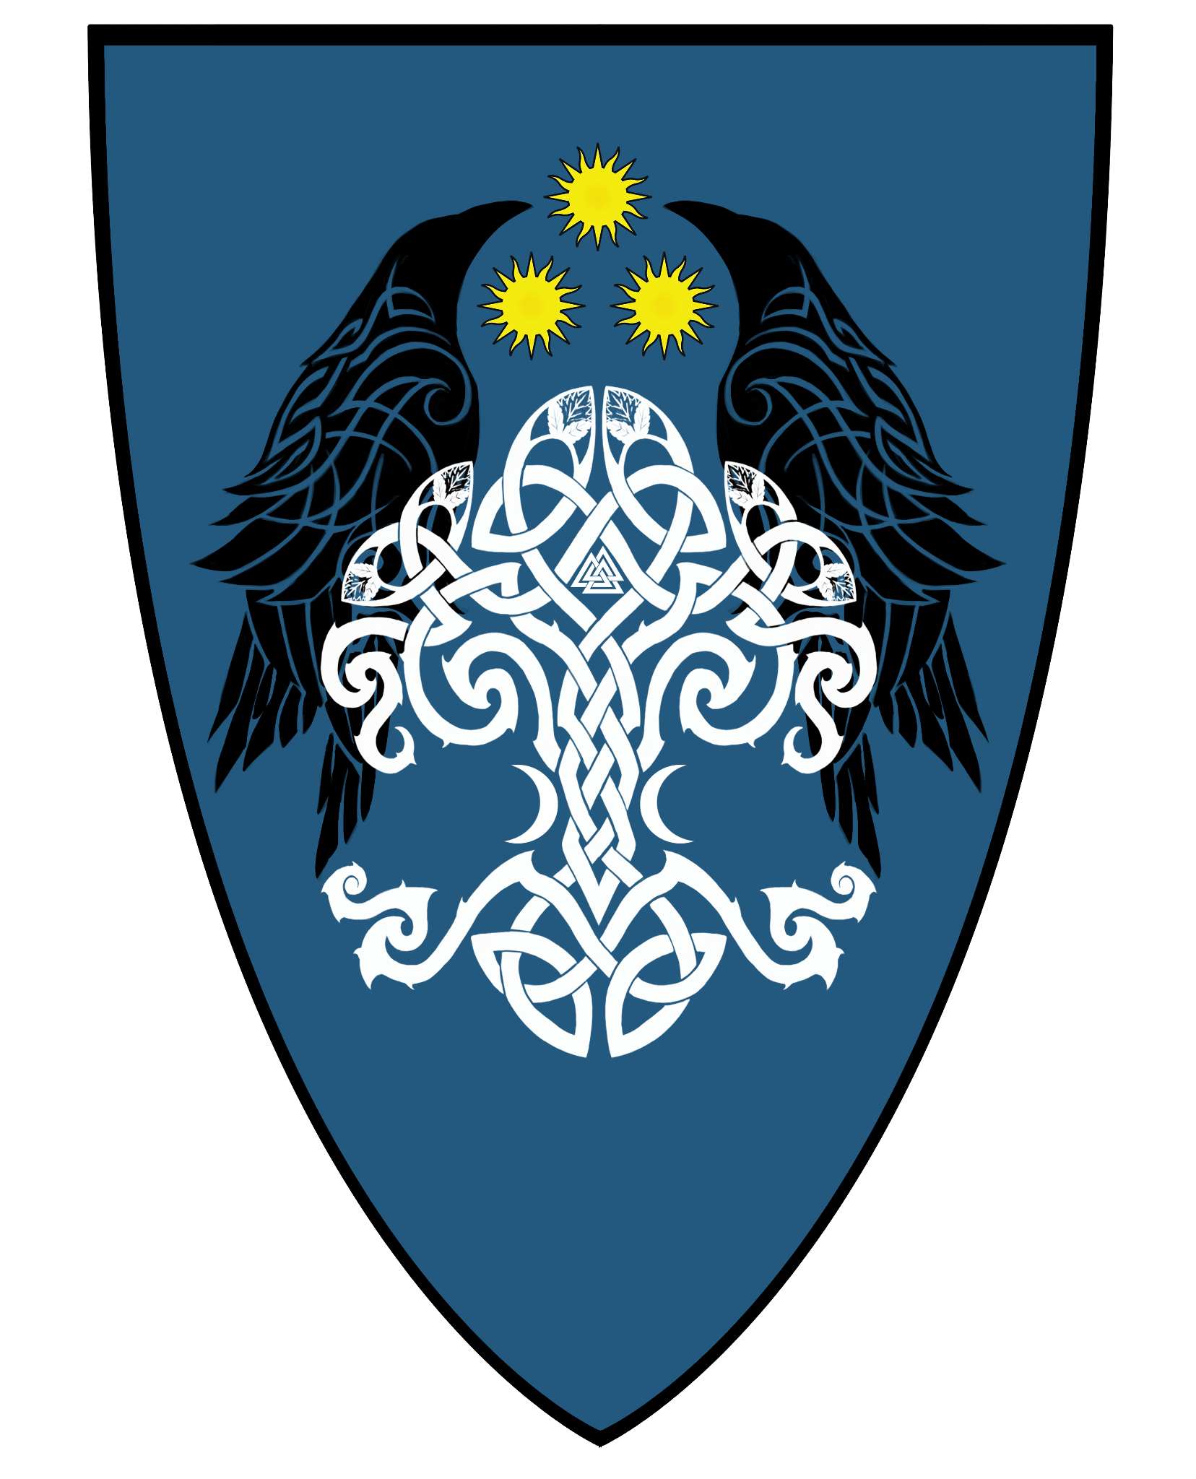 | 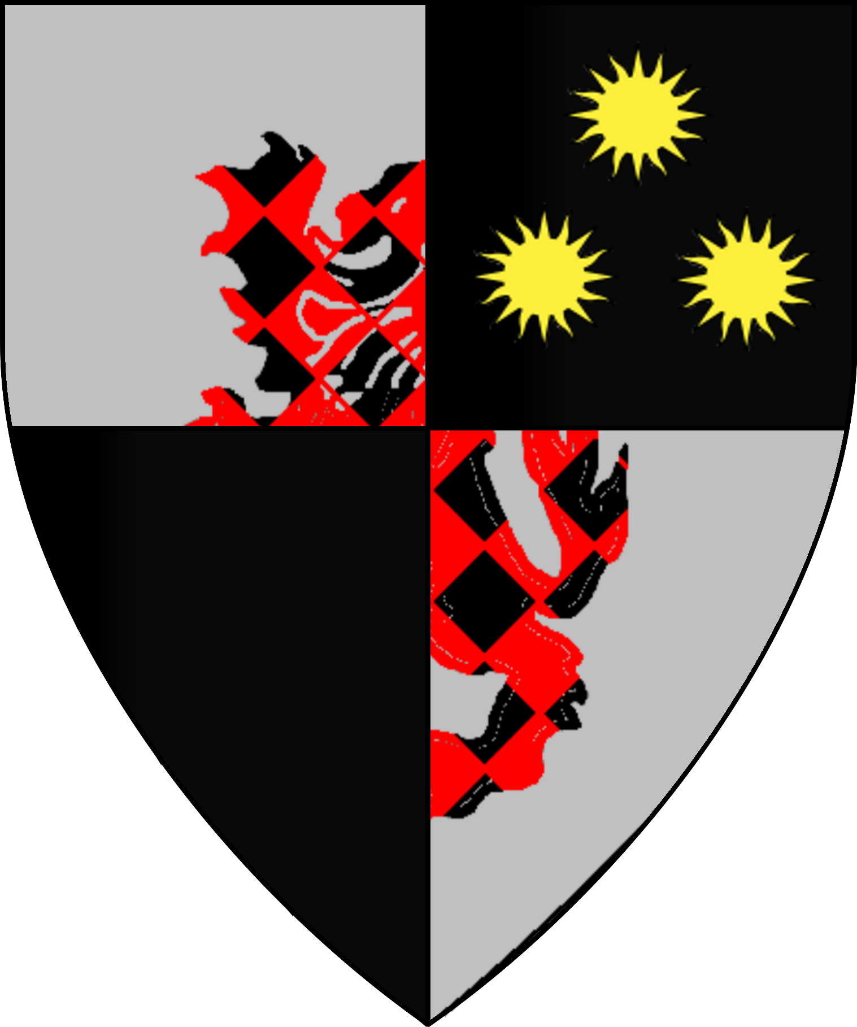 | 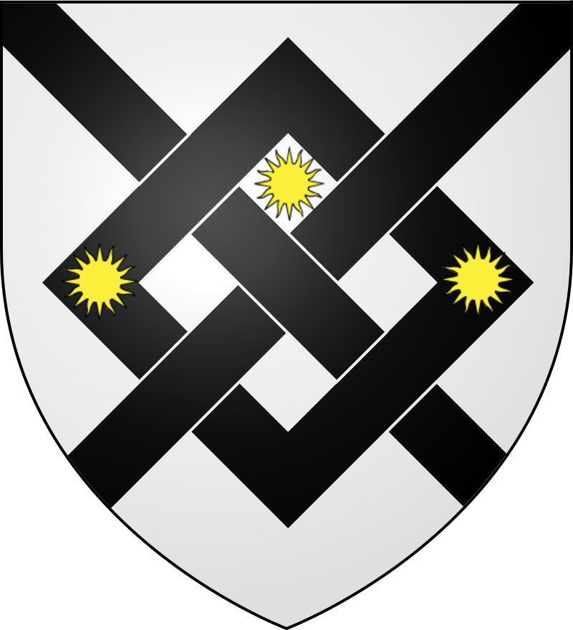 | 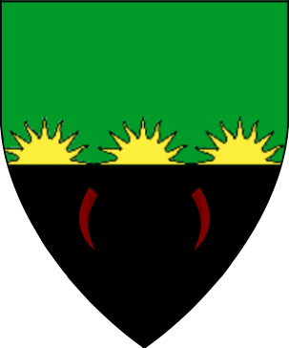
Ulfgar Trollbleeder | Dame Laelin Aenelianas | Raisha Barotescu | Sir Tristan Dumondt | Dame Amelie Rozovsky
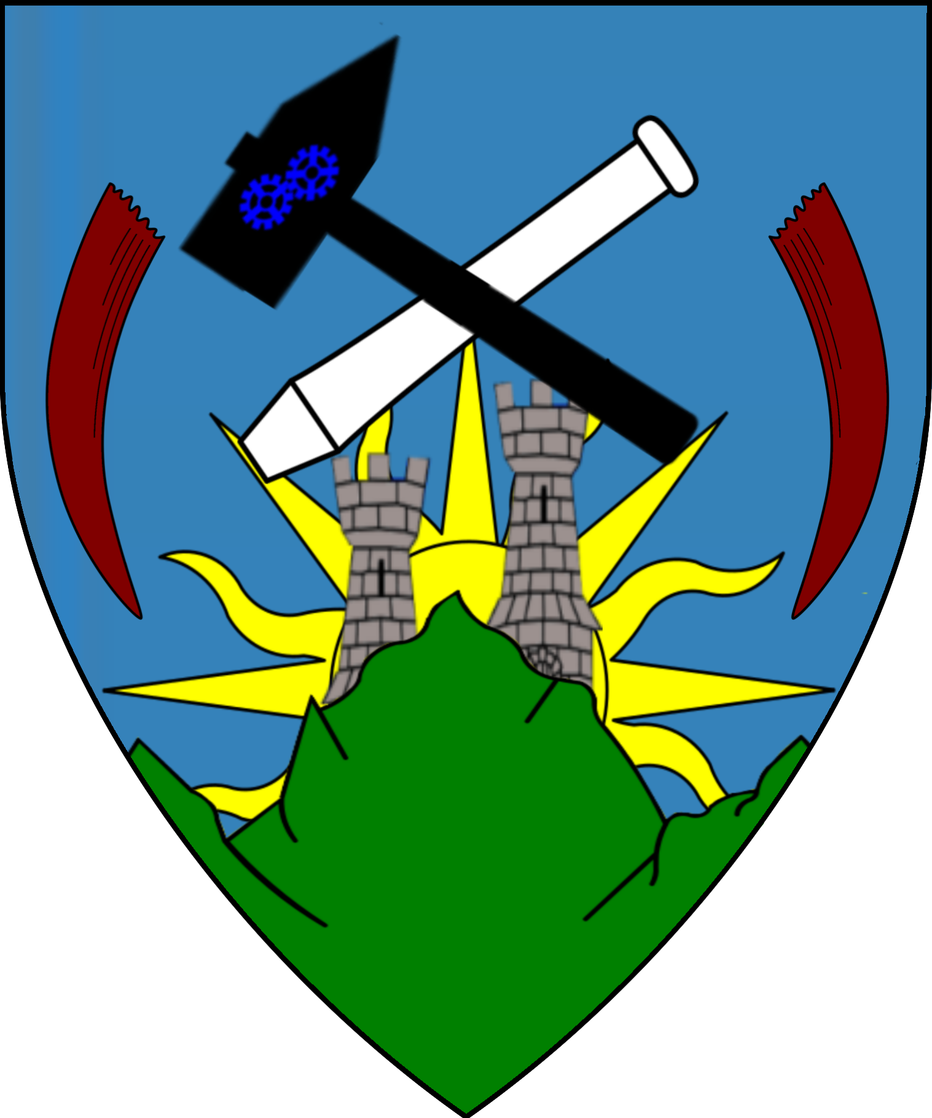 | 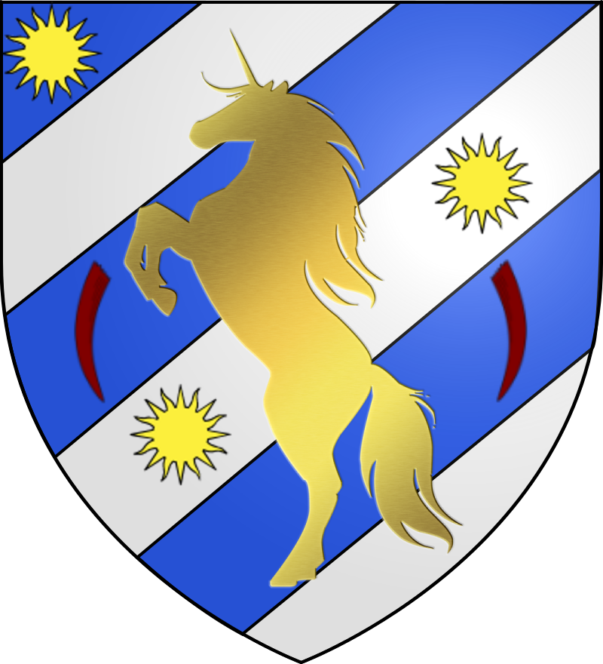 | 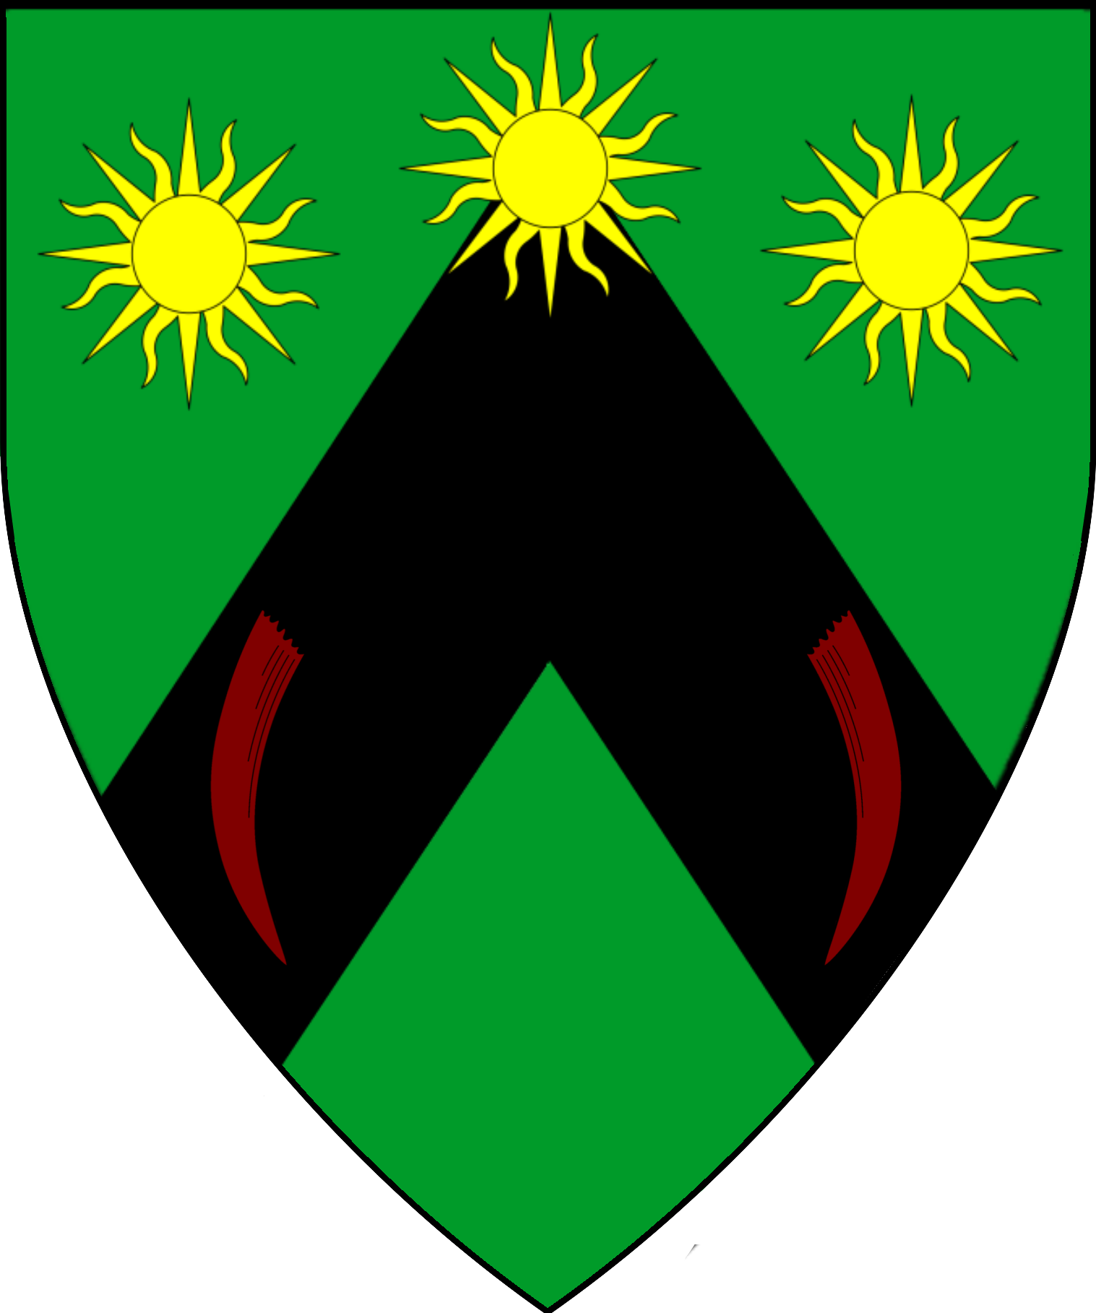 | 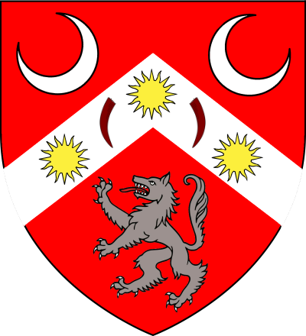 | 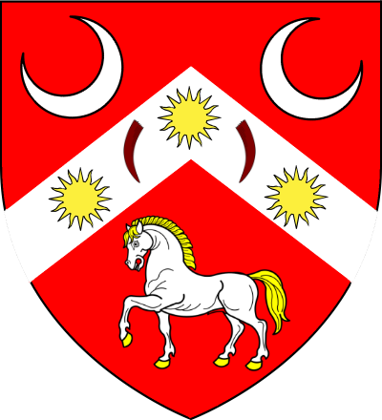
Colm Mercer | Ewan Valens | Valiar Severingin
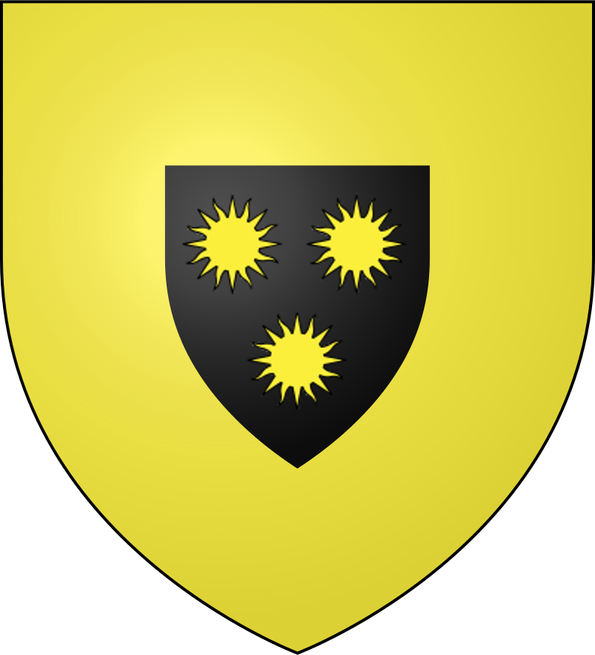 | 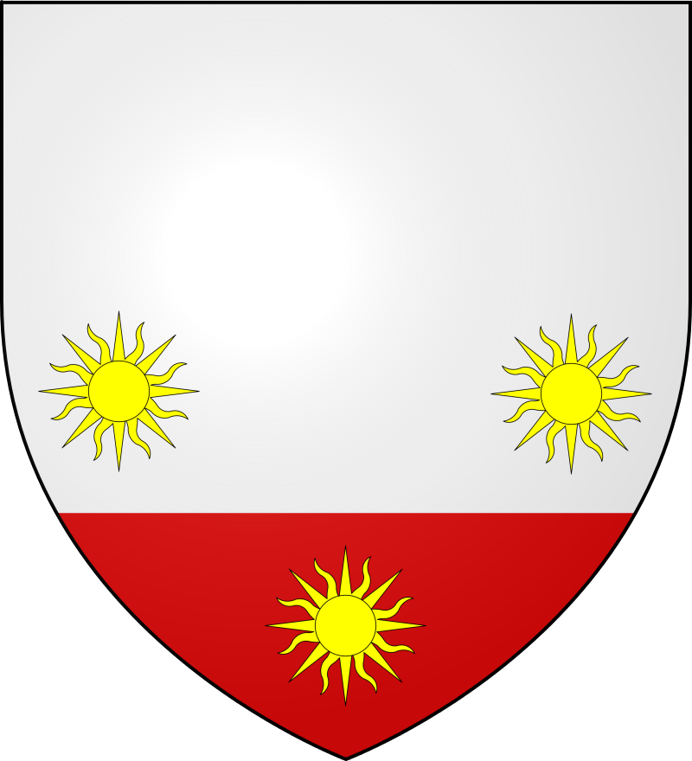 | 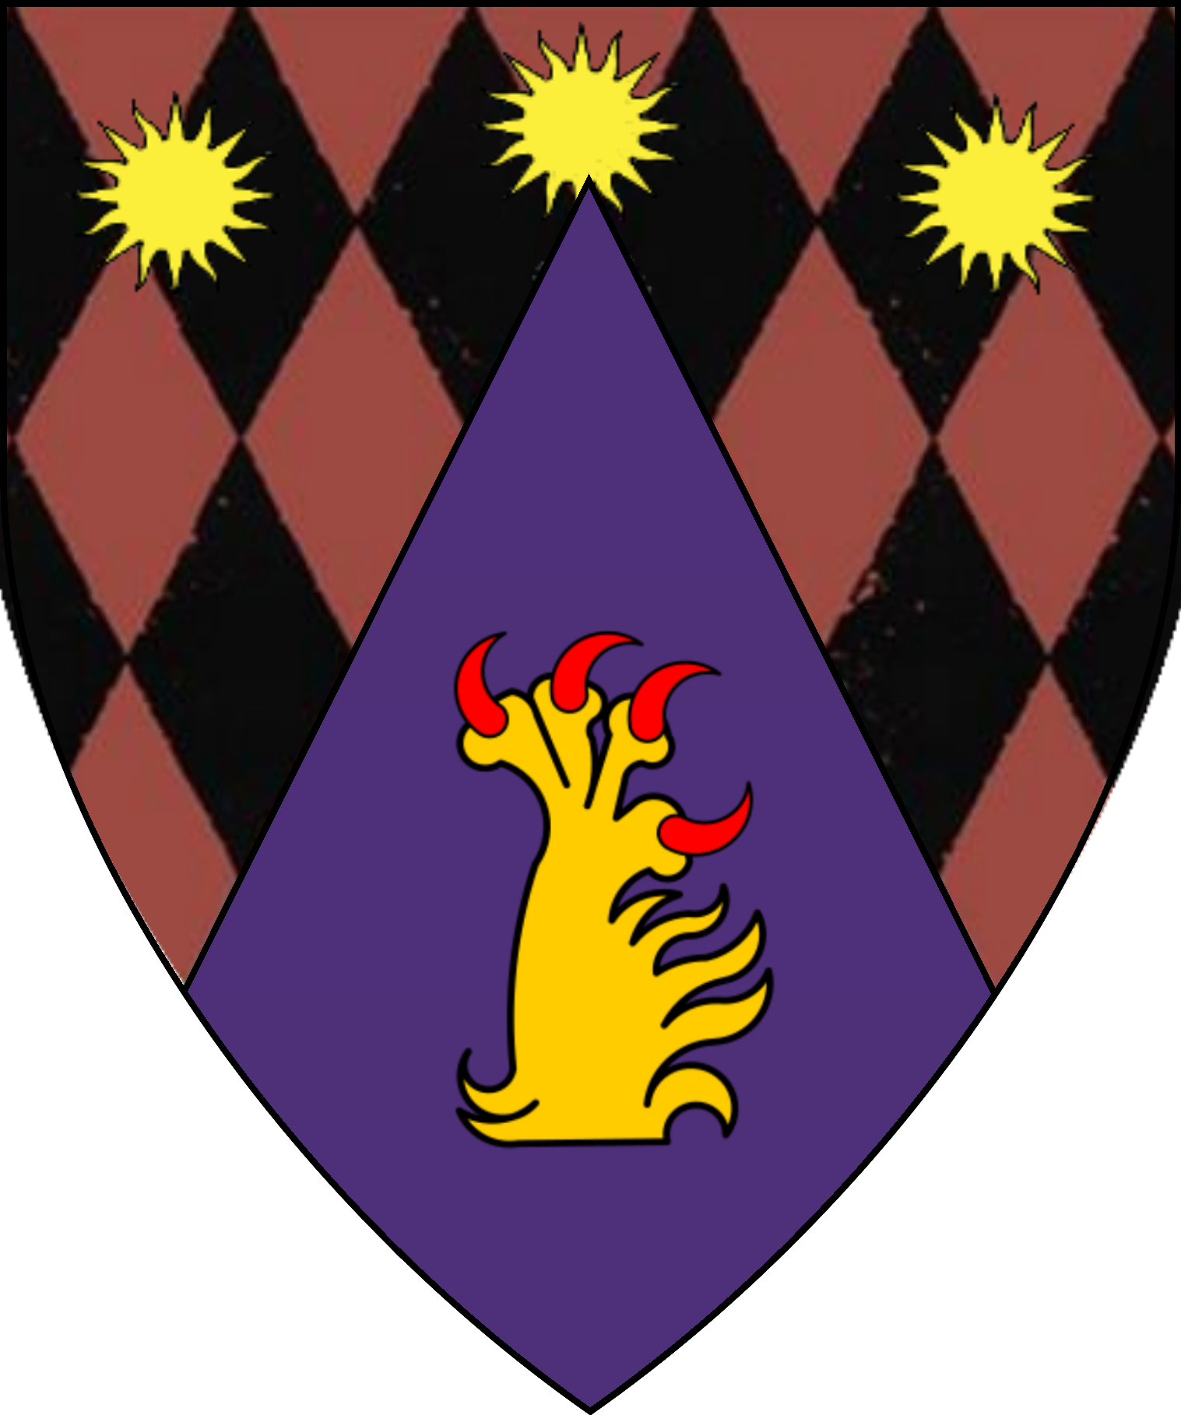
Fallen Brothers
Lord Arturus Penhaligon | Sir Lucian “Trueblade” Decimos | Sir Edvin Aurelian
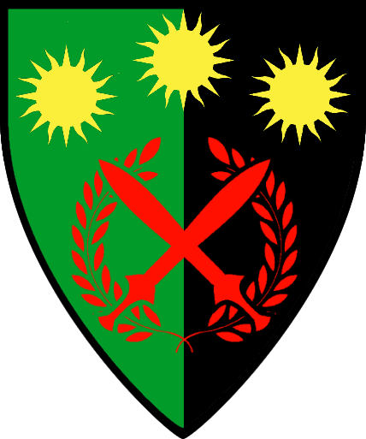 | 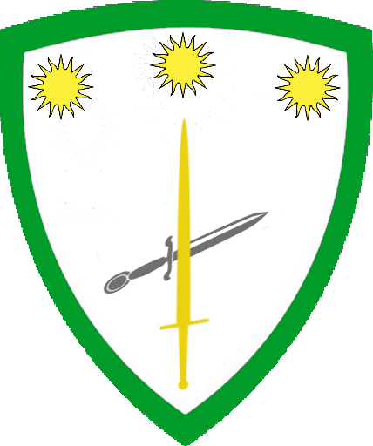 | 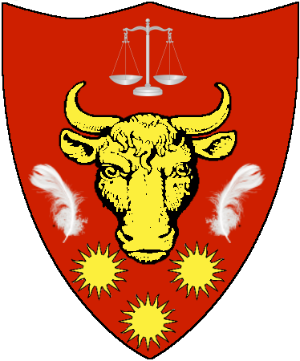
Order of the Pax Loxod Karameikos
Arms of the Order | Sir Kel of Loxado  Prince of the Imperial Hegemony of Loxado  Chapter Master Pax Loxod Karameikos | Sir Vecken Abakumov (aka Vecken of the Broken Horn) | Sir Hamlet  Knight of the Pax Loxod Karameikos,  Knight of the Order Karameikos, Knight Banneret of the Realm
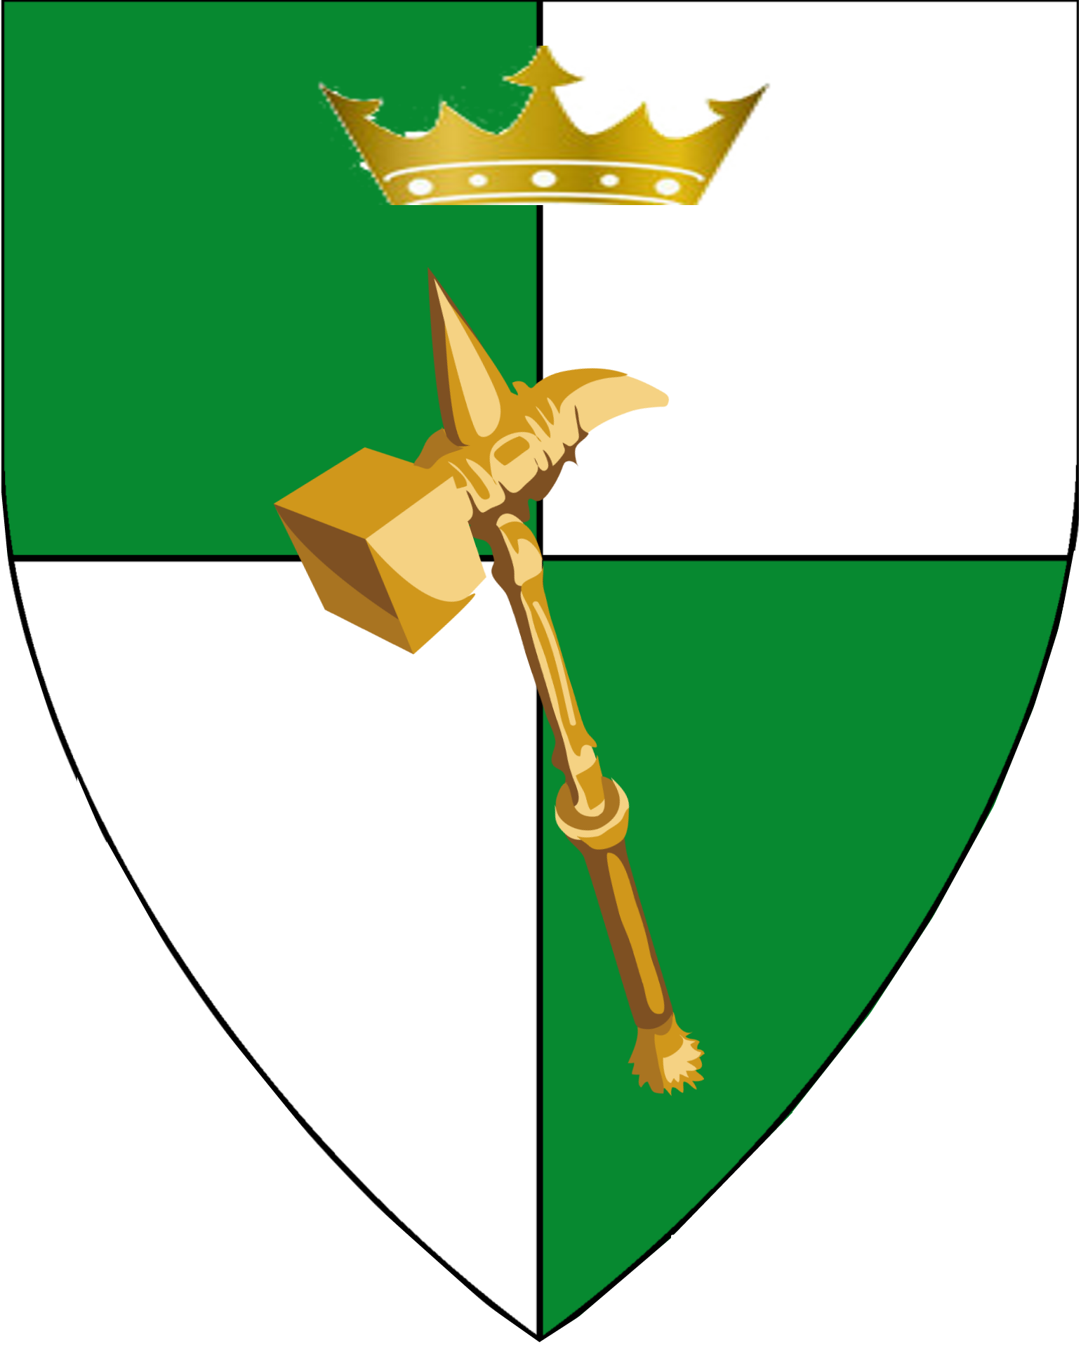 |  | 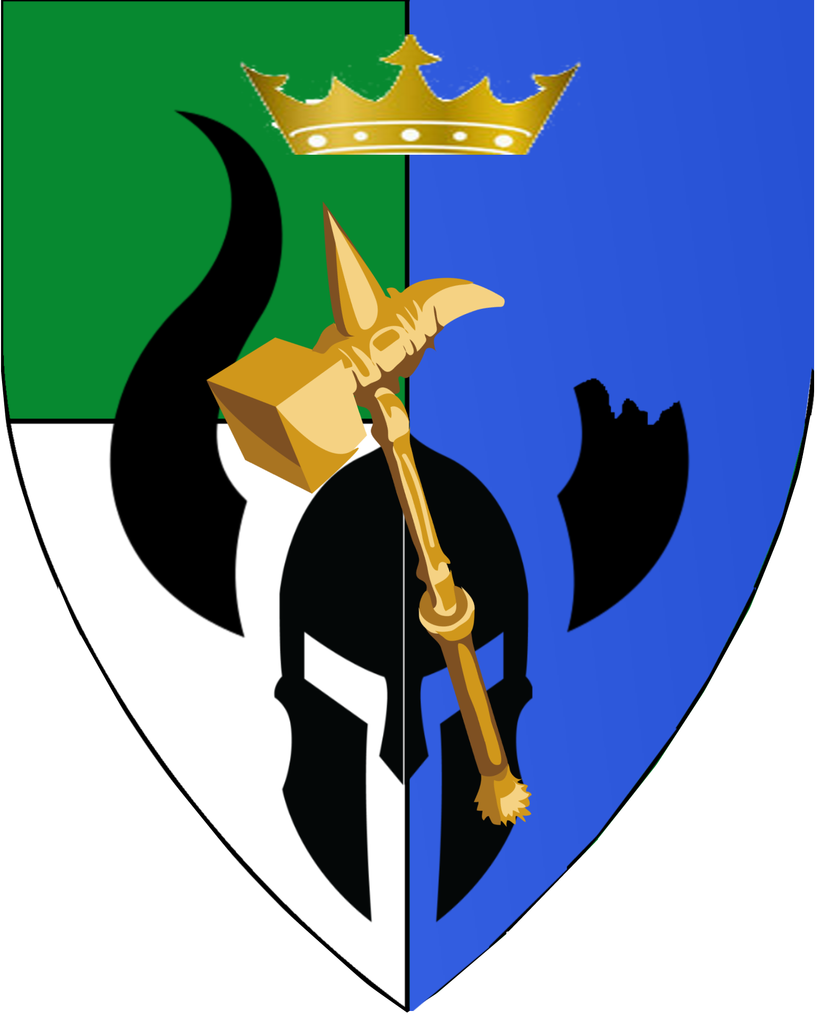

Barony of Penhaligon
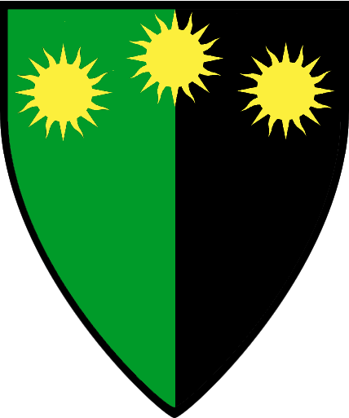
Baroness Arteris Cassandra Penhaligon
 | 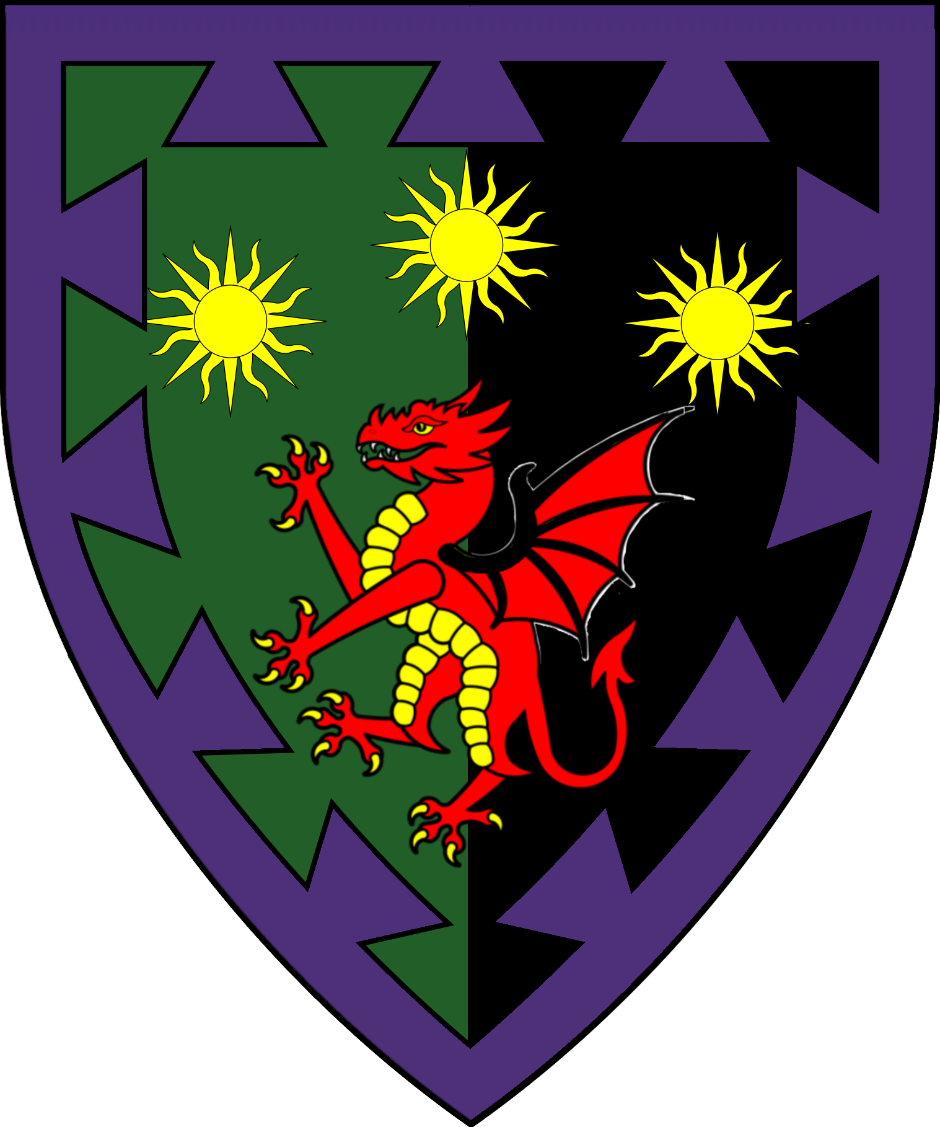
Sir Kaerin Penhaligon | Ilyana Penhaligon | Lord Arturus Penhaligon  (Deceased 996 A.C.) | Kevorquian Penhaligon  (Deceased 999 A.C.) | City of Penhaligon
 | 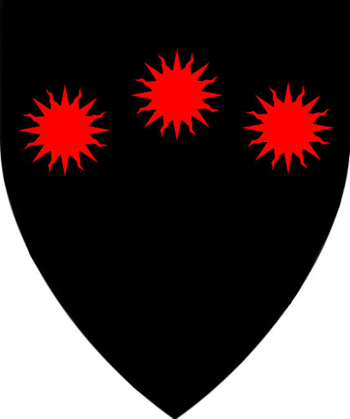 |  | 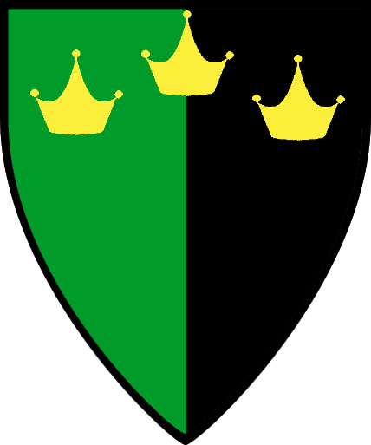 | 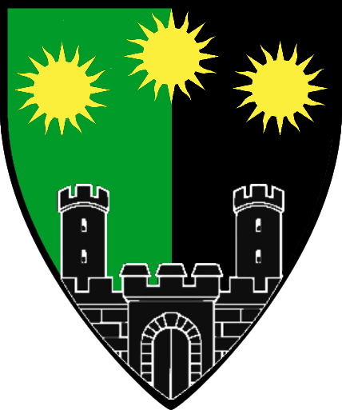
Lord Ubi Amuru  Lord Brightmane | Lord Ubi Amuru  Lord Stallanford | Sir Marin “Trollbreaker” Rothswayne  Lord of Laurel Hill | Sir Pontius “Coldheart” Severingin,  Lord of Pinecrest | Sir Gryndyr “Penhaligon’s Attack Dog” Bloodfang  Lord of Castelwatch
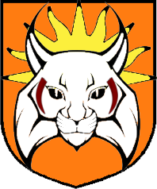 | 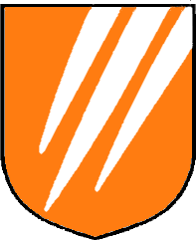 |  |  | 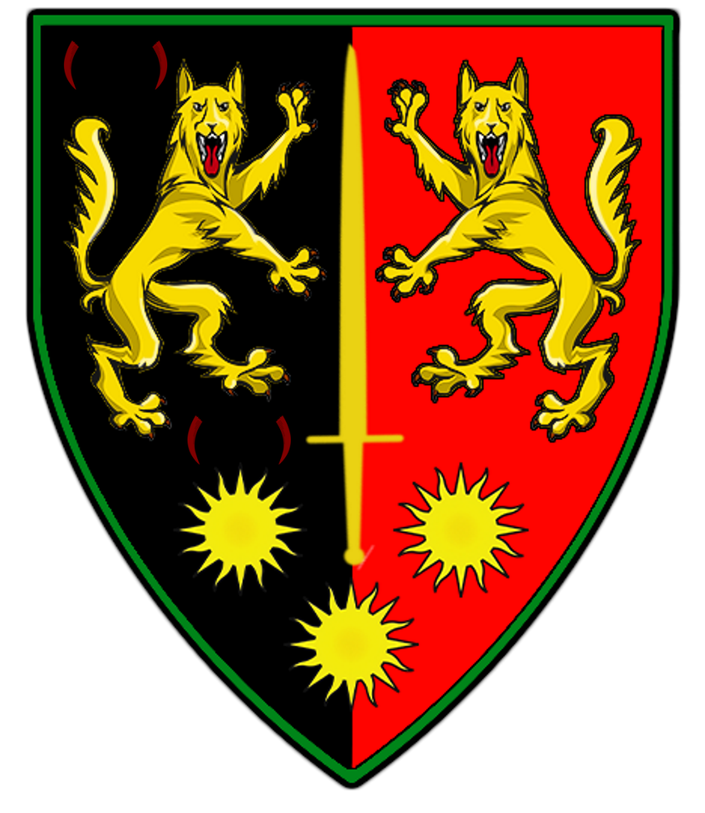
Sir Tristan Dumondt  Lord of Autumn’s Daughter | Dame Laelin Aenelias  Lady of Hope | Lord Trebor “Blackhawk” Marchant  Lord of Blackhawk Keep | Lord Cassius  Dumondt II  Lord of Dumondt Hall
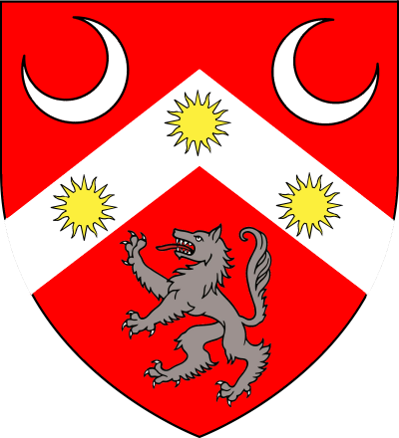 |  |  | 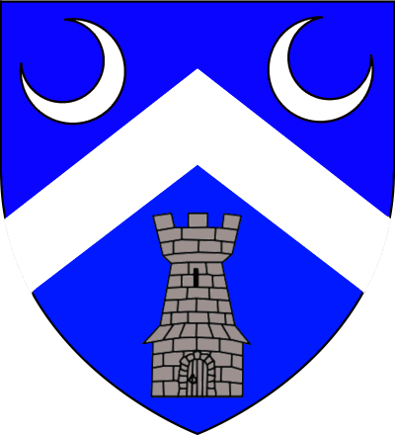

Barony of Kelvin
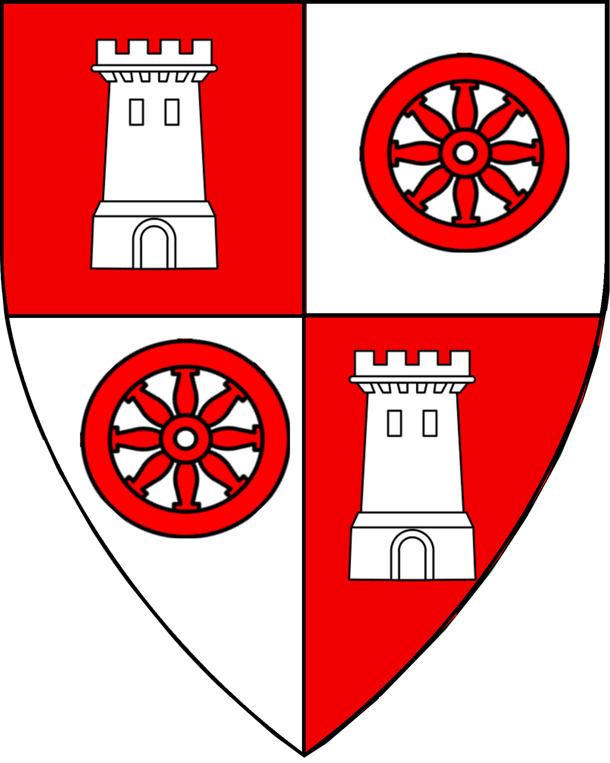
Baron Desmond  Kelvin II | Lady Alerena Kelvin  Heir of Kelvin | Lady Nemesis Kelvin | Lord Borthanus Niallus  Lord Seneschal of Kelvin | Lord Castor Kelvin  Lord of  Desmond & Dione
 | 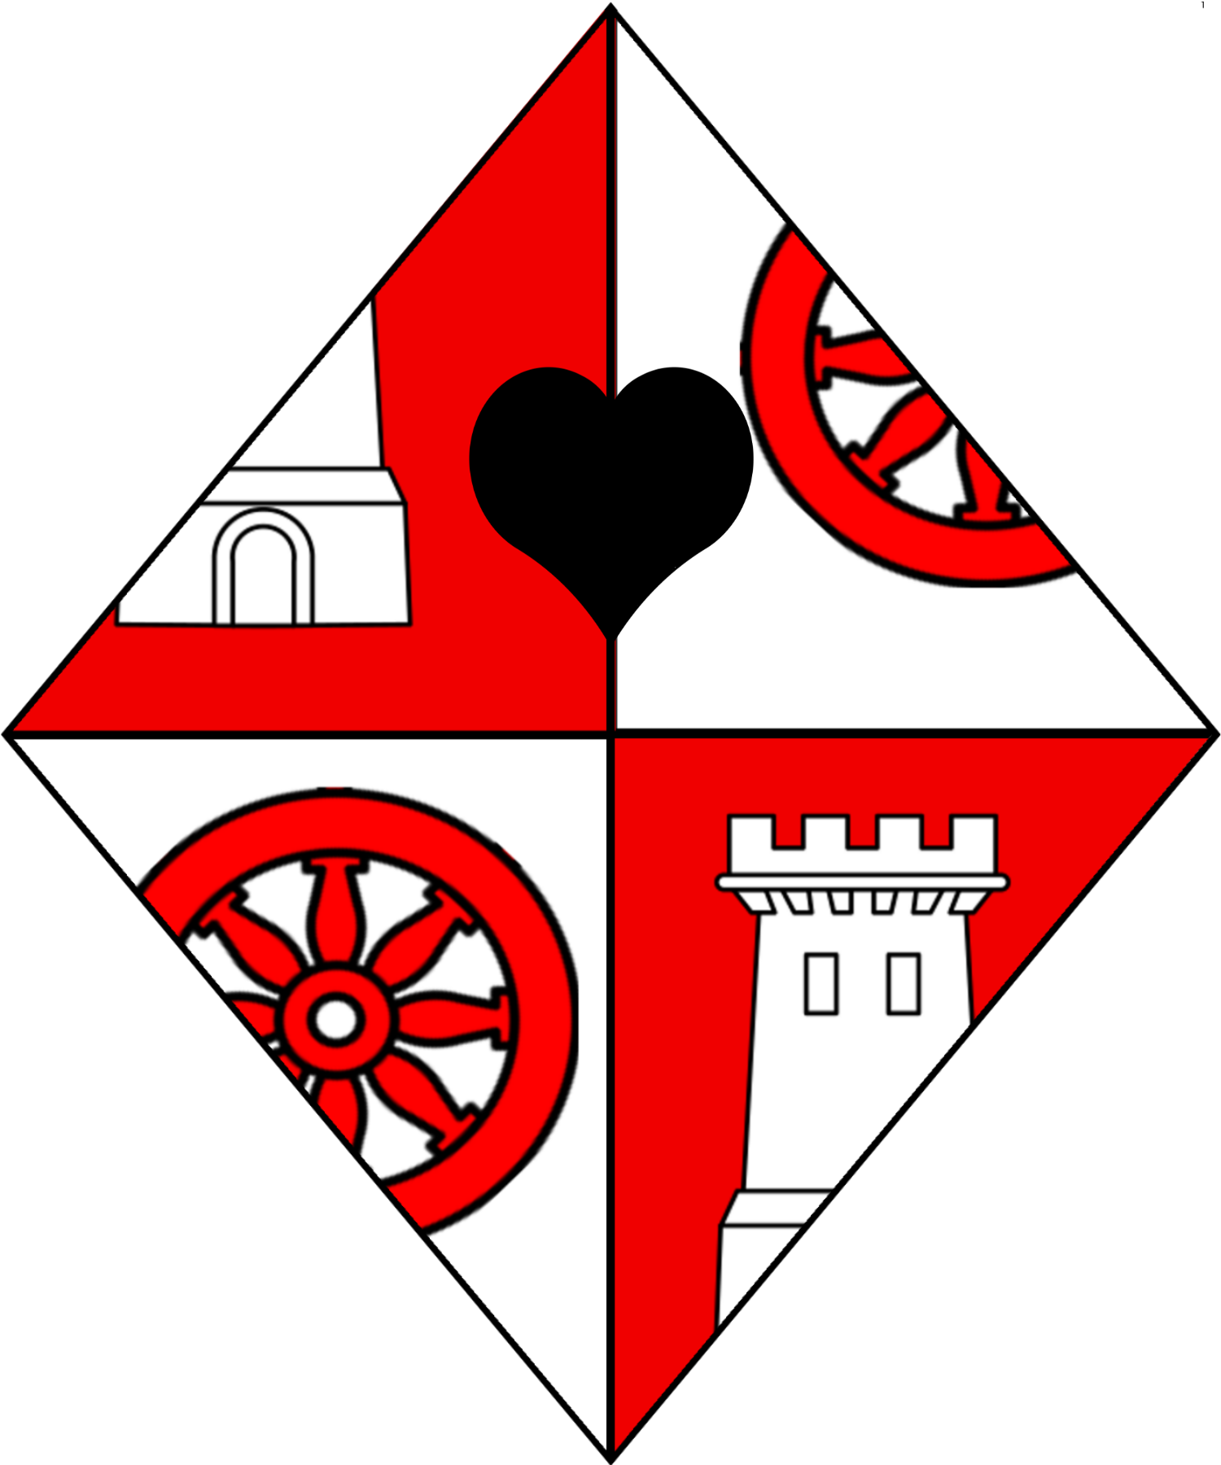 | 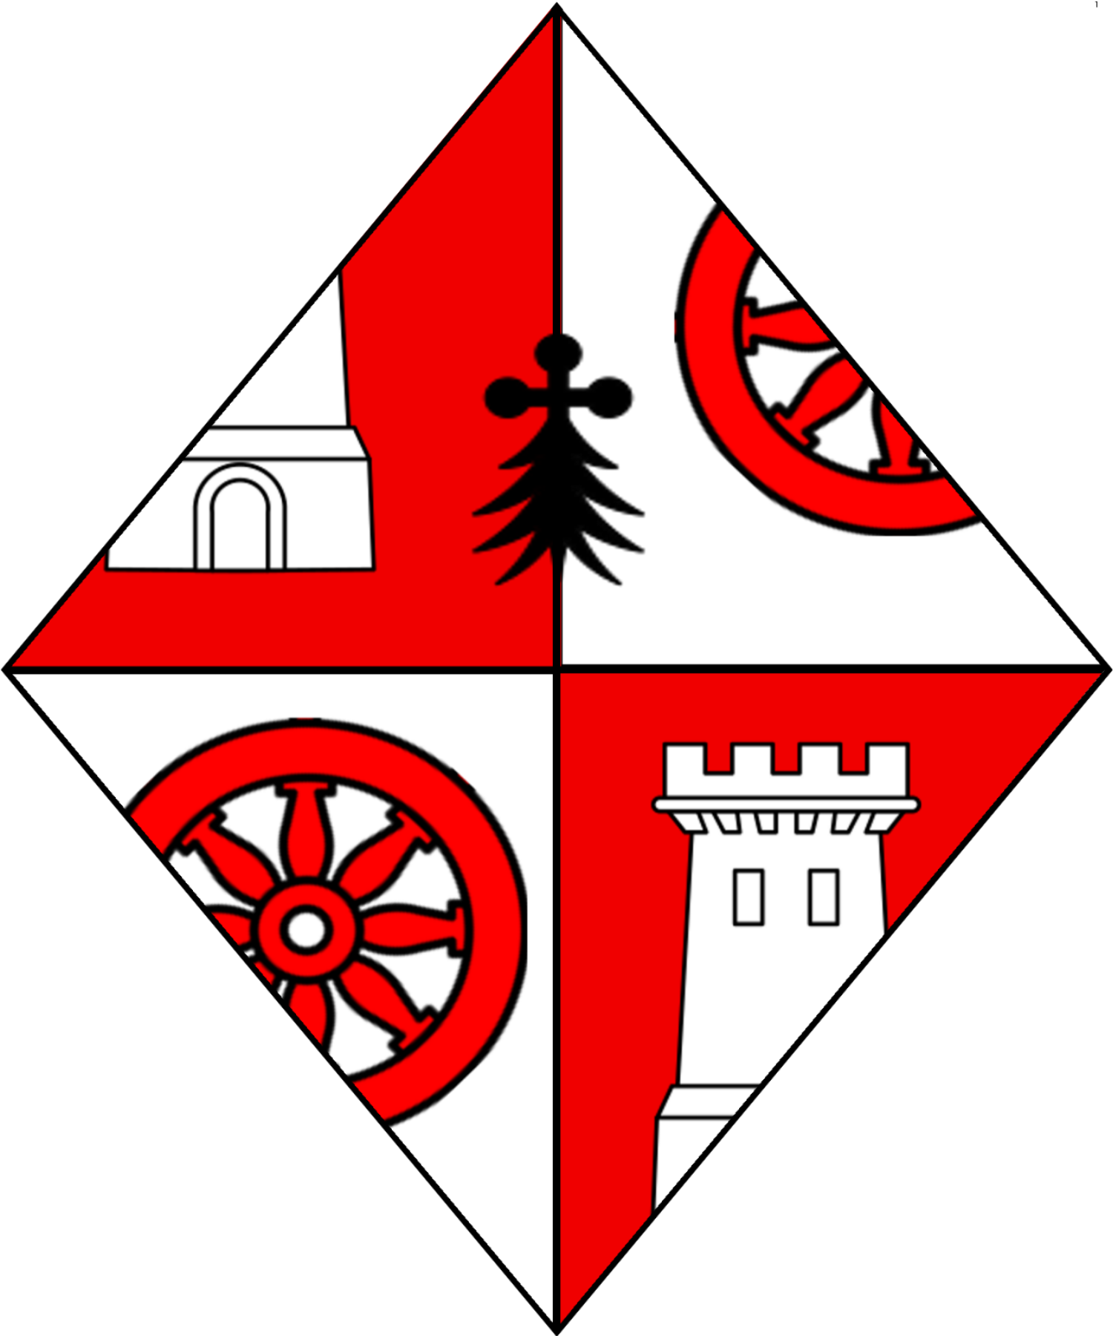 | 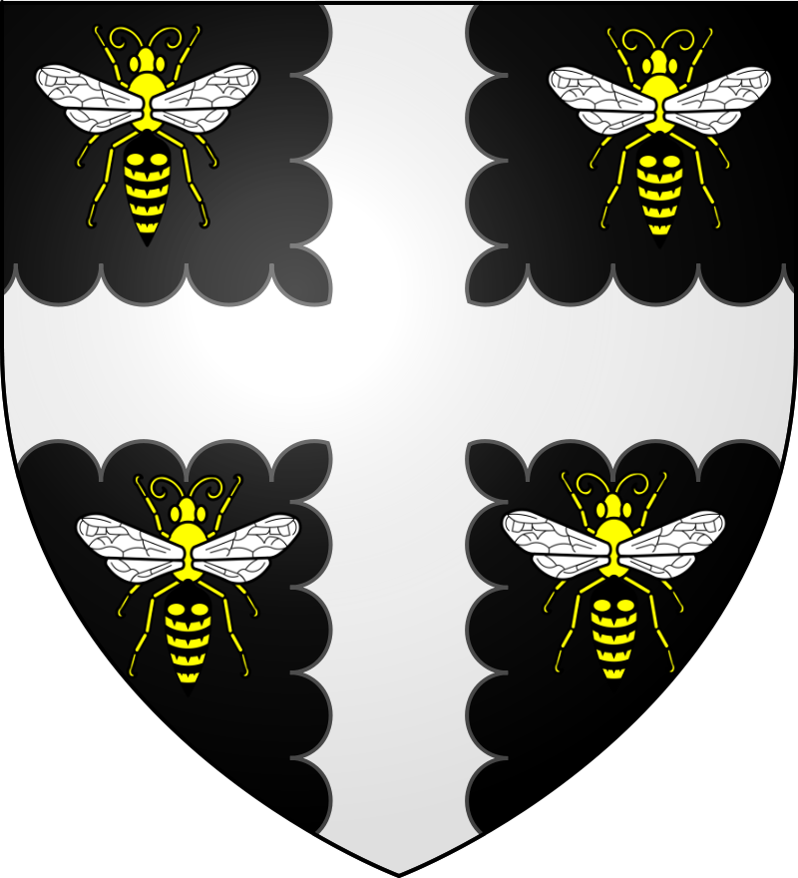 | 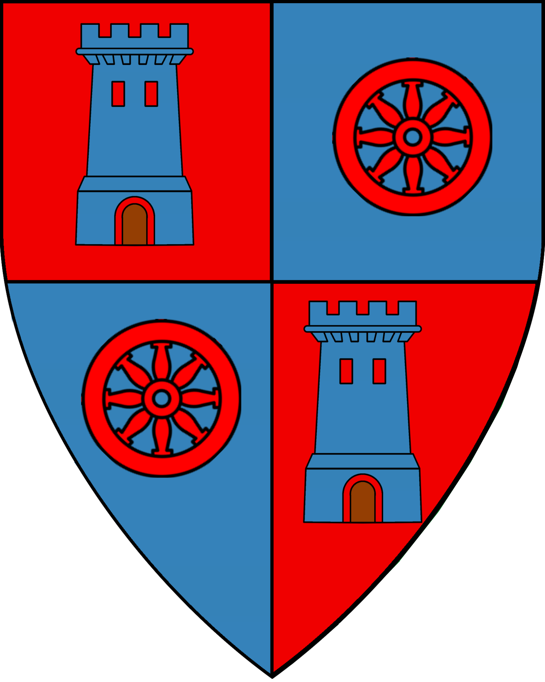
Lady Ilona Radanavich  Estate of Randanavich | Lord Tychus Bellerophontes | Sir Plovis Cerularius  Lord of Guido’s Fort | Sir Glaucus Icarus  Lord of Icarus Fields | Sir Arkady “the Bull” Pavelenko  Lord of Moor Dynor
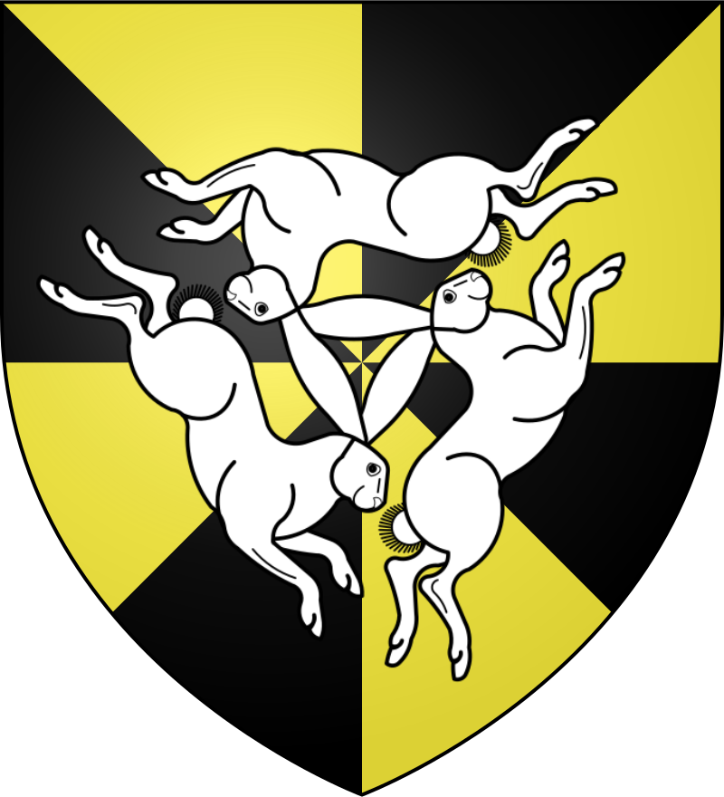 | 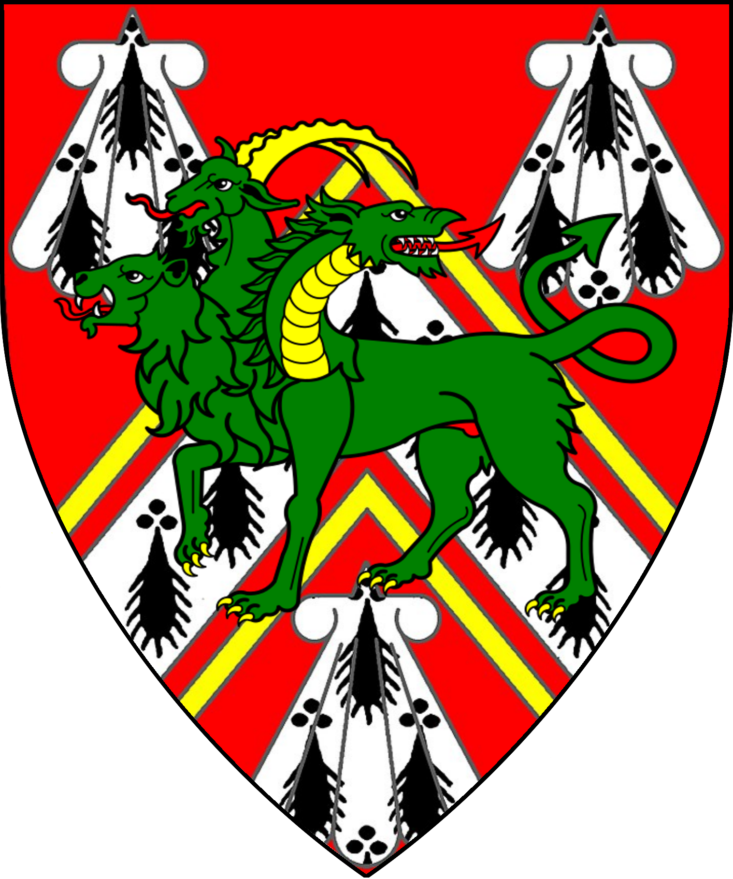 | 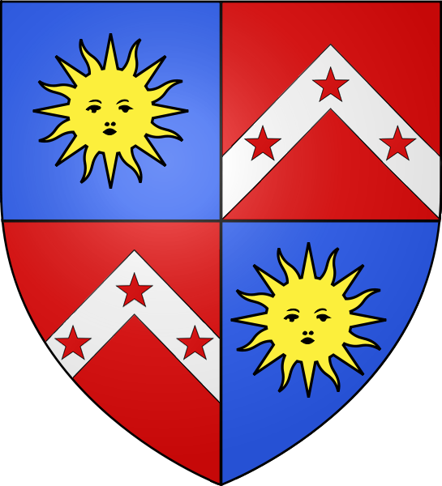 | 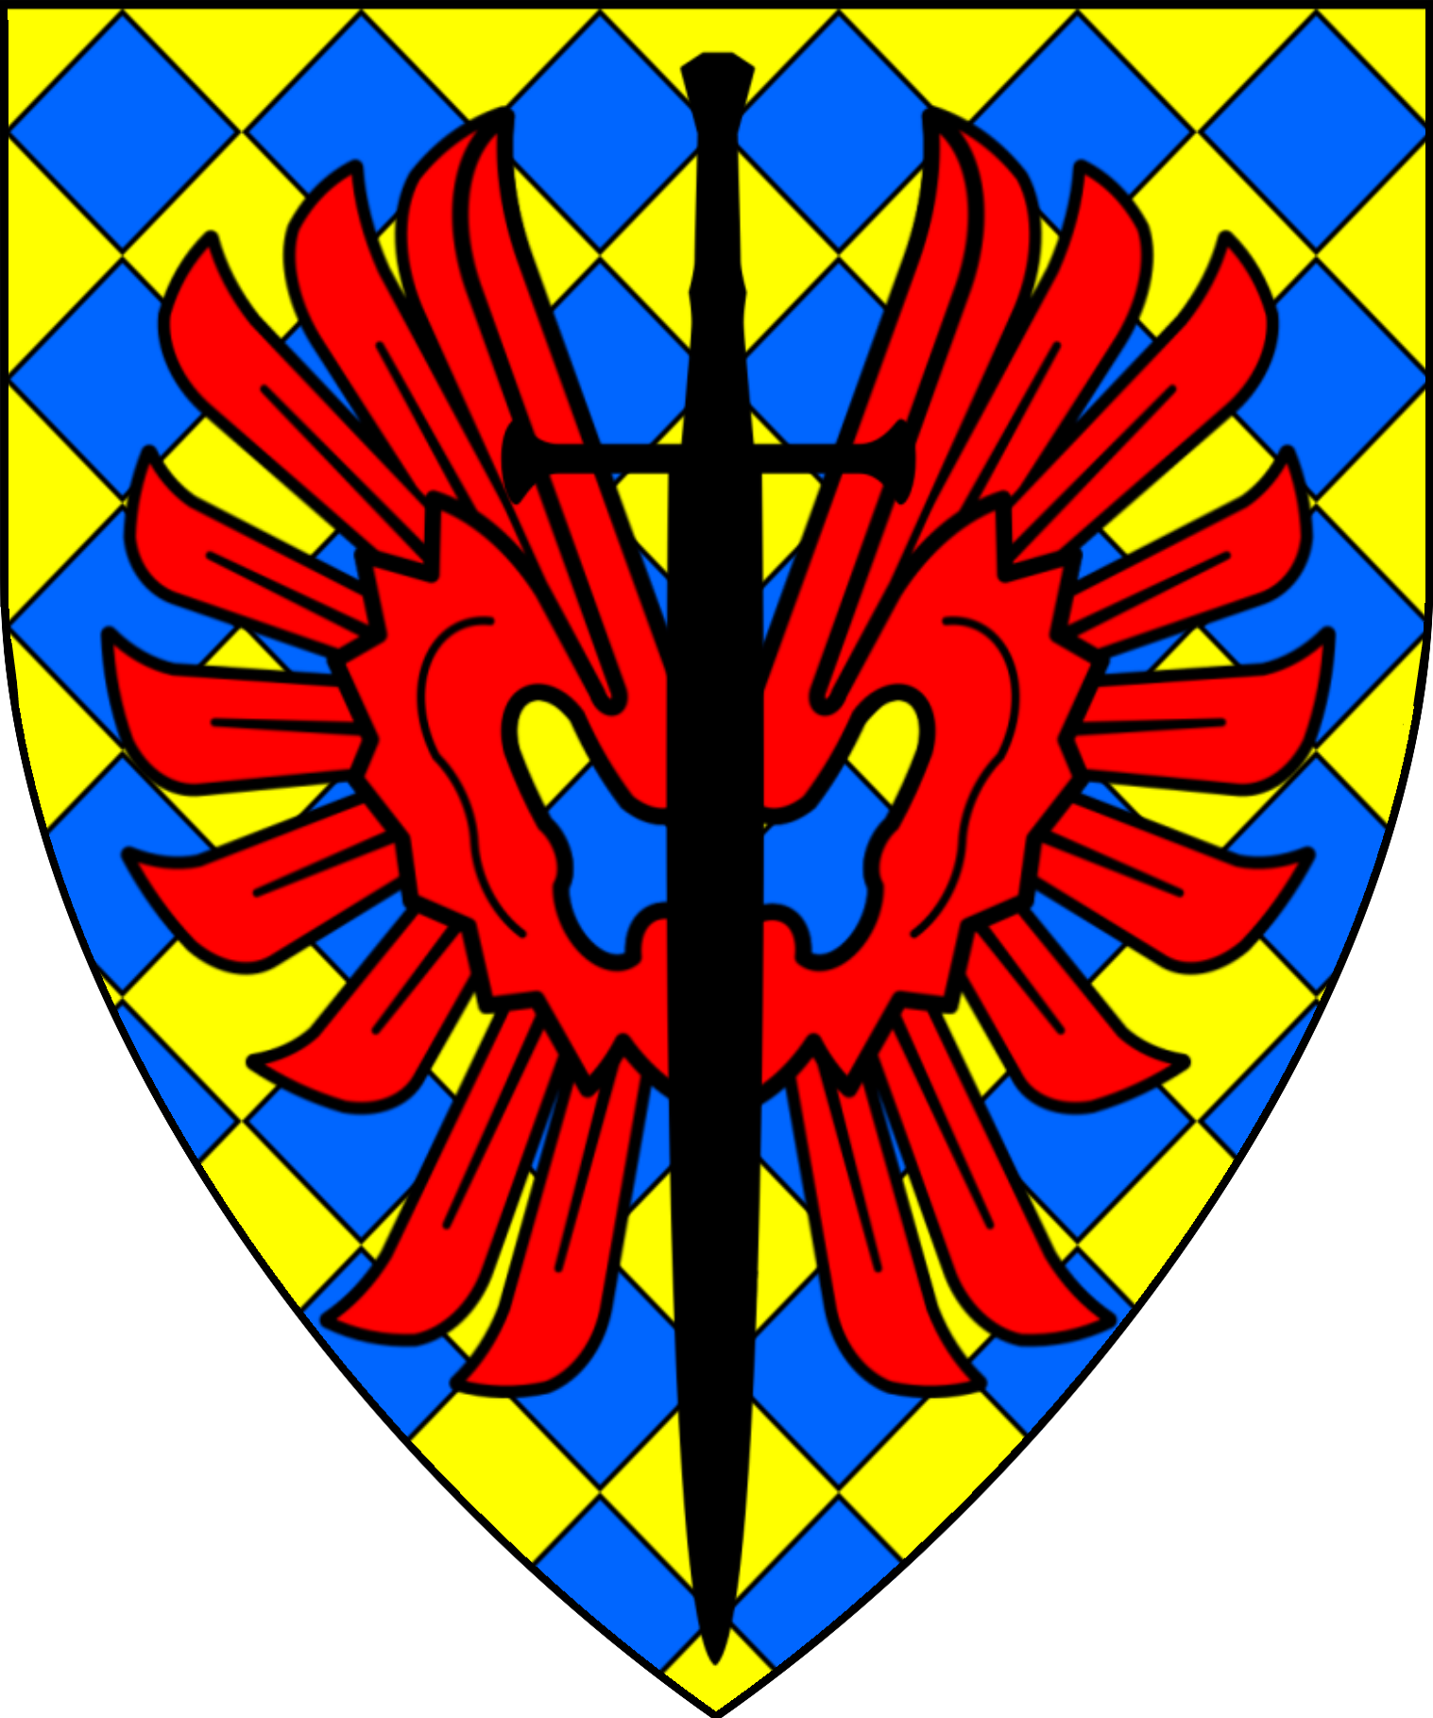 | 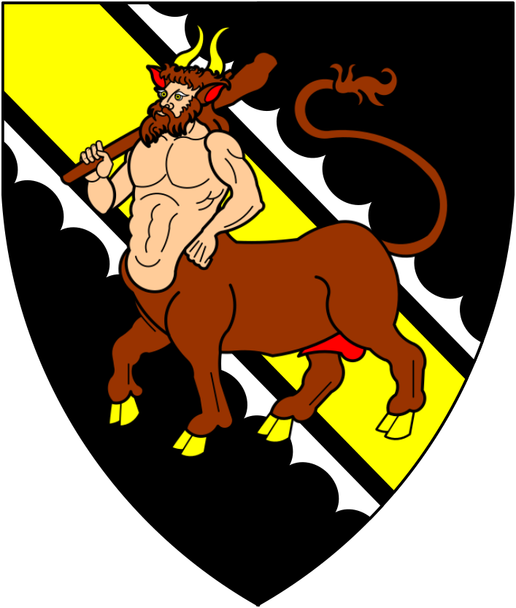
Lord Ivansky Suskyskin
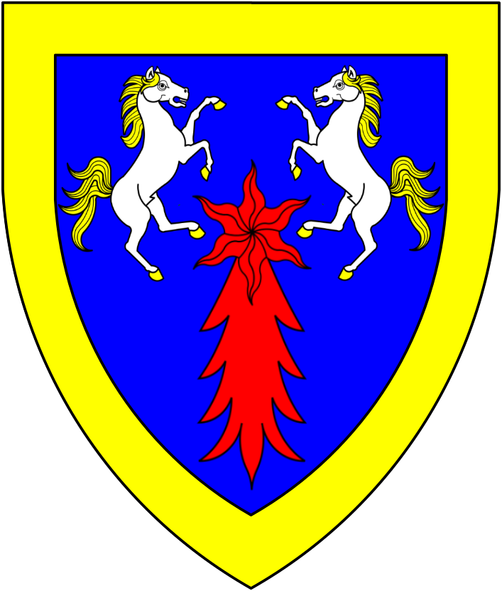

Barony of Threshold
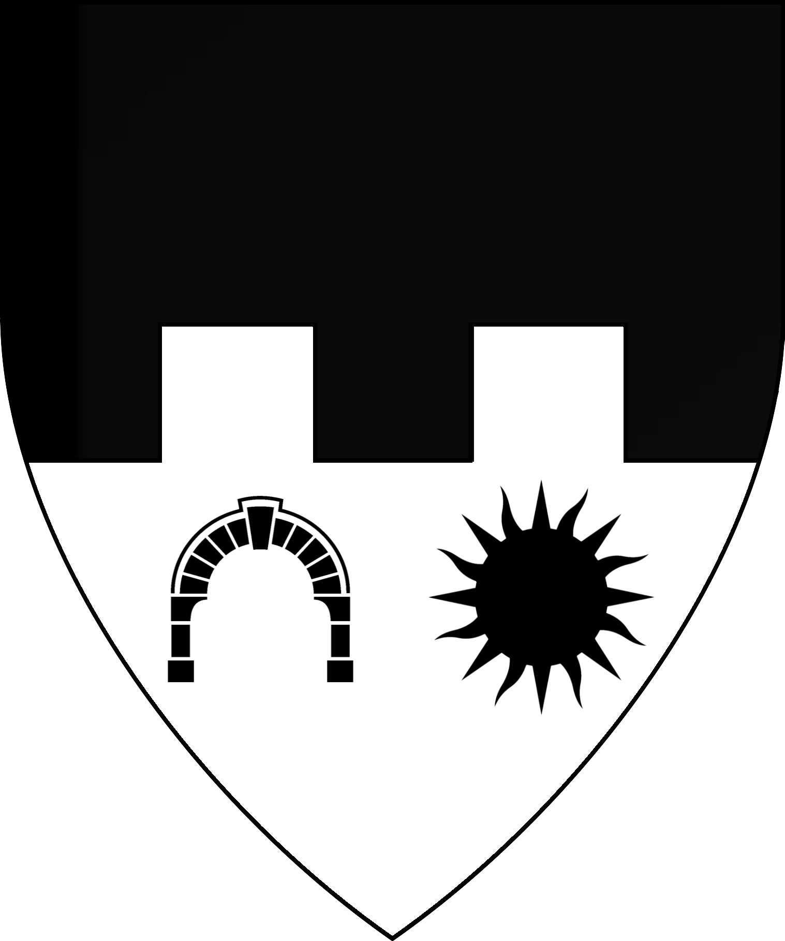 | 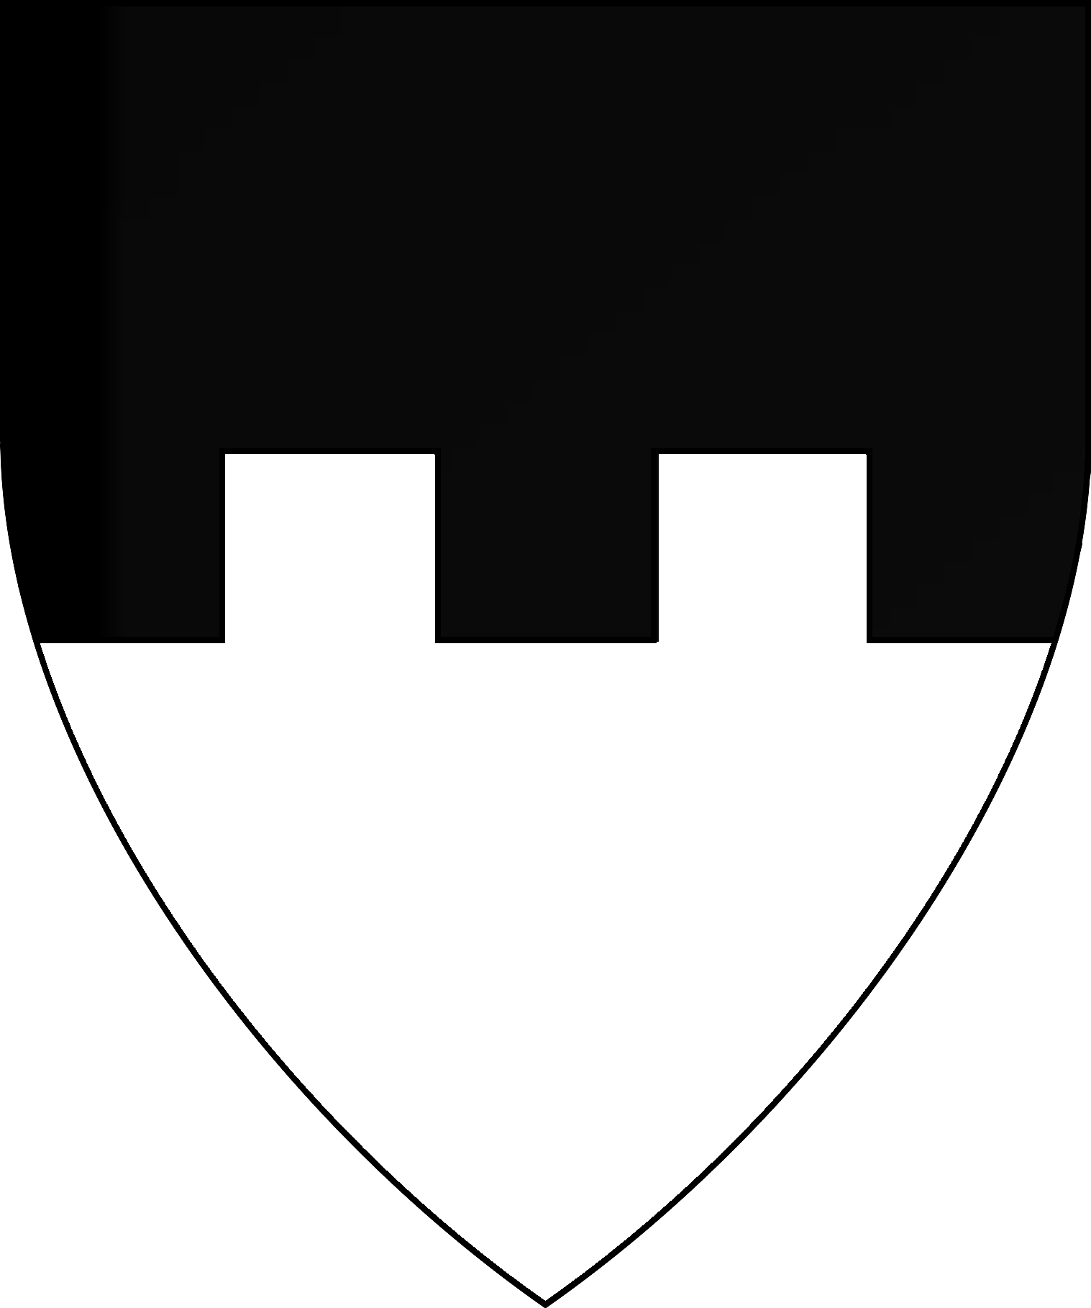
Patriarch Sherlane Halaran
Baron of Threshold
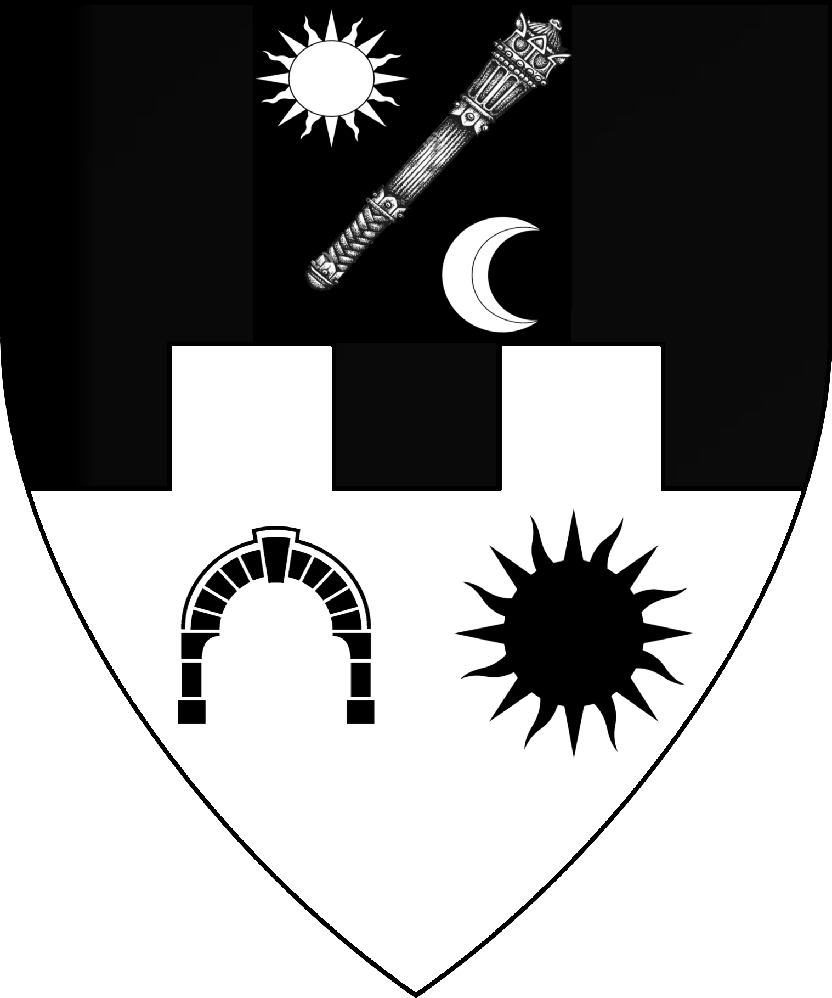
Sir Reynald Highdell  Estate of Highdell | Lord Romulus Chryspatitos  Estate of Chryspatitos | Sir Dalzell Carnwath,  Lord of Eltan’s Spring | Lady Helena Sylicerius  Lady of Rolent and Gorion
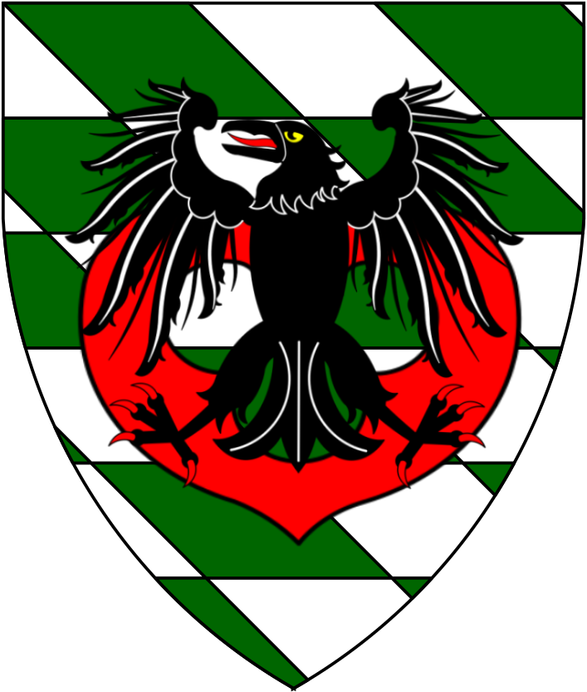 | 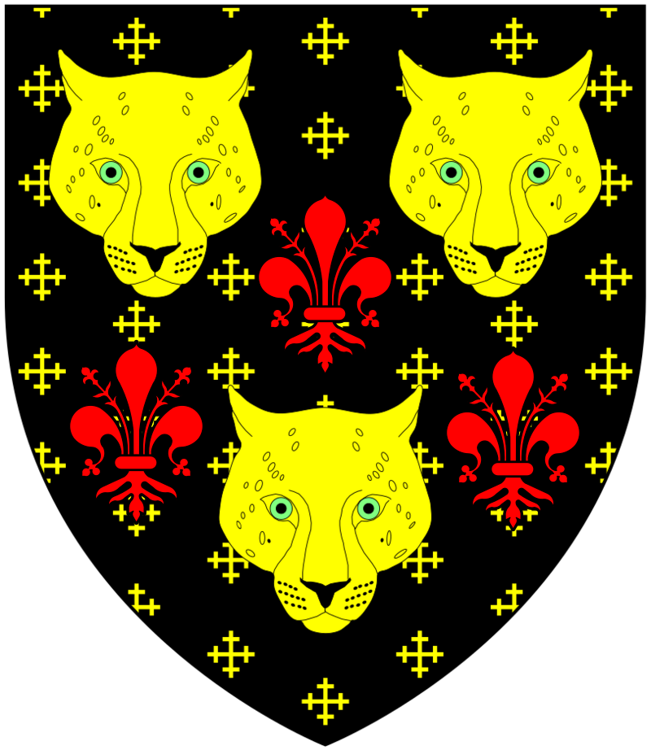 | 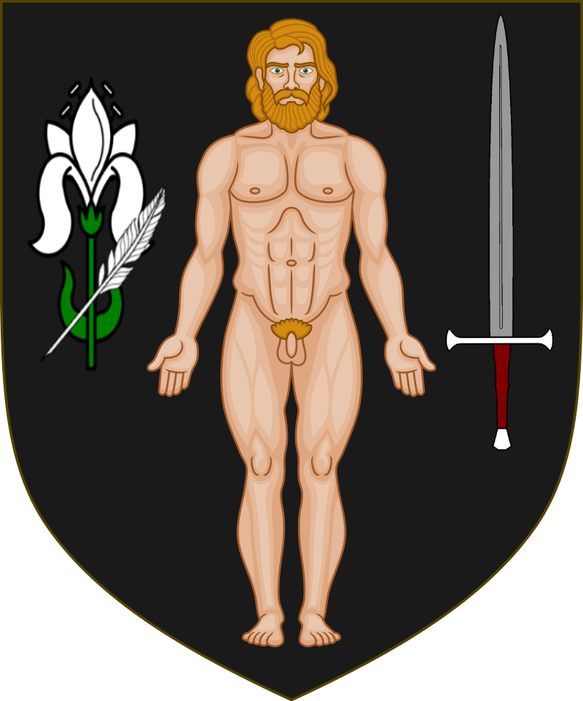 | 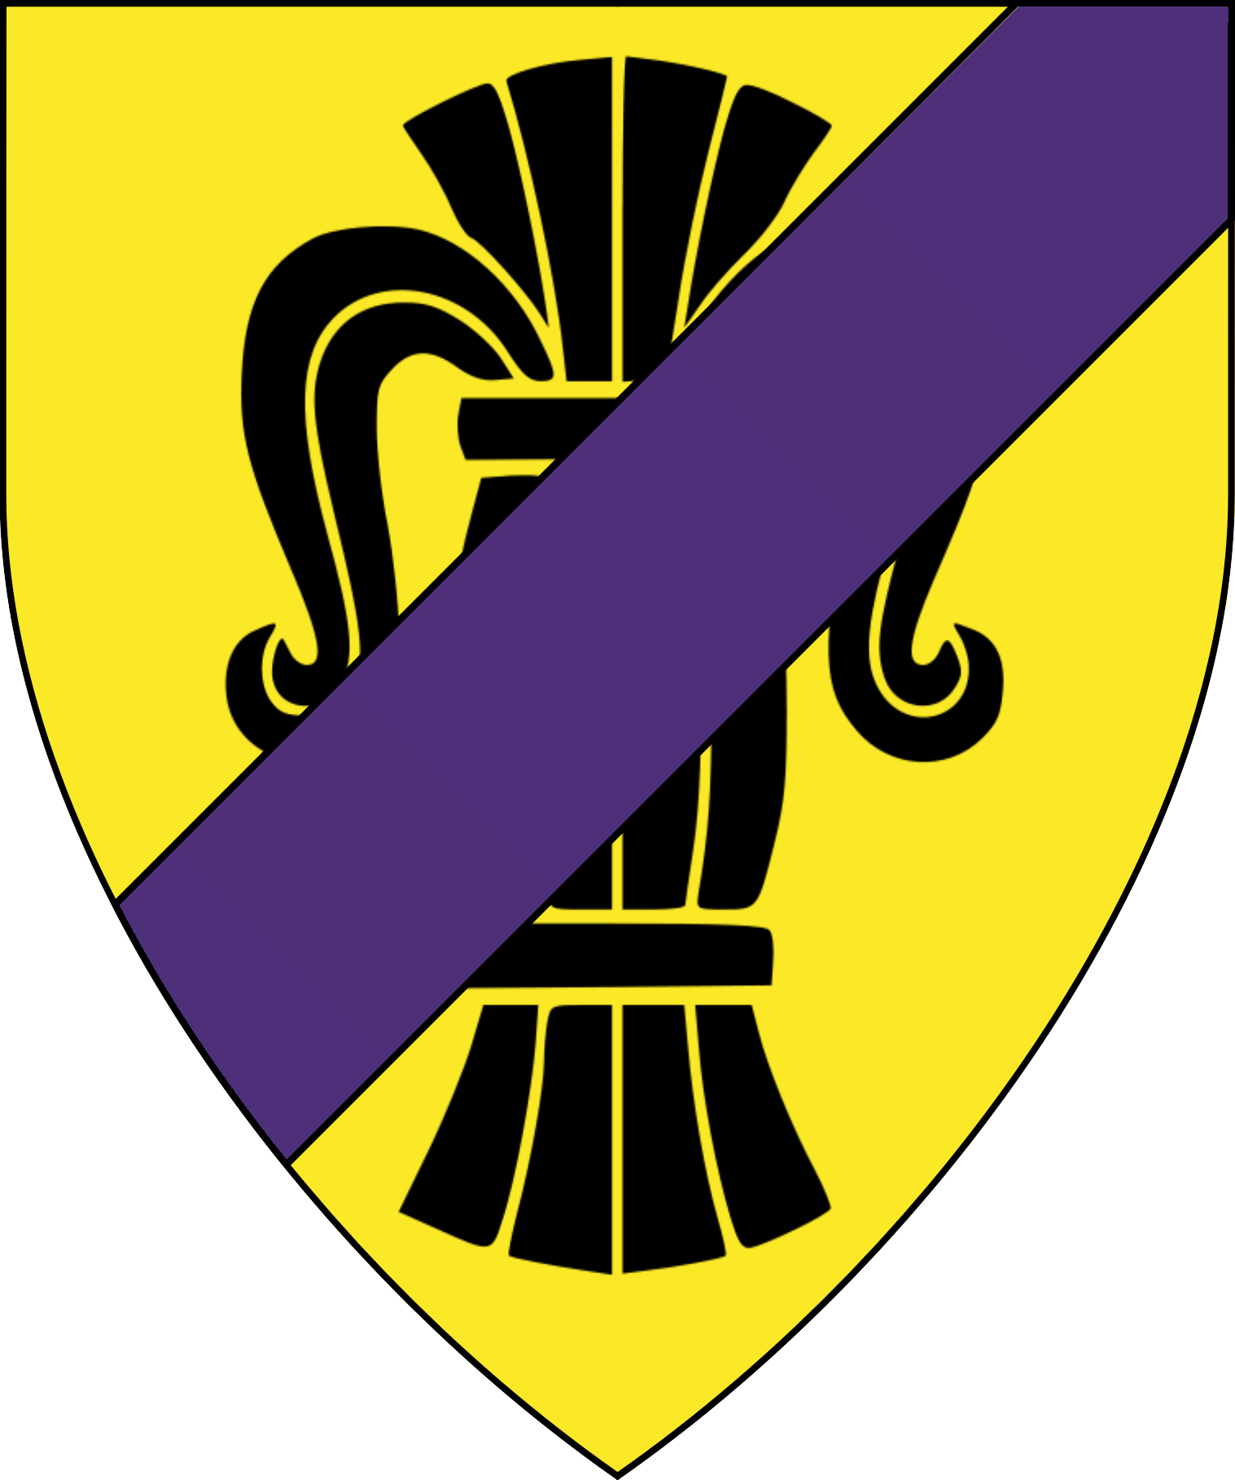

Barony of Vorloi
Baron Philip Vorloi | Lord Mikel Vorloi  Heir to Vorloi | Lady Marianna Vorloi
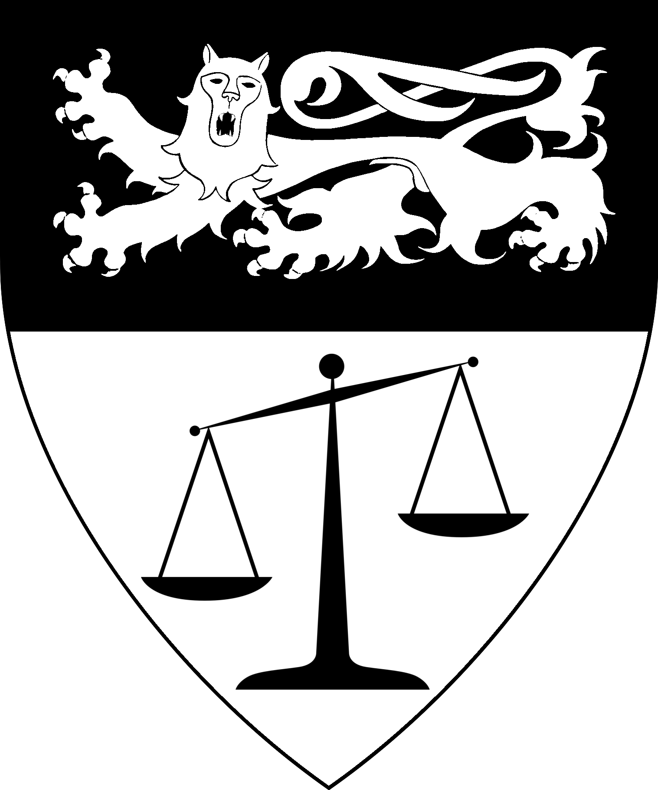 | 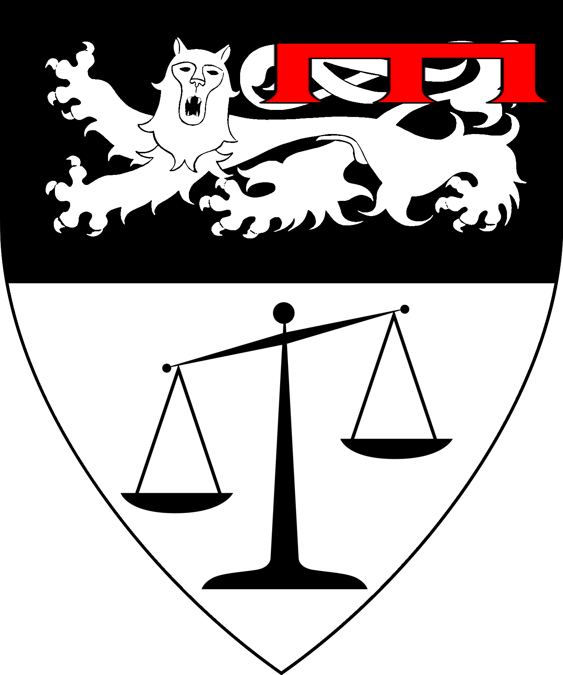 | 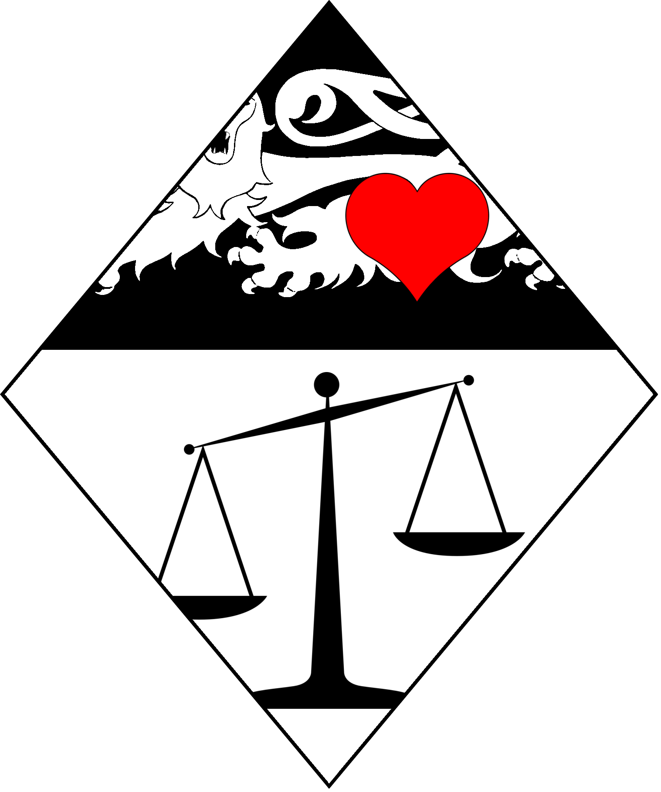
Commodore  Sir Godrik Vorloi  , Lord of Kyrios | Lady ?  Lady of Samberg  & Morpodiv | Sir Regulus Pomitan  Lord of Vidros | Lord Gepeddo Barber  Lord of Tomlin | Lord Ismail Quaigescu  Lord of Port Lisaruv
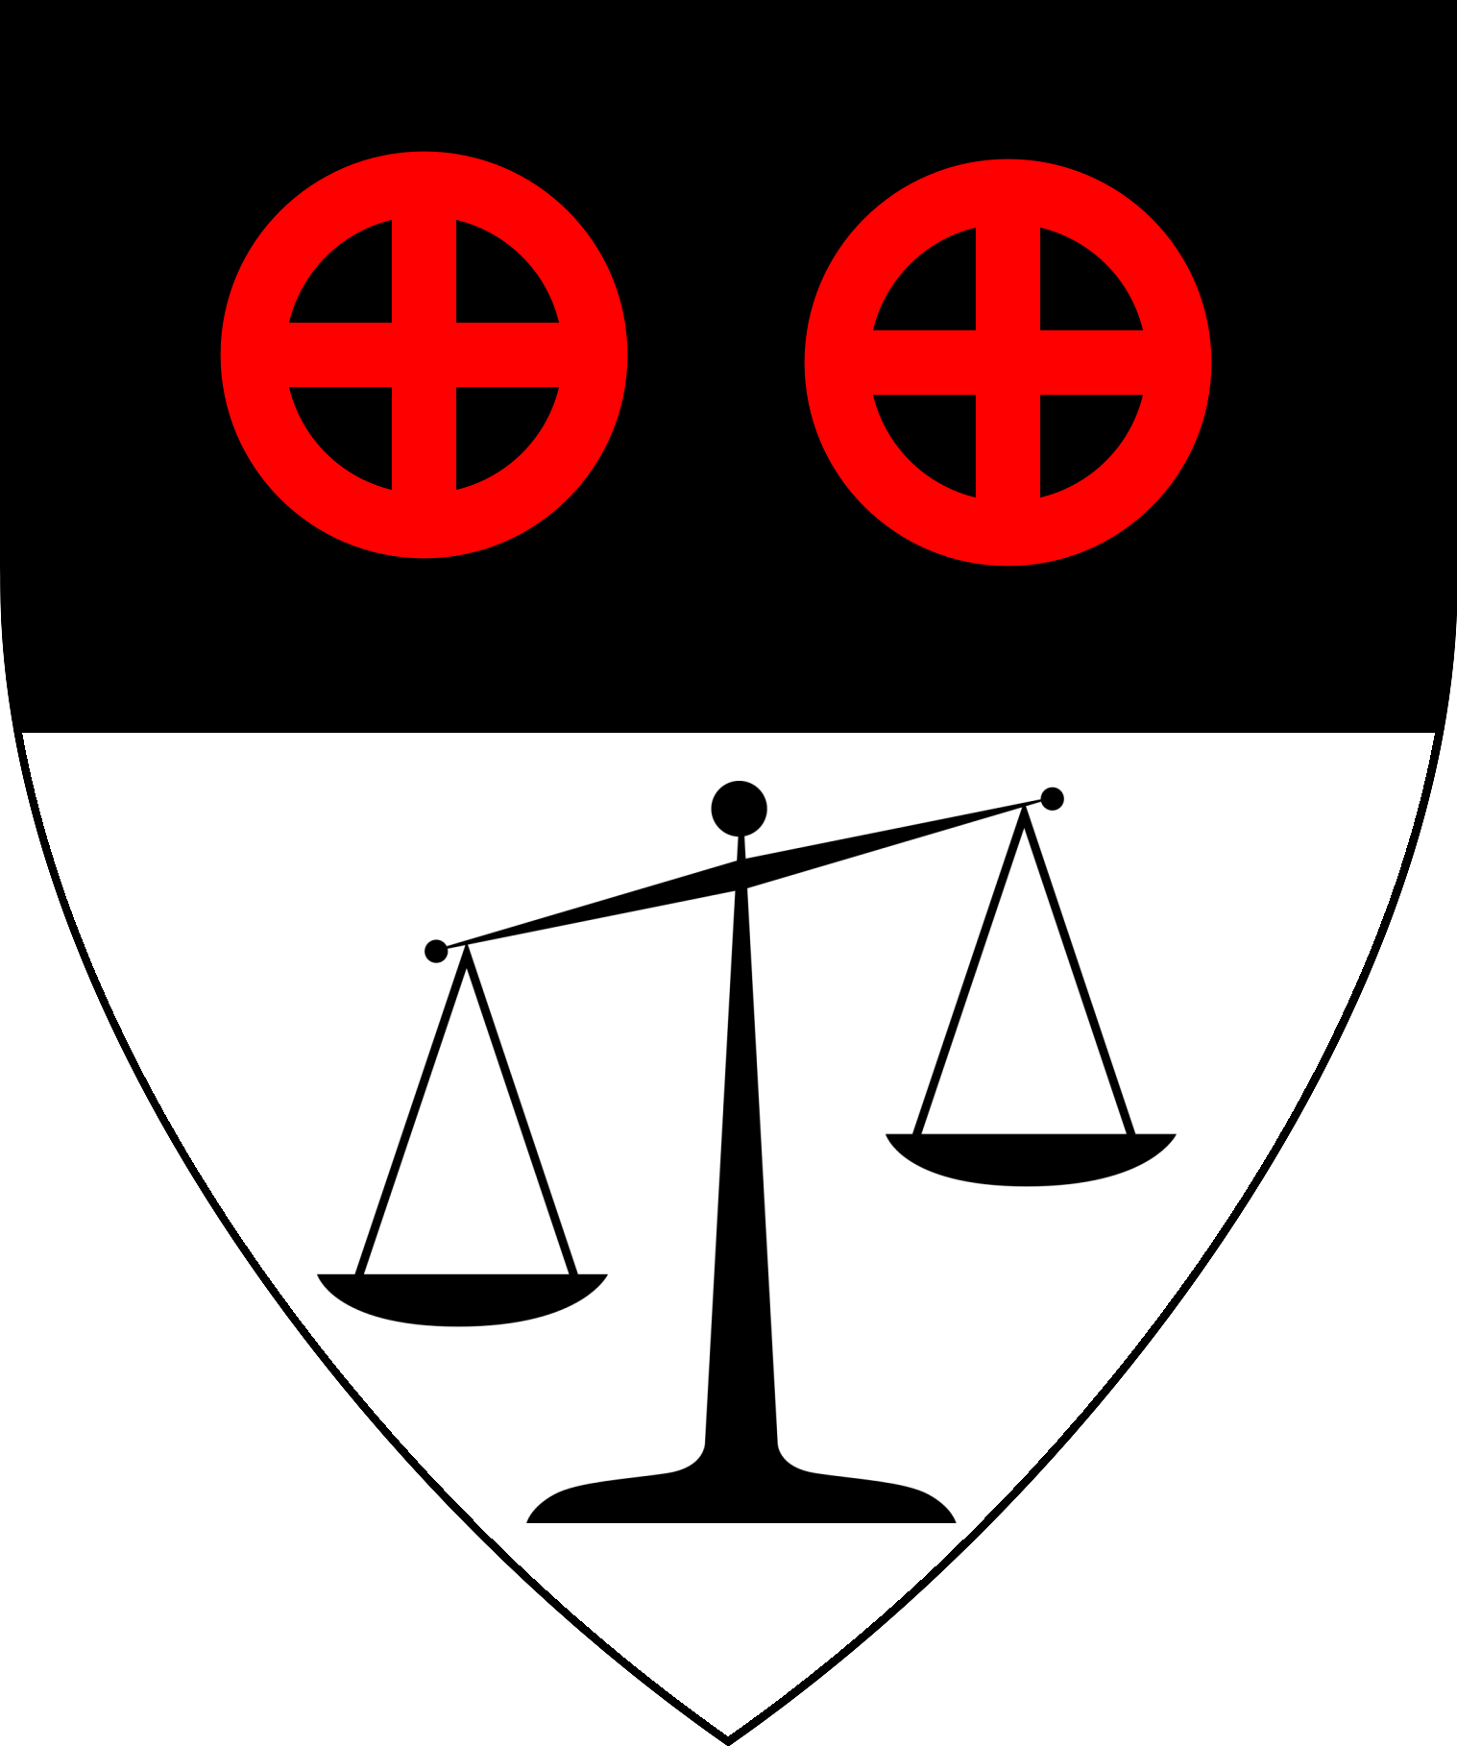 | 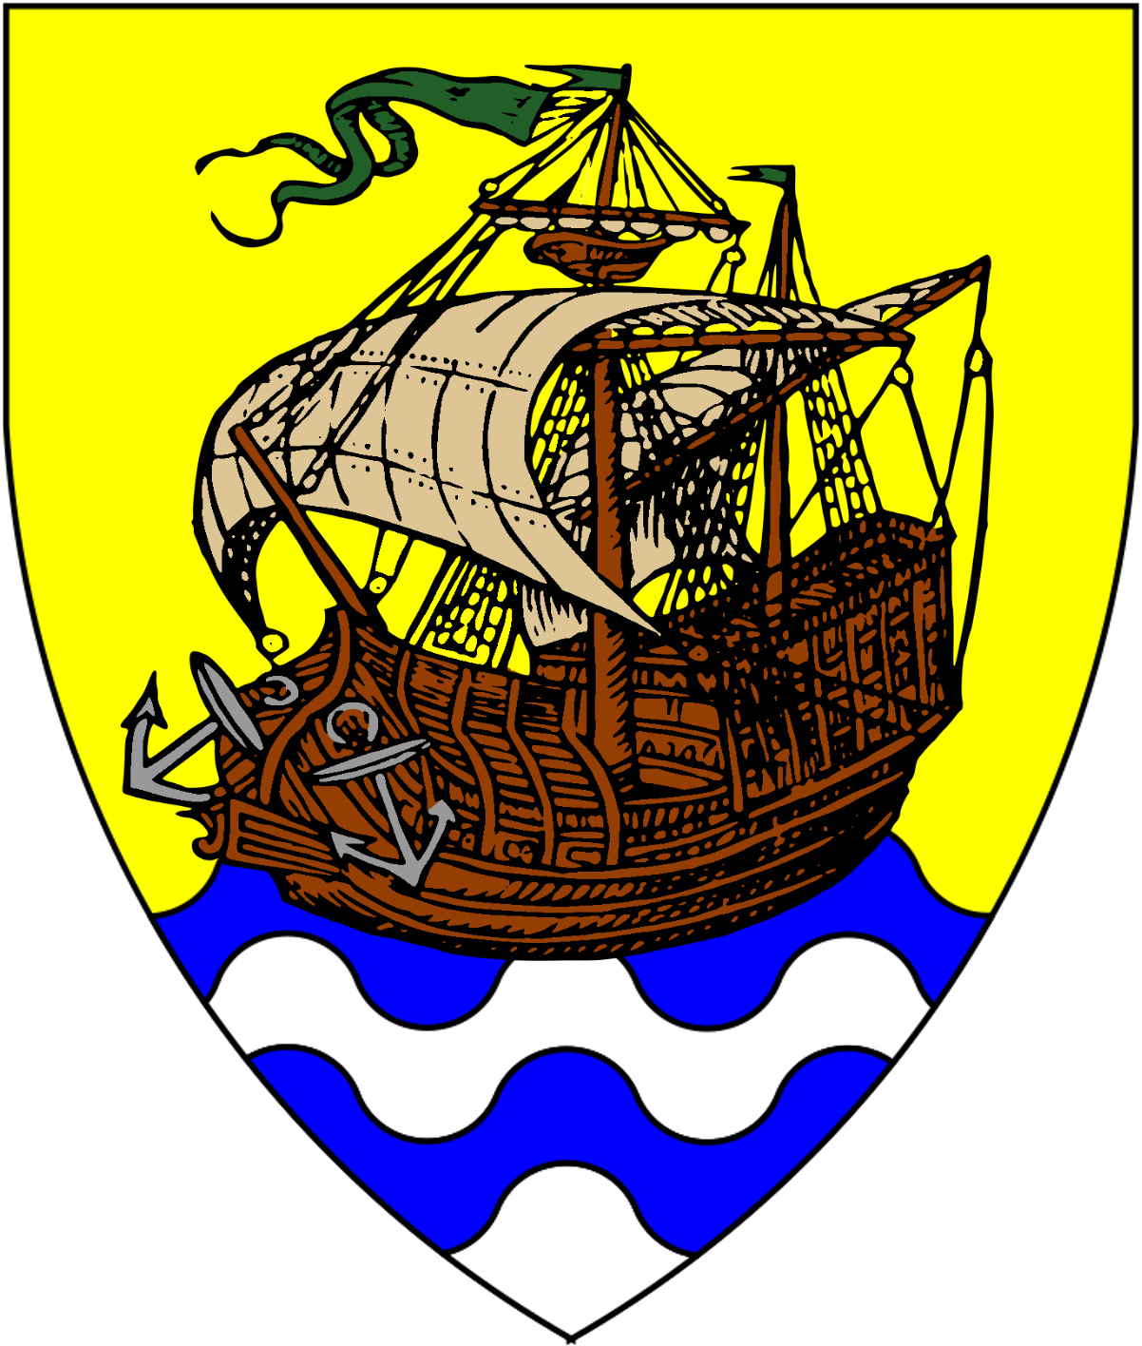 | 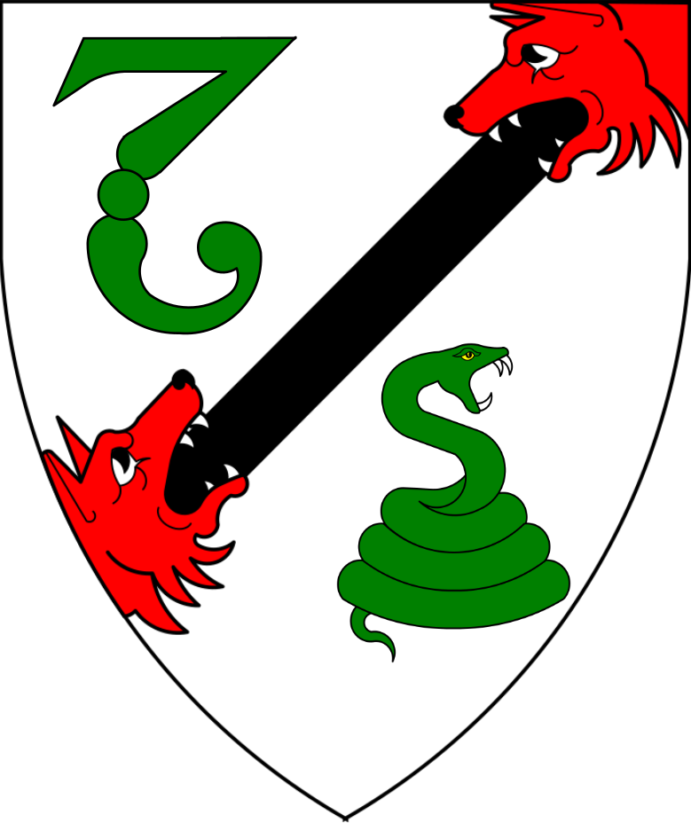 | 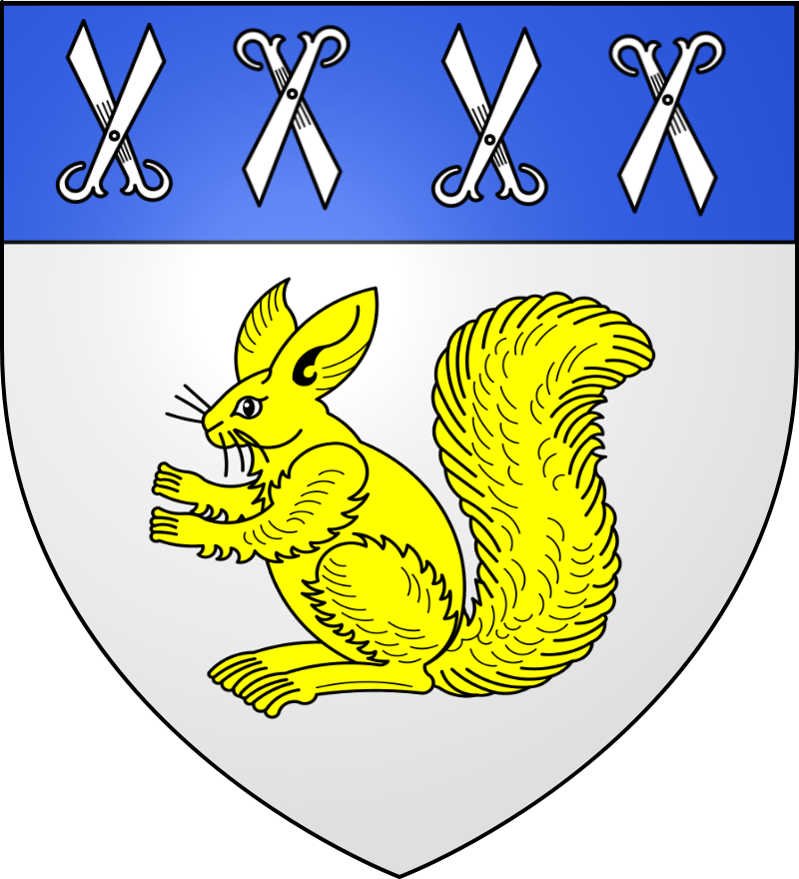 | 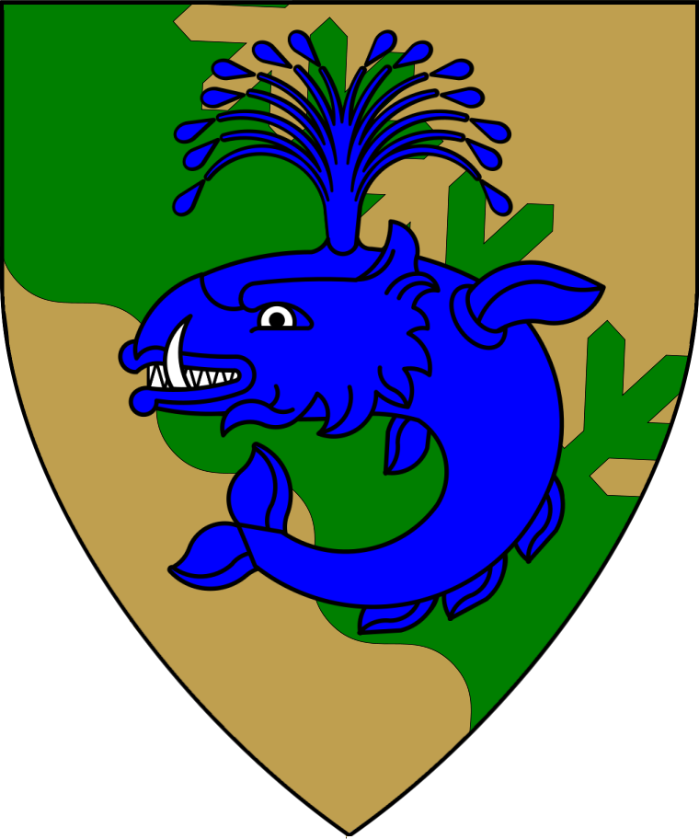
Lord ?
Lord of Valtscha
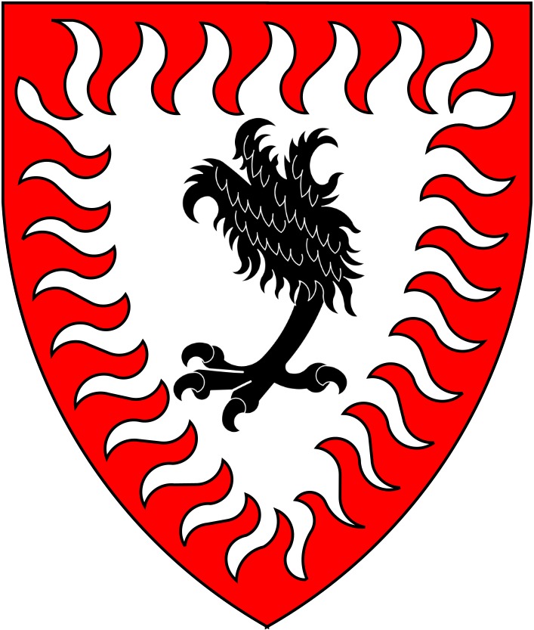

Black Eagle Barony
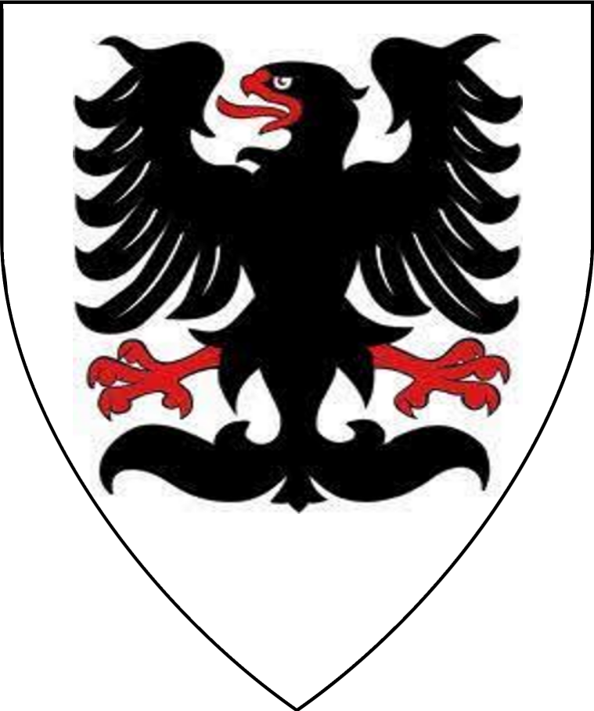
Baron Ludwig  “the Black Eagle:  von Hendriks | Baroness  Sophia von Hendriks | Lord Friedrich von Hendriks  Heir of the Black Eagle | Lady Amelie von Hendriks  Royal Magist | Lord Otto von Hendriks  “The Young Eagle”
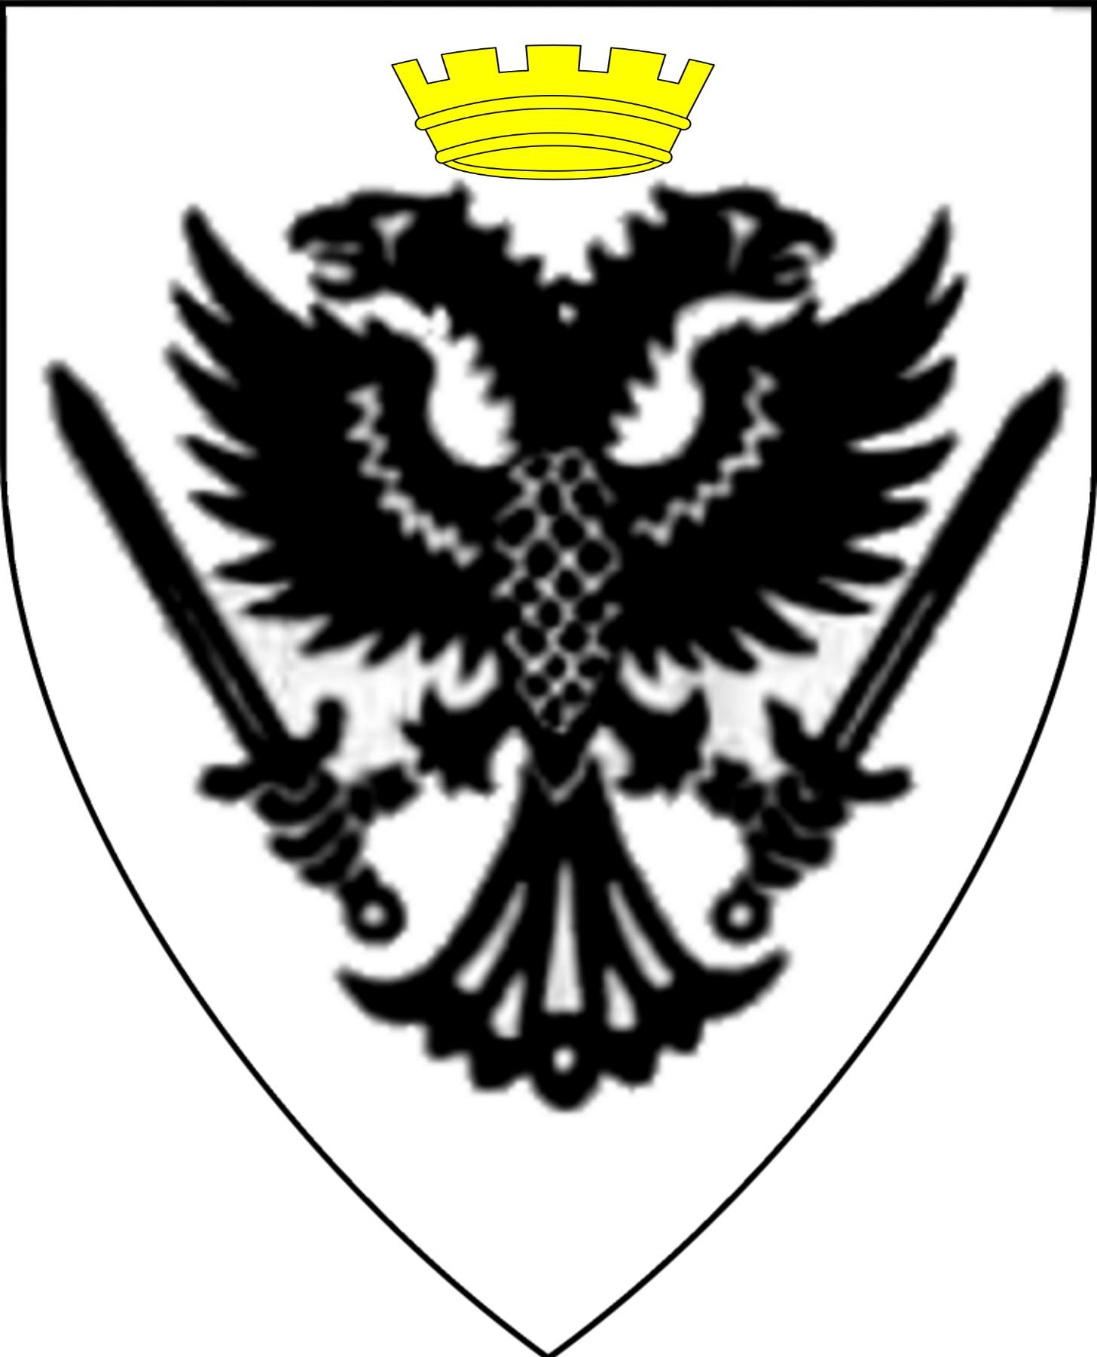 | 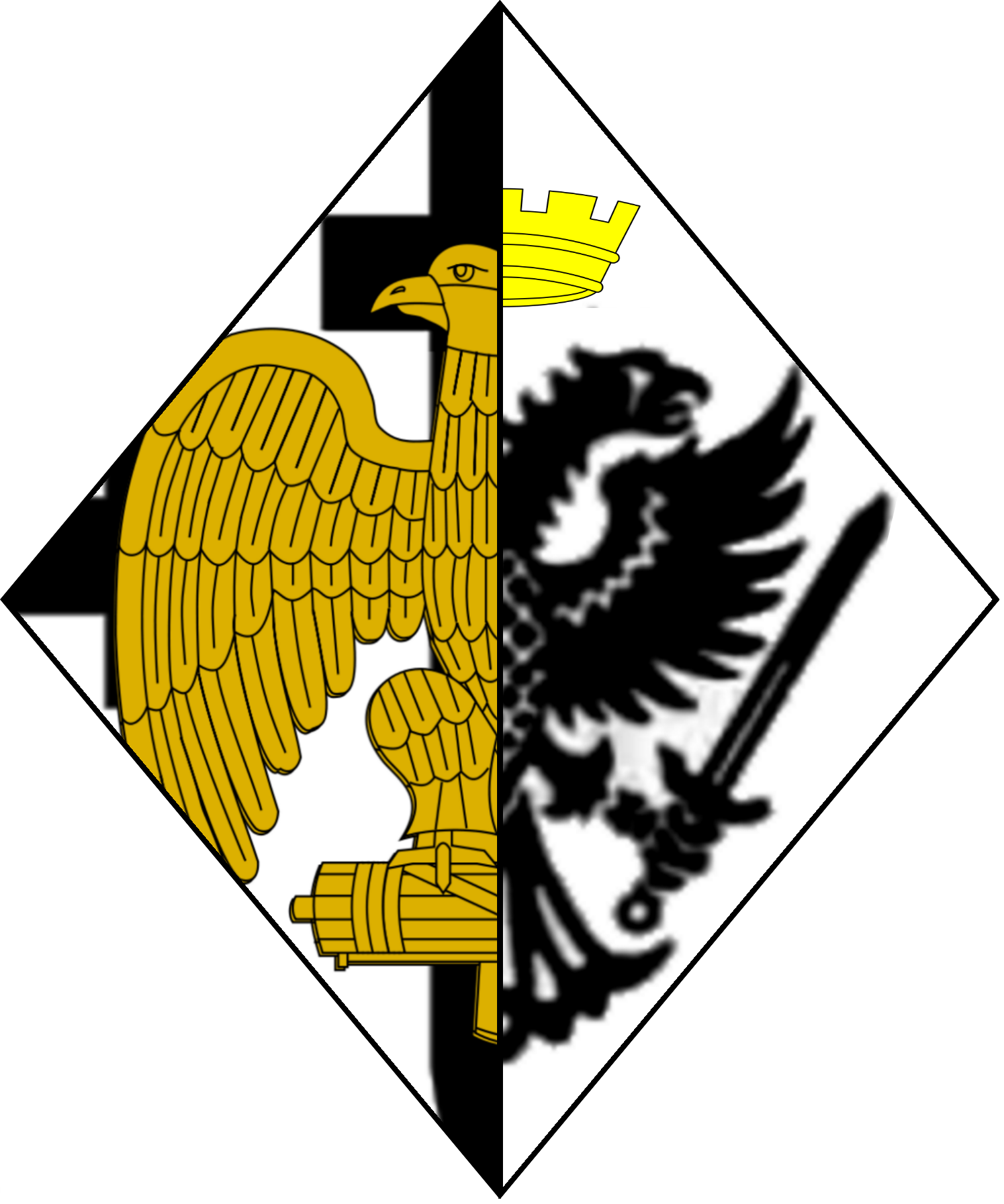 | 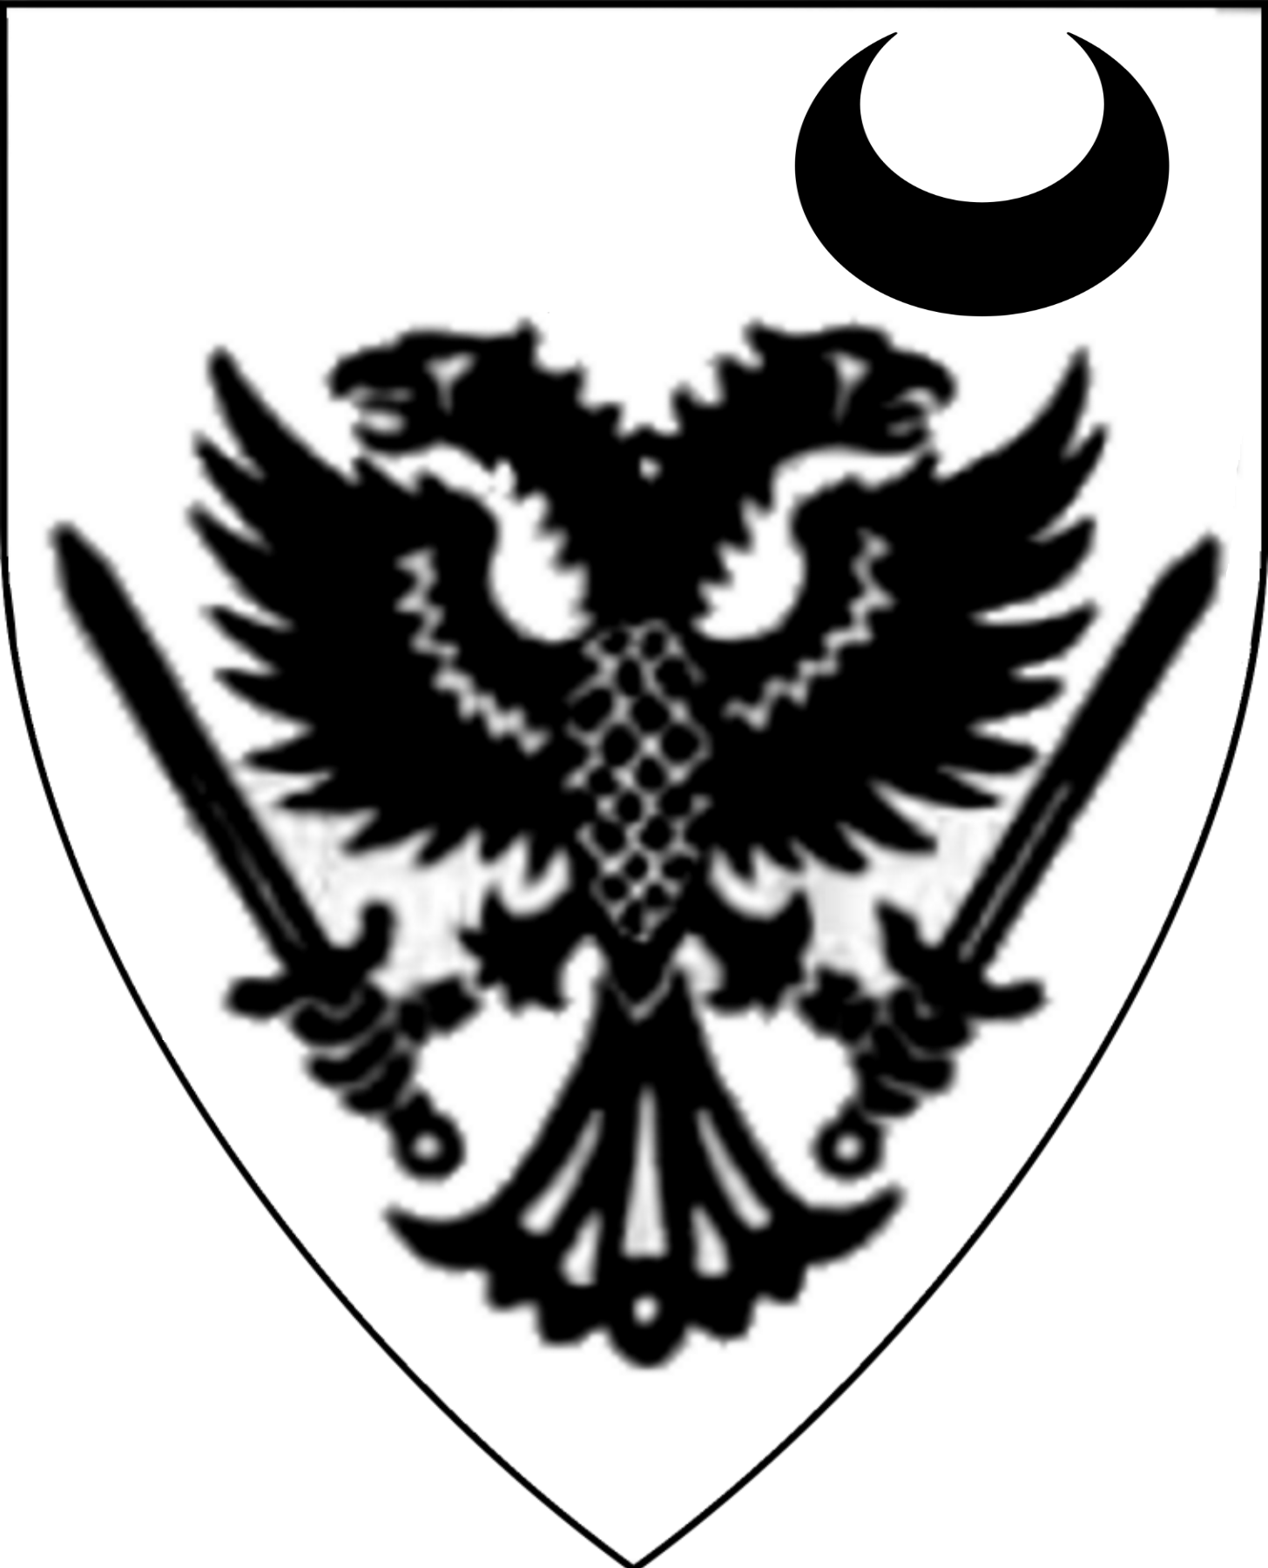 | 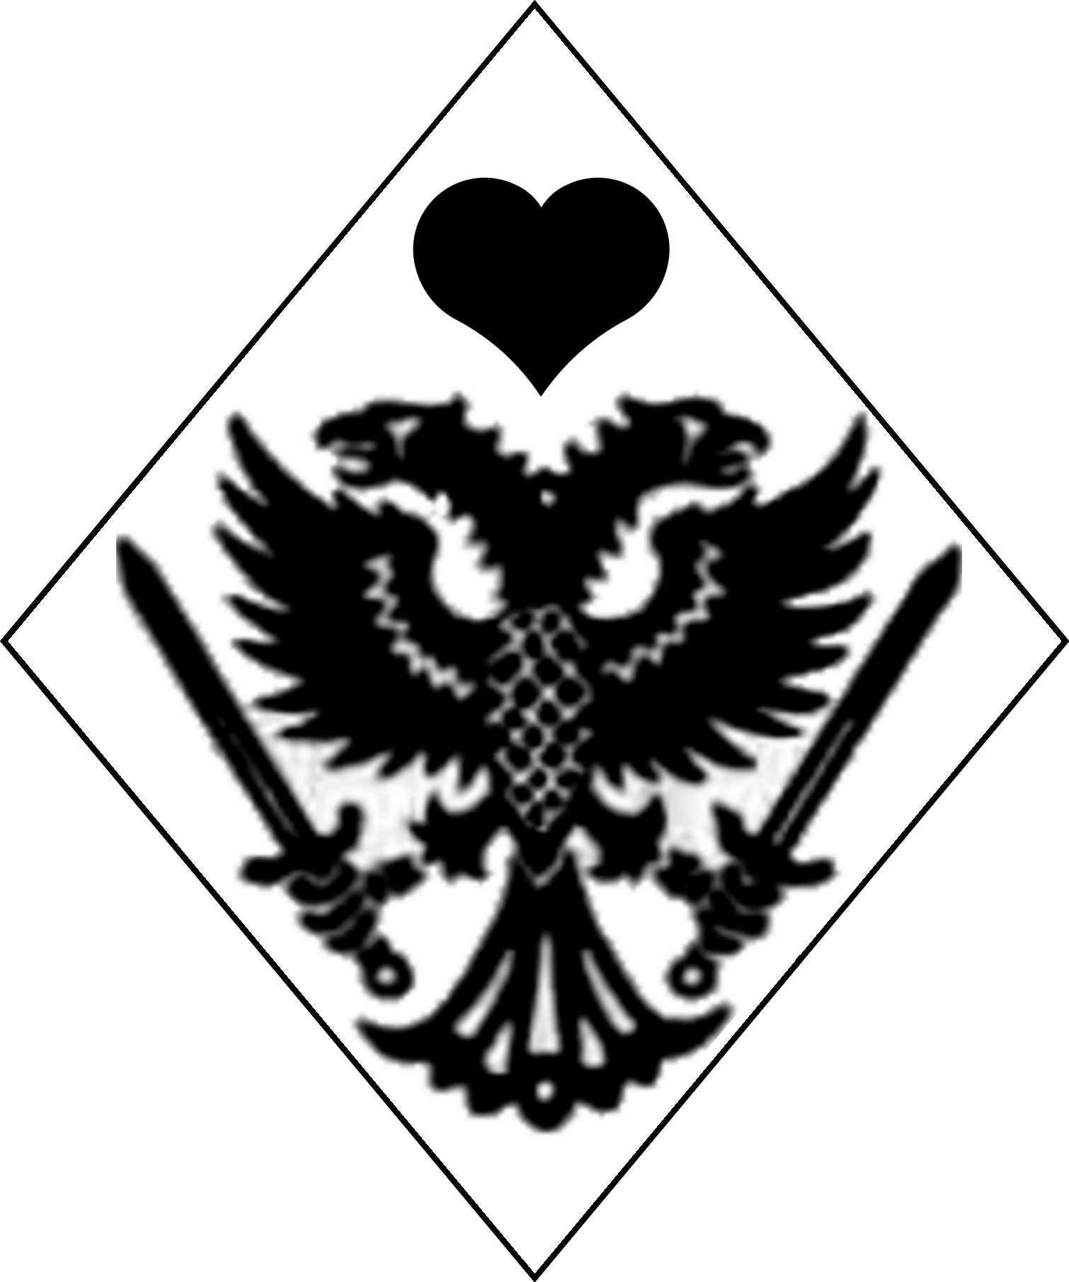 | 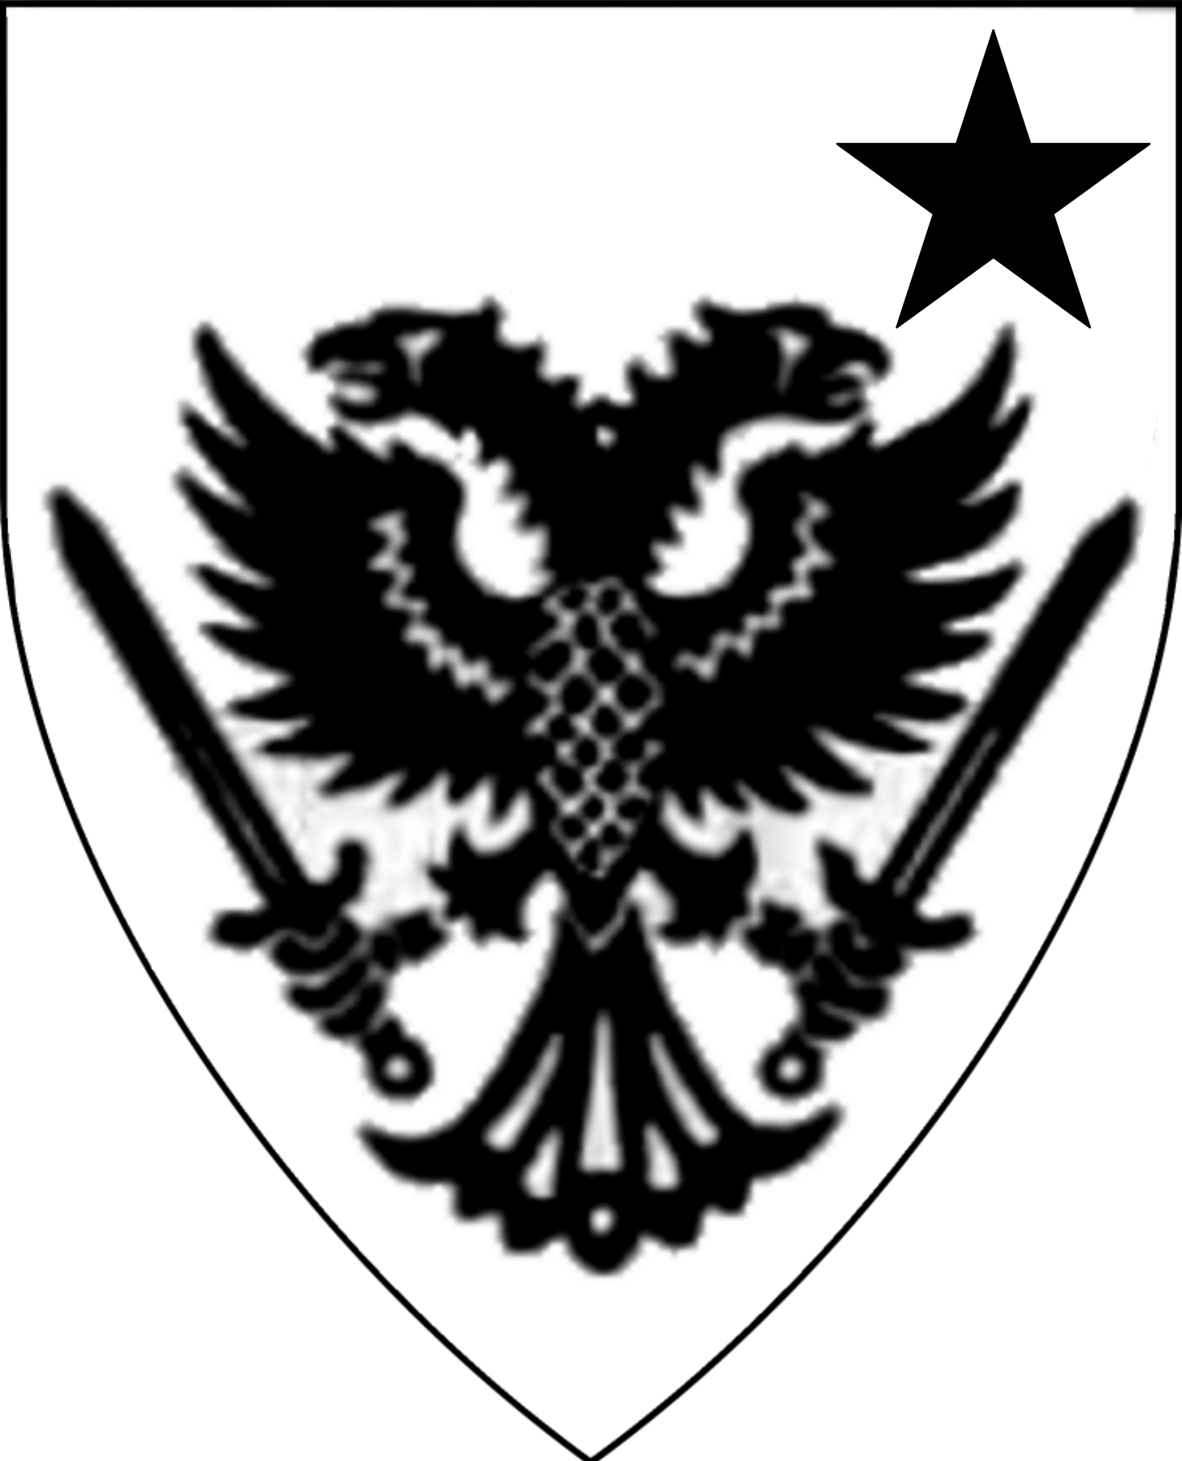
Knights of the Black Eagle
Arms of the Order | Sir Heinrich  von Kessler | Sir Konrad  Von Messerfeld | Sir Brohm  Von Ritter | Sir Manfred  Von Voght
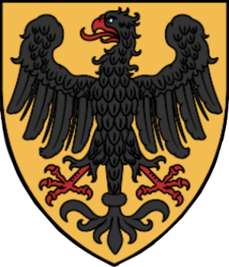 | 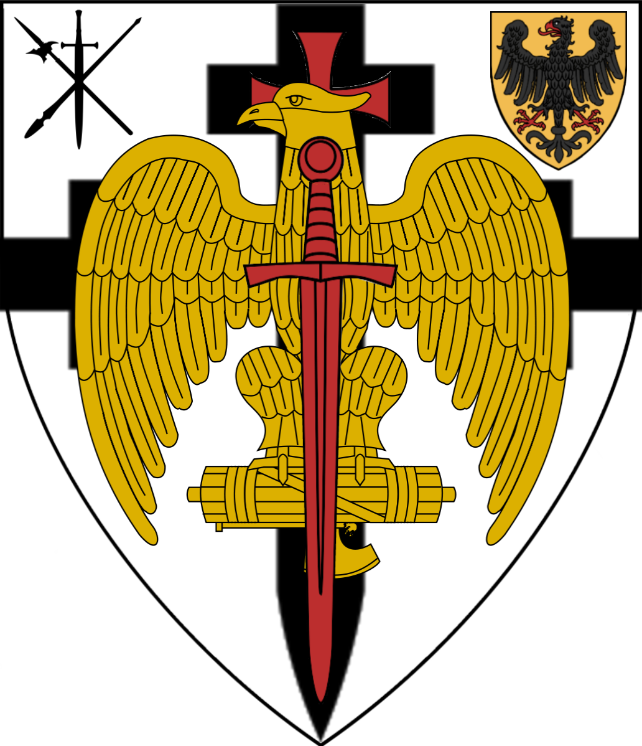 | 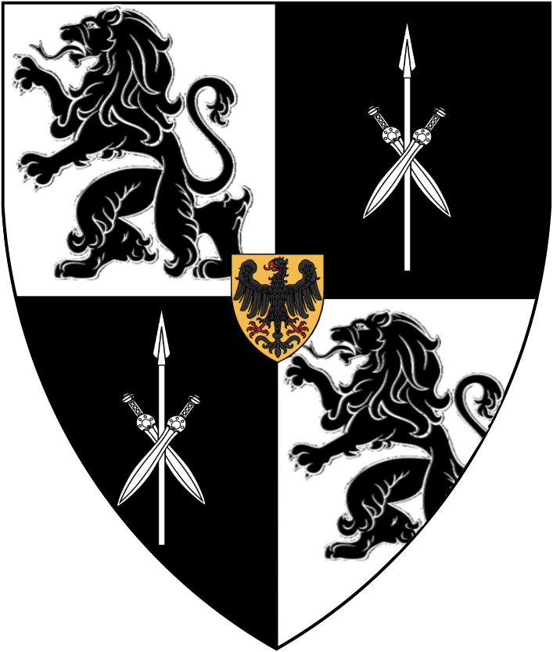 | 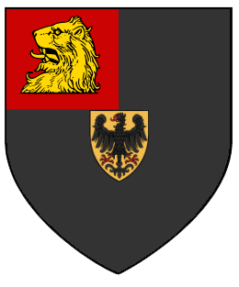 | 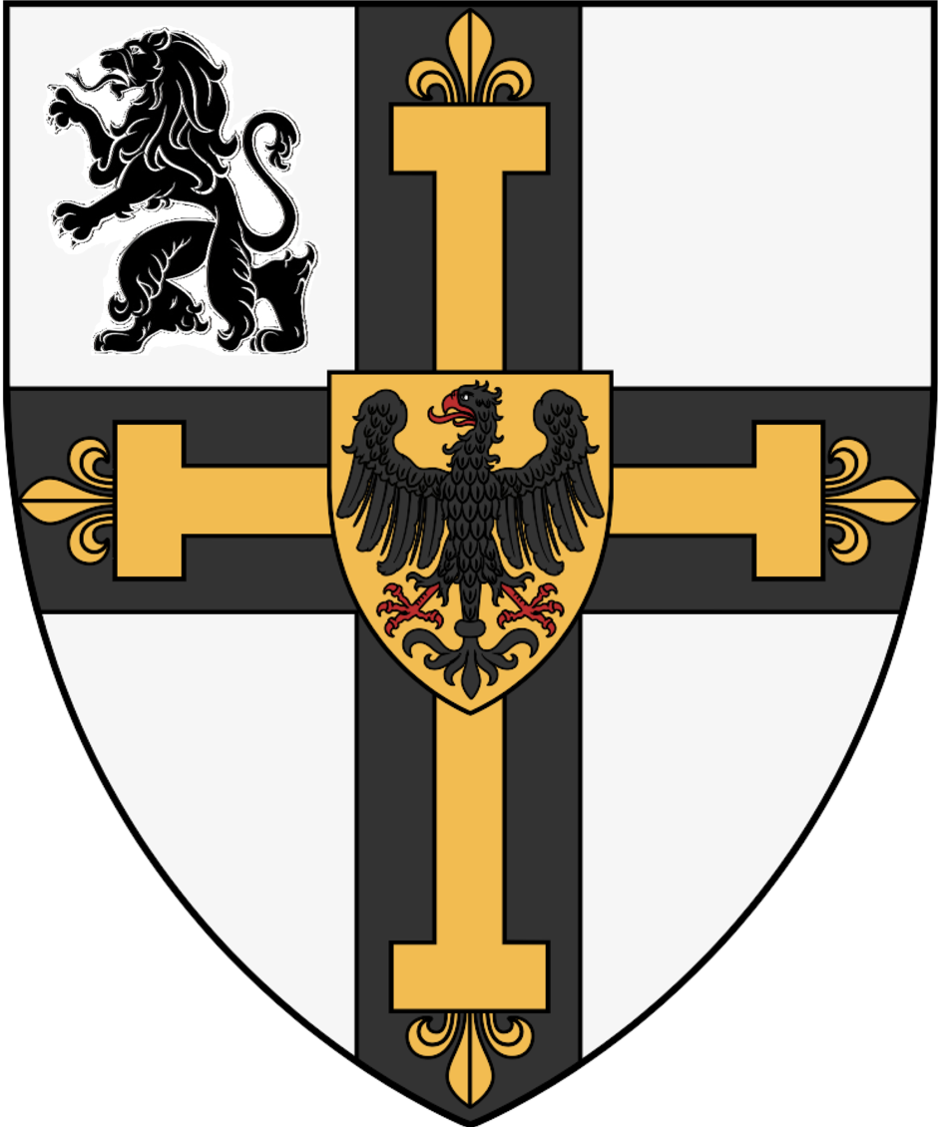
Sir Dante Khyber | Sir Meliagrance | Sir Ernst  von Hesselborg | Sir Turquine | Sir Brus sans Pitie
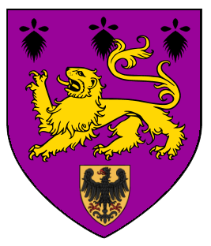 | 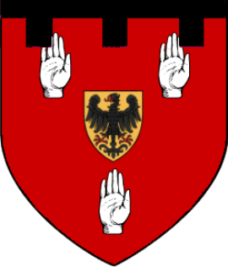 | 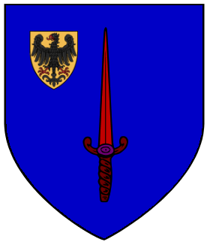 | 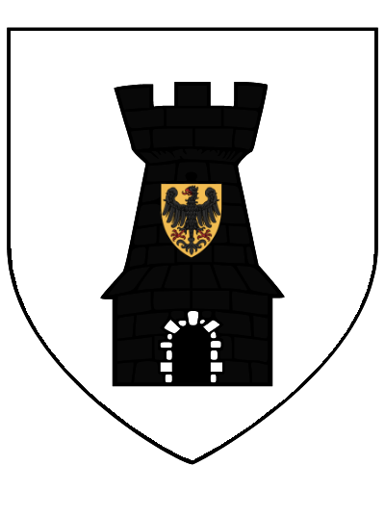 | 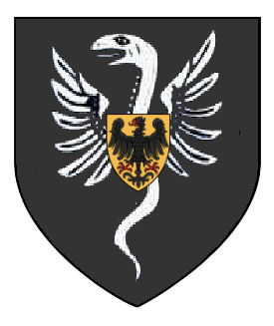
Sir Damas von Heim | Sir Aequititus Tranquillitas | Dahlennias Haakenberg
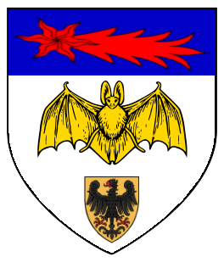 | 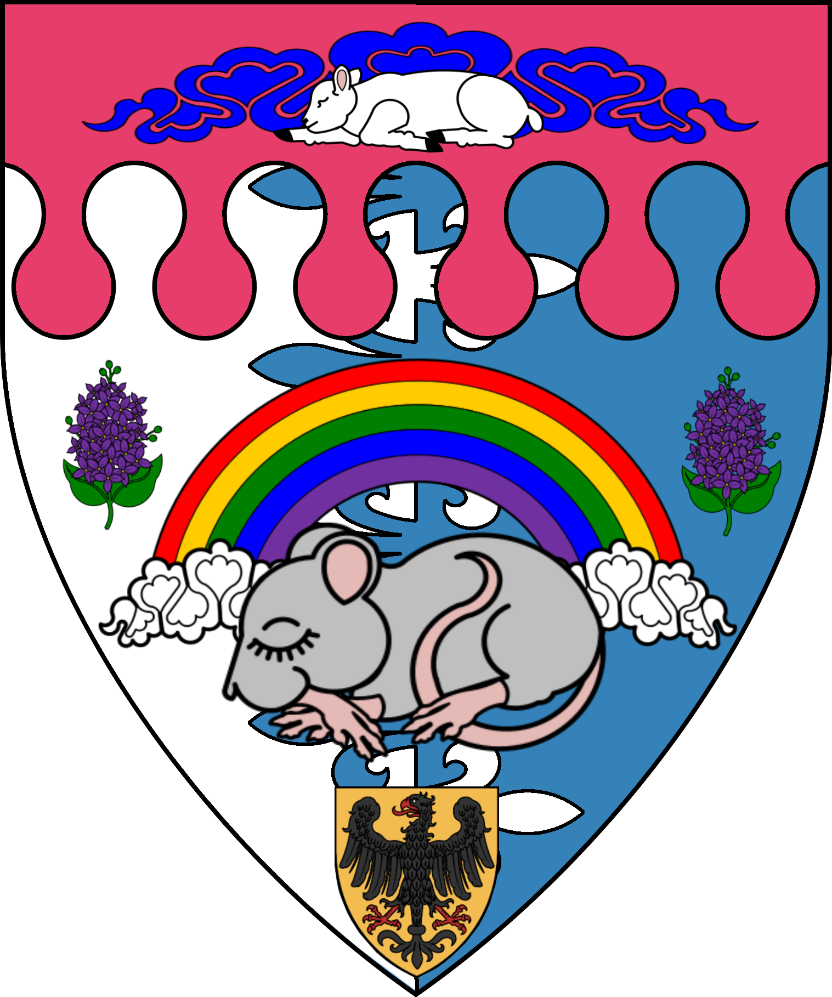 | 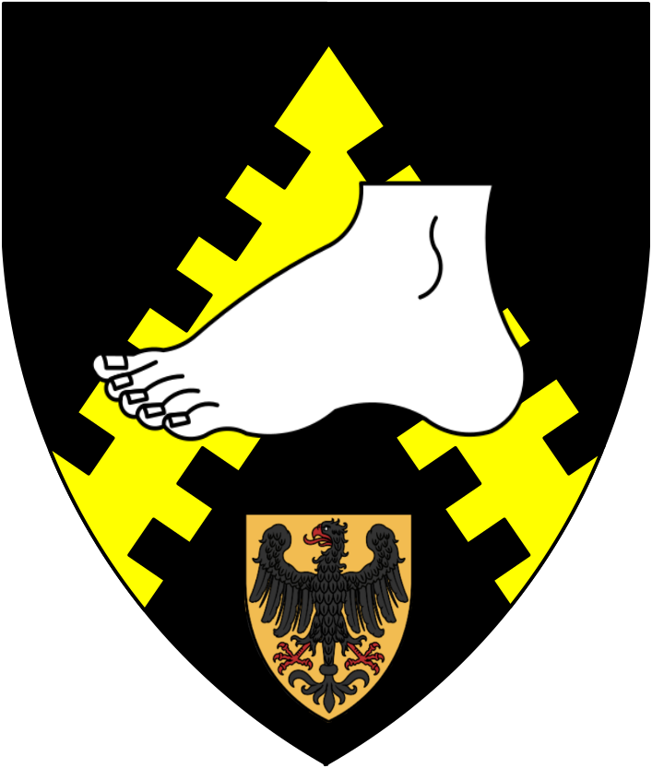
The Fallen
Sir Erik von Hendricks
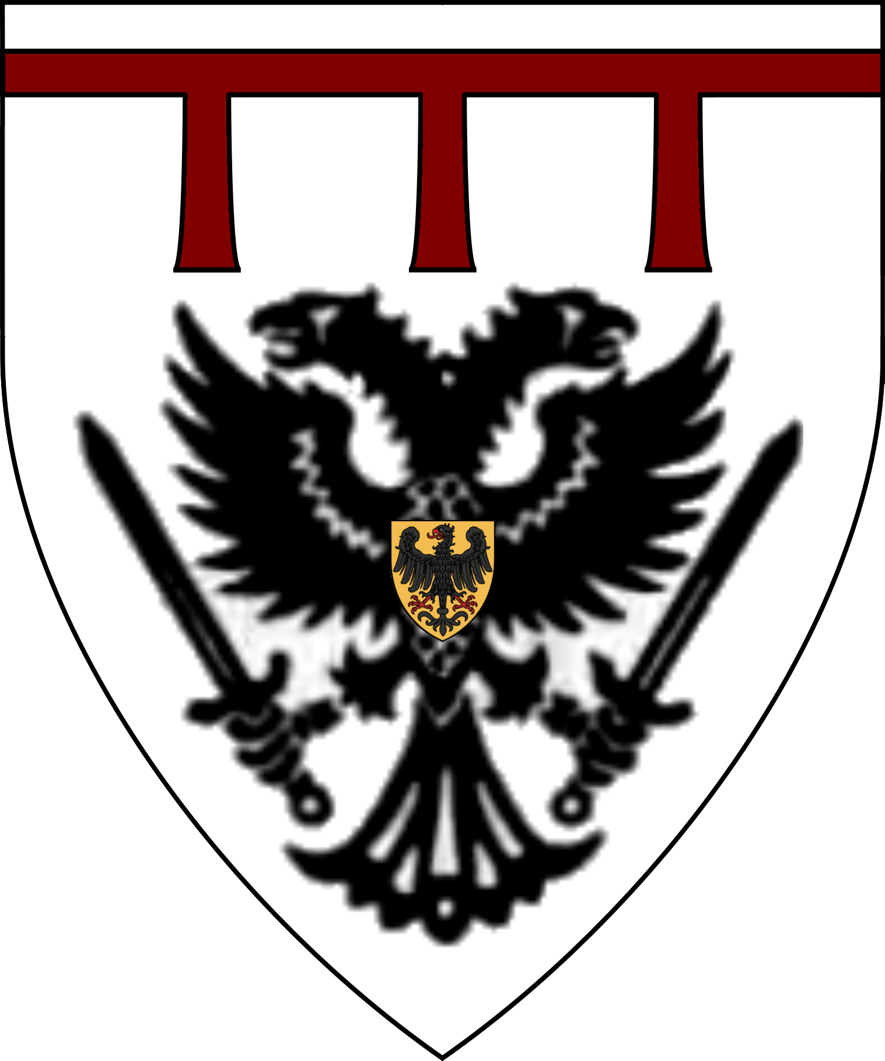
Peerage of the Black Eagle
Sir Heinrich  von Kessler  Lord of Port Gorod | Sir Konrad  von Messerfeld  High Priest of Vanya | Sir Donna  Von Hendriks  Lord of Hendriks | Sir Brohm von Ritter  Lord of Lungrad | Sir Dante Khyber  Lord of Stuv
 |  | 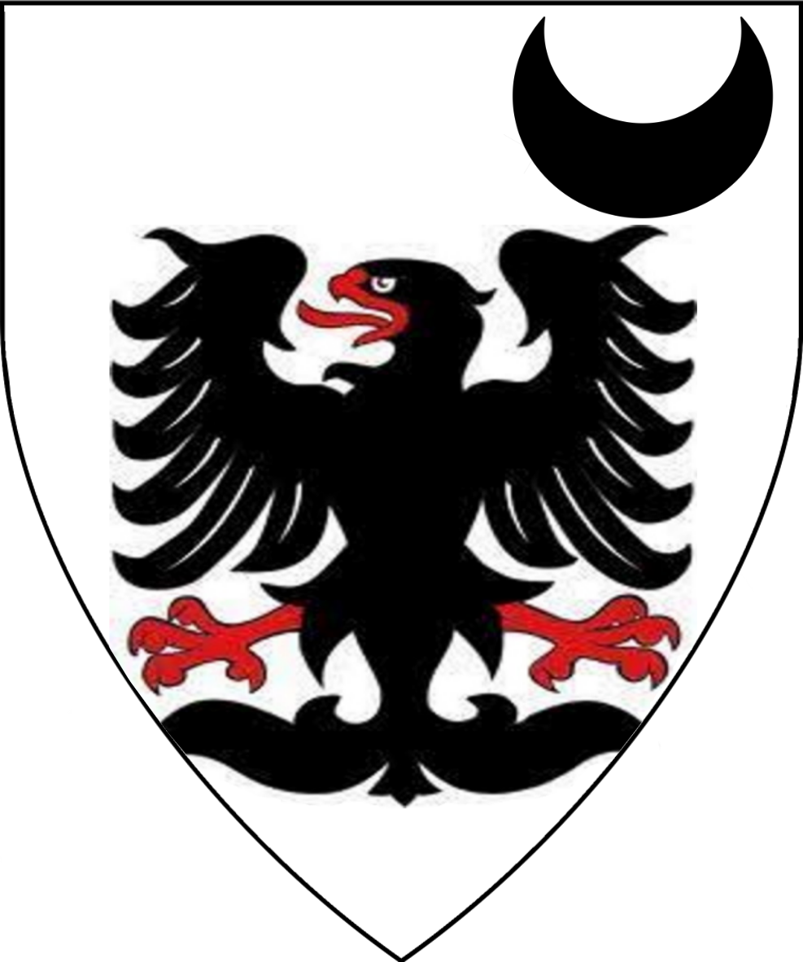
Sir Meliangrance  Lord of Trov | Lady Elsie  von Hendriks  Lady of Ludwigia | Sir Ernst  Von Hesselborg  Lord of Mokrat | Sir Turquine of the Dolorous Tower  Lord of Watchtower | Lord Konradt Torzegy  Lord of Südenhalag
 | 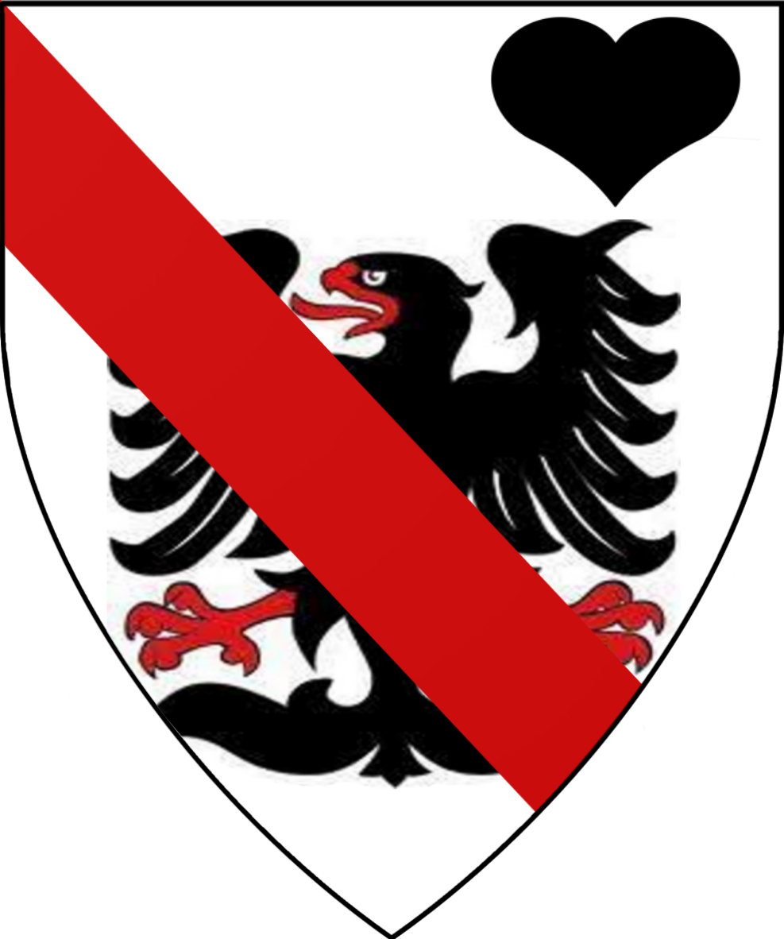 |  |  | 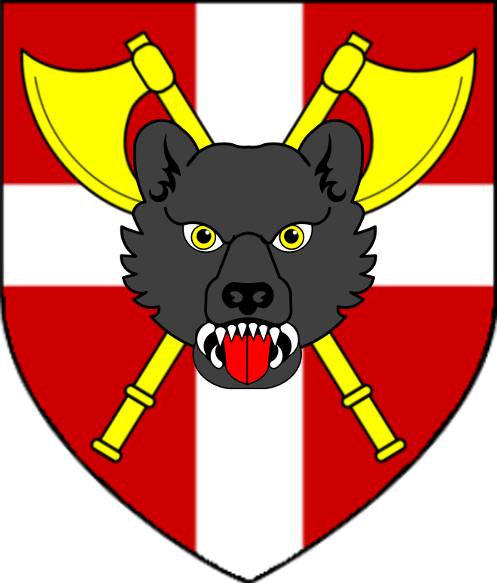
Lord Gerhardt  von Schmeissen  Lord of Ivanov | Lord Adelbert  von Lindenhof  Lord of Stivov | Lord Harmut Russ  of Hattias  Lord of Russenhimmer
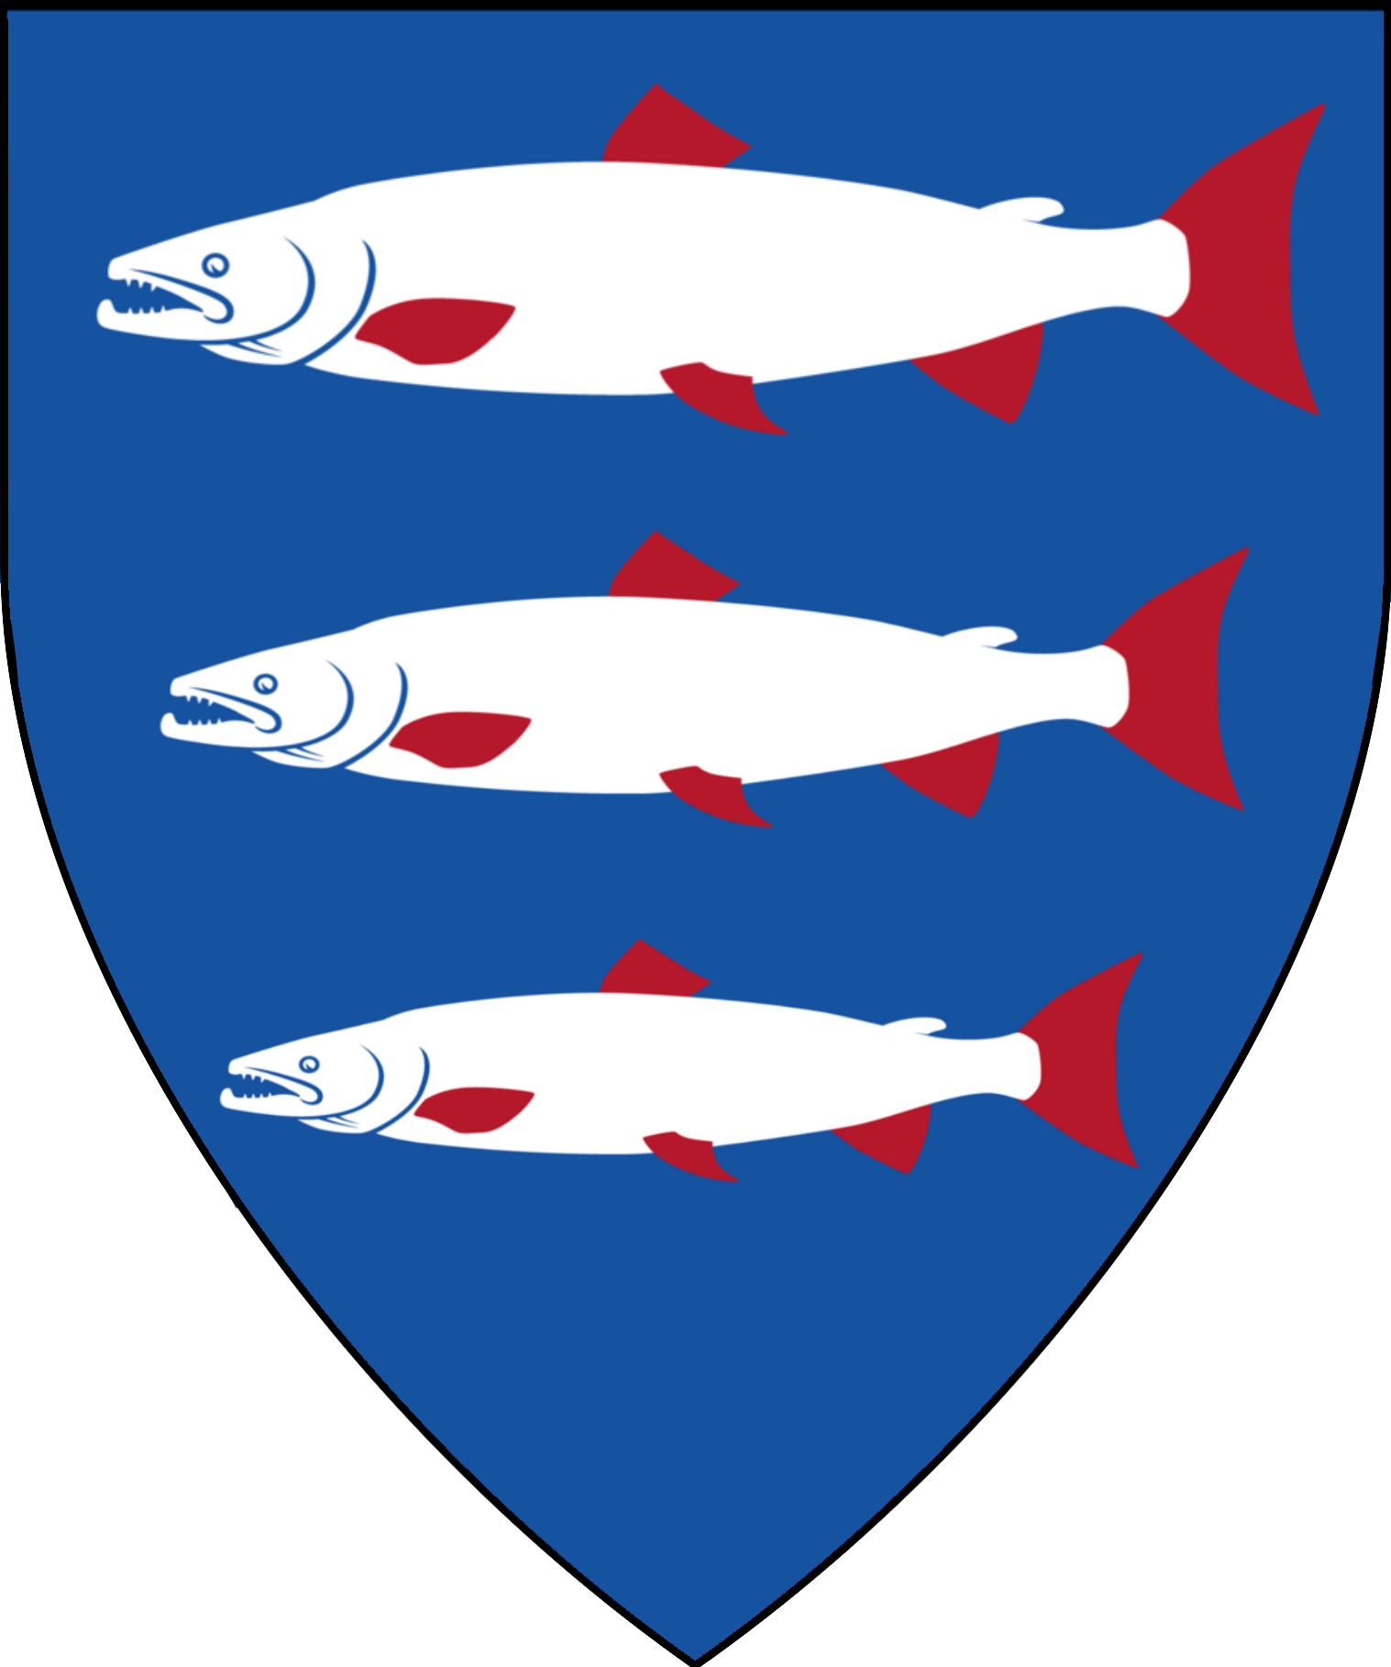 | 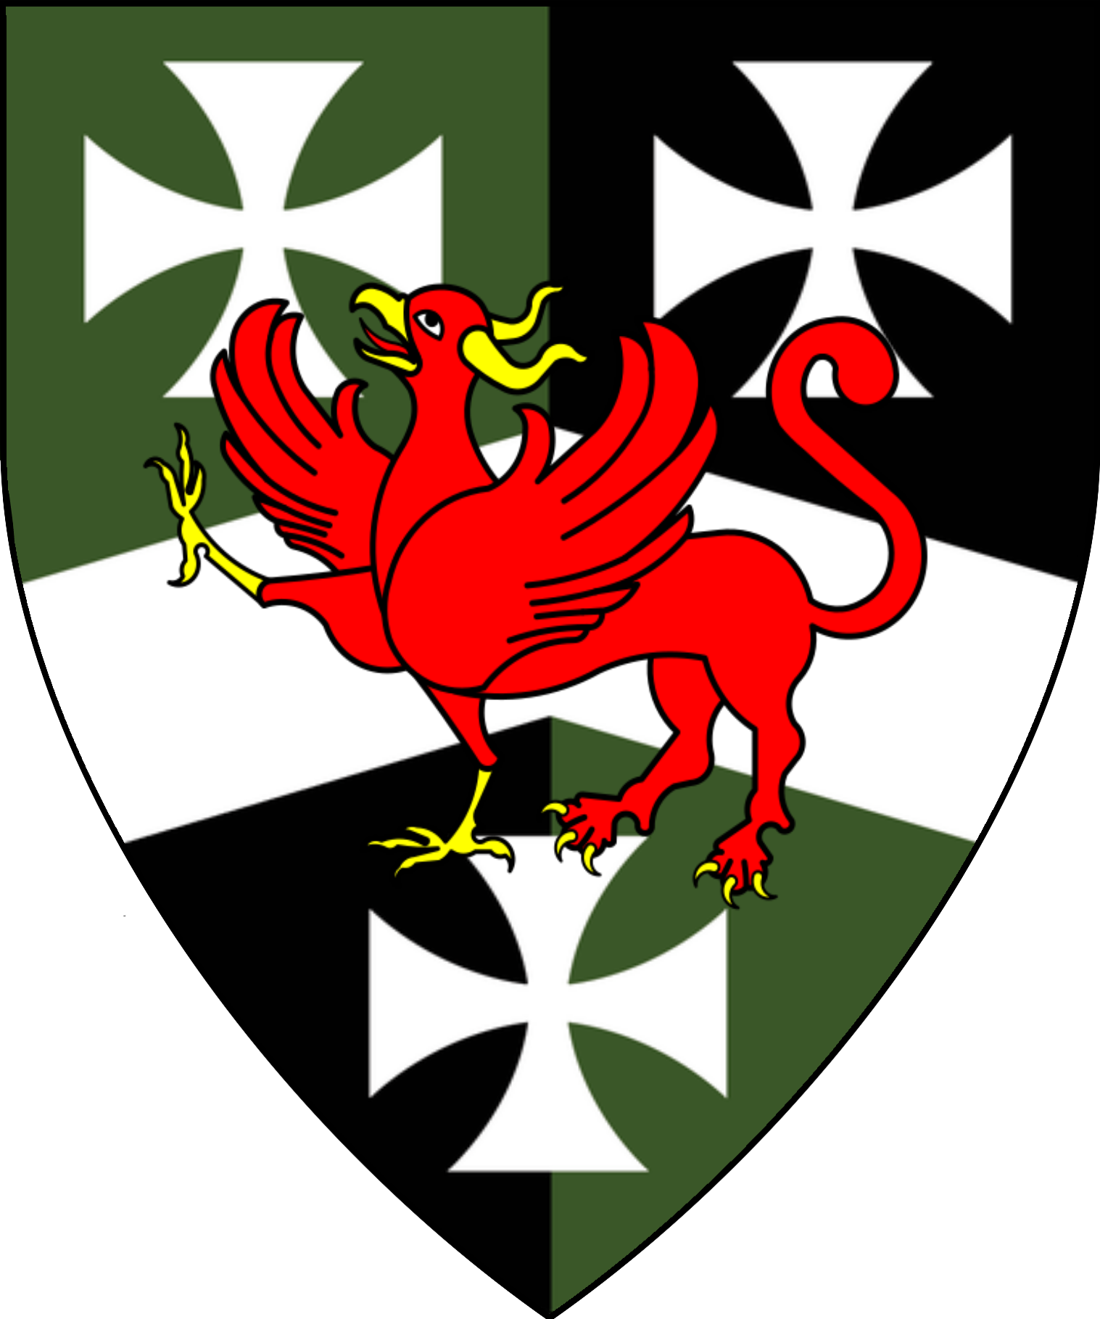 | 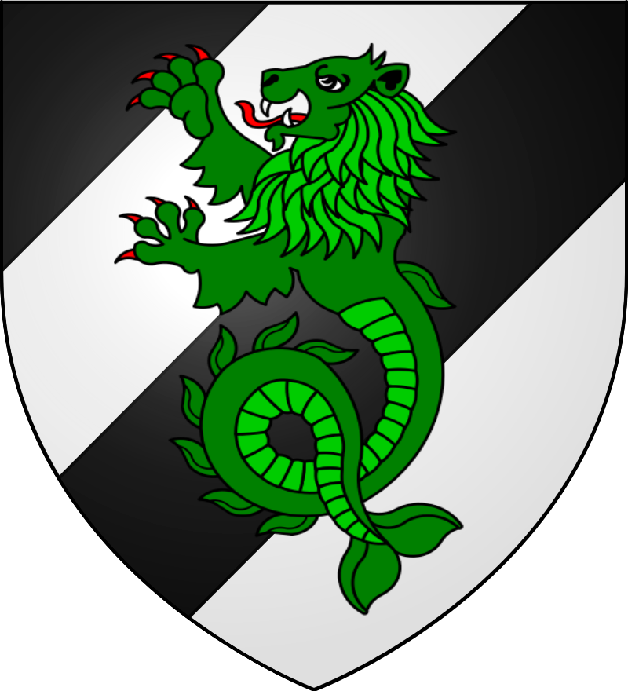

Estate of Hreafenwolde
Sir Ayden Sylvoril
Landed Knight of the Realm, Knight of the Three Suns
Sir Decimos Meridian  Lord of Haradraith’s Keep | Lord Chan  Lord-Mayor of Tortleton | Lord Argahast “the Bold” Osdelic  Lord of Osdelic | Subarek  Underlord of the Wulfwolde Hills
 | 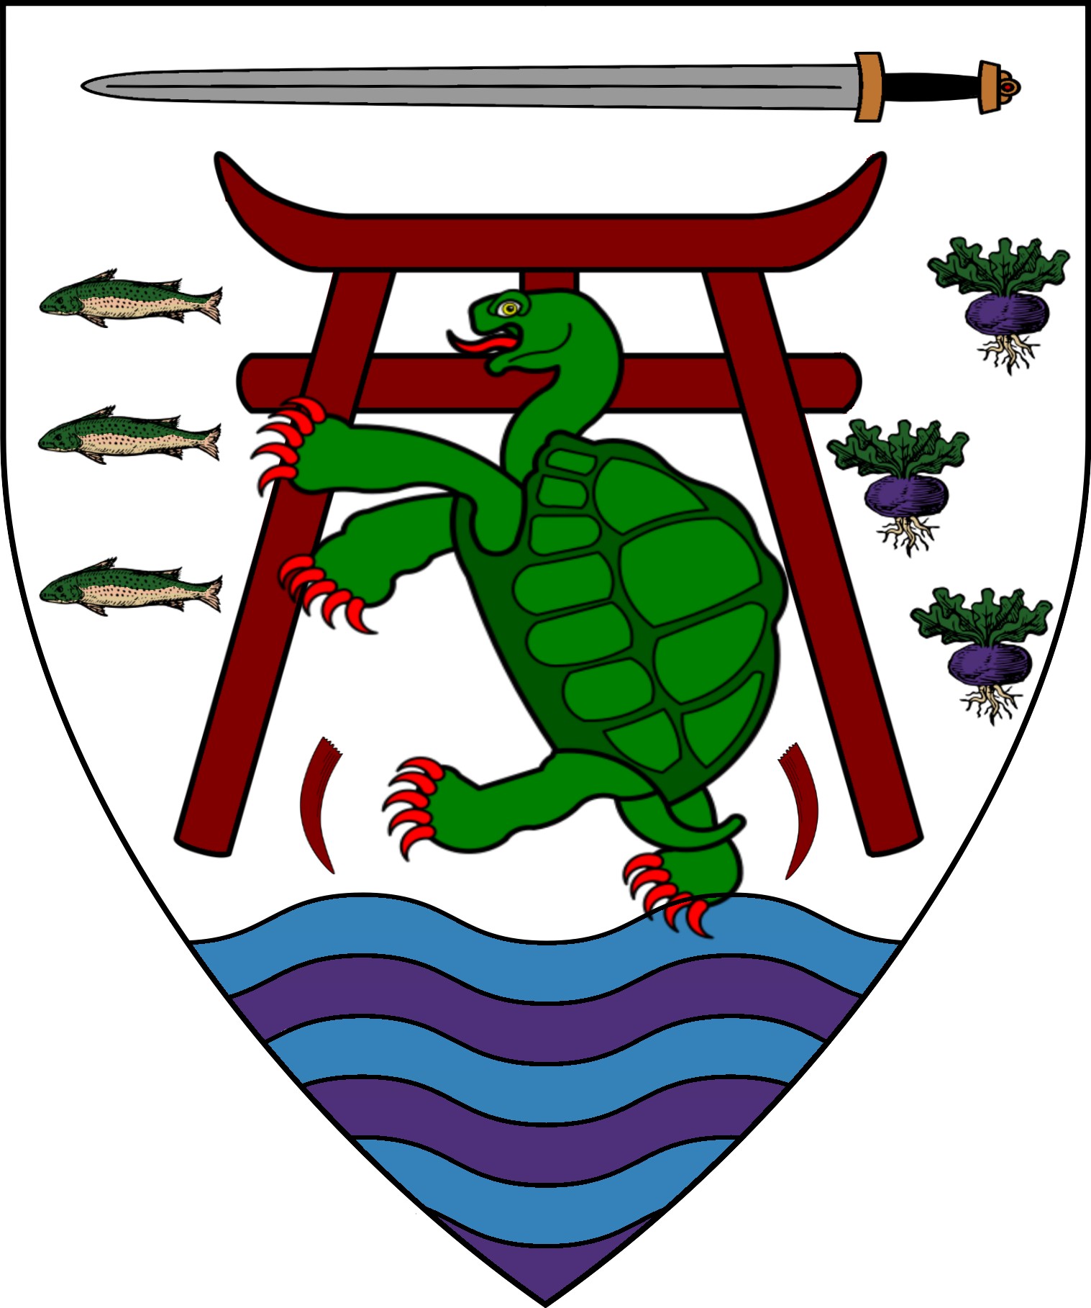 | 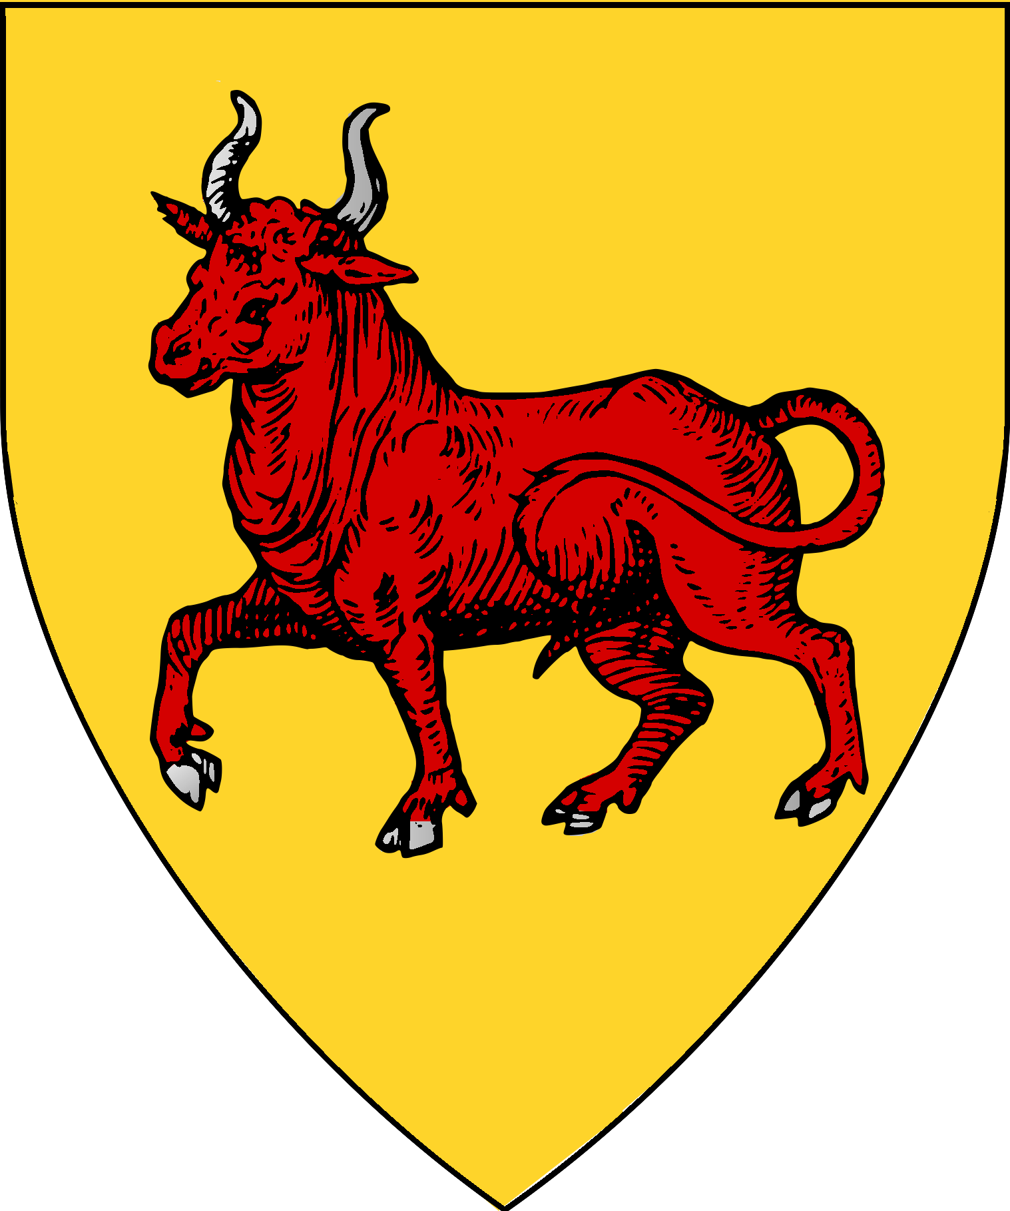 | 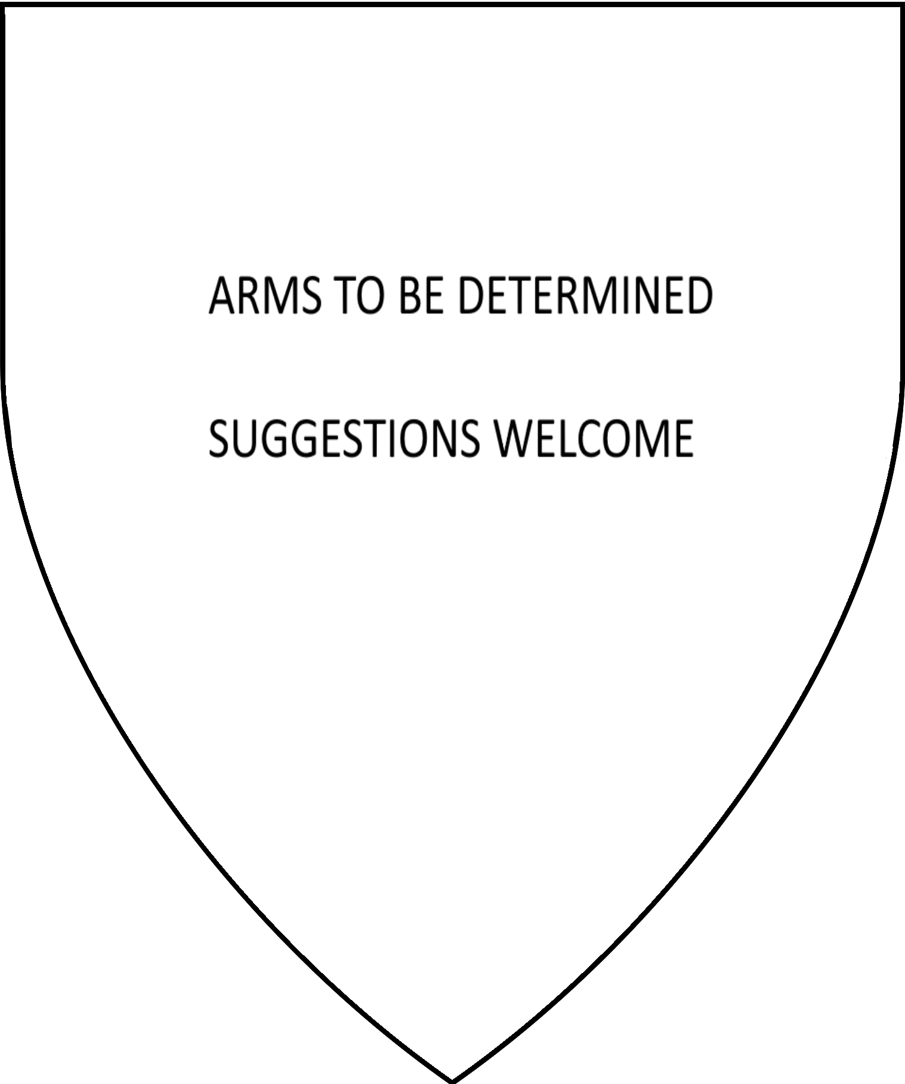

Estate of Verge
Verge | Sir Retameron Antonic |  | Lord Menecles Acastaran  Lord of Acastaran & Varnica
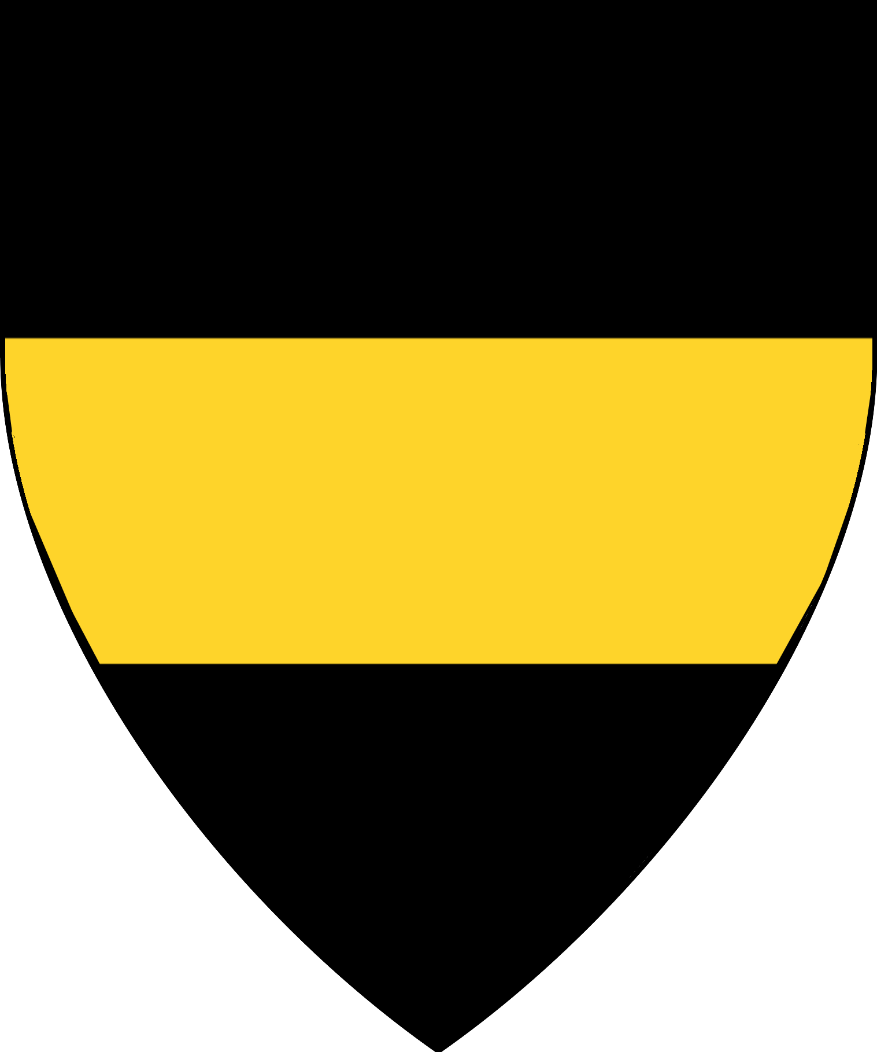 | 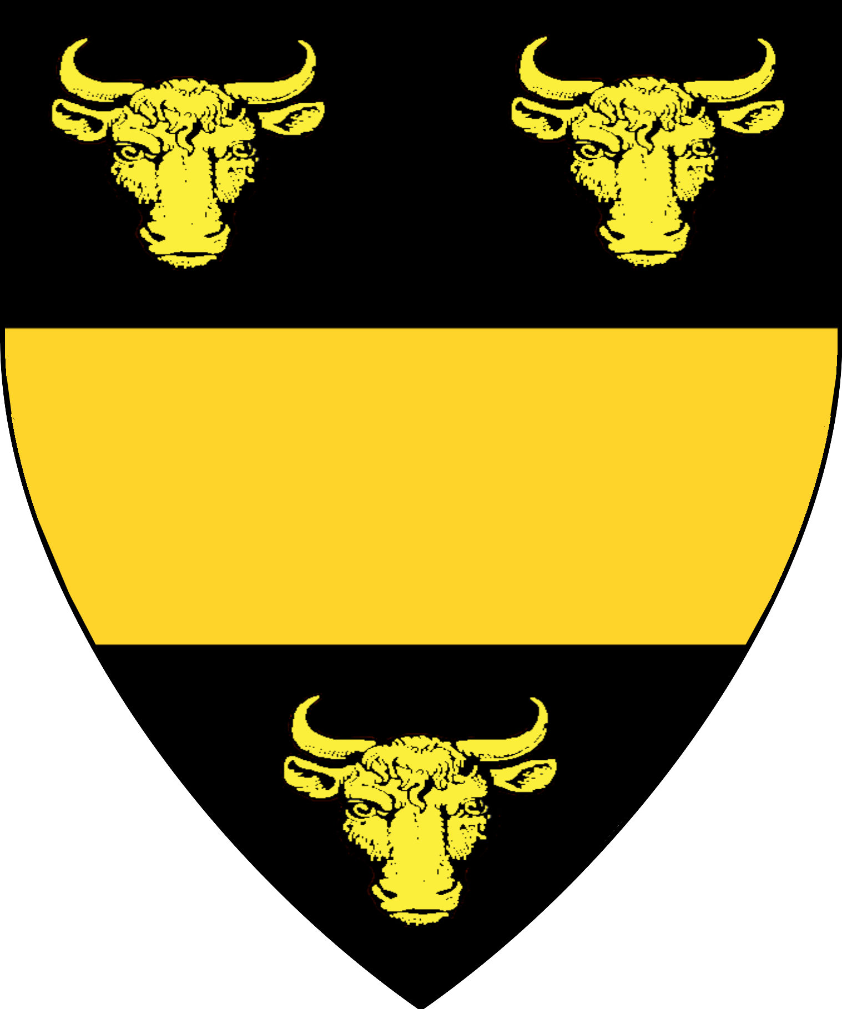 |  | 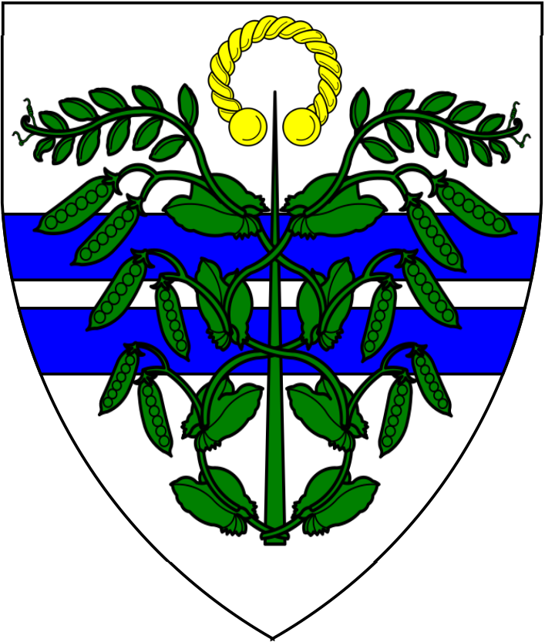

Estate of Draconius | Estate of Wolf | Catarthian Estate
Sir Bessarion Draconius | Captain Sir Heinrich Wolf | Sir Hans “Das Hund” Catarthian
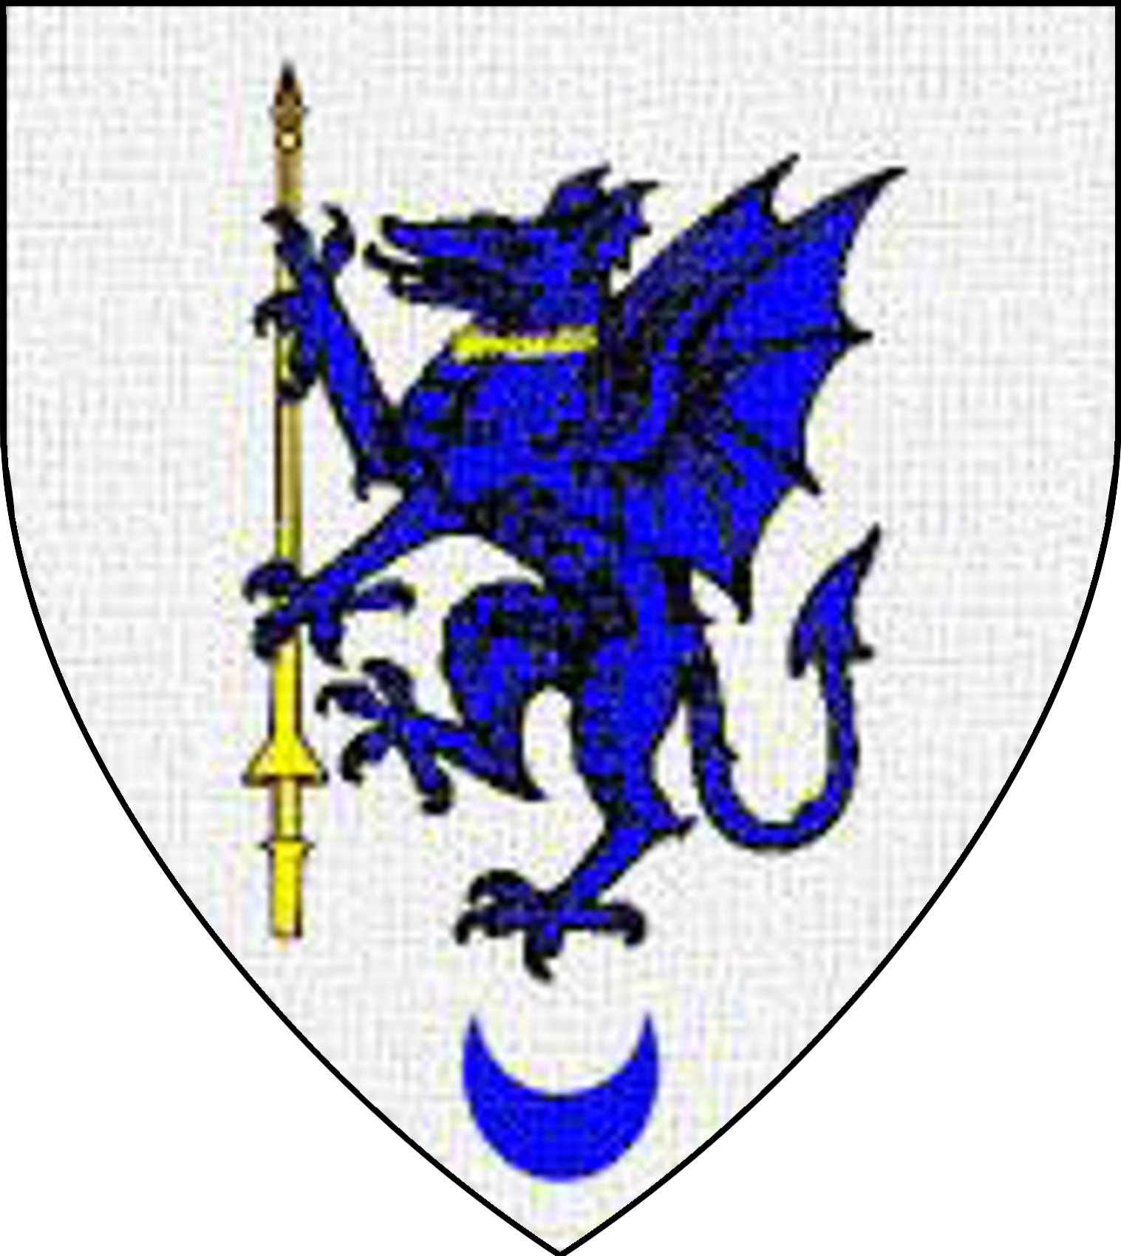 |  | 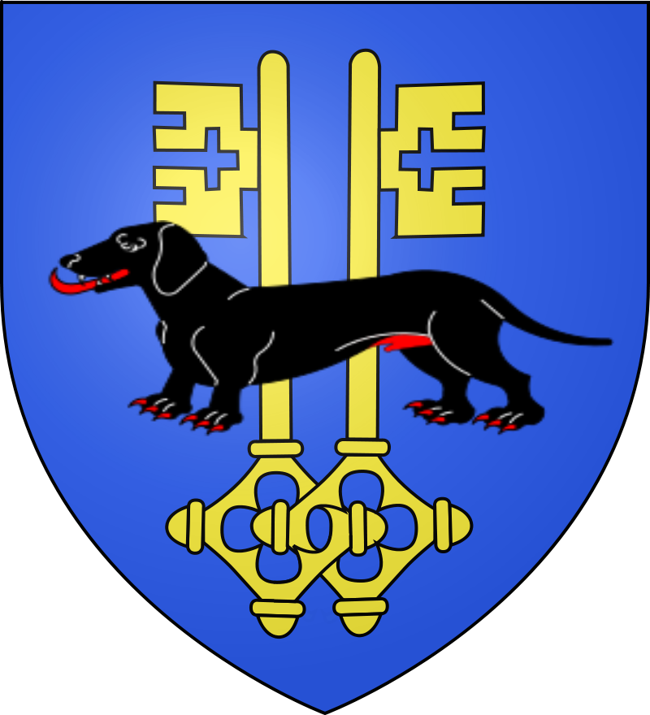

Estate of Dmitrov
Lord Lev Dromilov
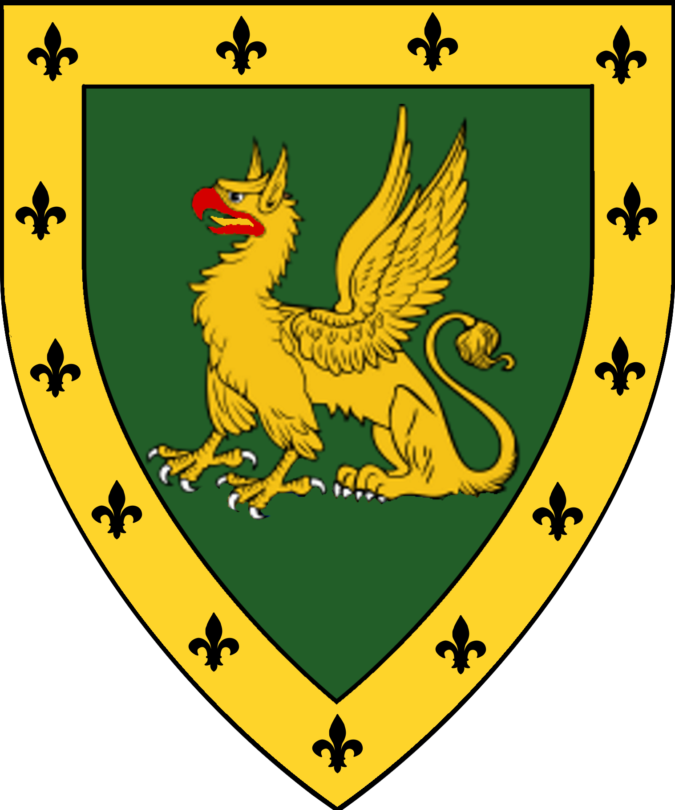
Sir Dardanos Archapfel  Lord of Riga | Lord/Lady ? of Krasrit | Lord/Lady? of Sinyrit | Lord/Lady? of Kaita | Lord/Lady? of Ingvar
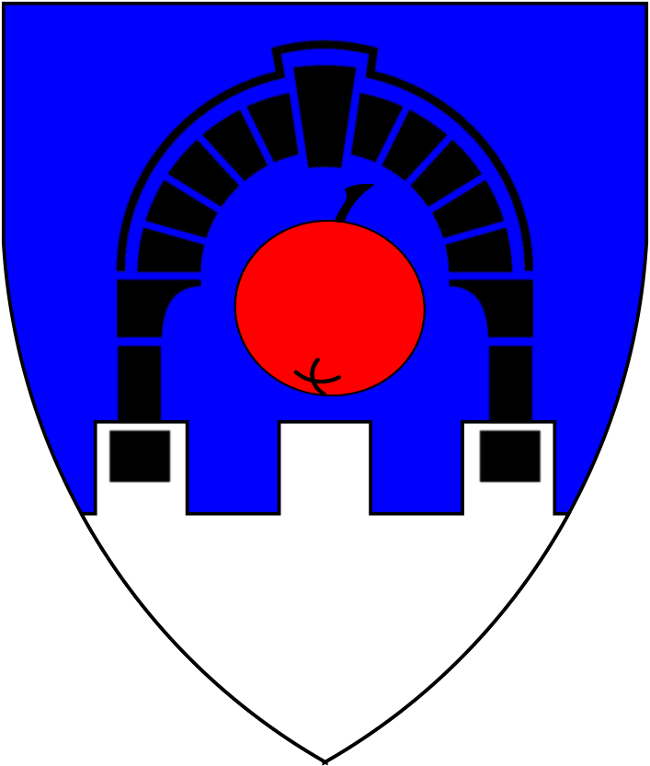 | 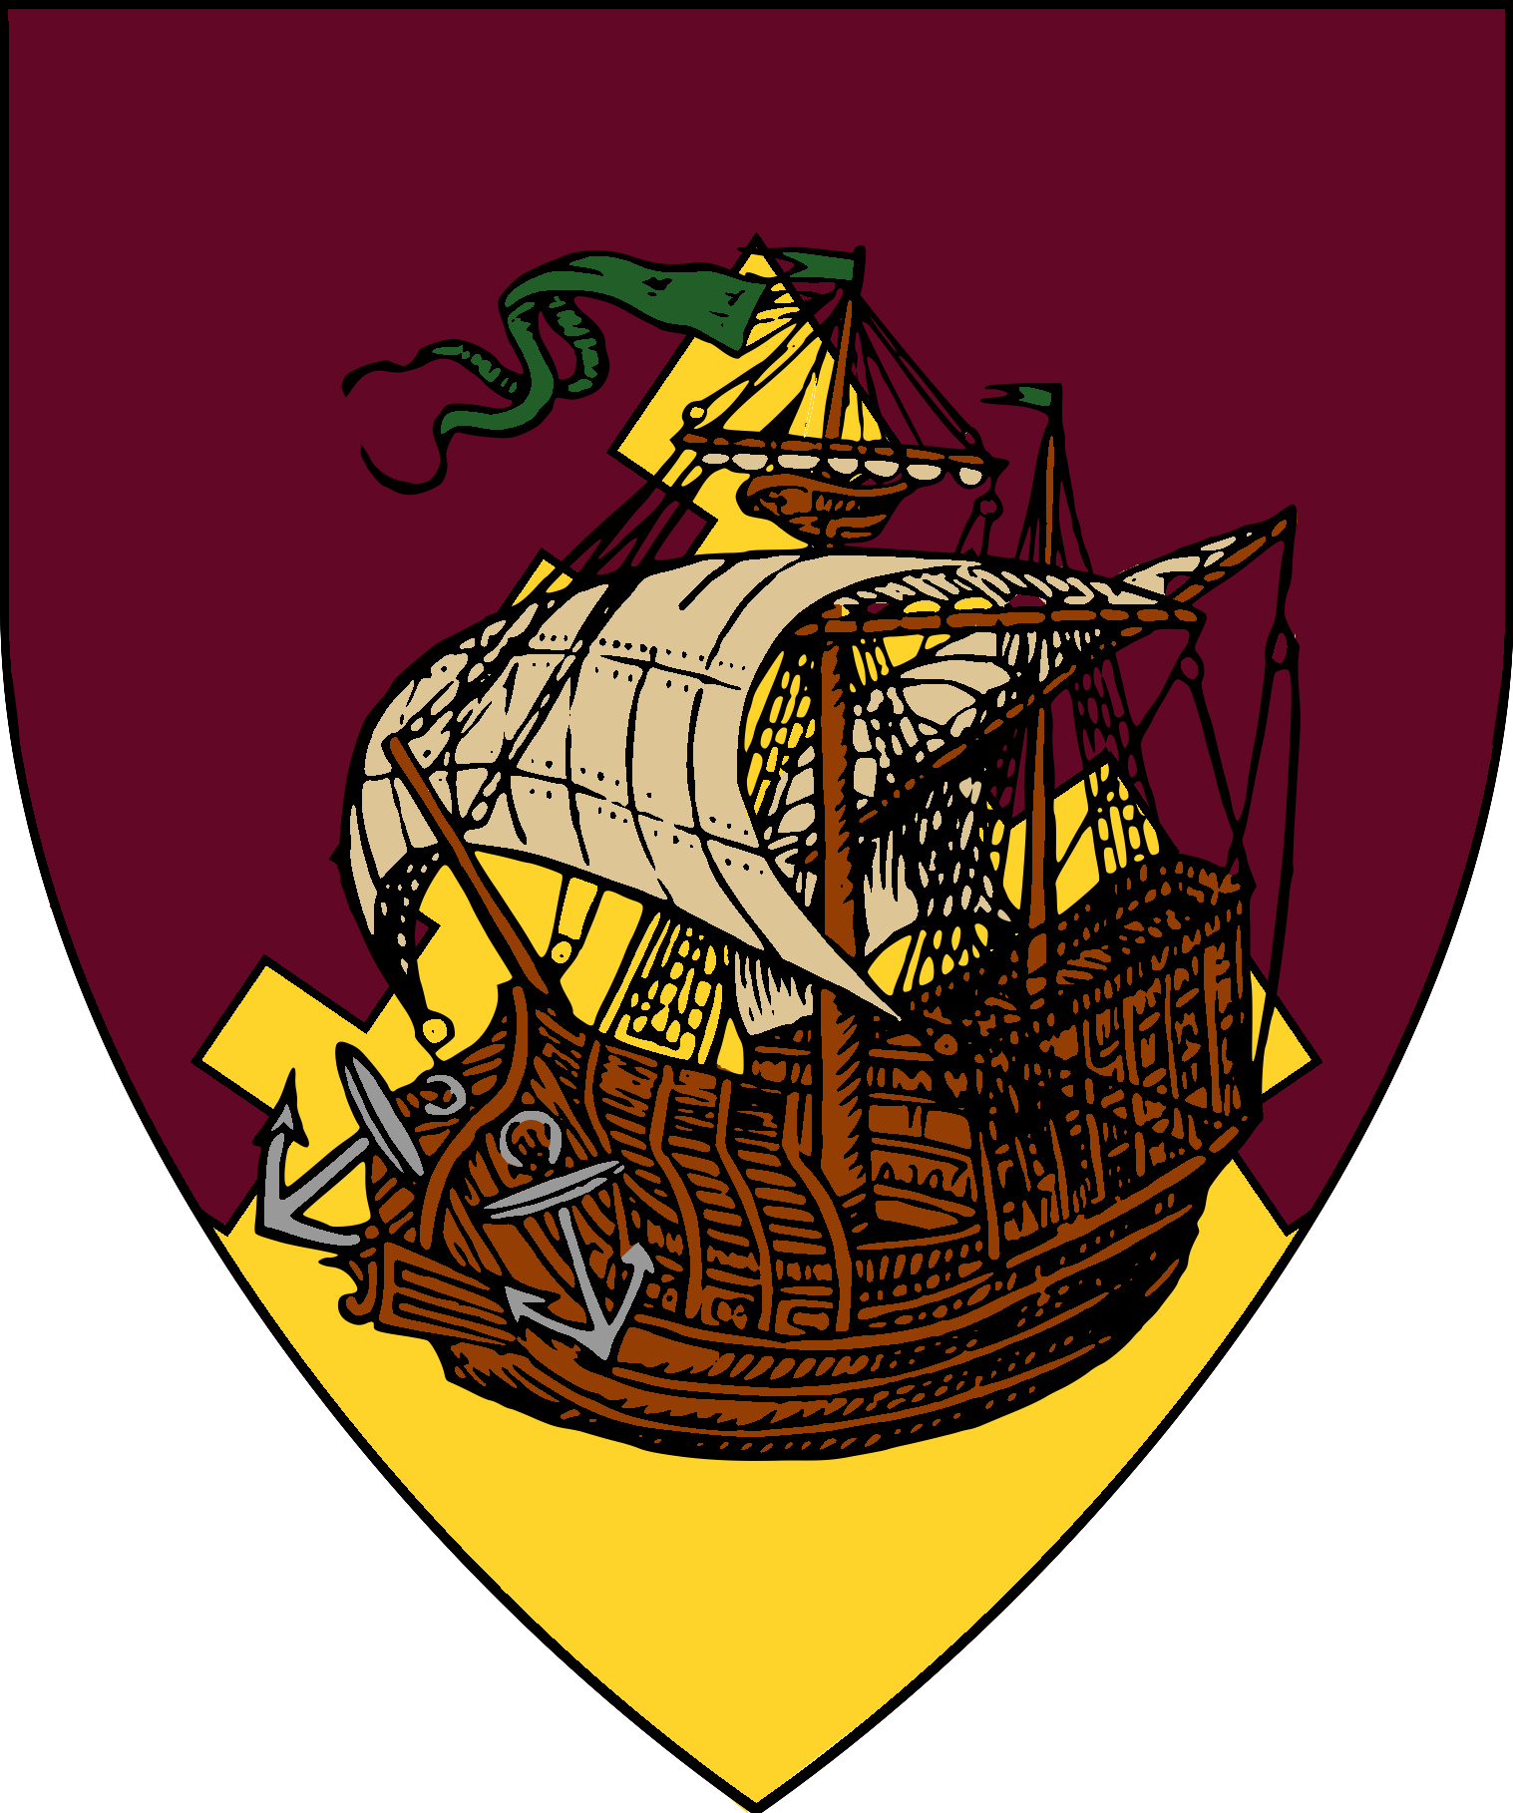 | 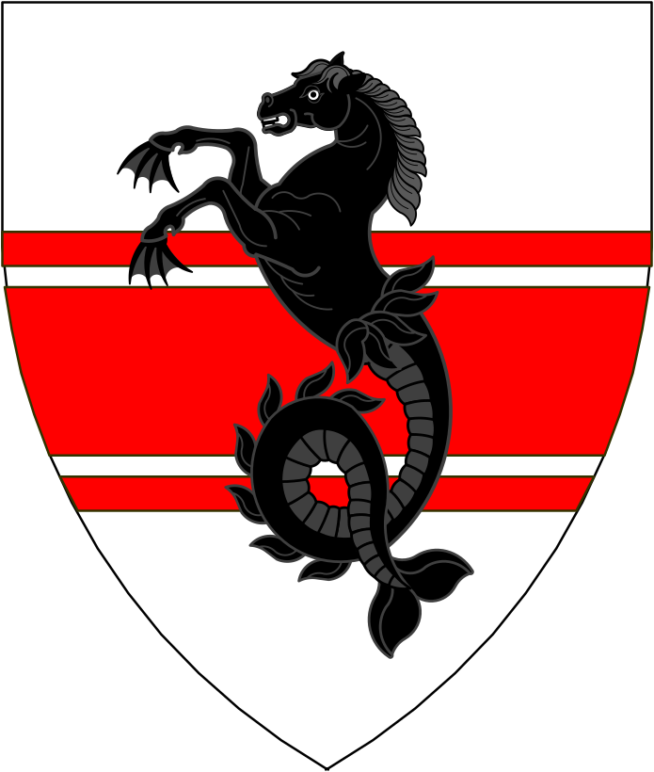 | 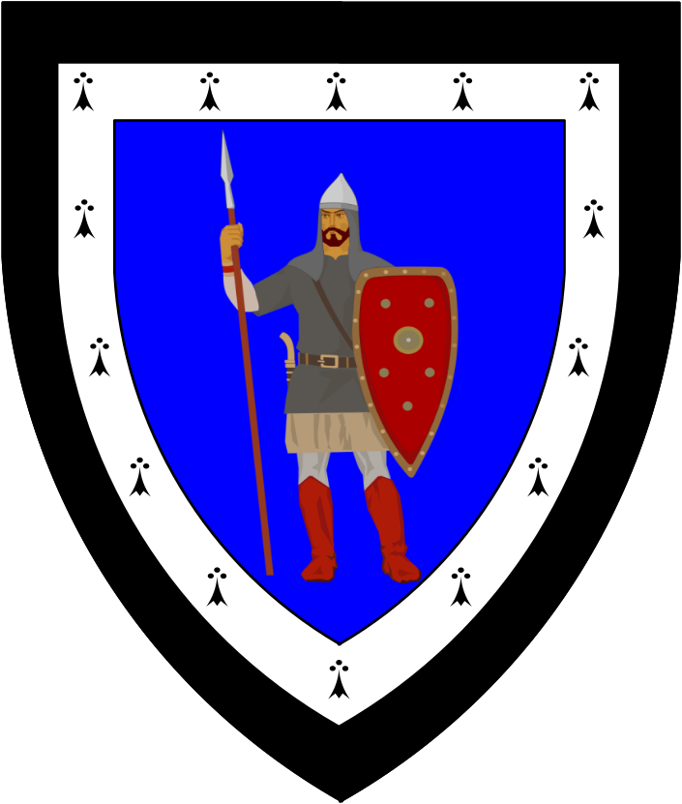 | 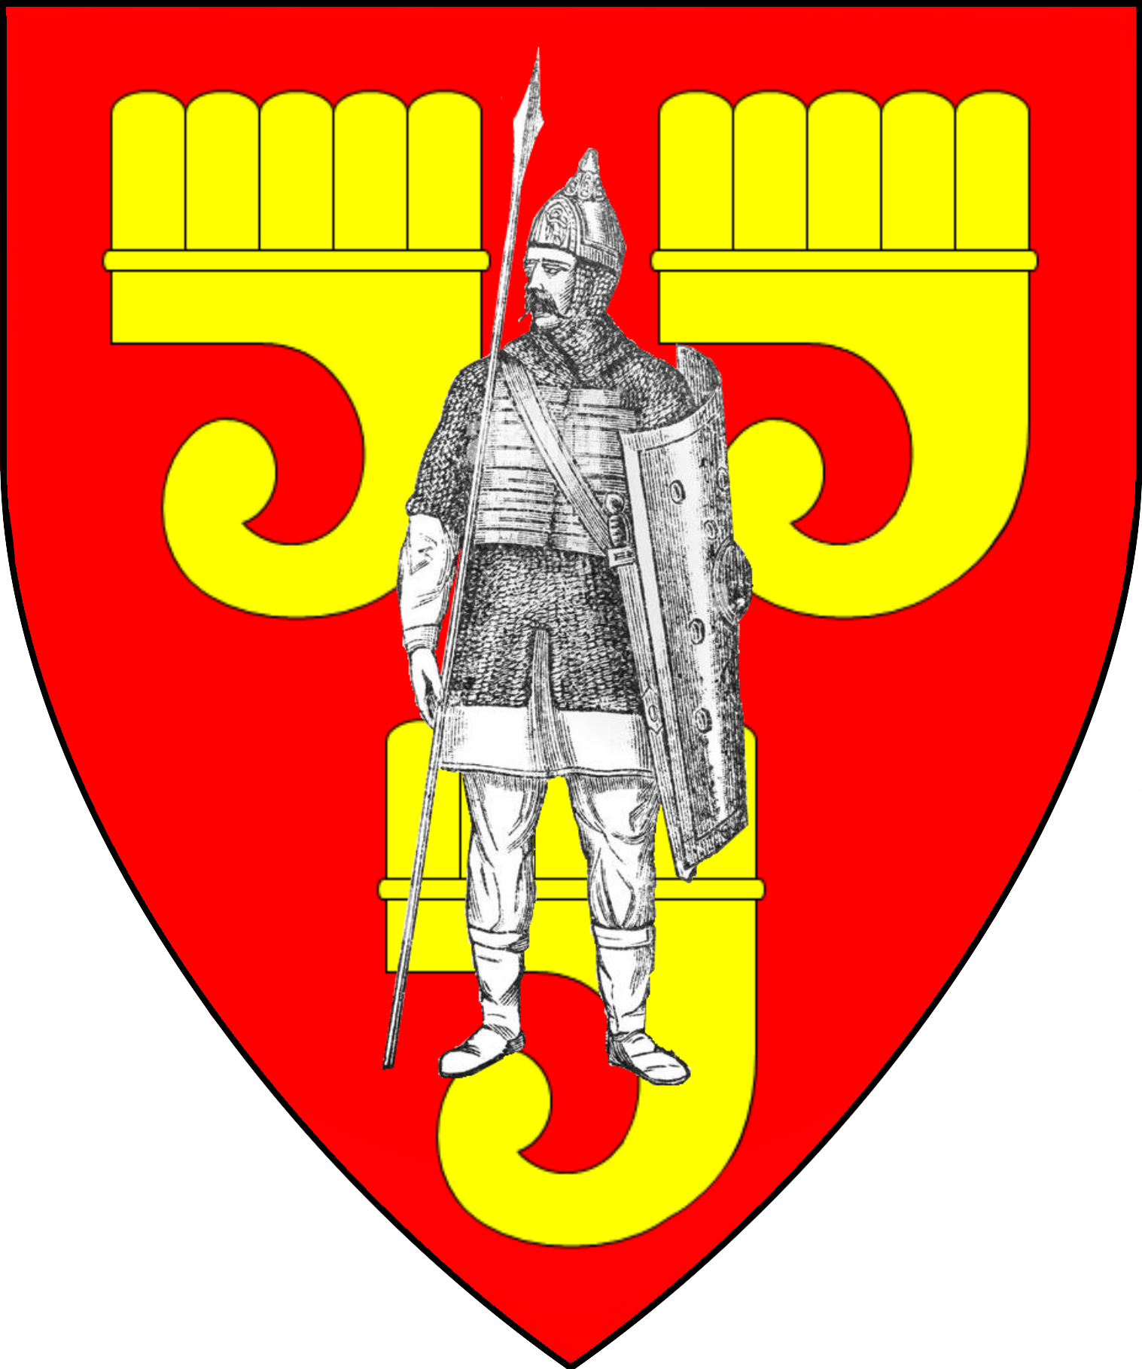

Estate of Marilenev
Lady Magda Marilenev | Lord Izák Neruda  Seneschal of Marilenev
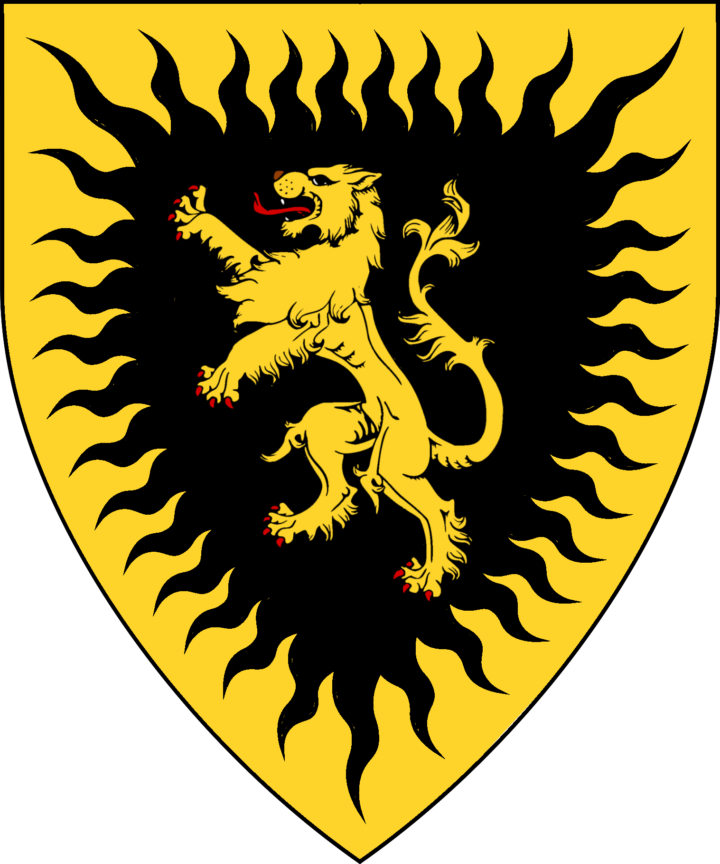 | 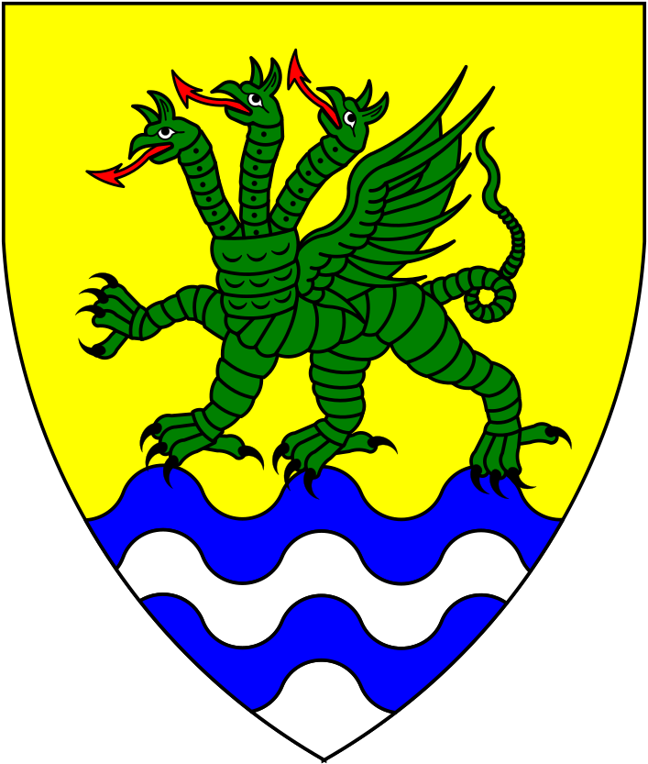
Lord Ignác Dargova  Lord of Arkoi | Lady Yrena Herebor  Lady of Herebor Wood | Lord Marcel Hyraksos  Lord of Cellun | Lady Tereska Sadek  Lady of Prama
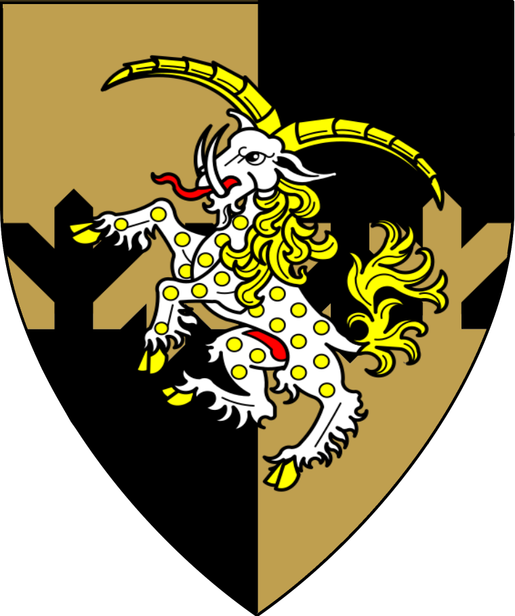 | 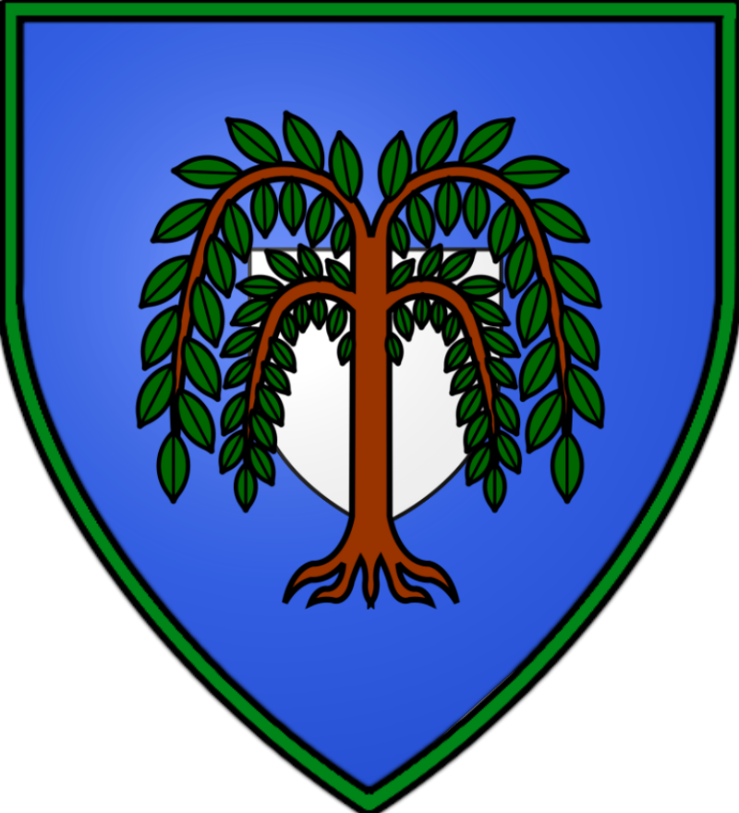 | 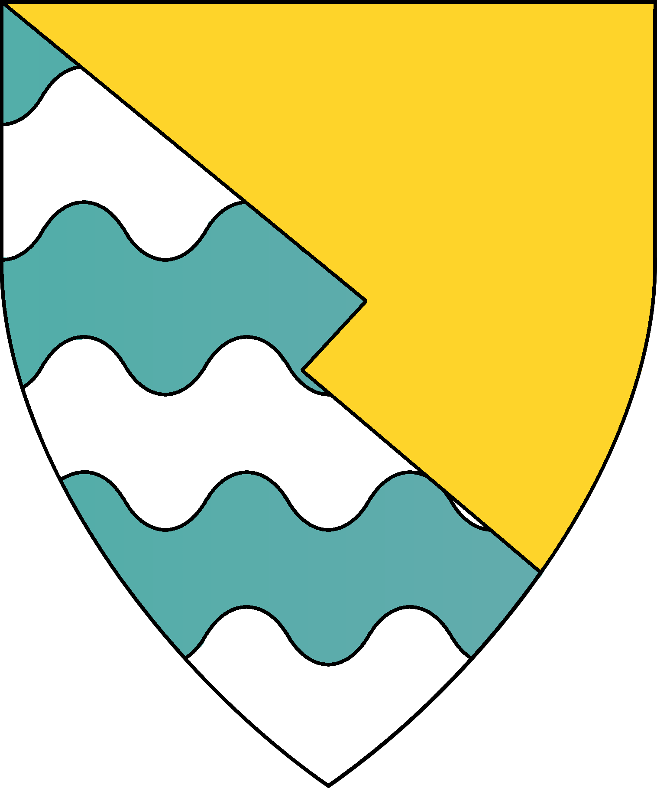 | 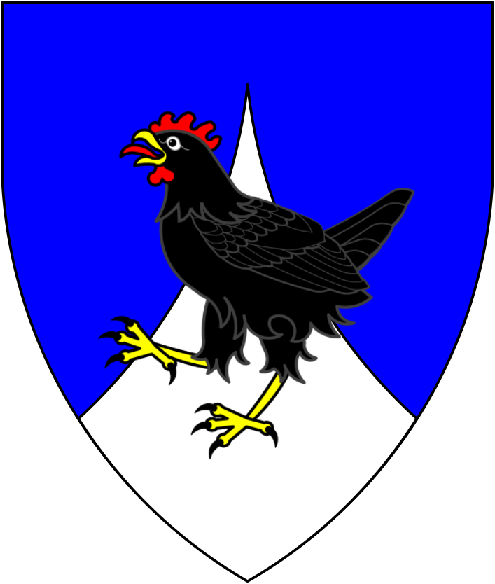

Estate of Rugalov
Lord Vlas Lutescu
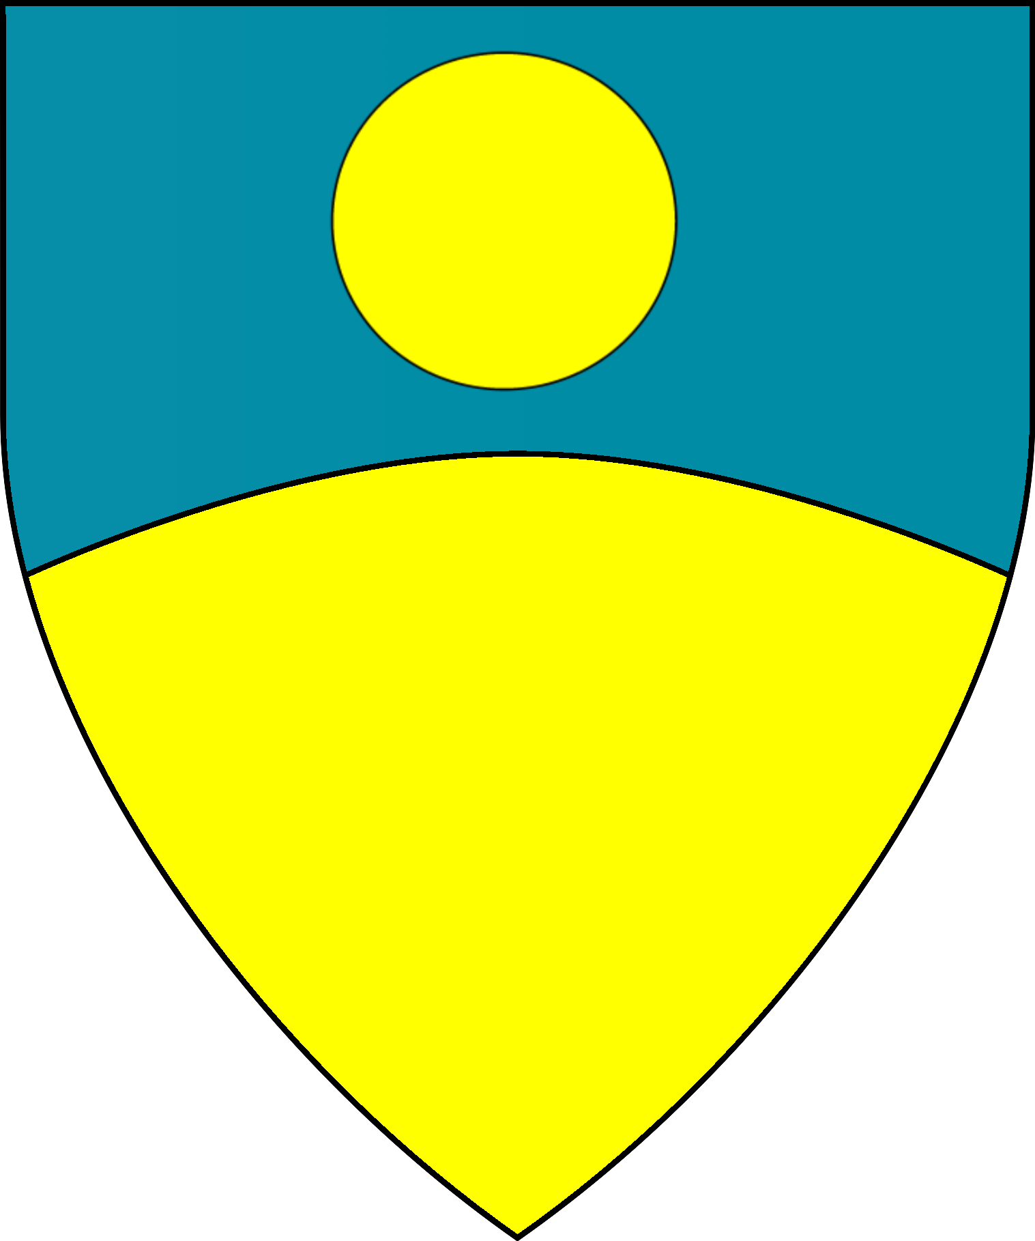
Lord/Lady? of Coltian | Lord/Lady? of Kondrien | Lord Balázs Žáček  Lord of Verrau
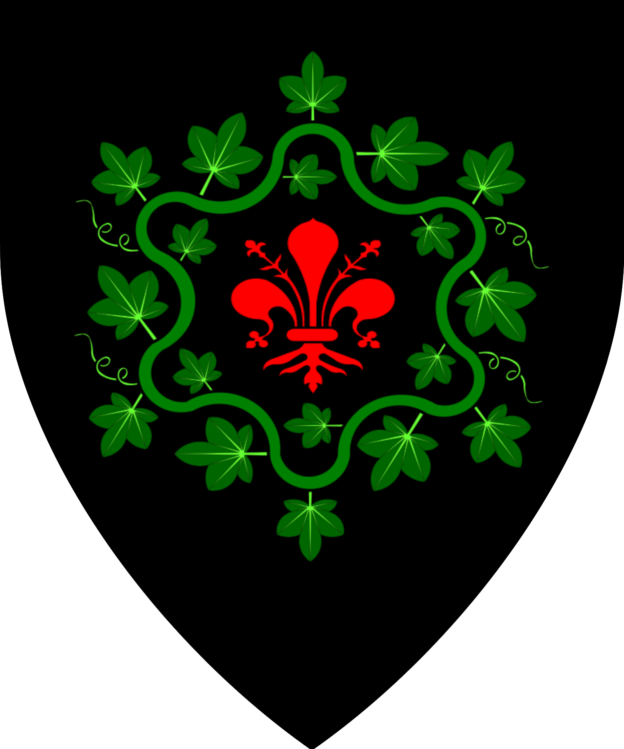 | 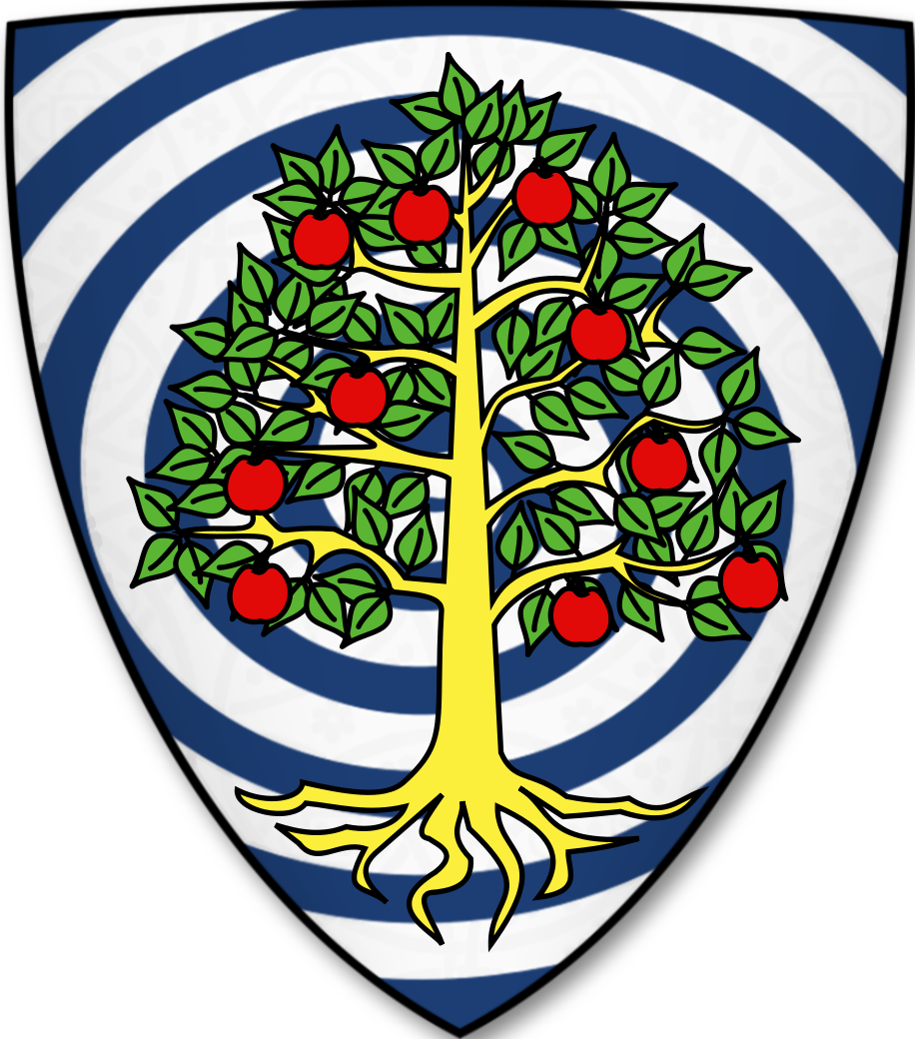 | 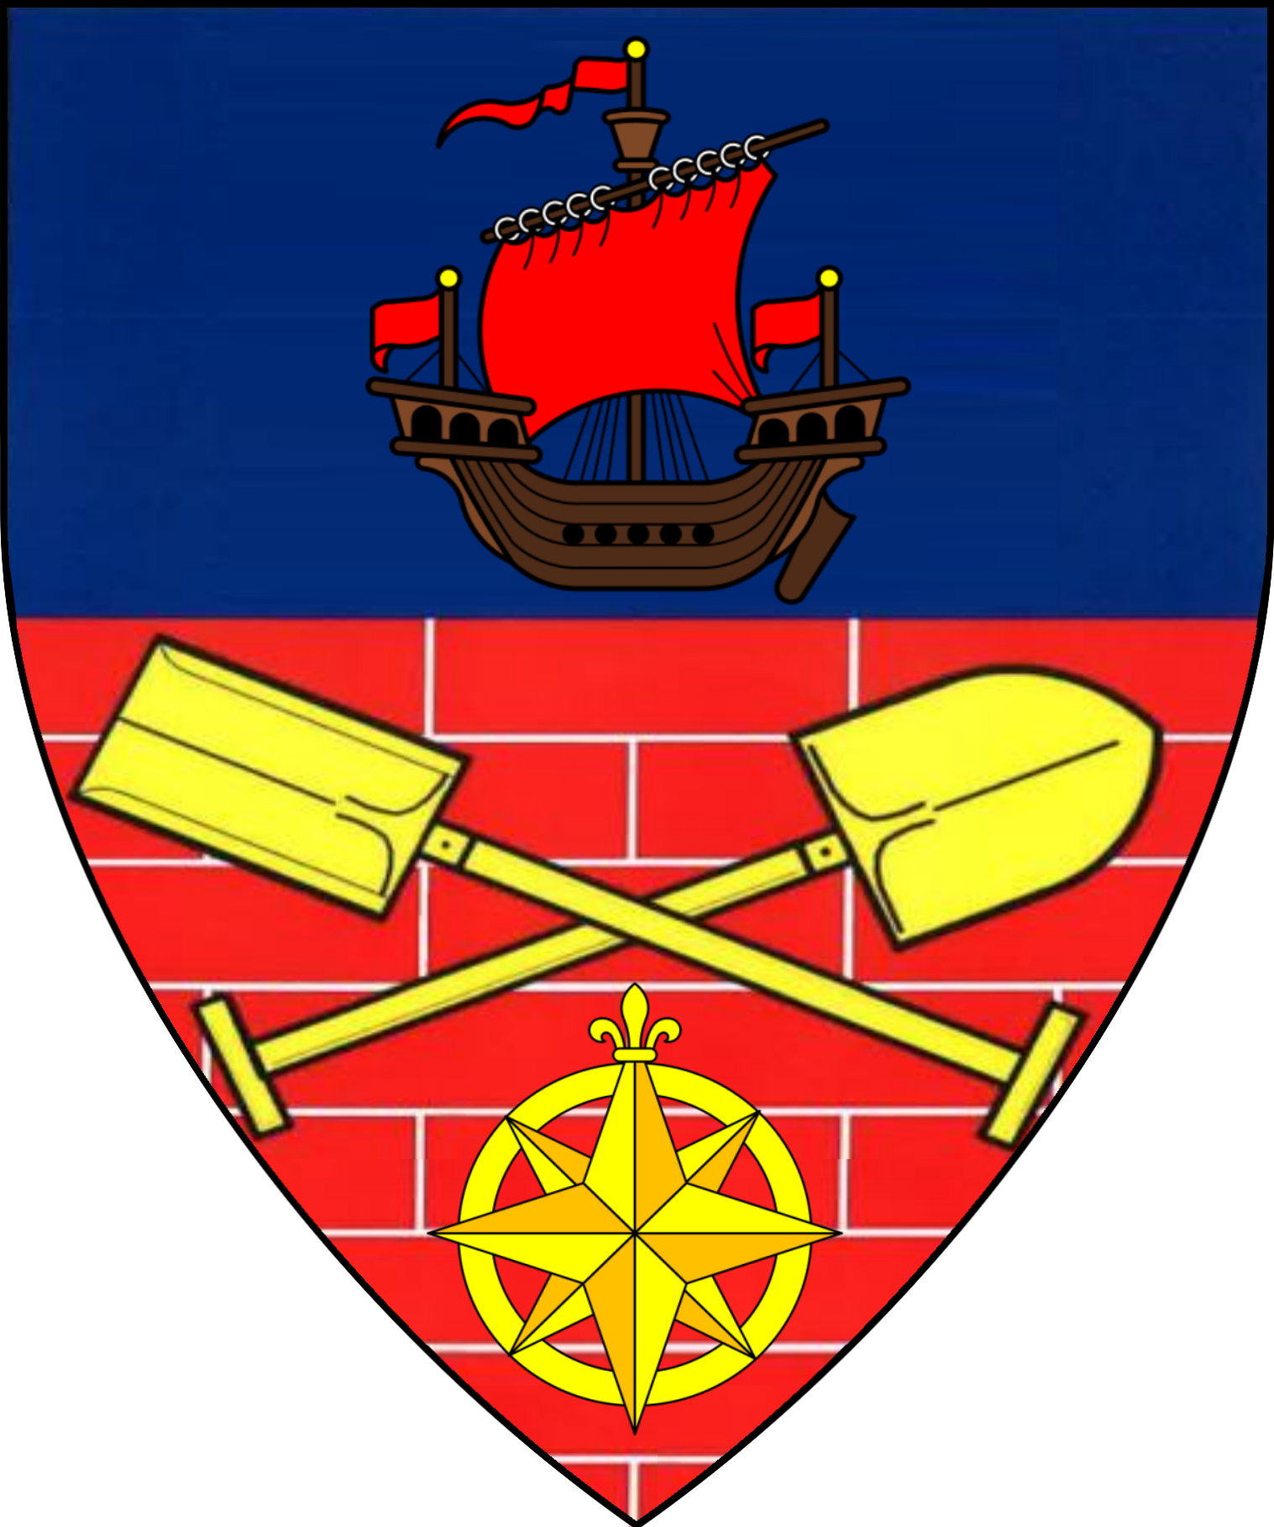

Estate of Sulescu
Lord Zemiros Sulescu |  | Lord Zemedai Sulescu  Heir of Sulescu
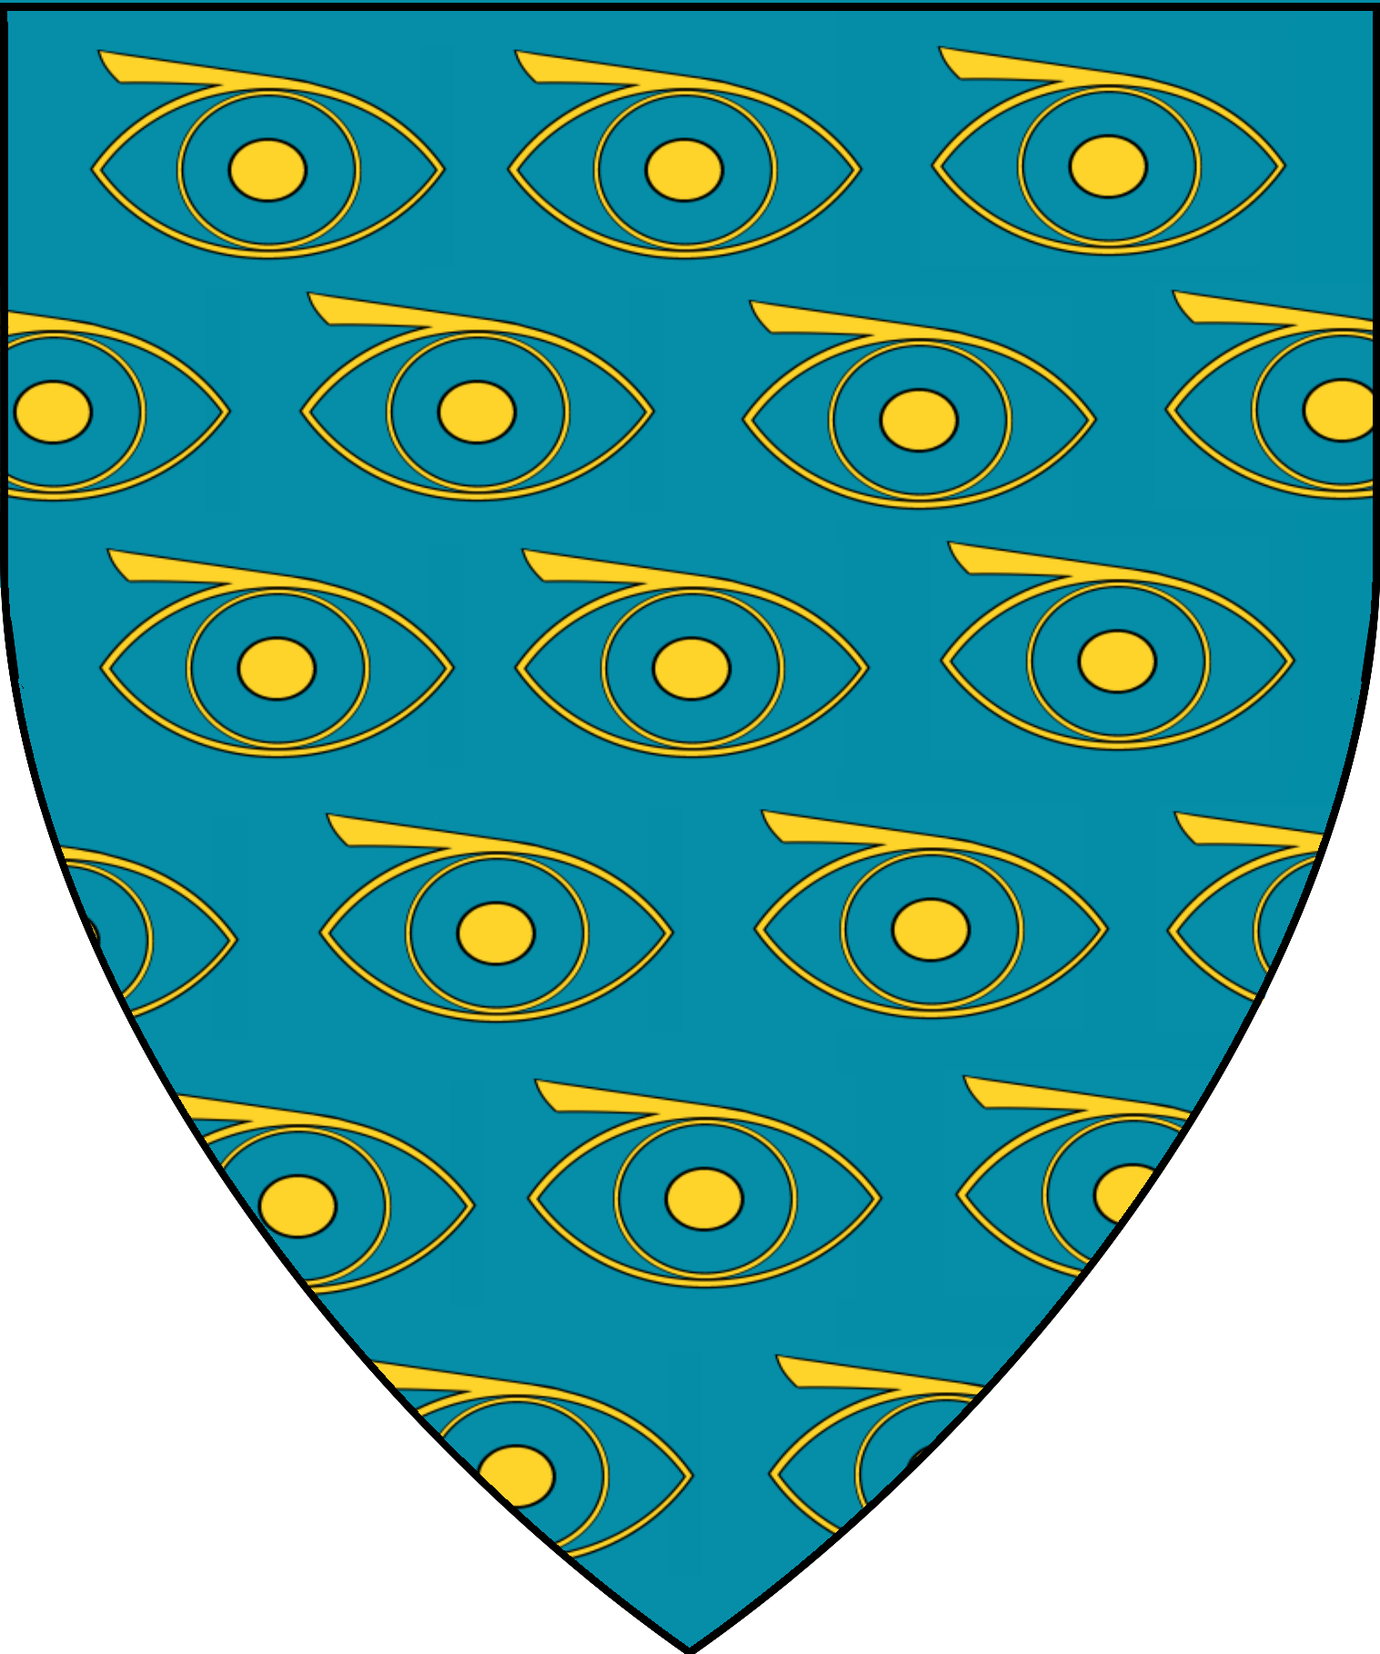 | 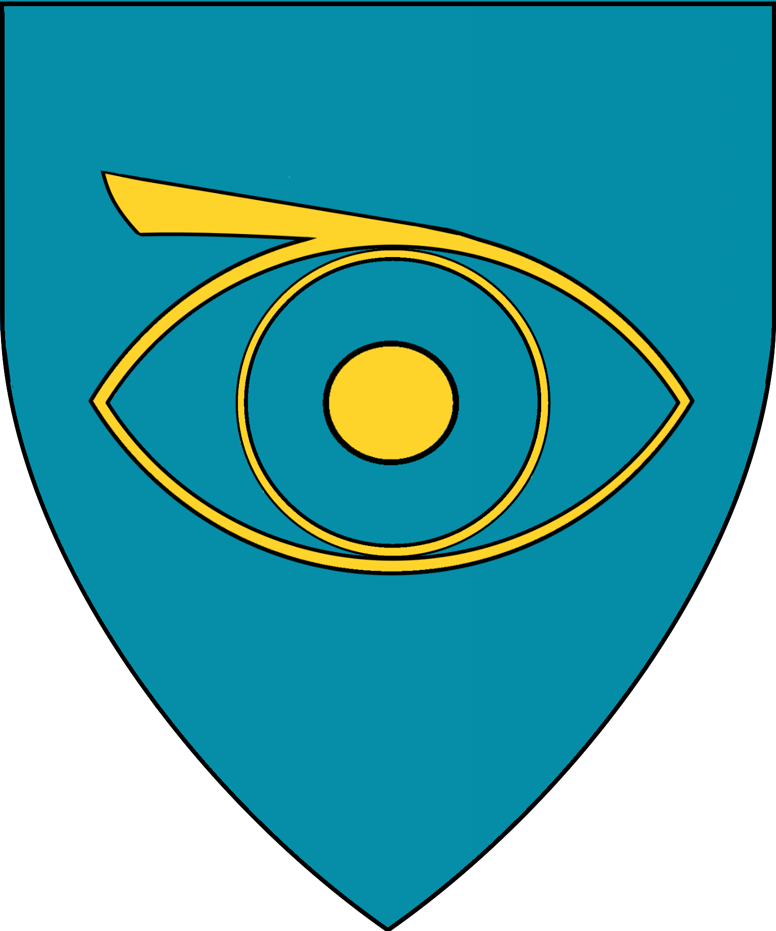 | 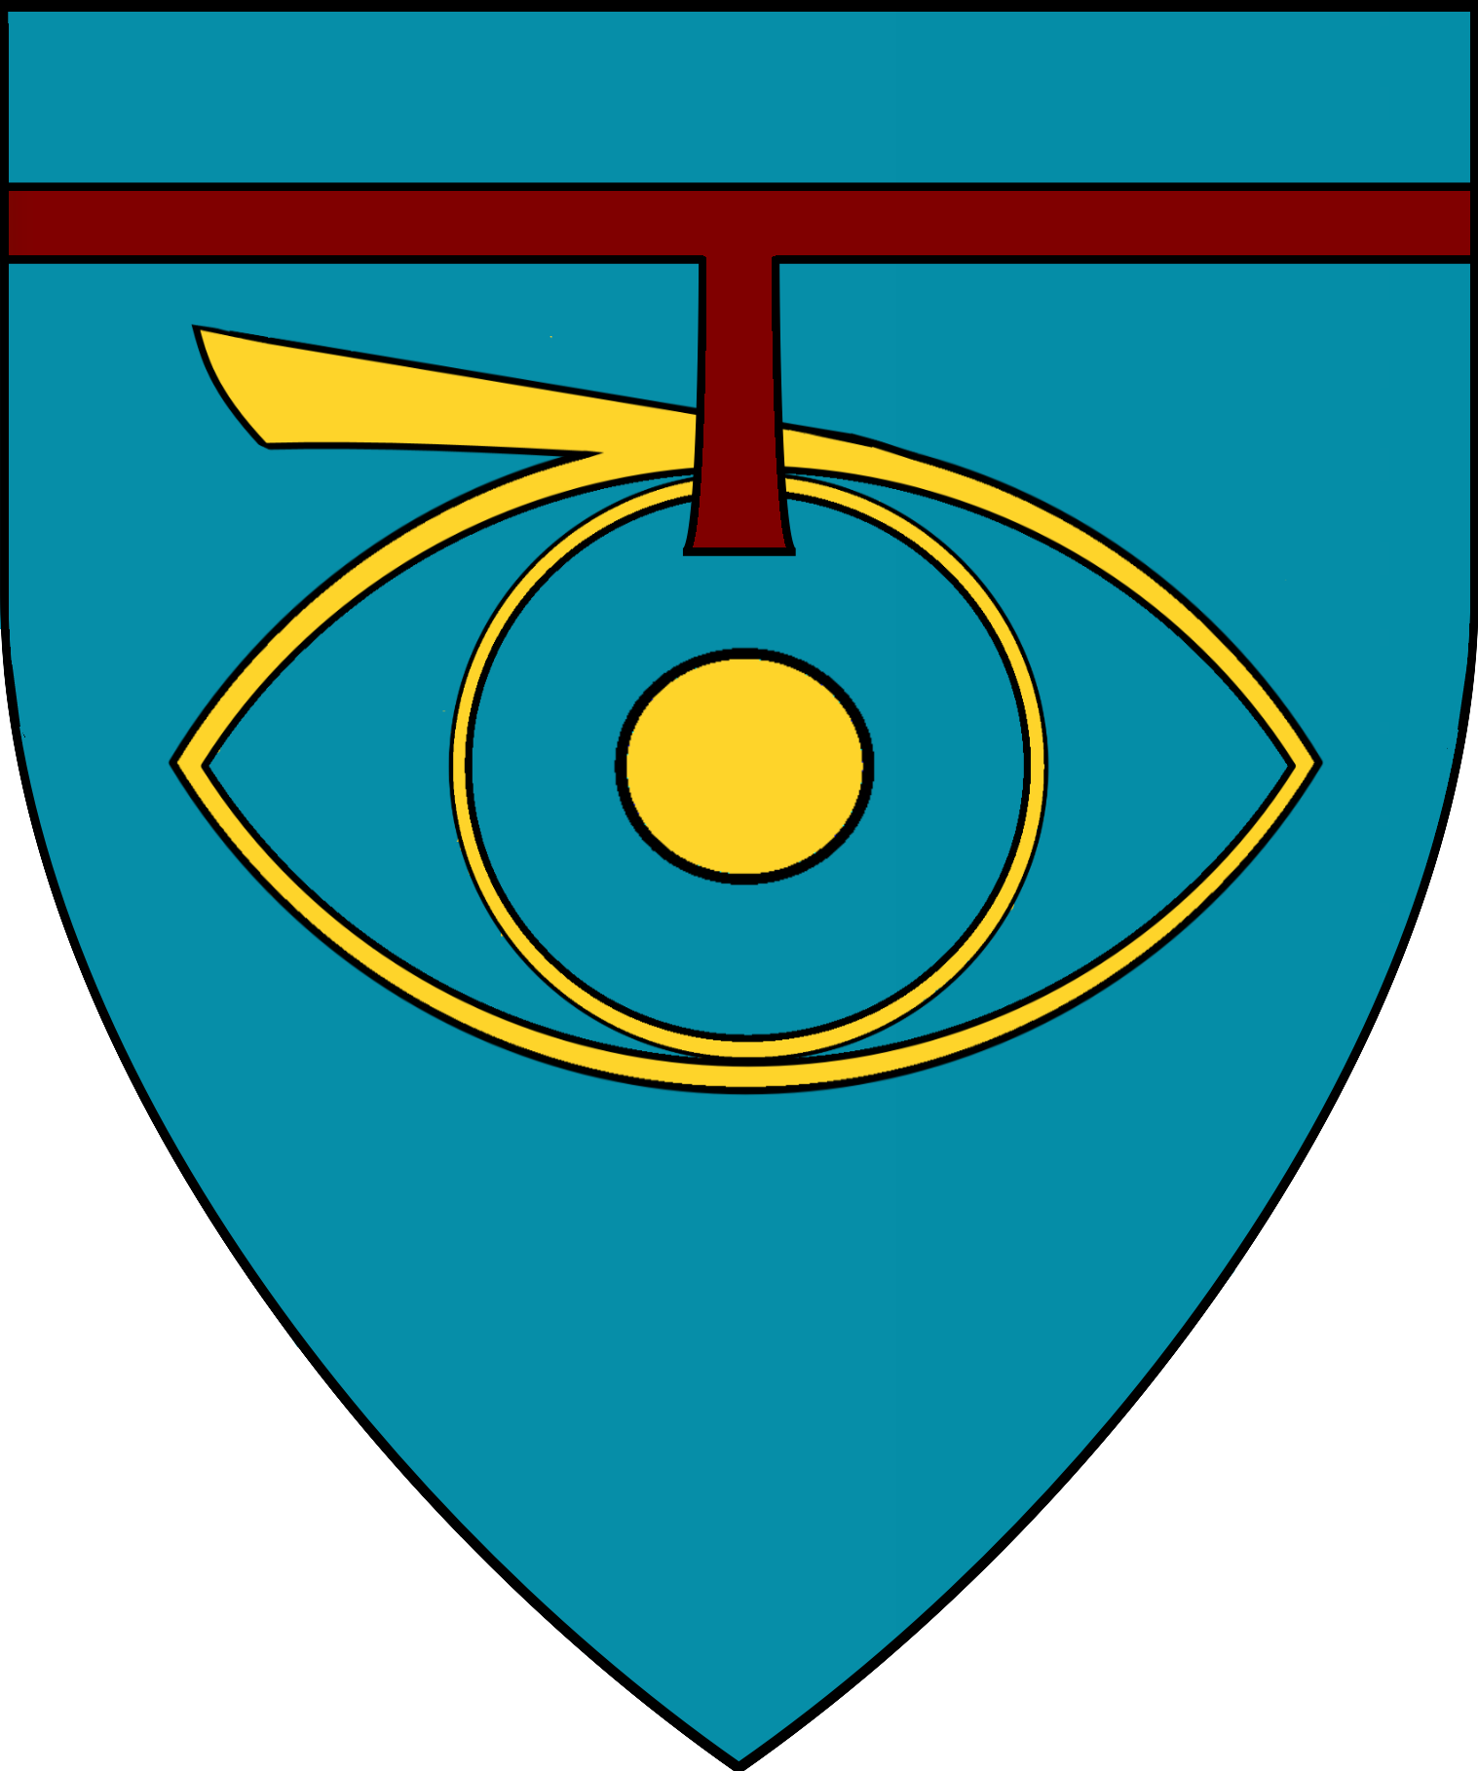
Lady of Beliu | Lord/Lady of Carmei | Lord/Lady of Darinov | Lord Vasil Ourosco  Lord of Ourosco | Lord/Lady of Vesztu
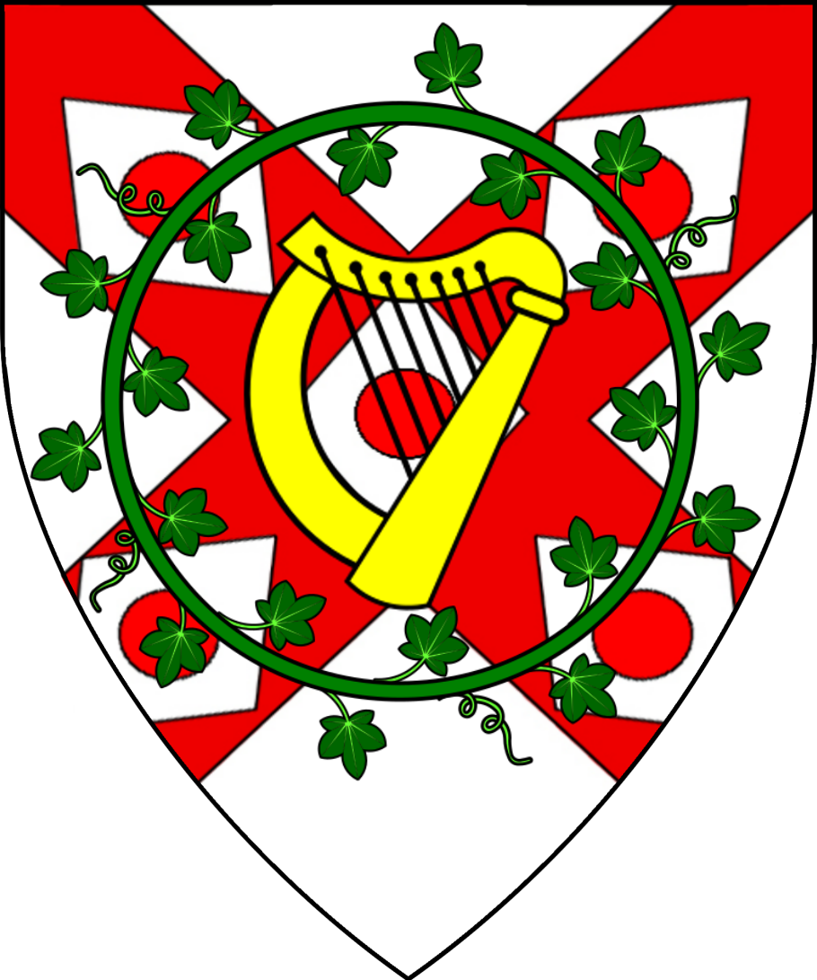 | 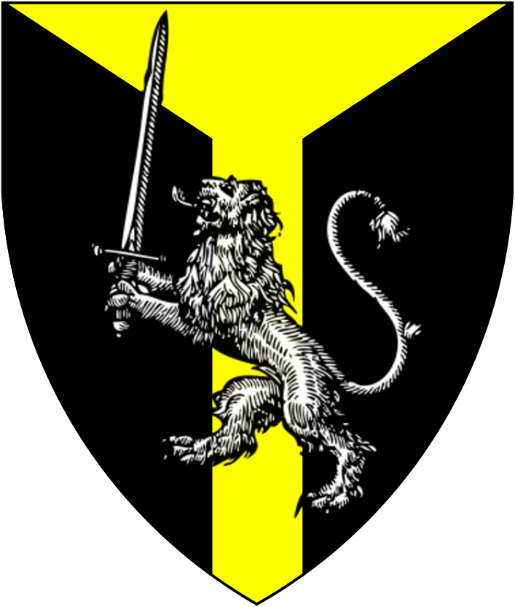 | 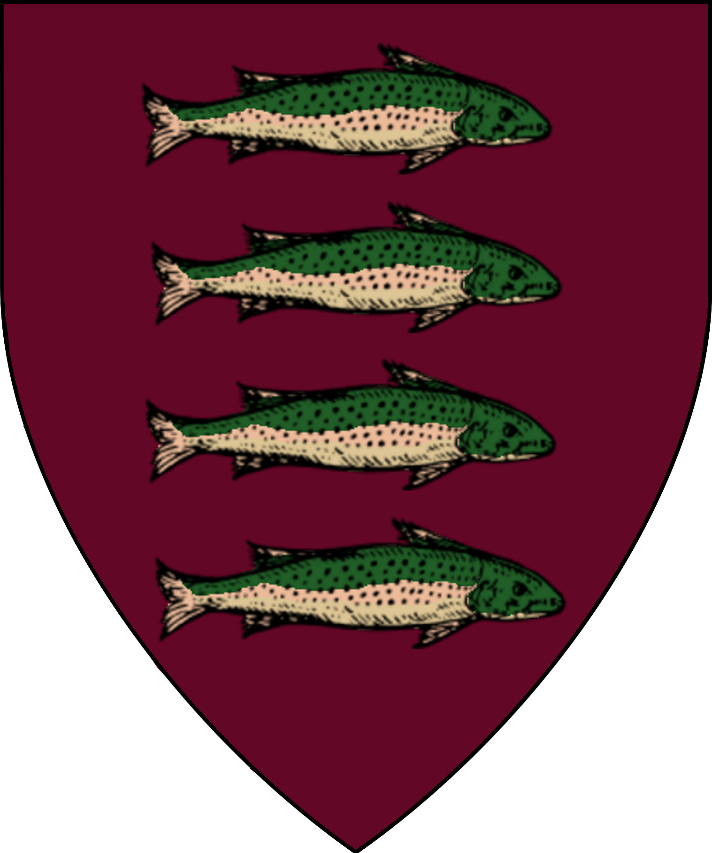 | 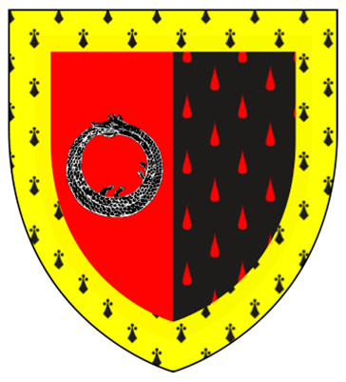 | 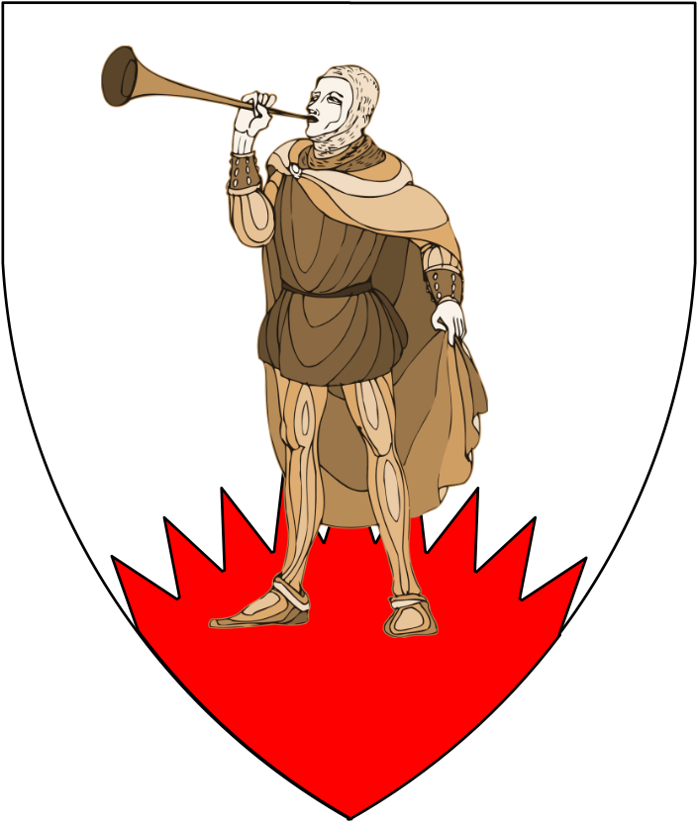

Estate of Vandevicsny |  |  | Estate of Korrigan
Lord Gustav Vandevic |  |  | Lord Alexius Korrigan
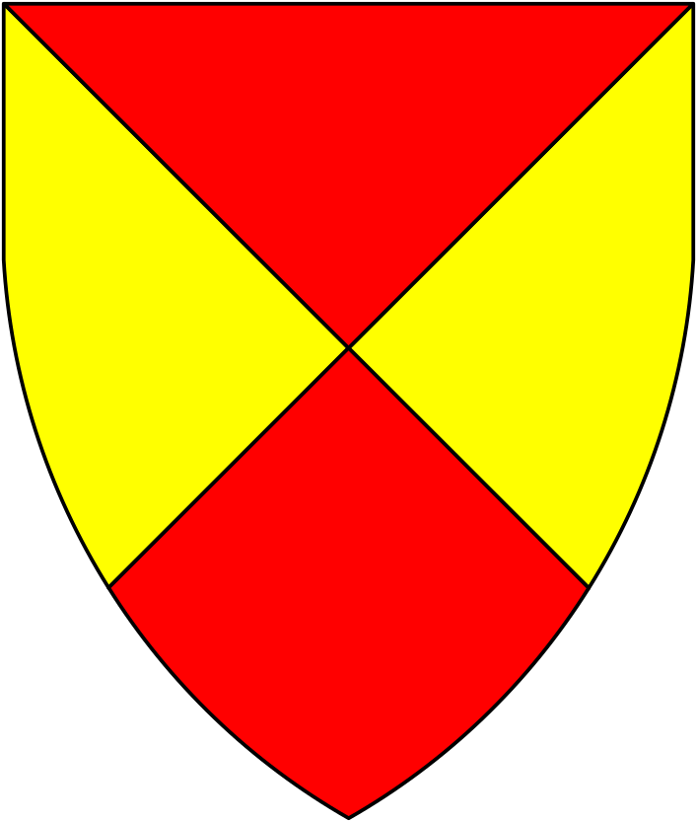 |  |  | 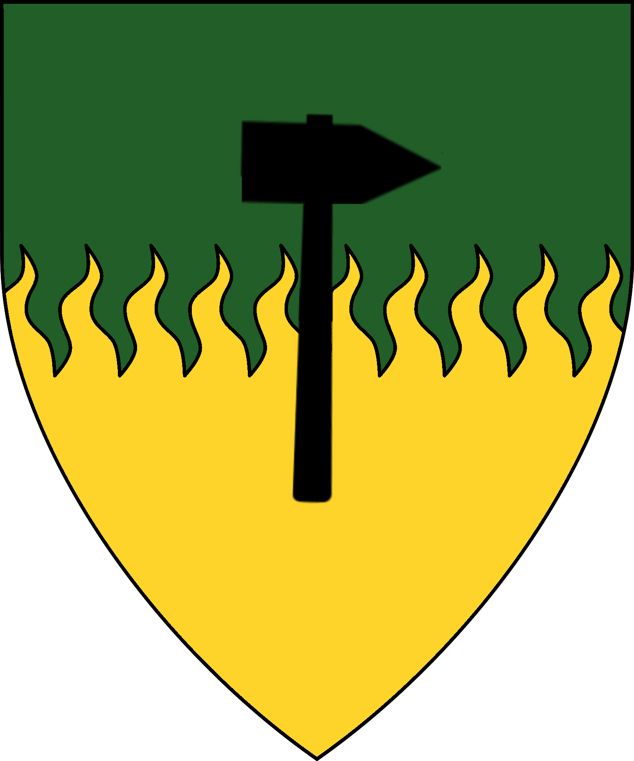

Estate of Hyraksos
Admiral Lucius Hyraksos | Sir Devon Hyraksos | Captain Sir Ulric Brezovo  Lord of Brezovo | Lady Constantina Brezovo  Heir to Brezovo
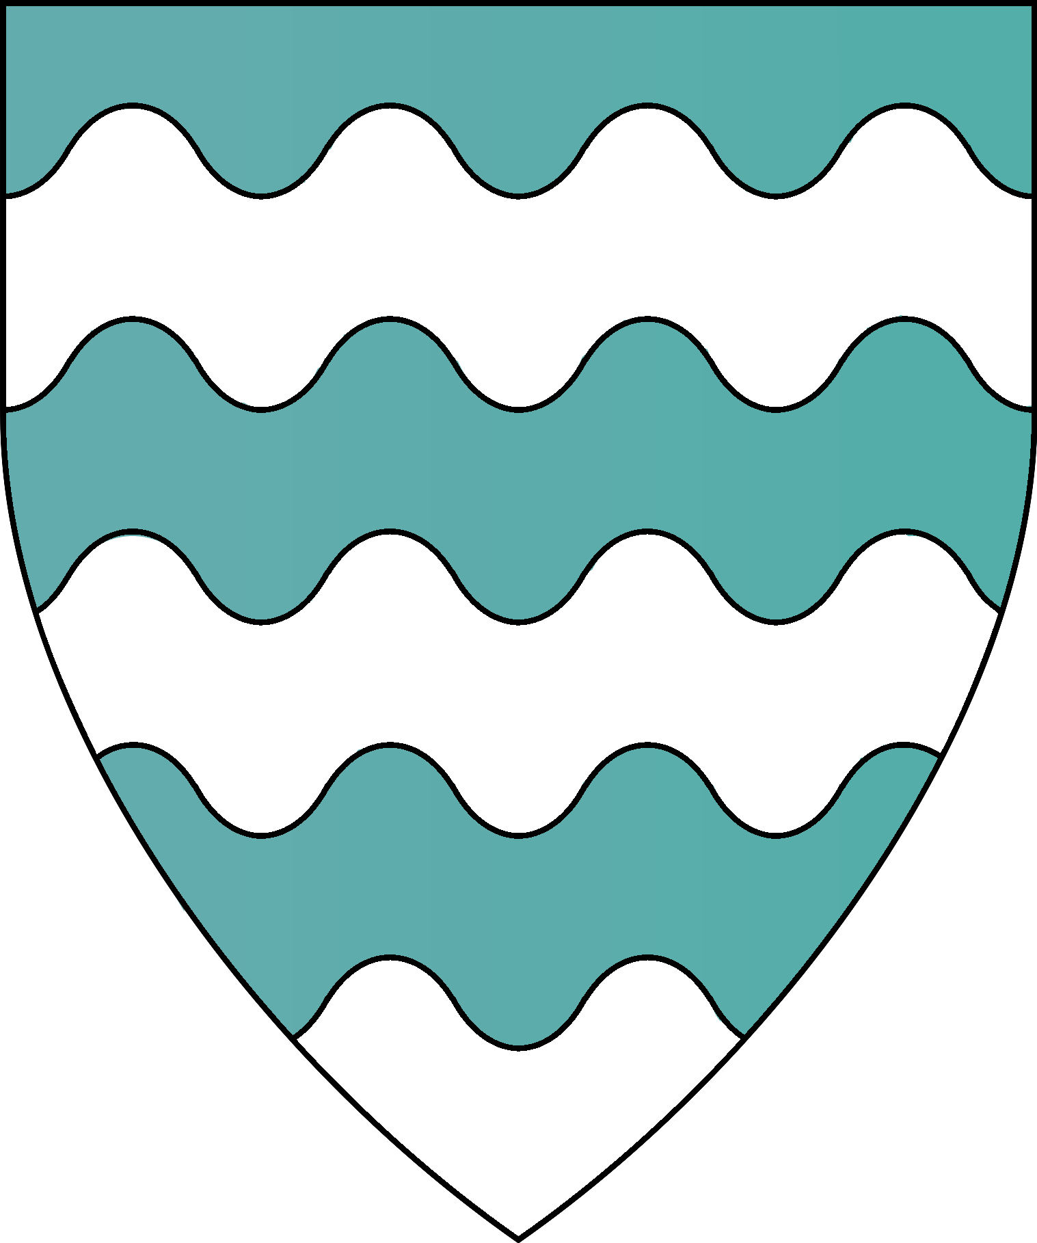 | 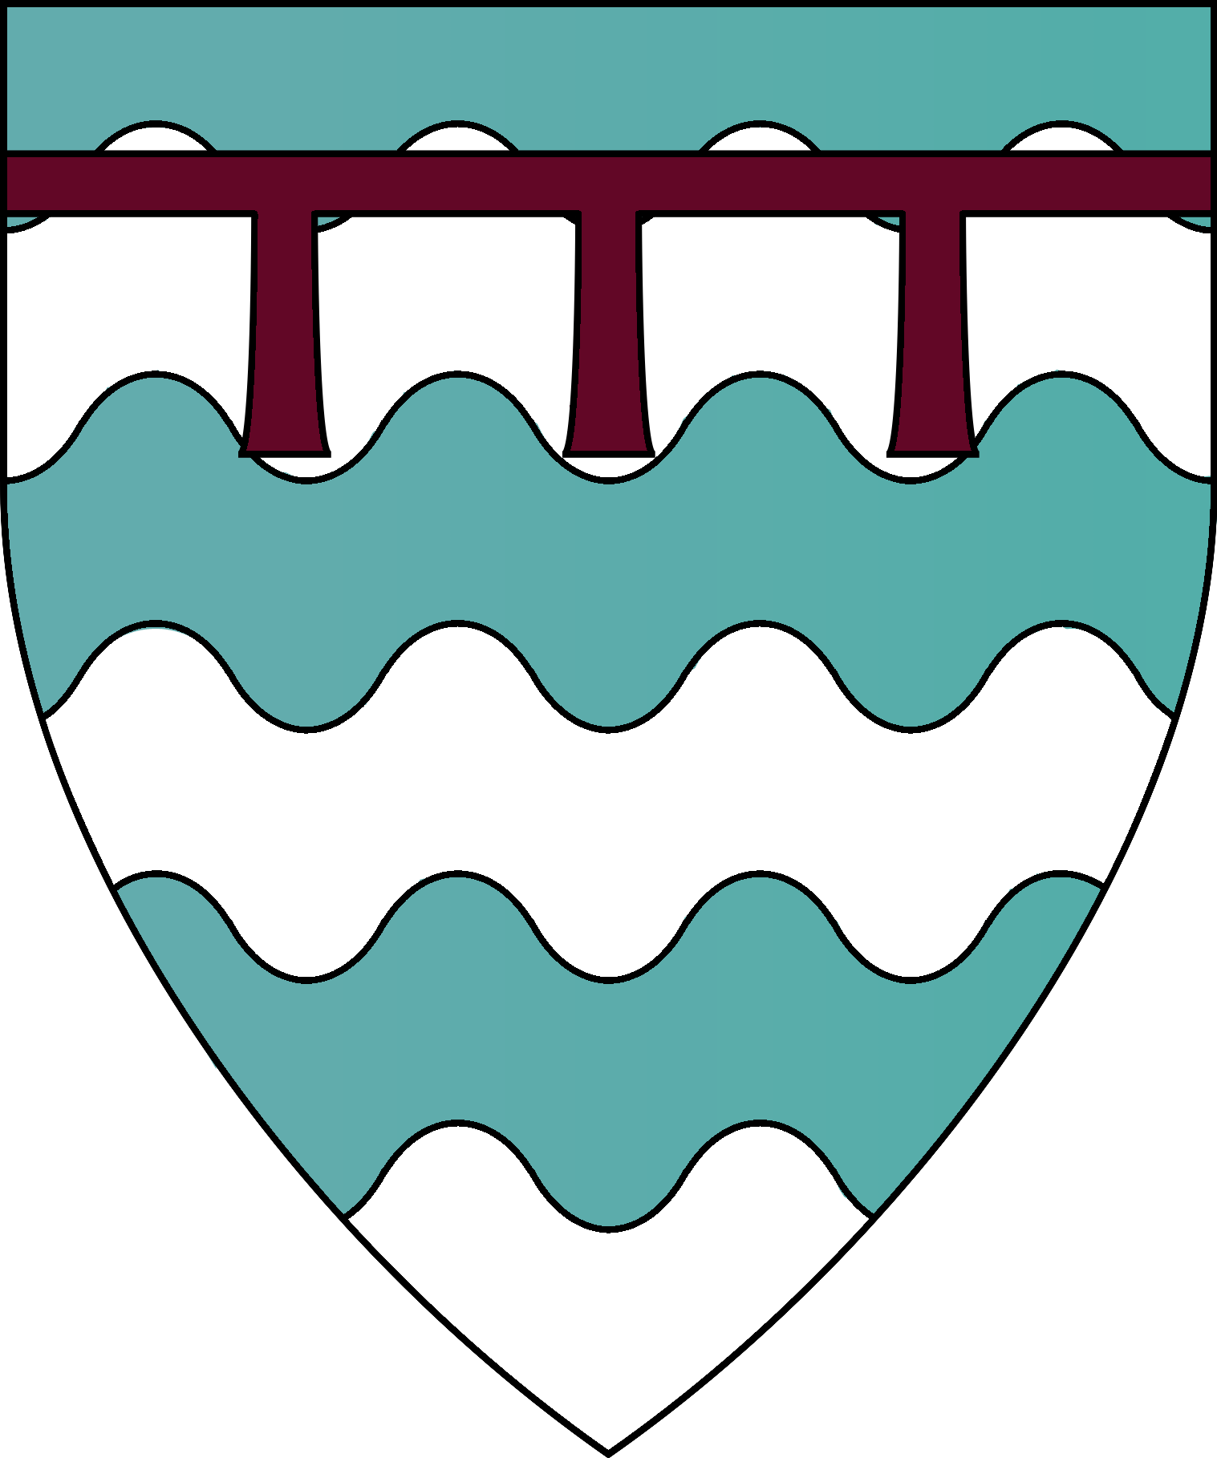 | 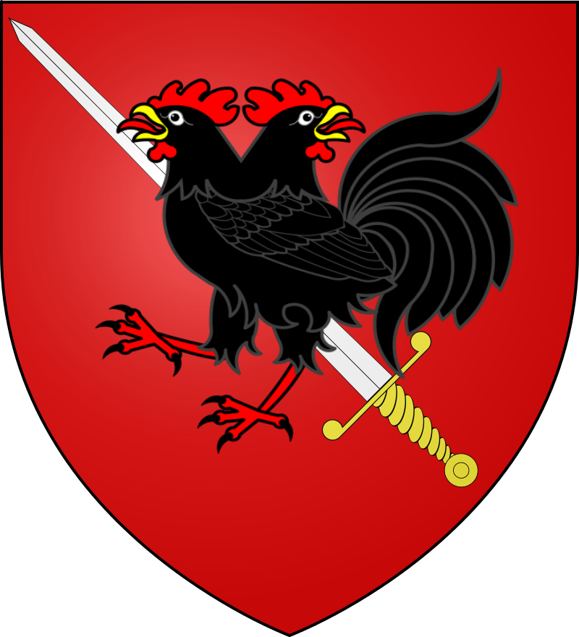 | 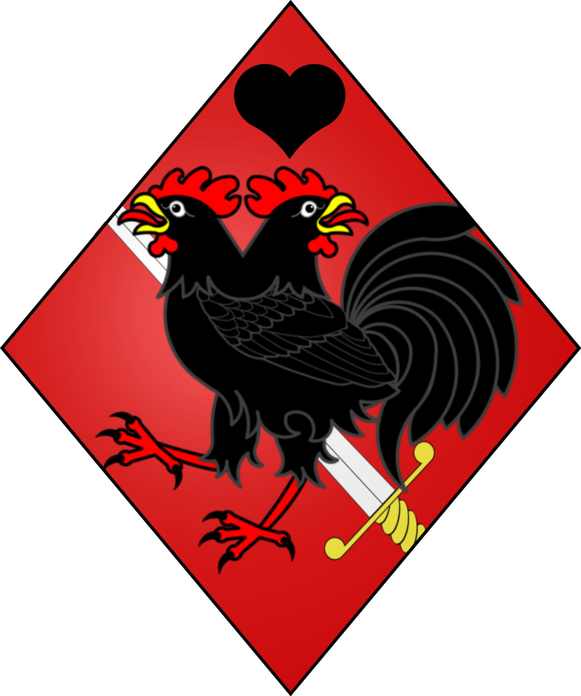

Estate of Torenescu
Lord Aleksandr Torenescu | Lord Nichola Torenescu  Lord Seneschal of the Estate of Torenescu
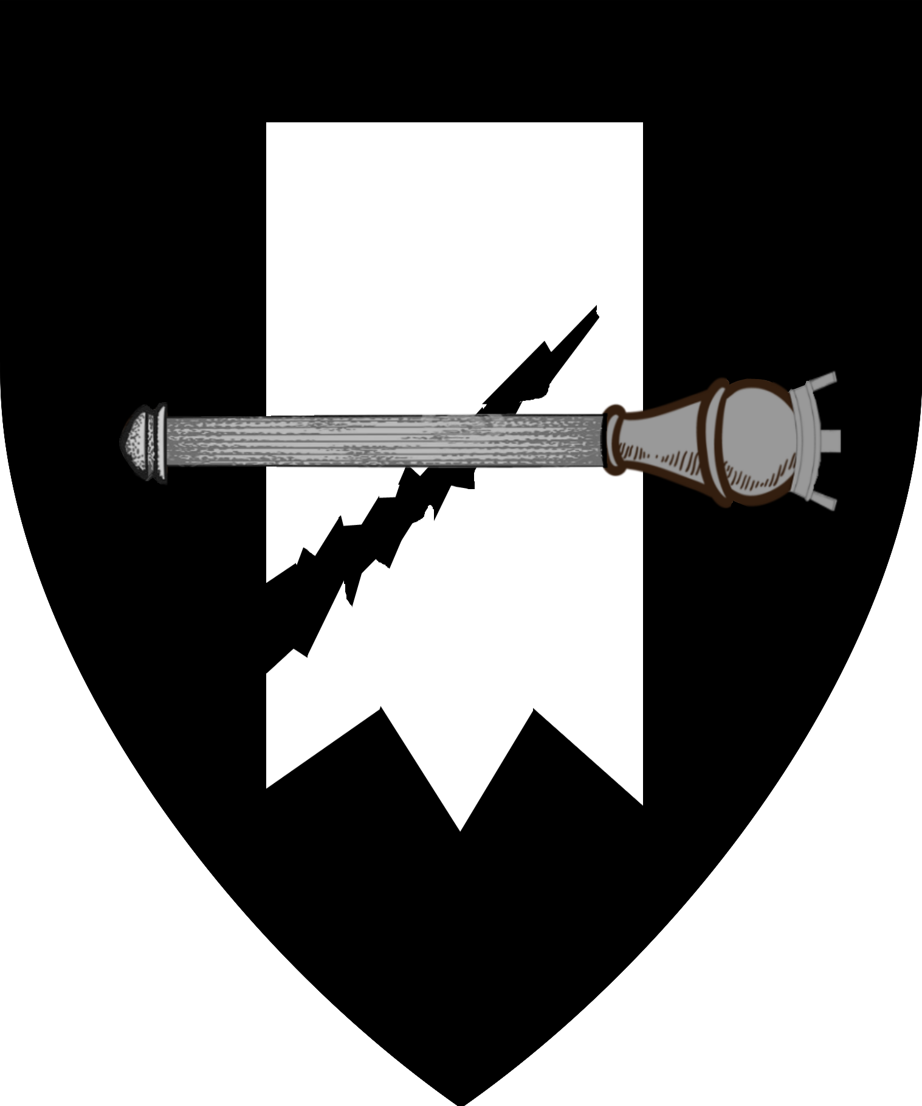 | 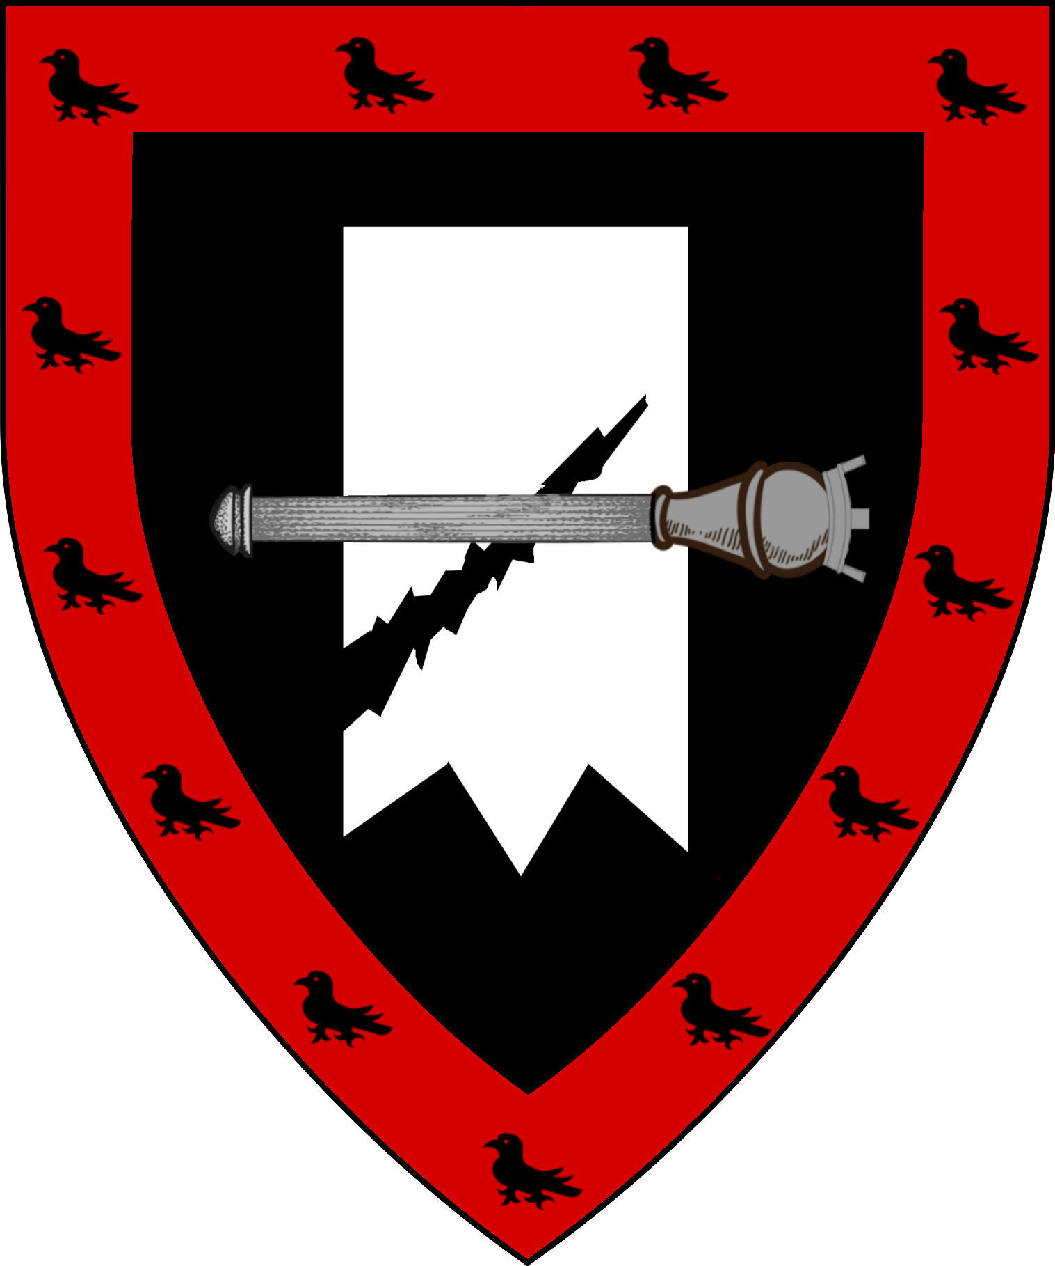
Lord Boris Torenescu  Lord of Yuschief | Lord ?  Lord of Passum | Lady ?  Lady of Shadow
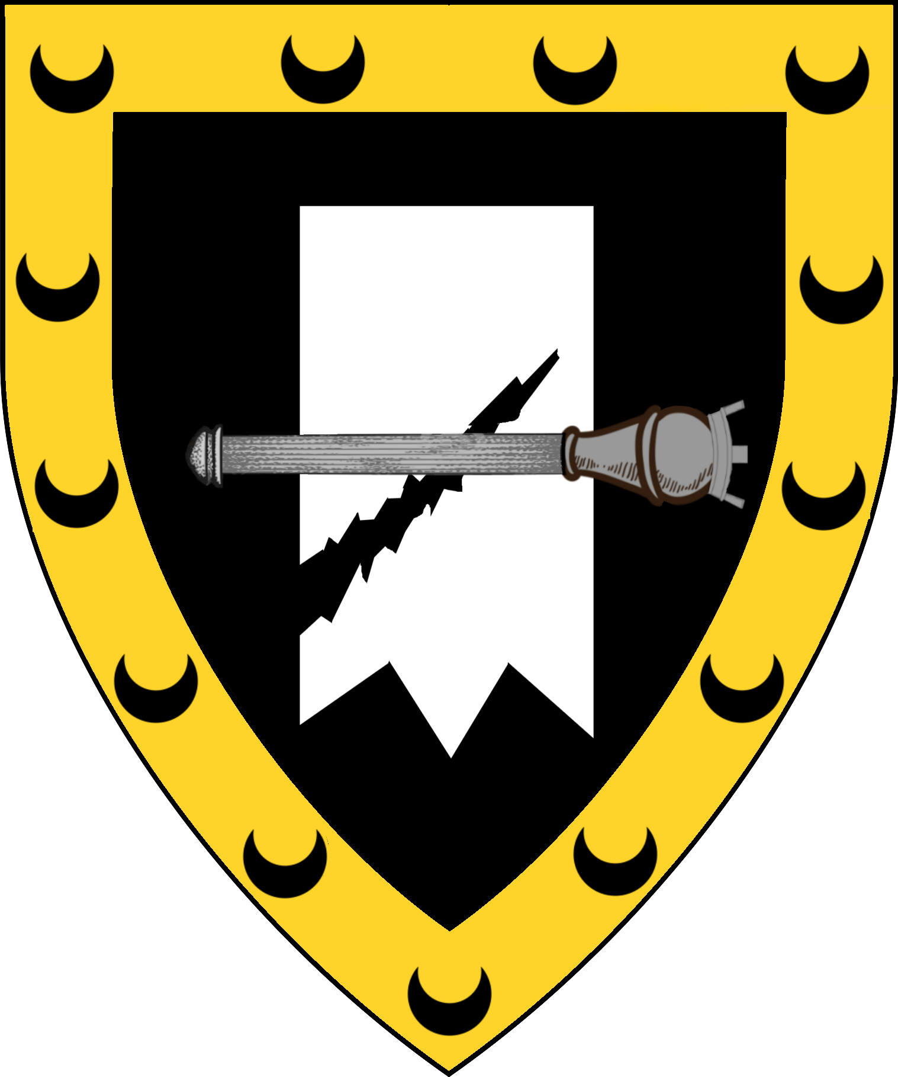 | 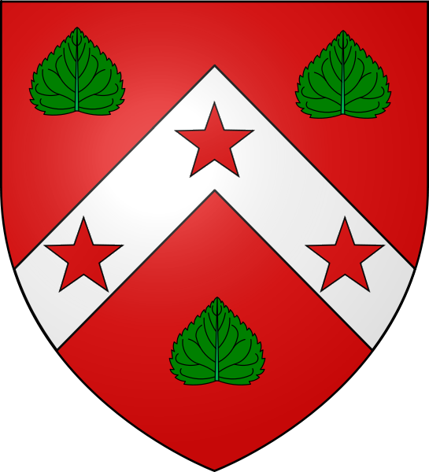 | 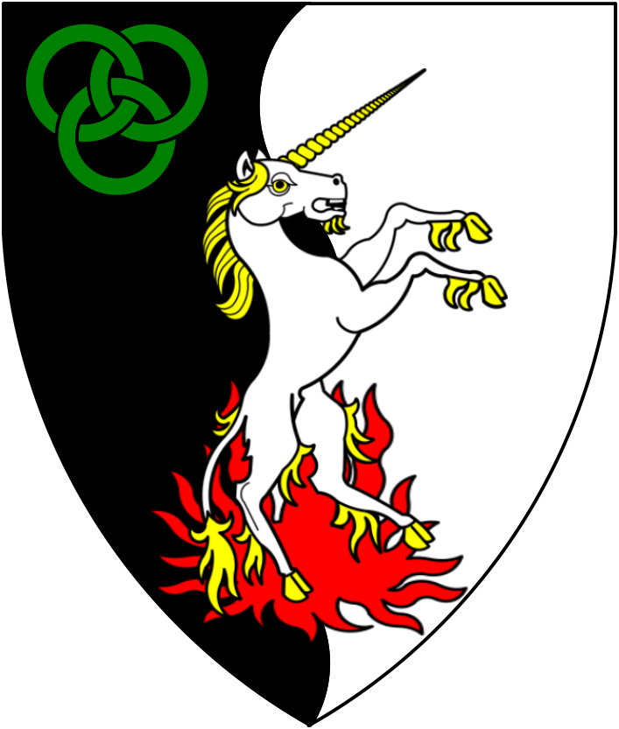

Estate of Locrida | Estate of Strolojca | Estate of Cordelius | Estate of Walerian | Estate of Thrakius
Lord Leoniel Retebius | Lord Marius Steolojca | Lord Bartran Cordelis | Lord Publius Walerian | Lord Marius Thrakius
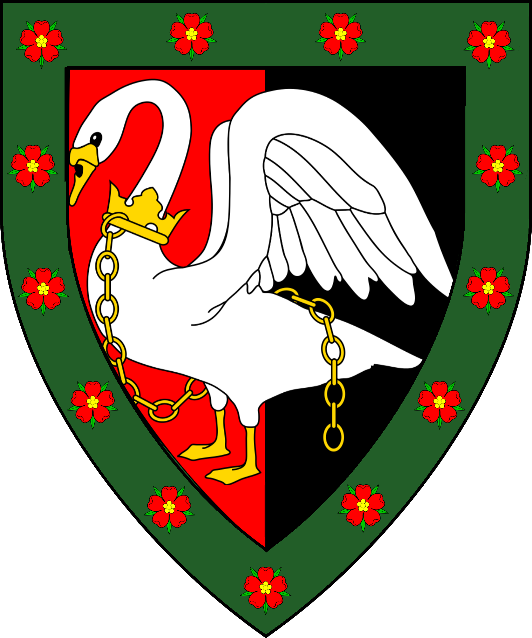 | 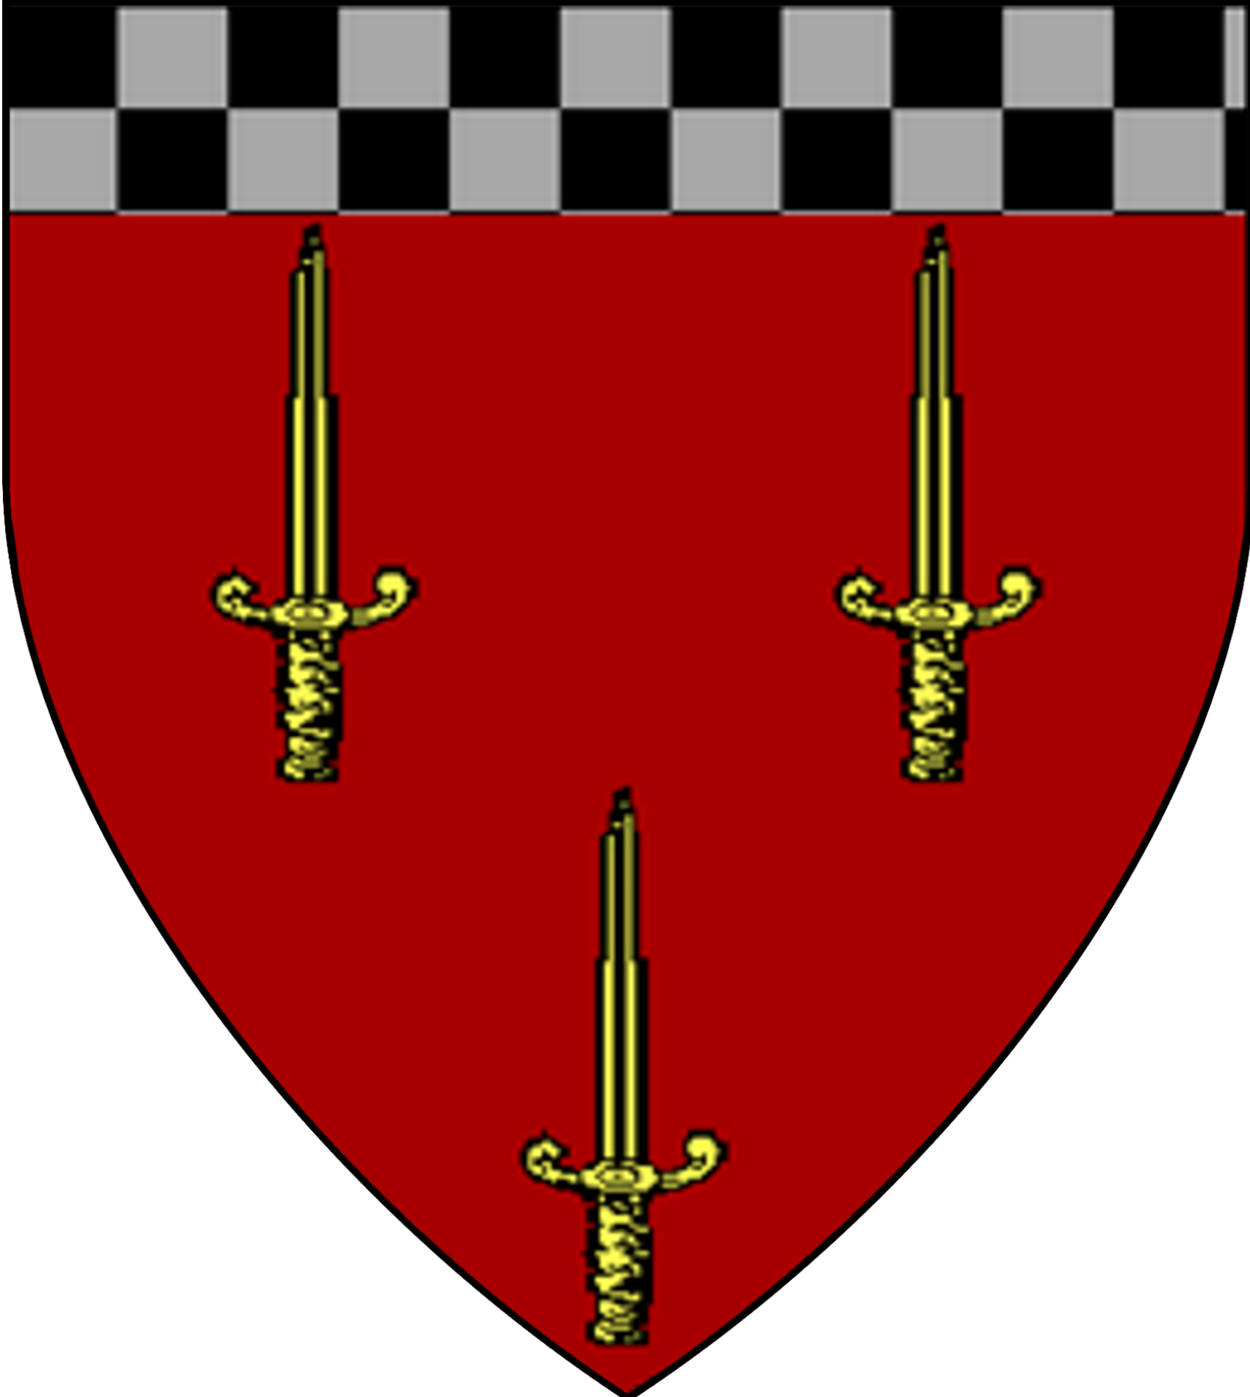 | 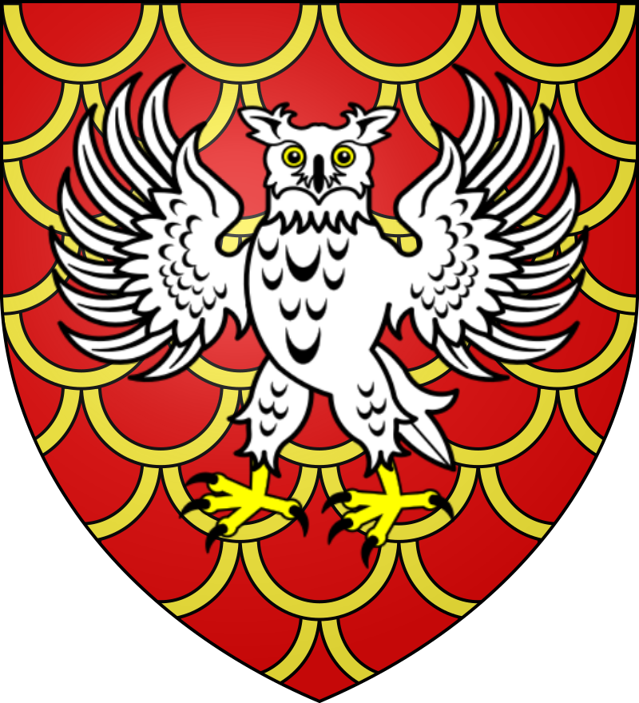 | 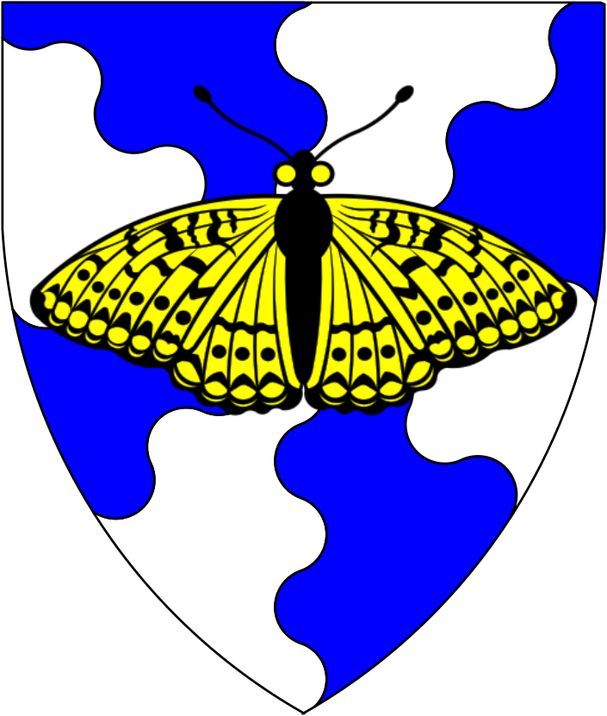 | 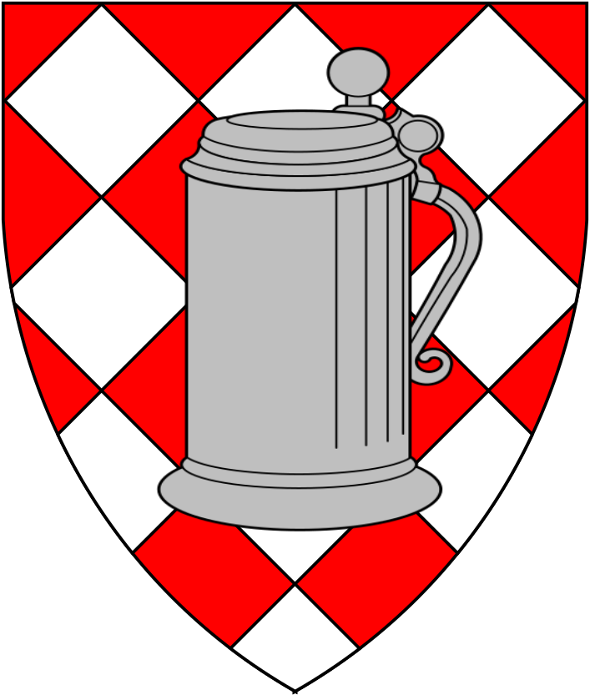
Estate of Andreanus | Estate of Maricianus | Prothemian Estate | Arkanites Estate | Kallergan Estate
Lord ? | Lord Grel Byrndraig D’Tyr | Lord Baltazar Prothemian | Lady ? Paullia | Lord Dominic Kallergan
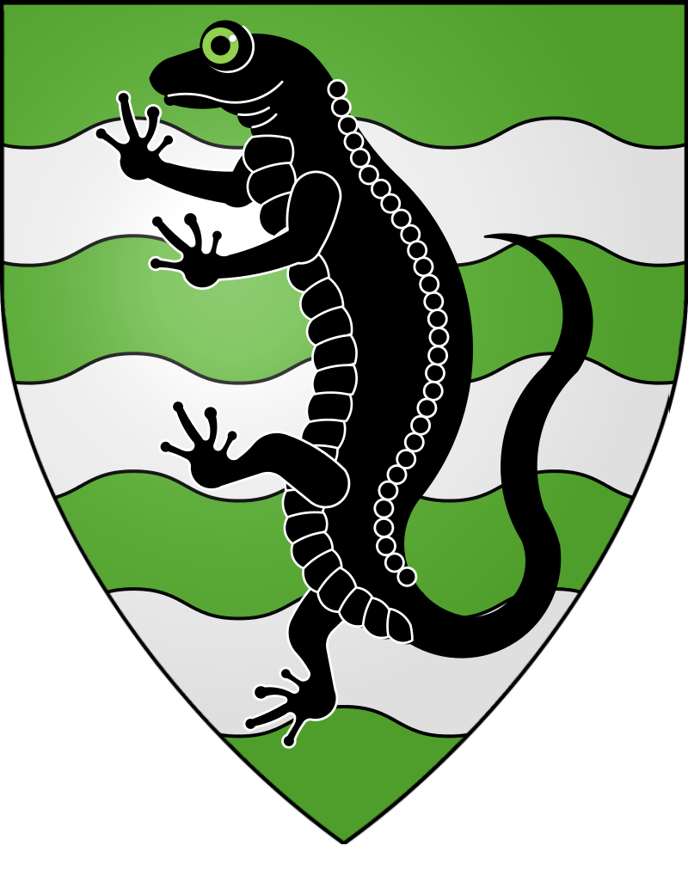 | 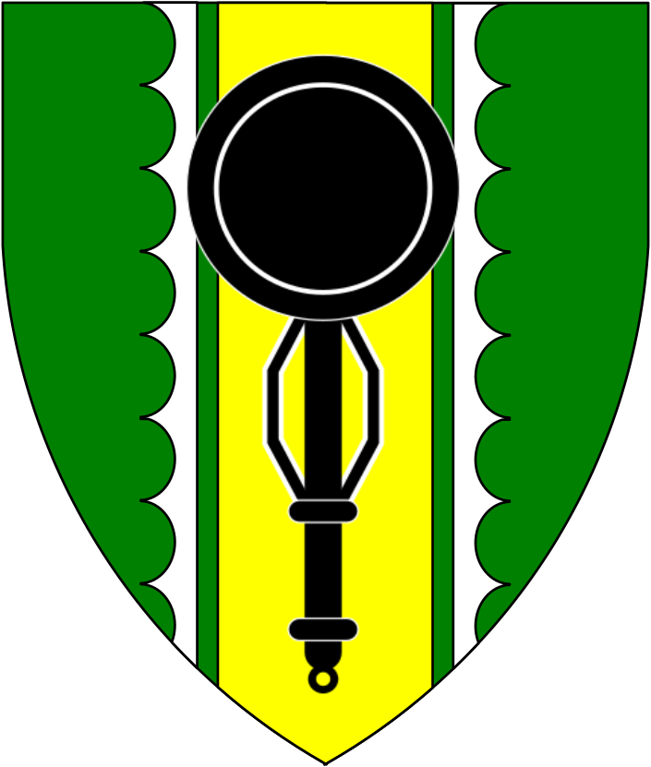 | 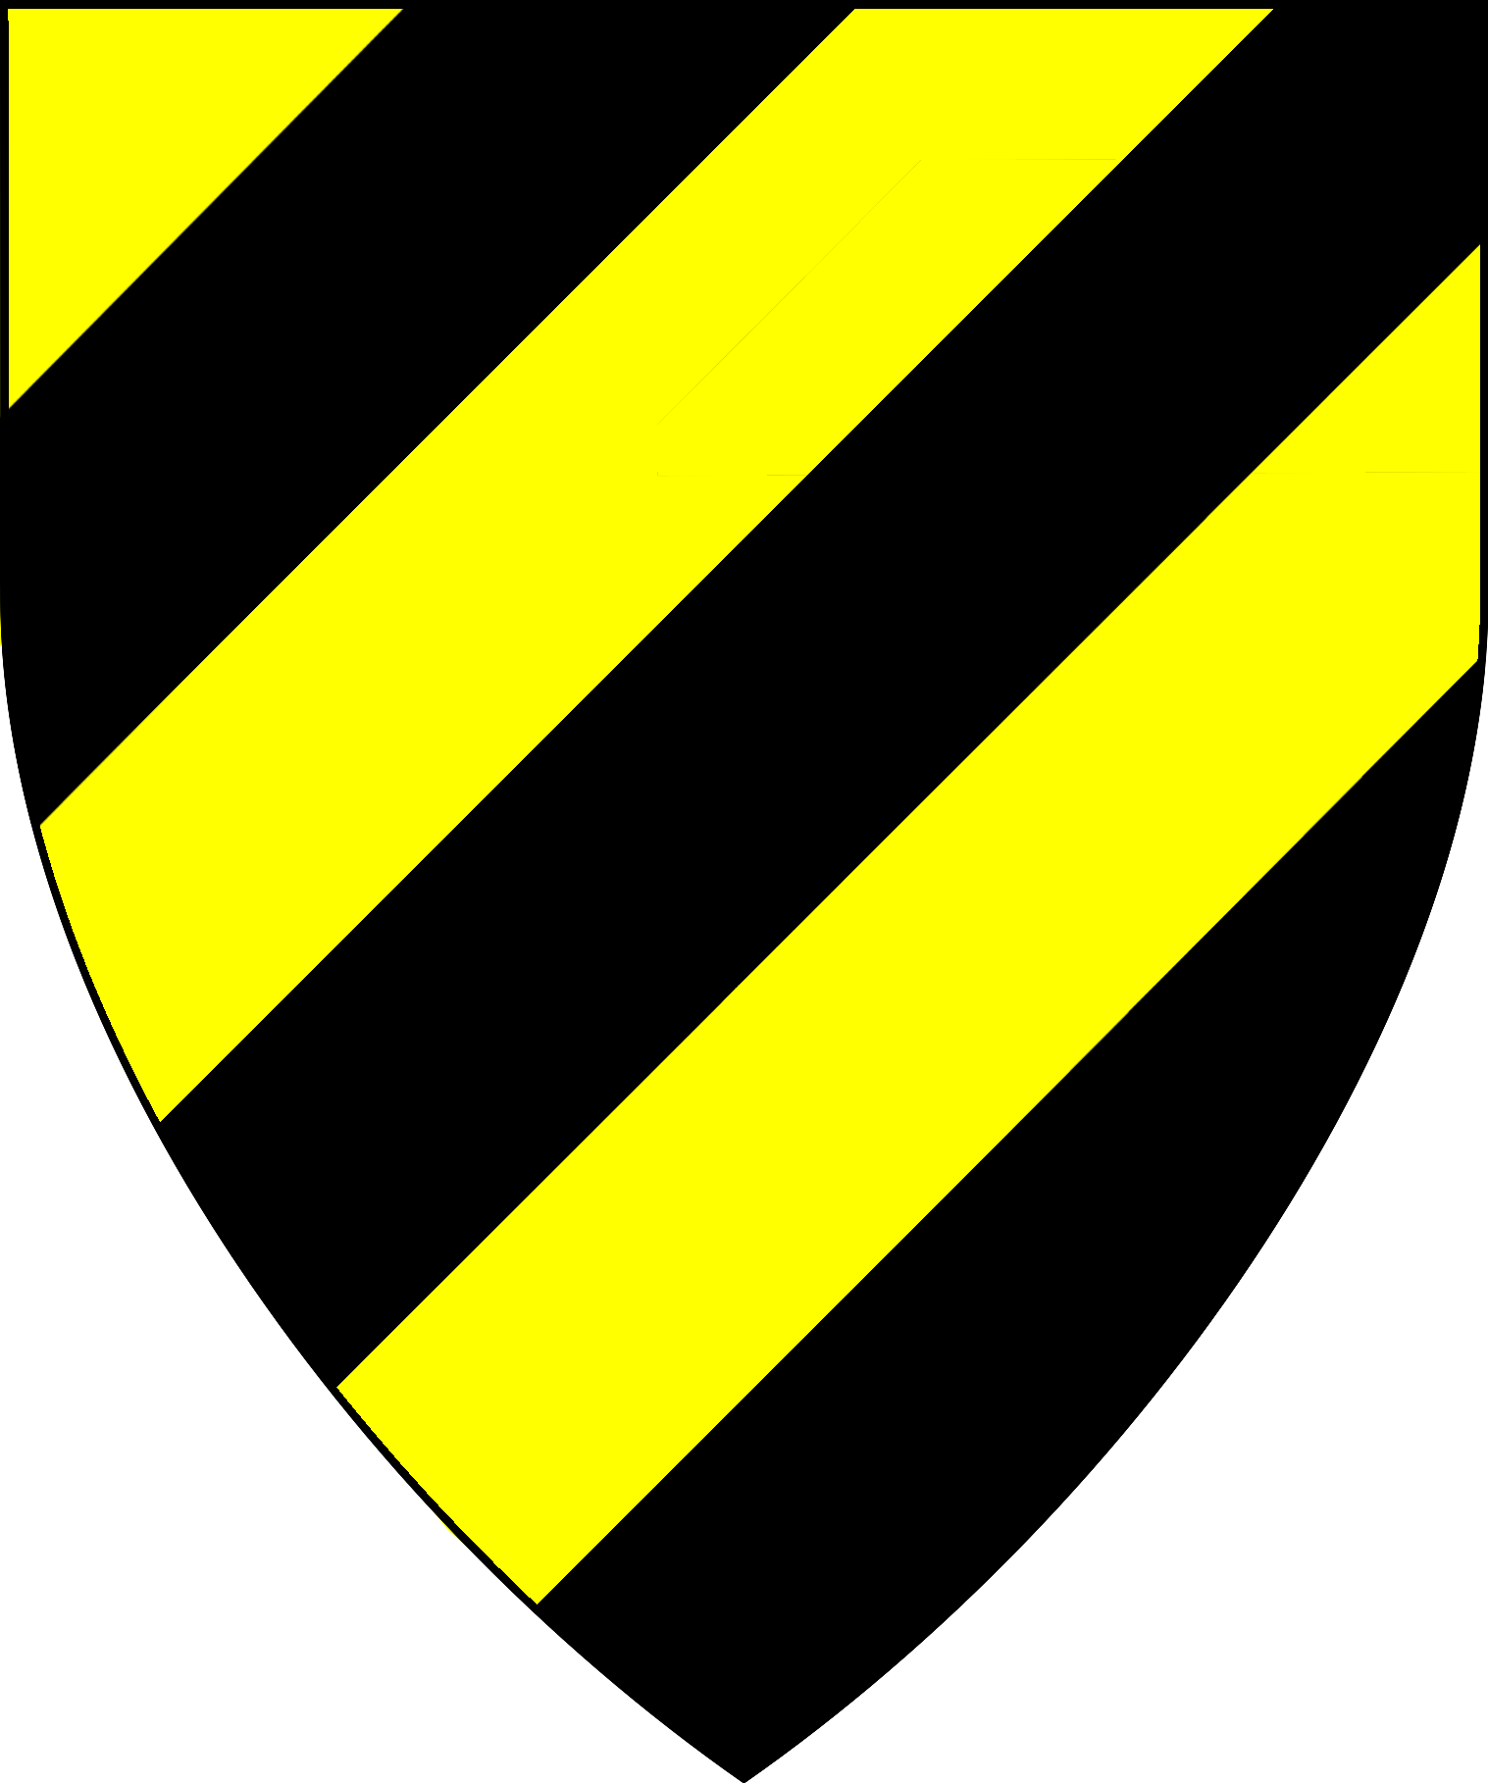 | 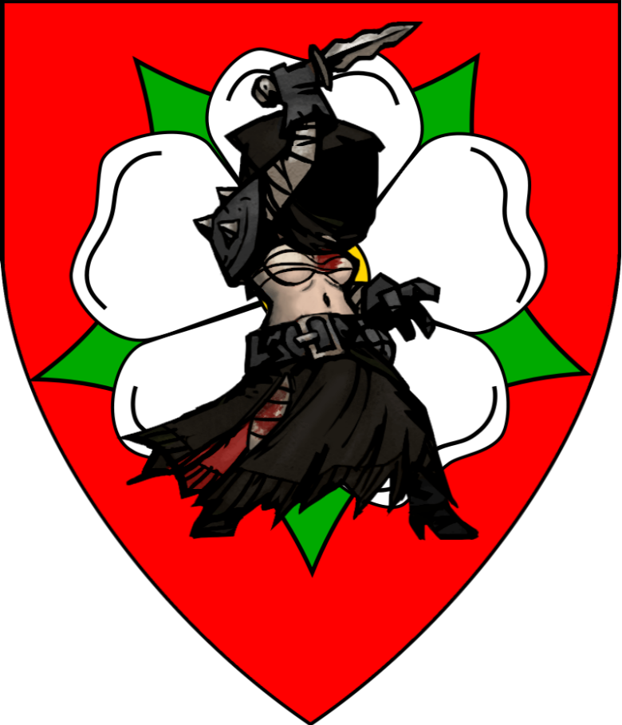 | 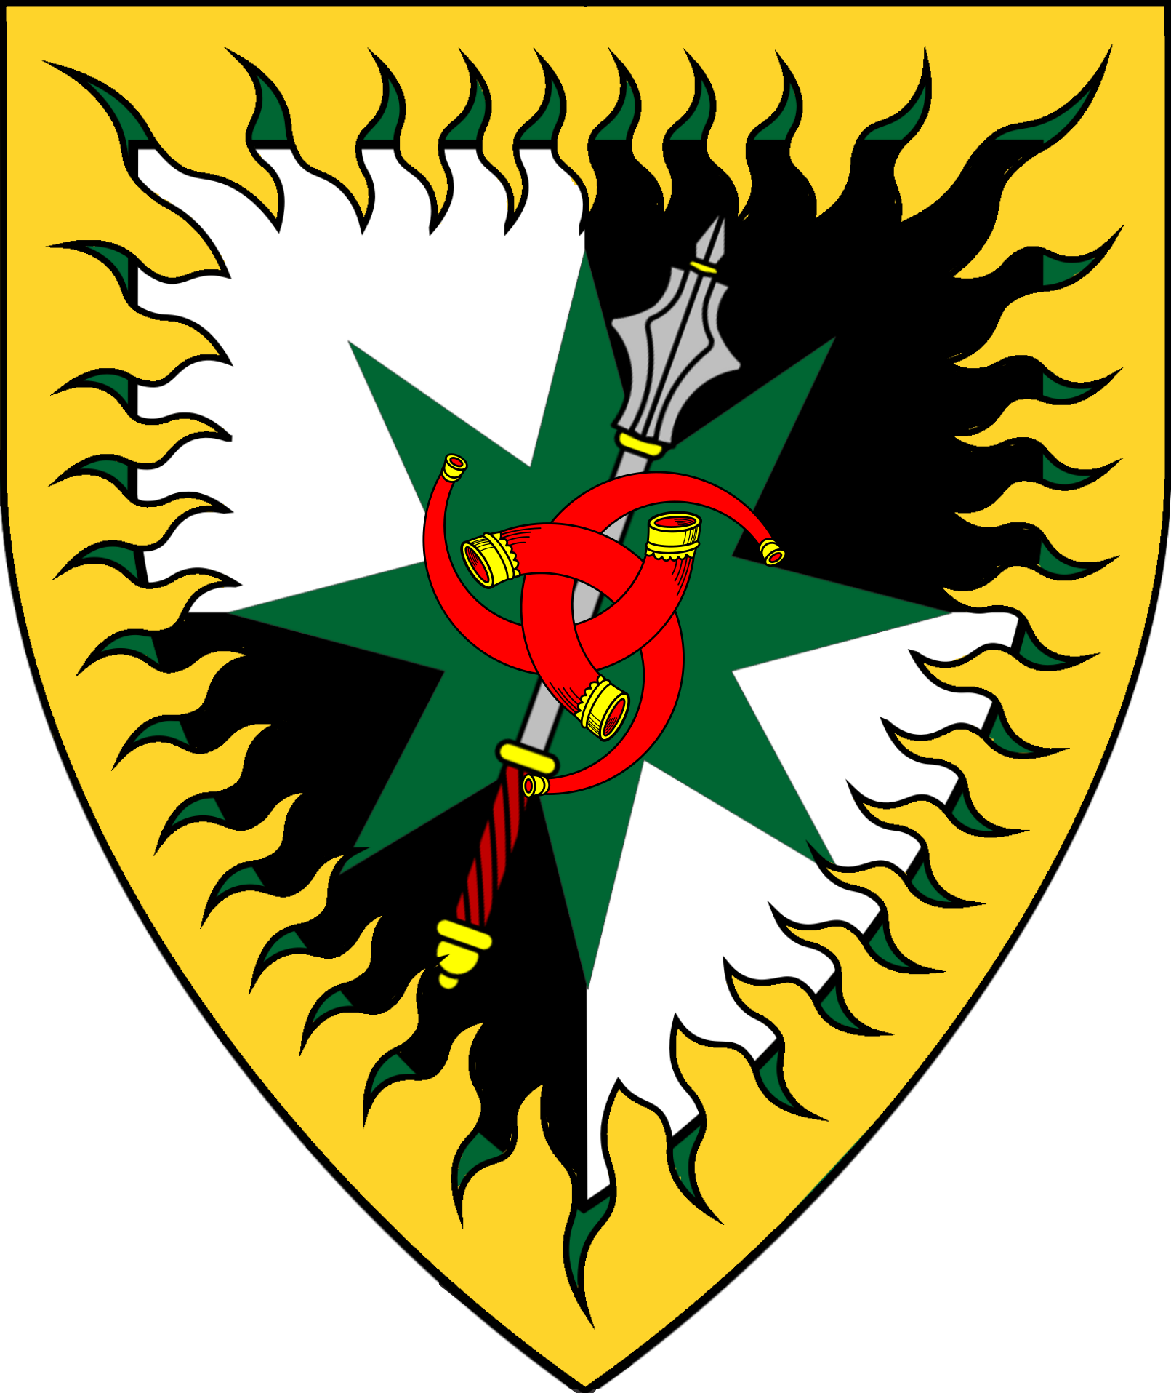
Estate of Bergoi | Estate of Veseya | Estate Korgenarius | Patrizio Estate | Lastarthus Estate
Lord Stanislav Kutinov | Lord Mladen Miltchev | Lord ? Korgenarius | Lord ? Patrizio | Lord Hengersol Lasthartus
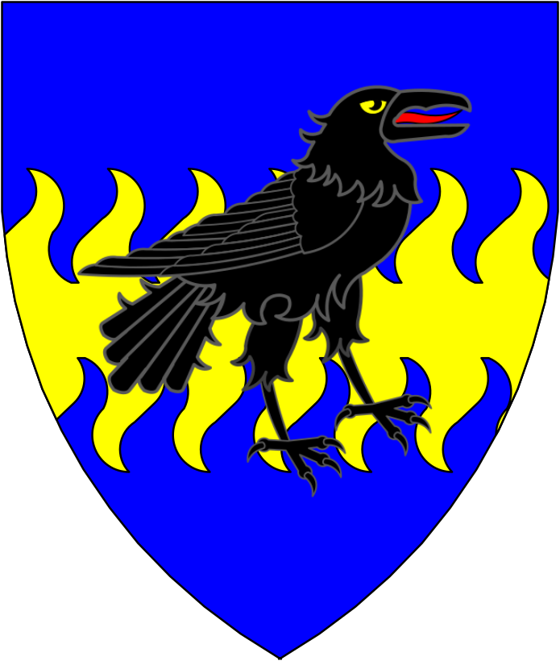 | 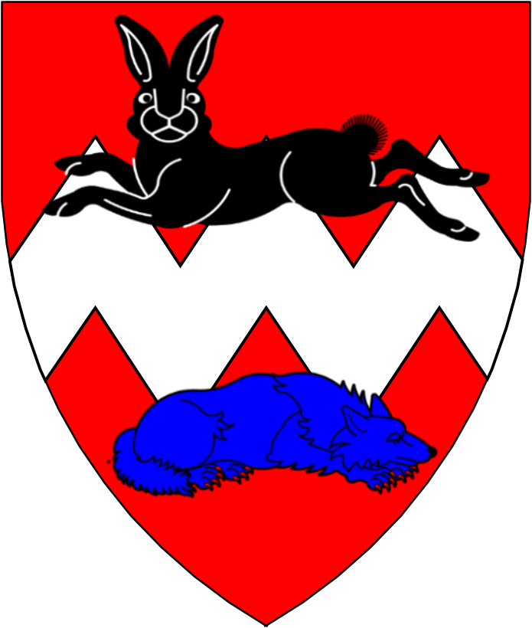 | 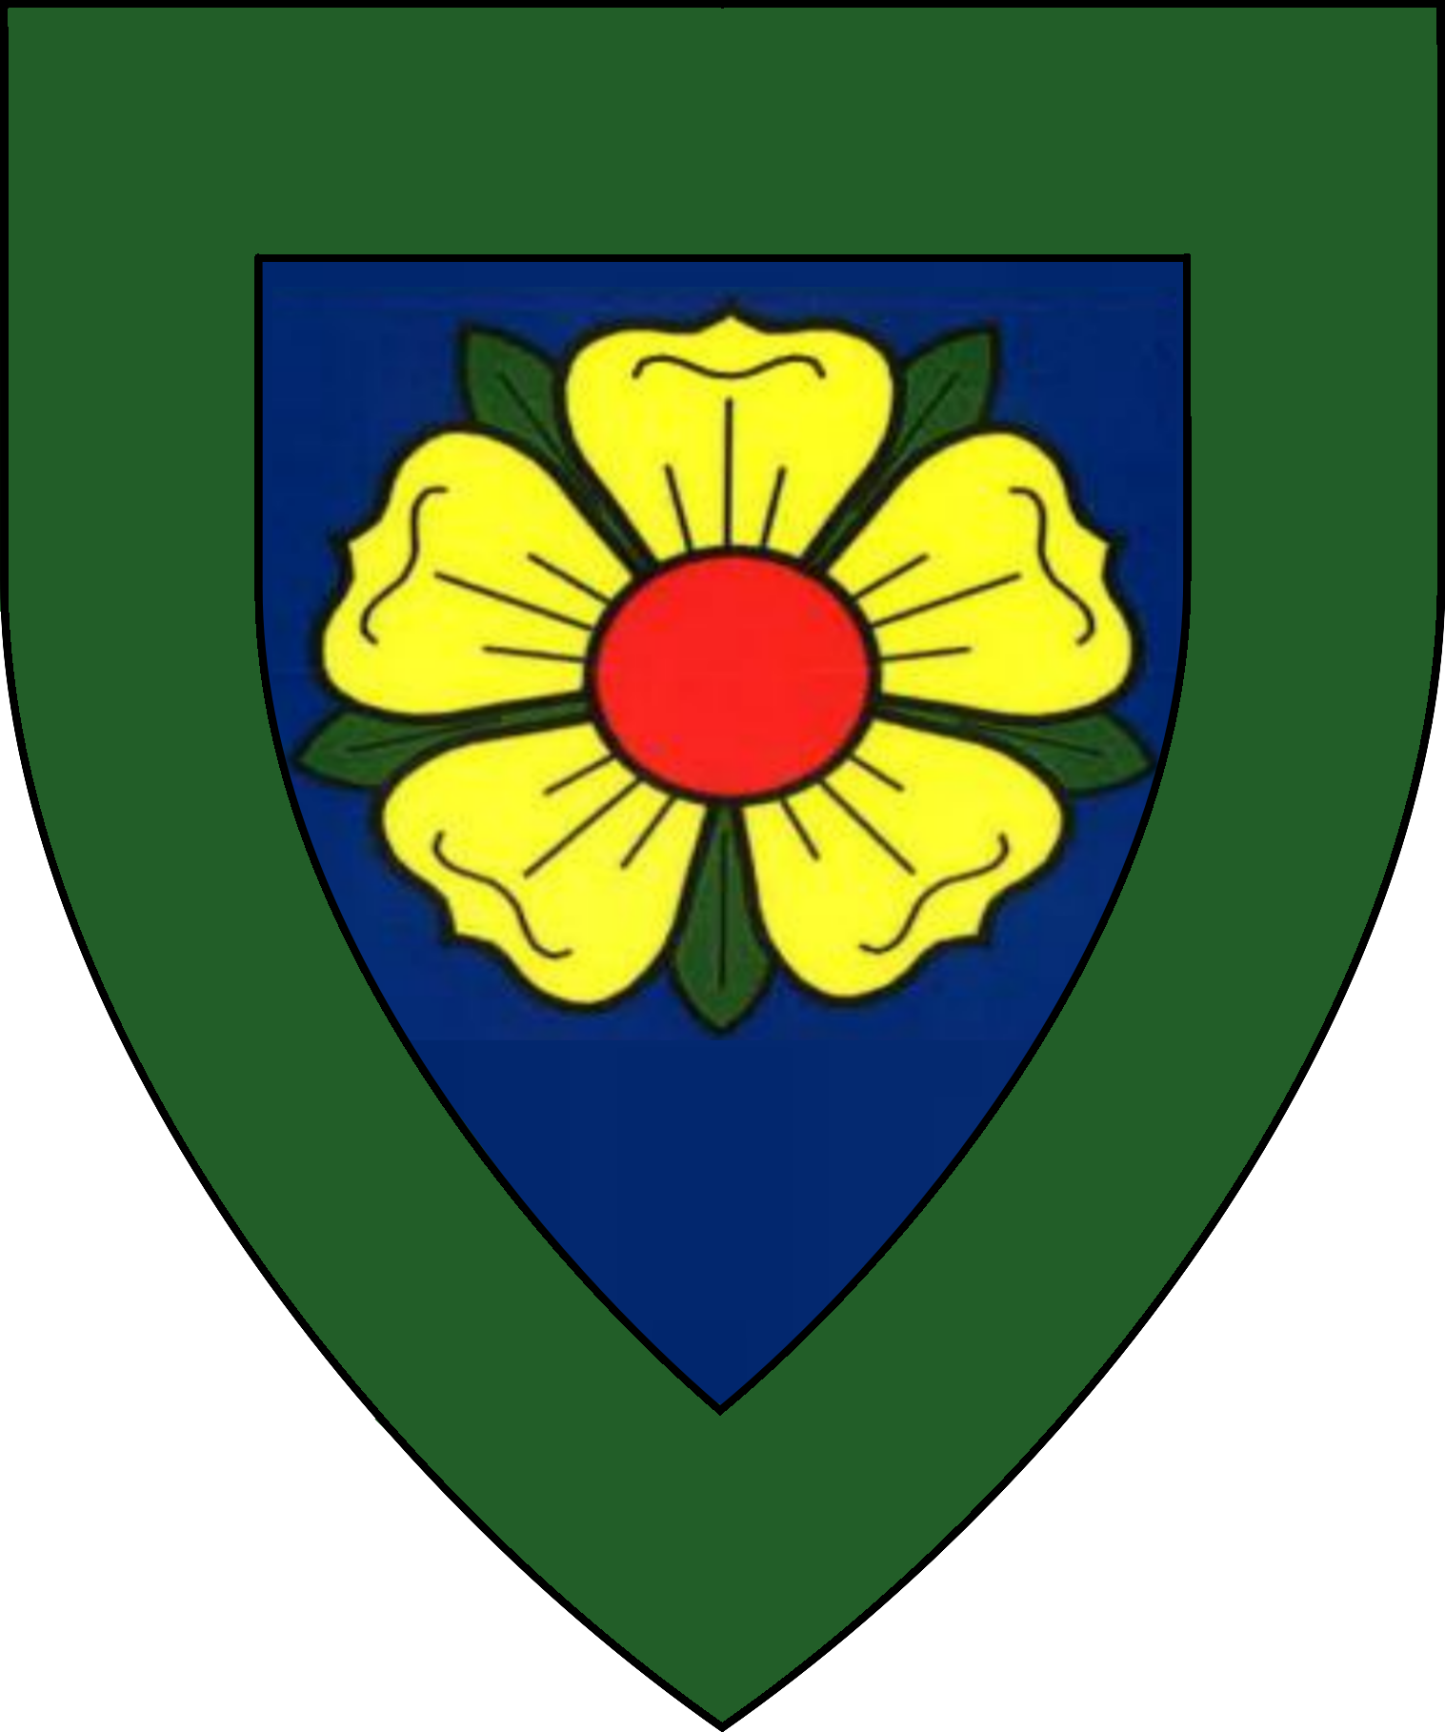 | 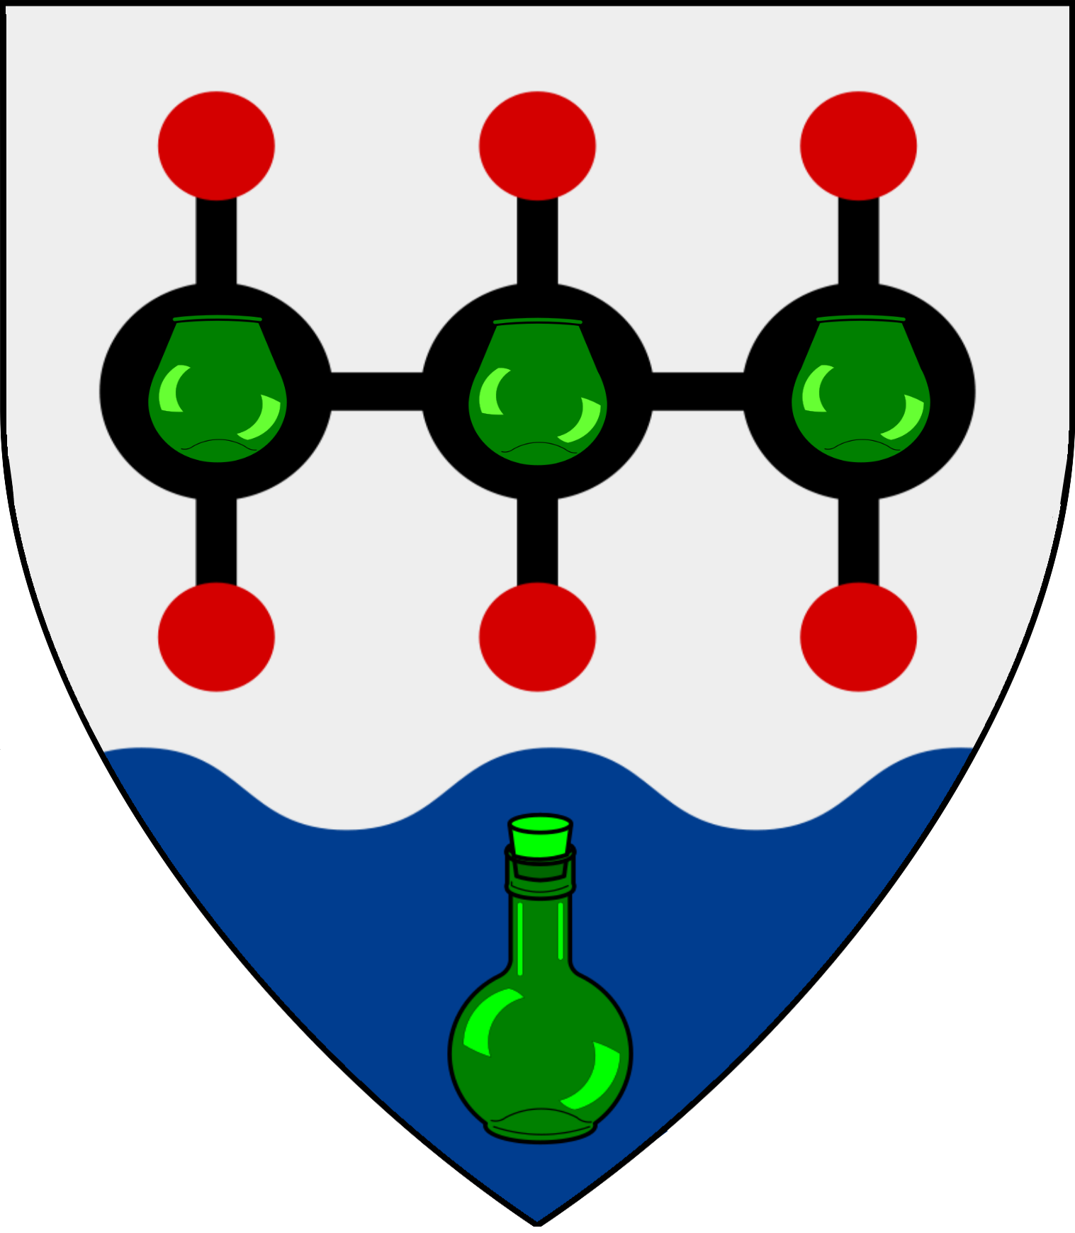 | 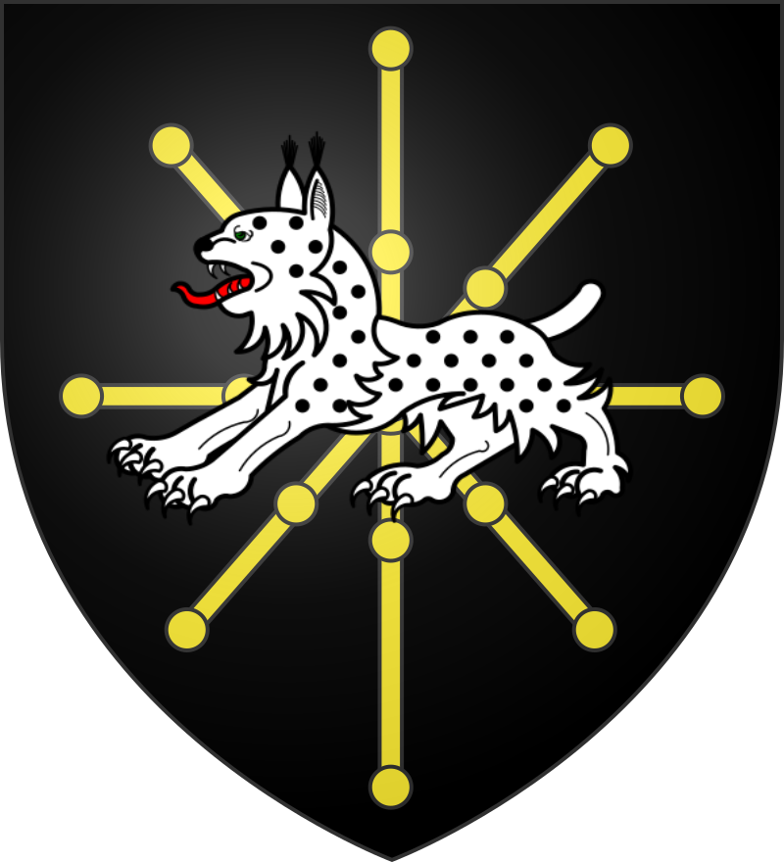
Furmenglaive Estate | Haakenberg Estate | Papholopolus Estate | Zargovia Estate | Oesterhaus Estate
Lord Devolyn Furmenglaive | Lord Lotharius Haakenberg | Lord ? Papholopolus | Lord ? Kirklen | Lord Nerios Oesterhaus
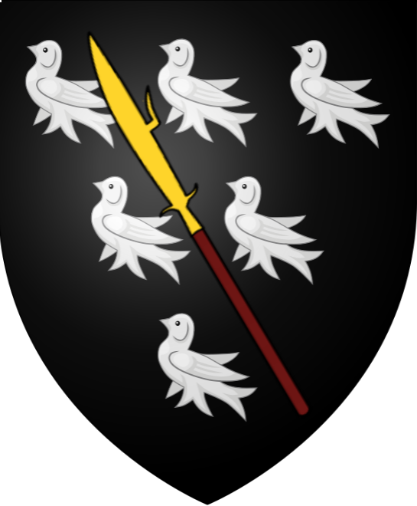 | 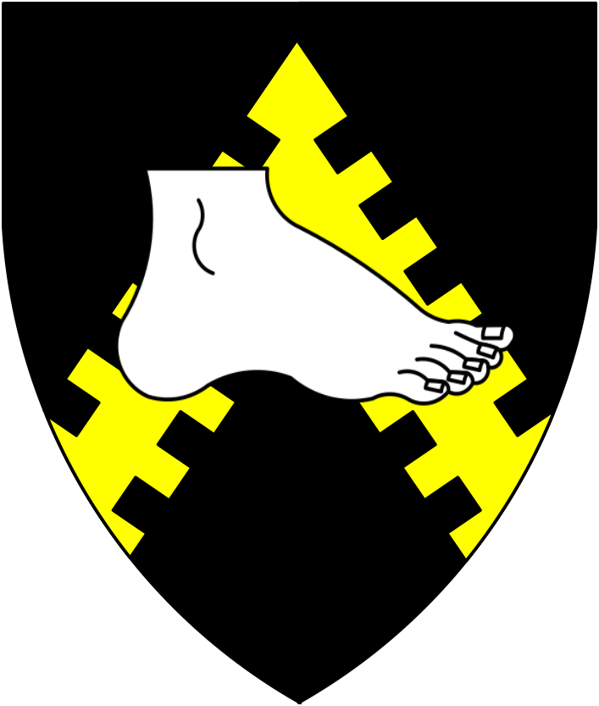 | 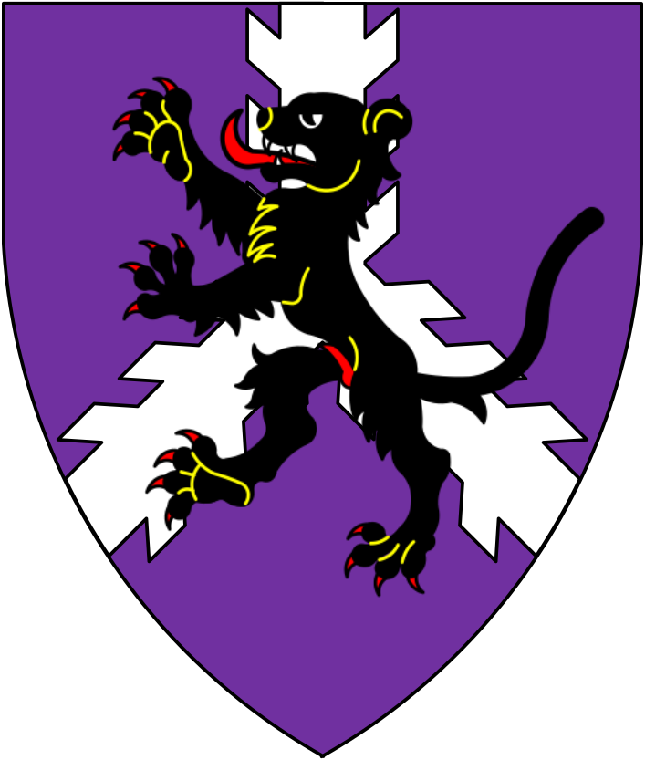 | 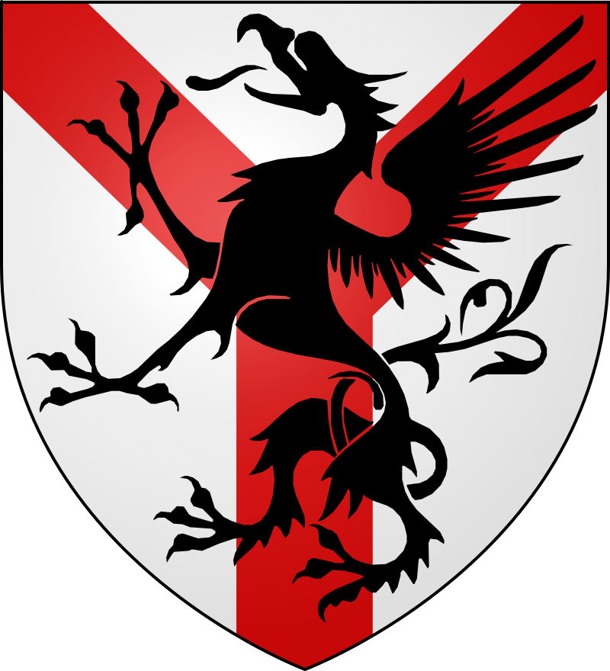 | 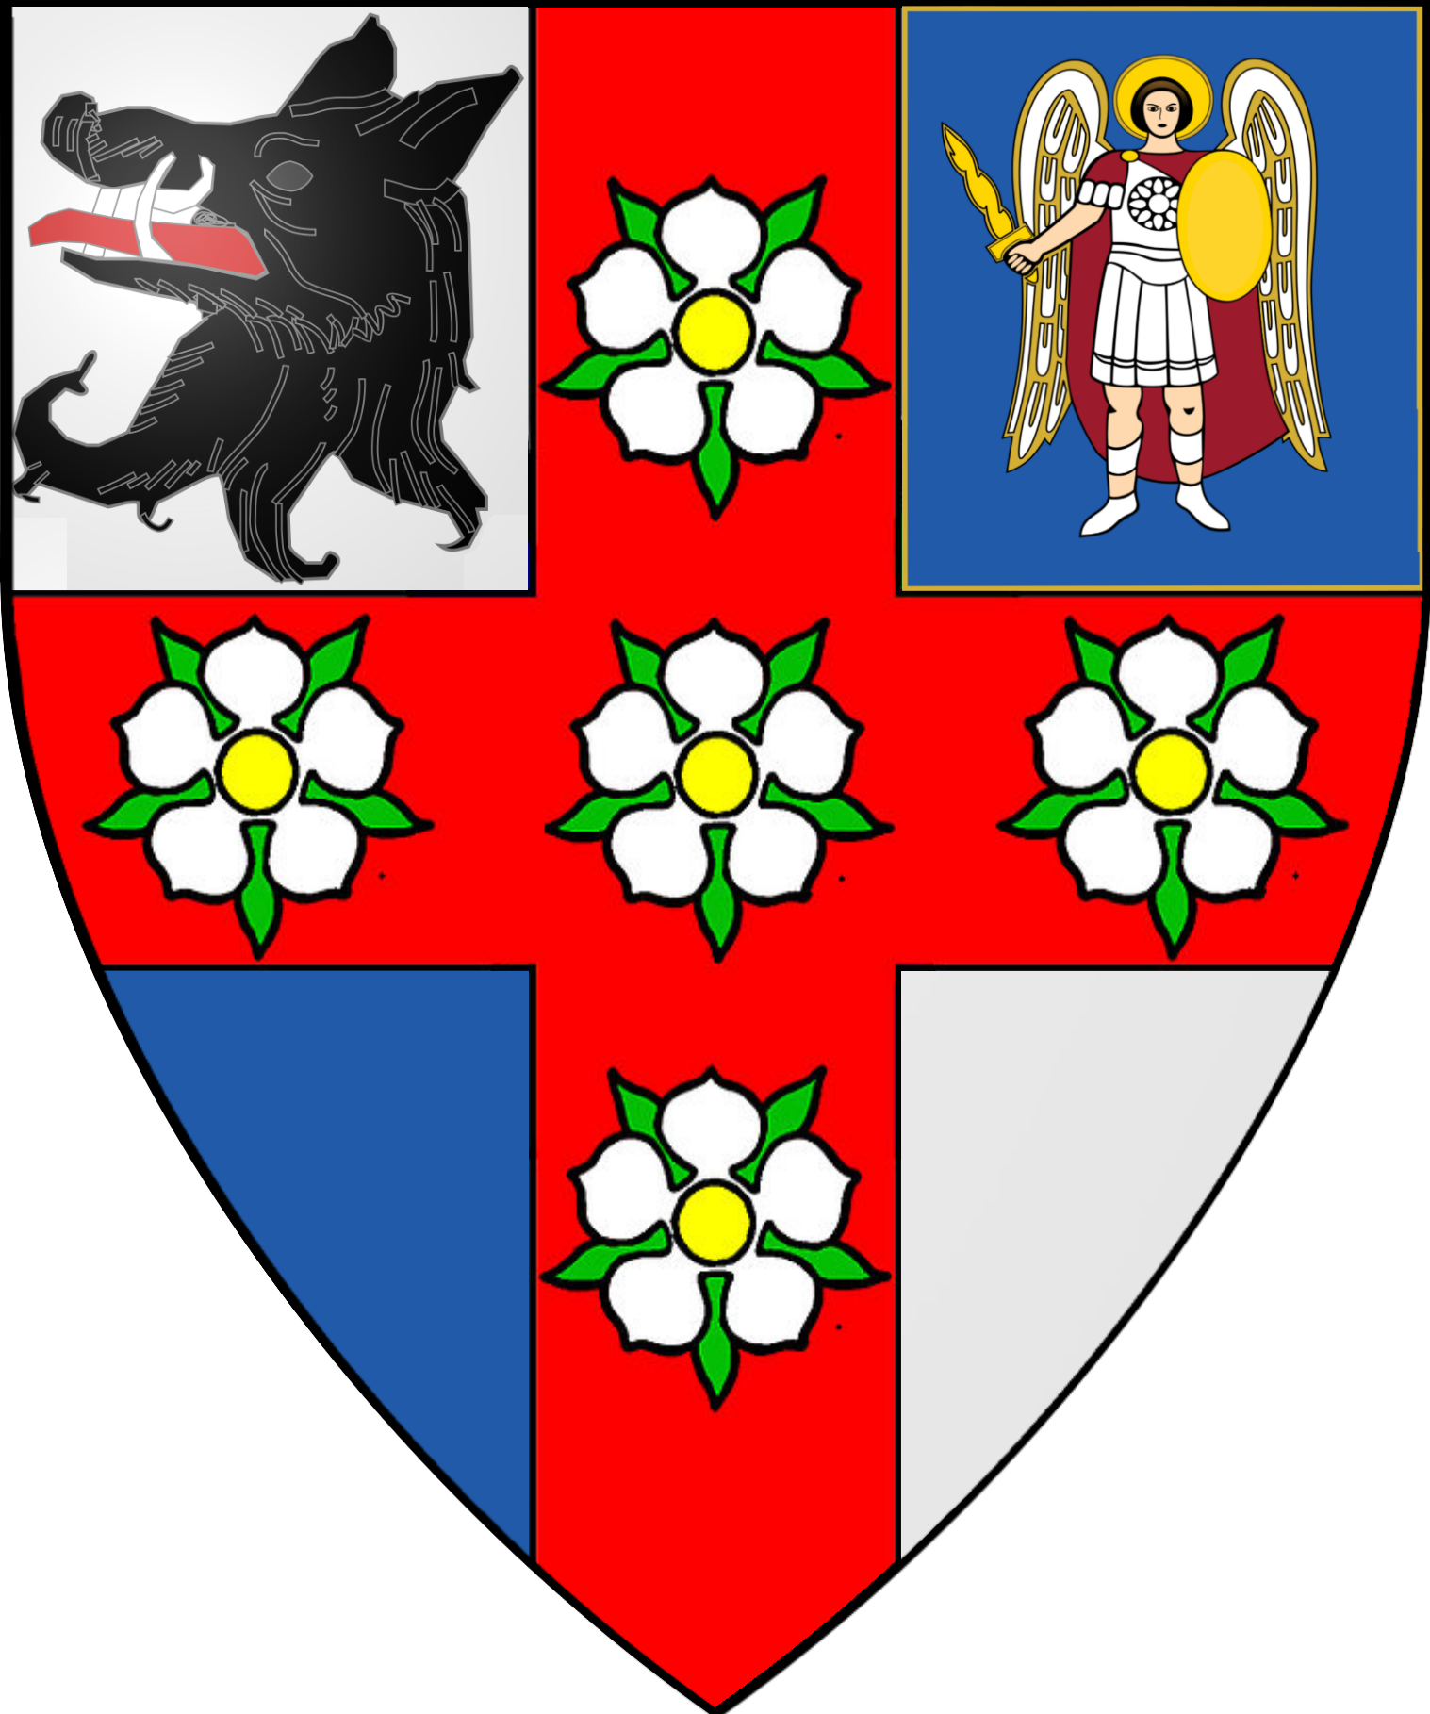
Independent Minor Lords
Lord Philos Actavius  Lord of Actavias and Phandalin | Lady ?  Lady of Cerularius
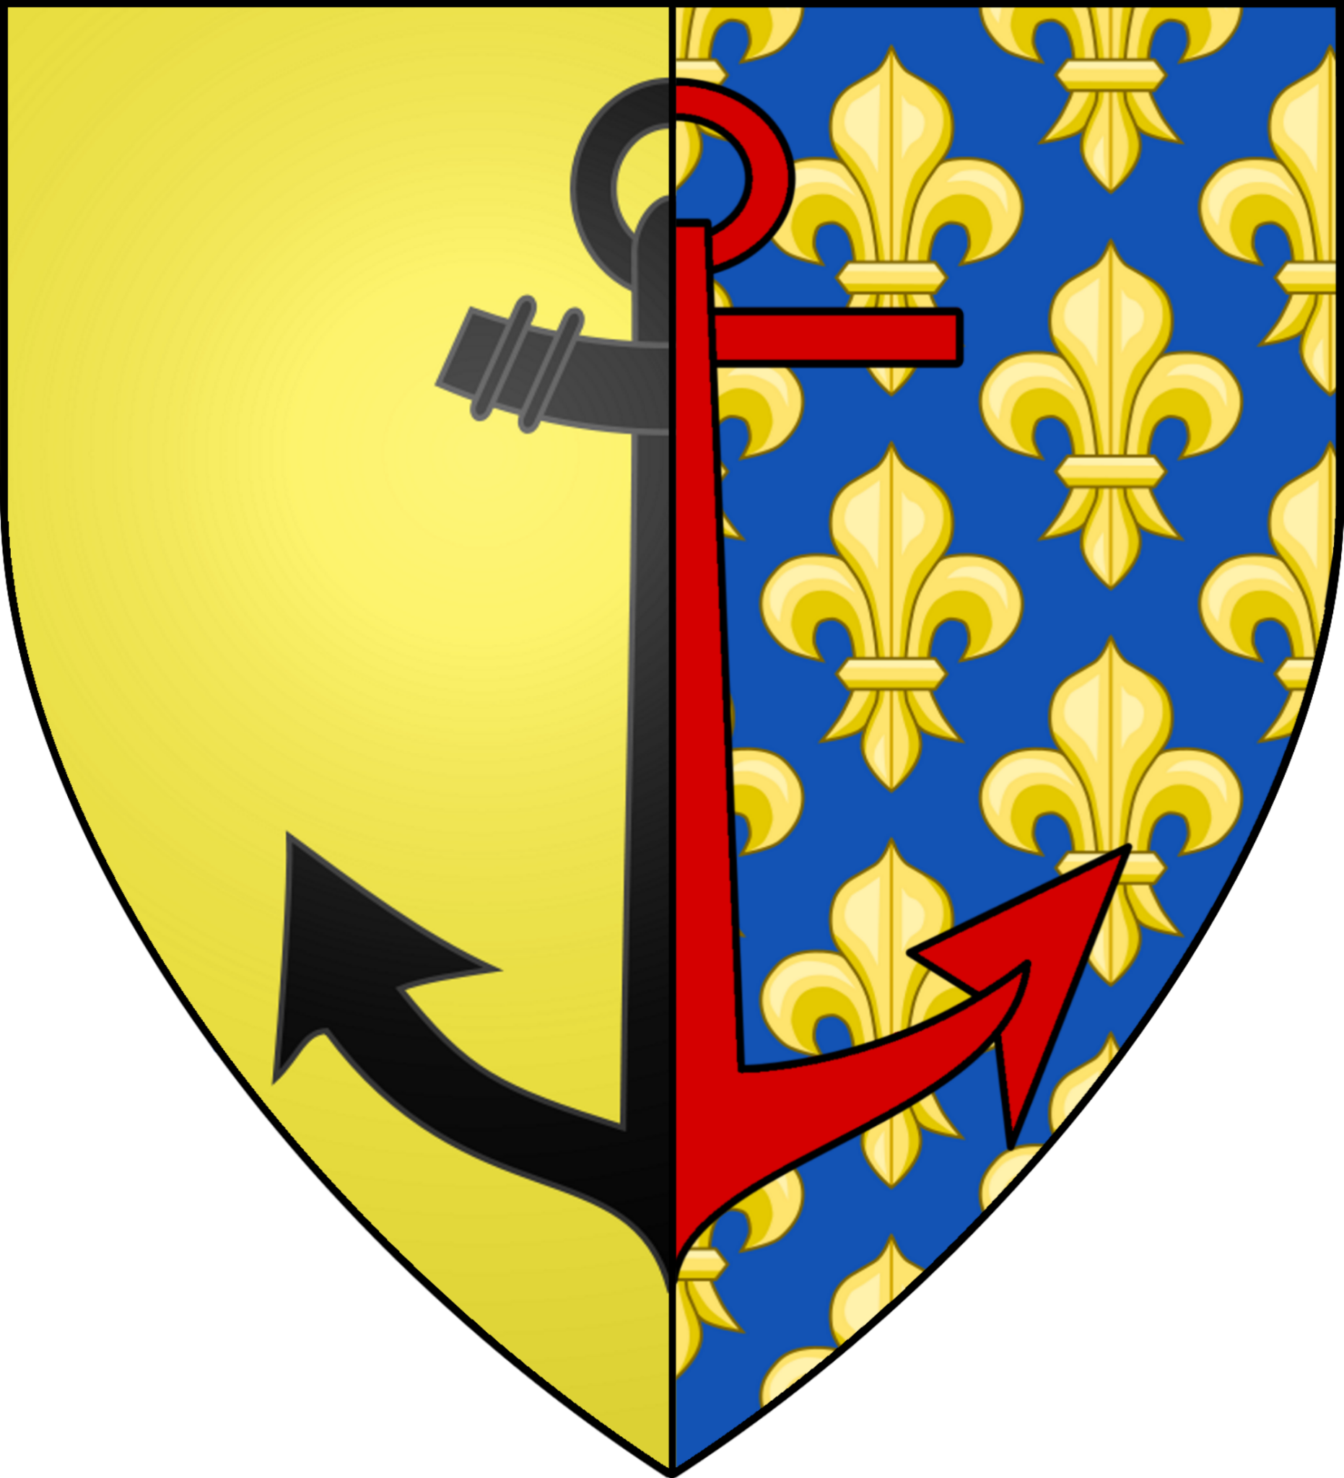 | 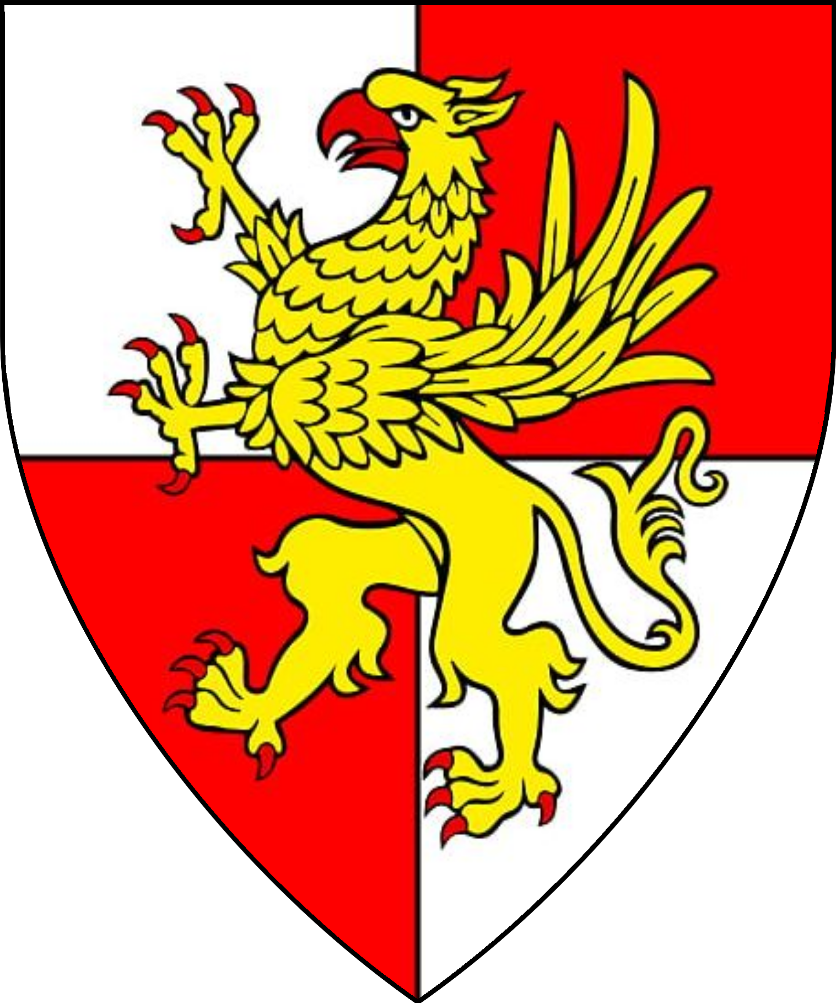

Knights Bachelor
Sir Theobald Curdle | Sir Gwanon Belloc | Sir Aberfors Escar | Sir Derrik Dimatopolous | Sir Ibram Popovski
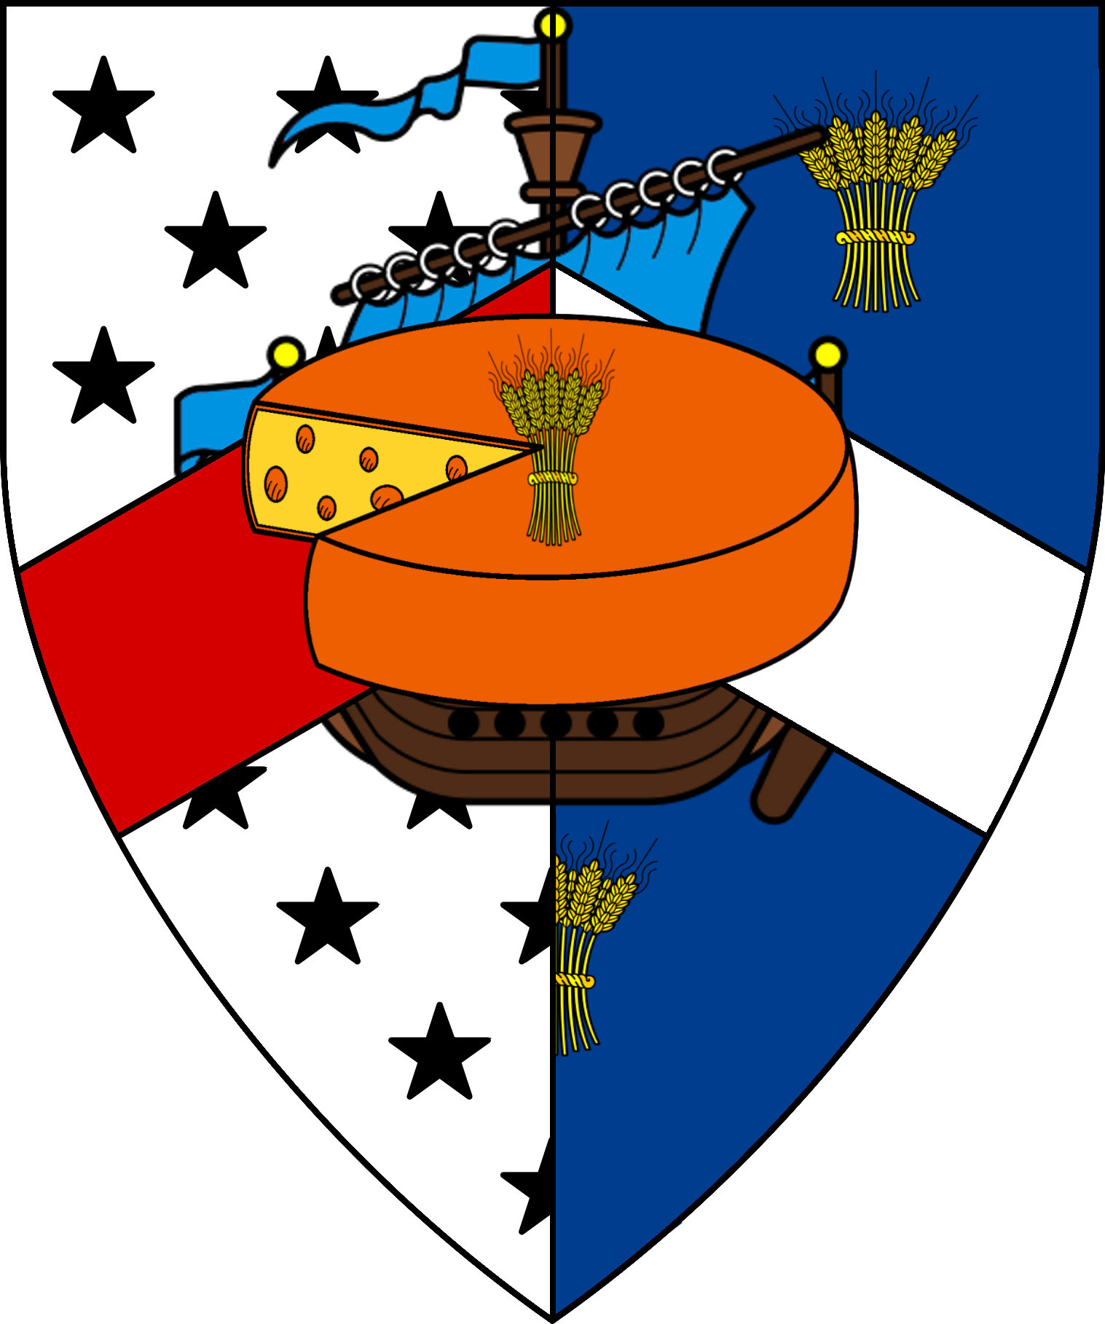 | 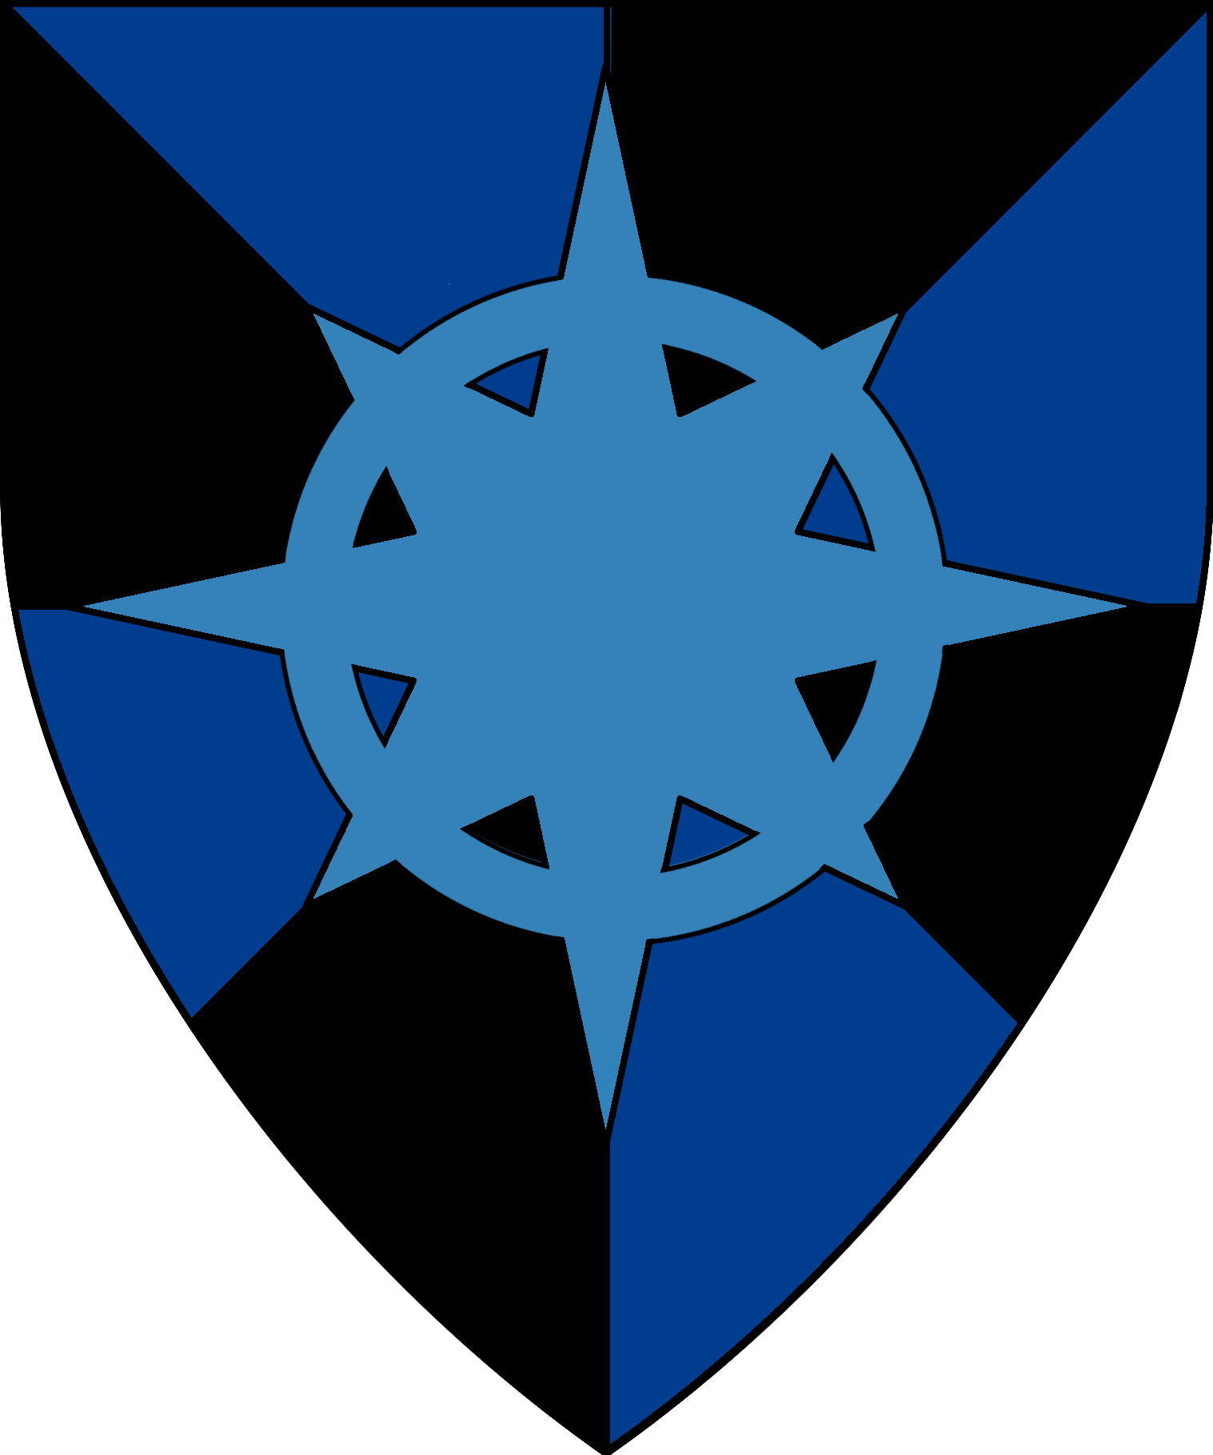 | 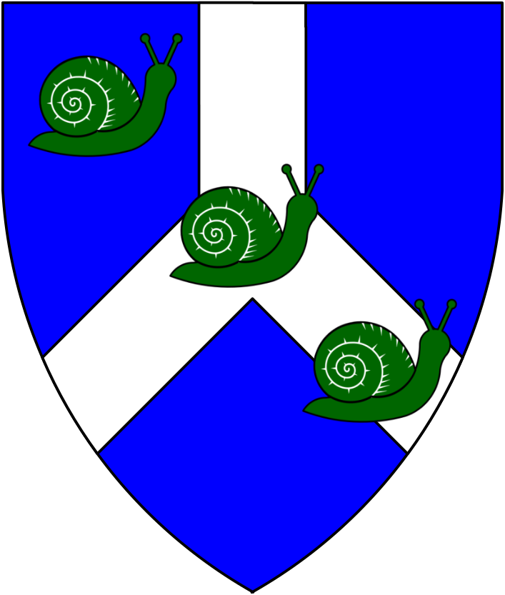 | 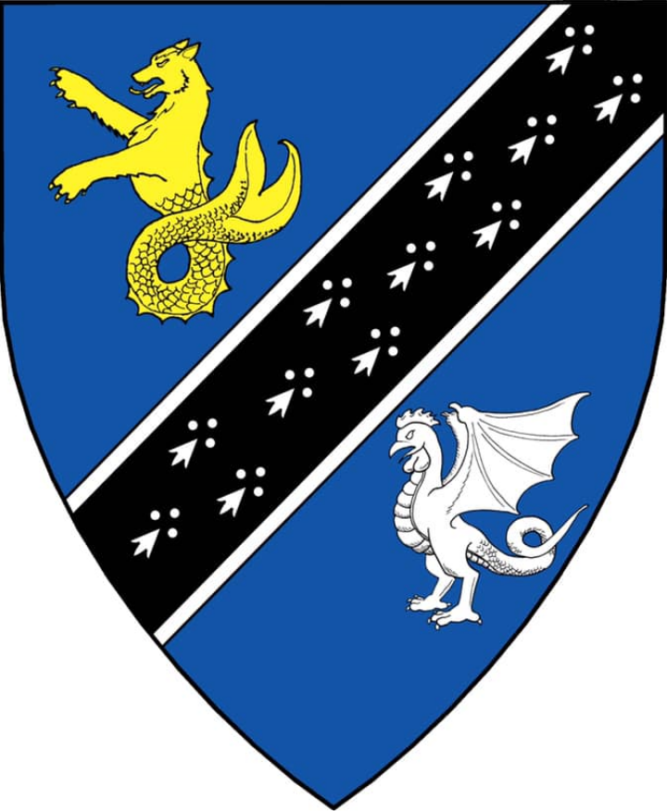 | 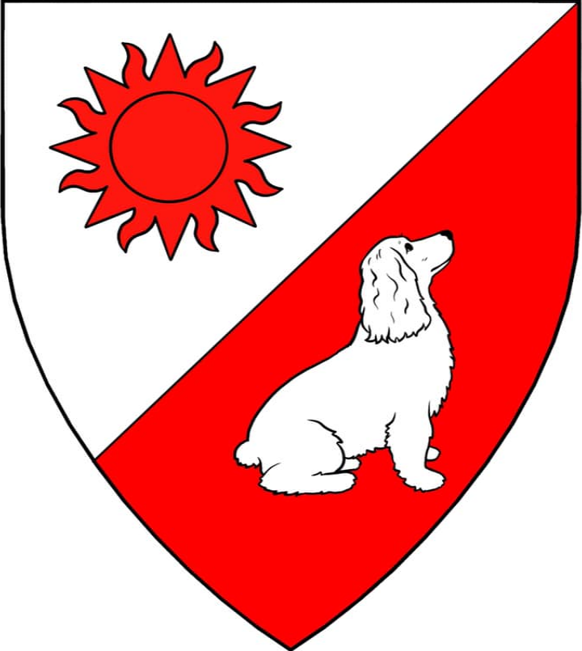
Sir Jon Oster | Sir Garmon “the Red Rabbit” of Brun | Sir Walter Willet | Sir Leopold Garten | Sir Augustin “ex Gladius” Gaianus
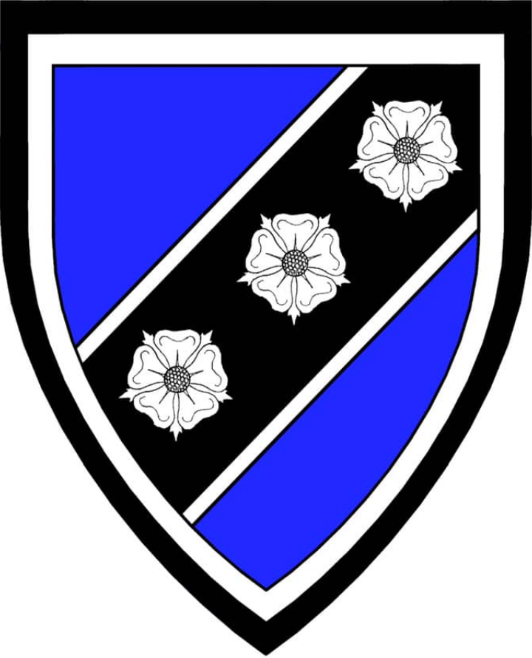 | 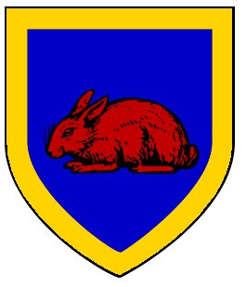 | 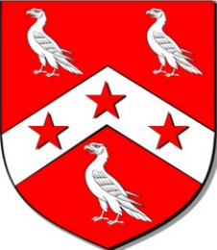 | 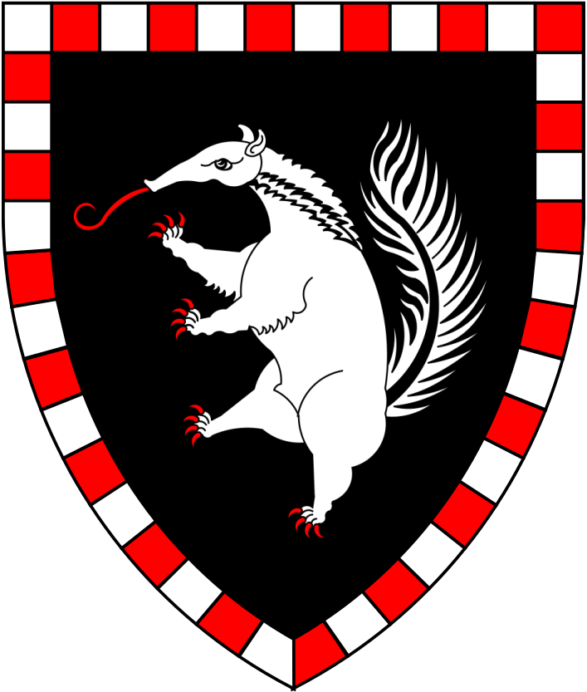 | 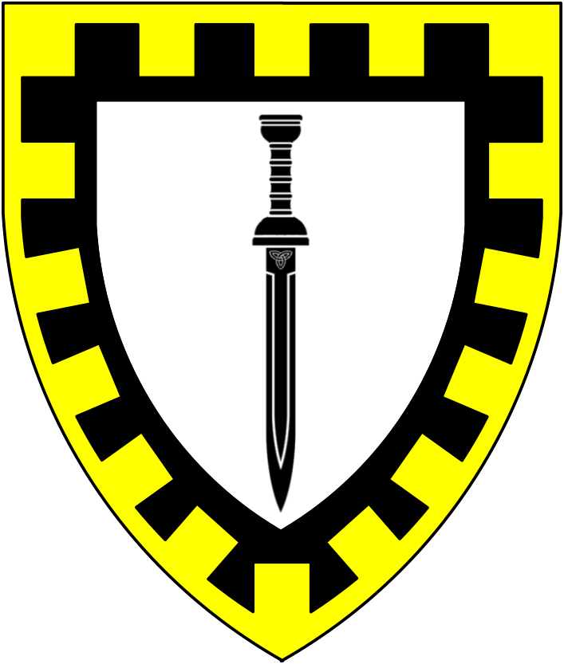
Sir Geriant Belloc | Sir Pavel Borgia | Sir Diocletian Malenois | Sir Plovis Cerularius | Sir Glaucus Icarus
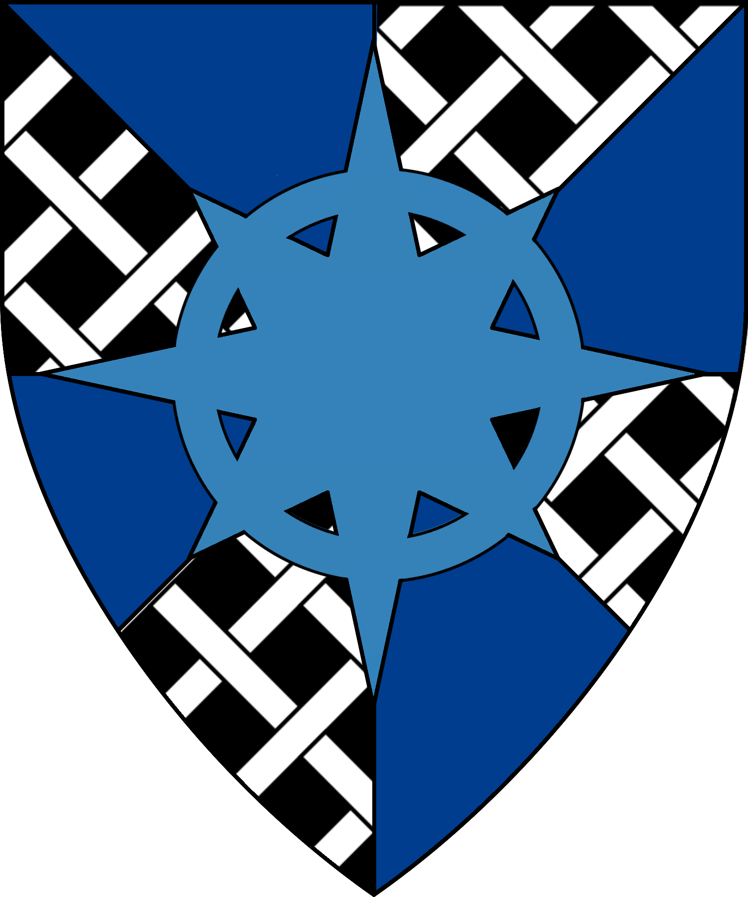 | 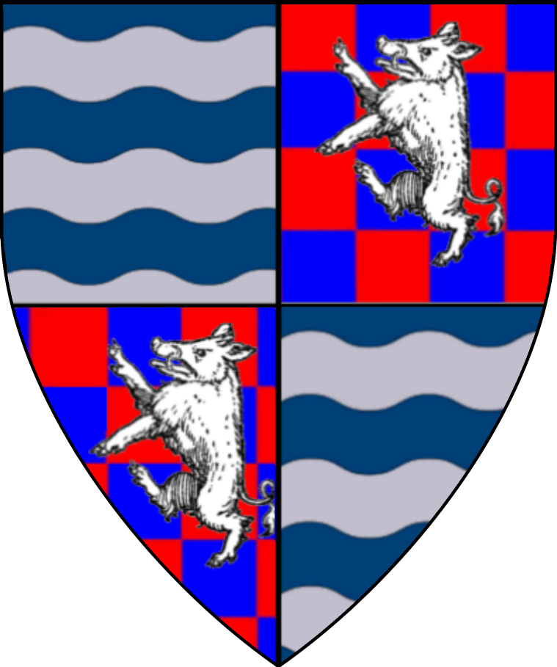 | 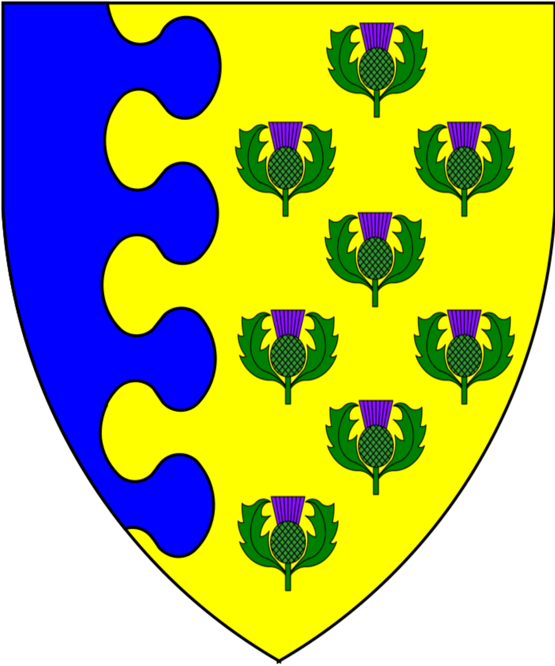
Sir Arkady “the Bull” Pavelenko | Sir Anschluss Escar | Commodore Sir Godrik Vorloi | Sir Regulus Pomitan | Sir Gwydhalad Belloc
 | 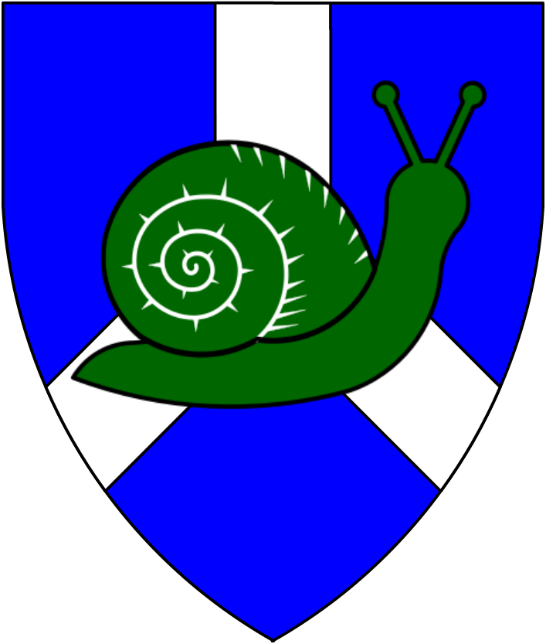 |  |  | 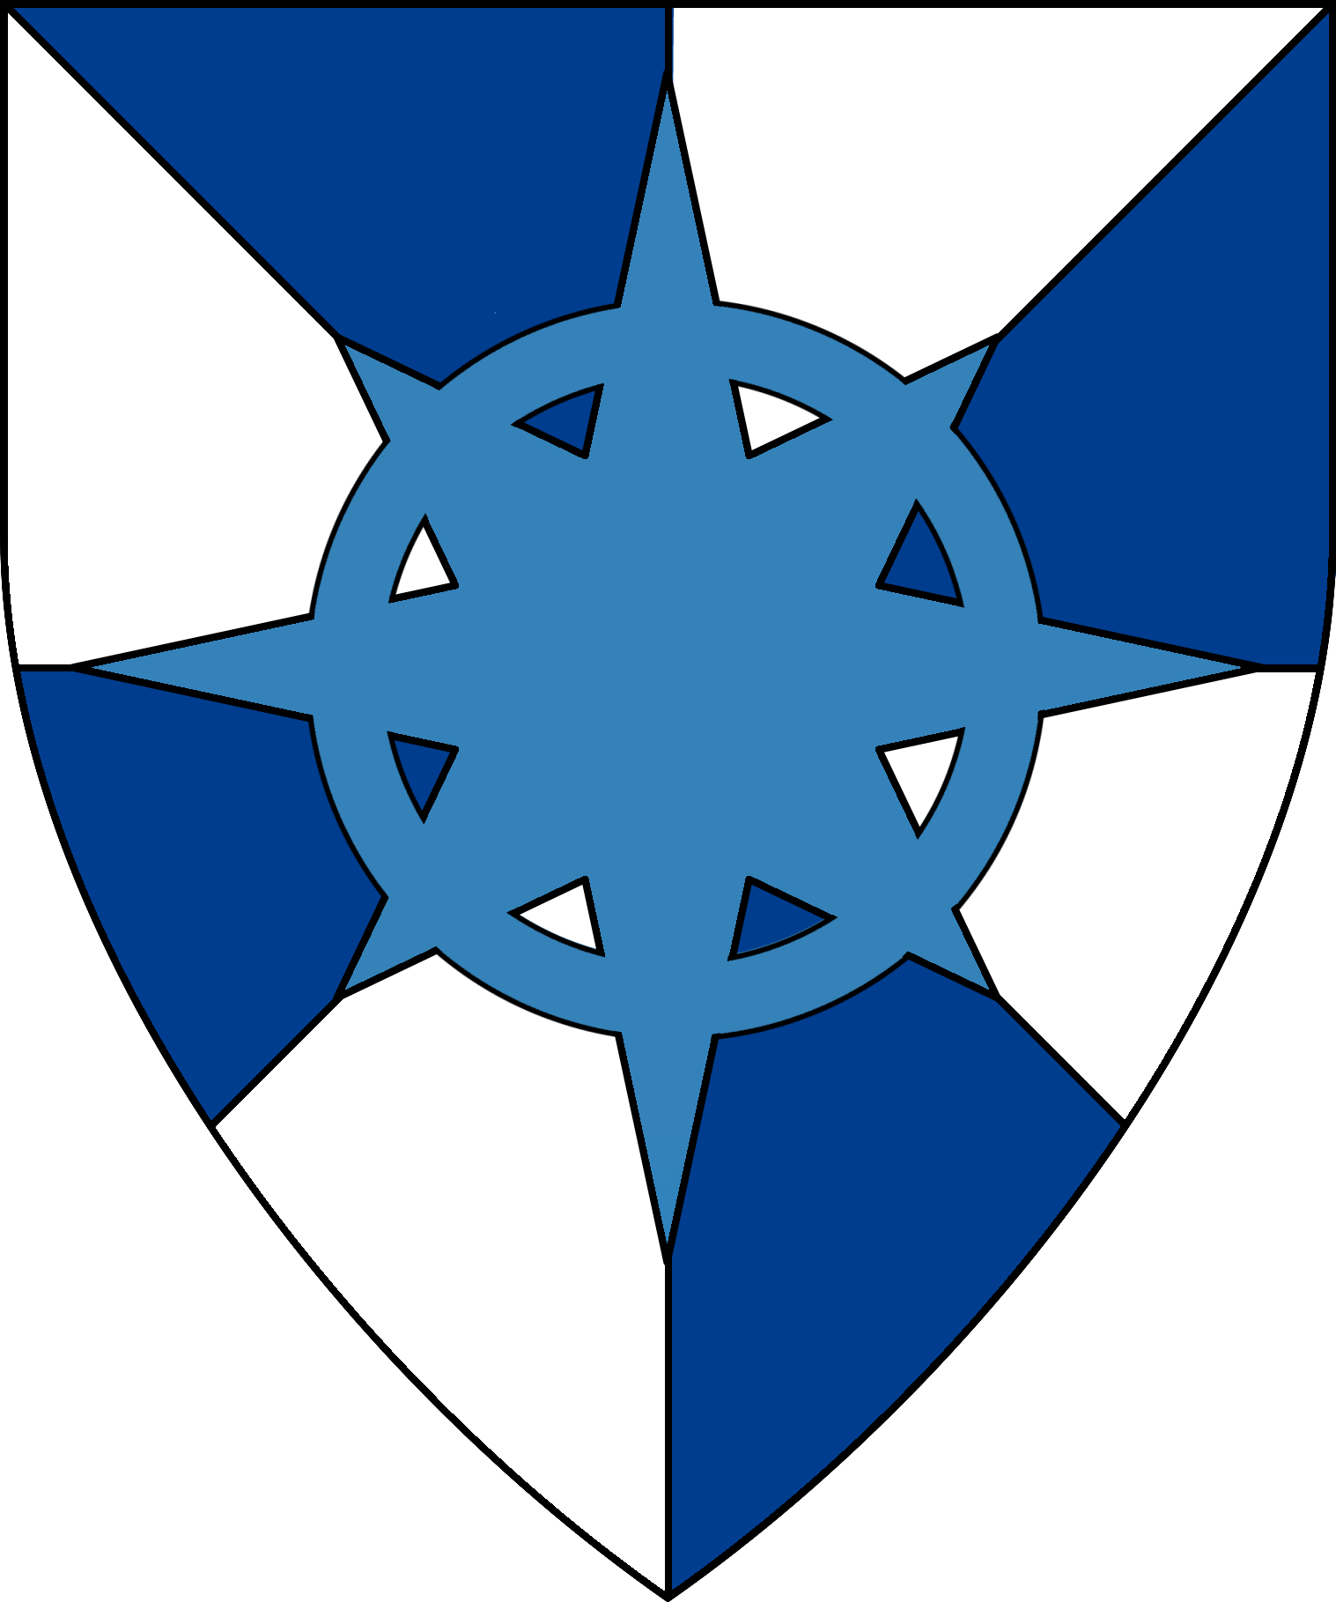
Sir Benedict Manderly | Sir Donna von Hendricks | Sir Dante Khyber | Sir Meliagrance | Sir Ernst von Hesselborg
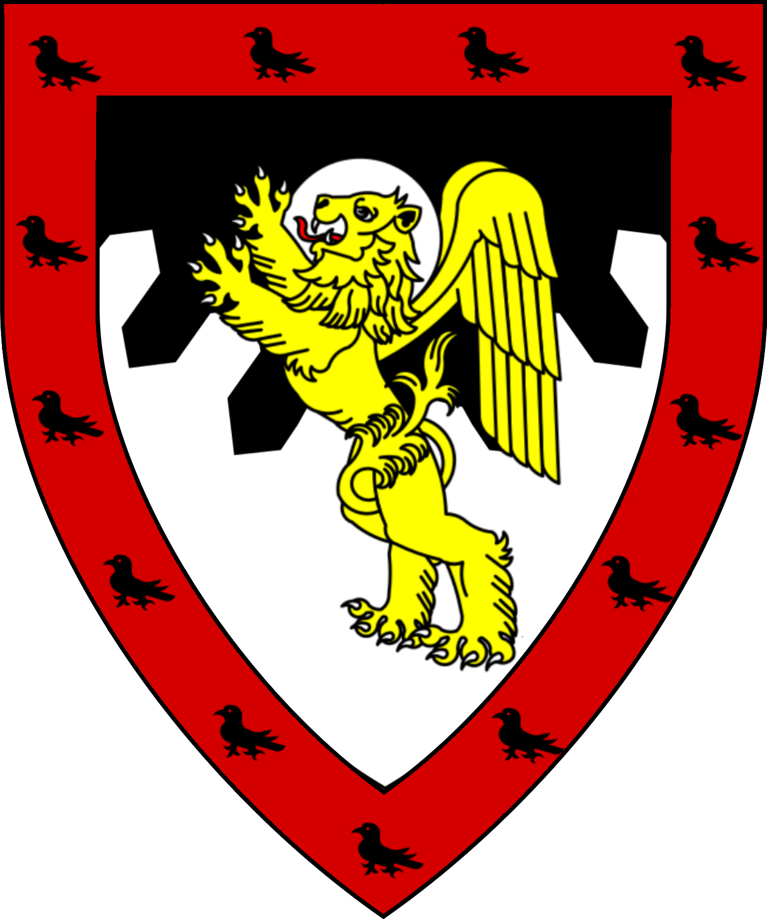
Sir Stanislav Antonov | Sir Dardanos Archapfel | Sir Priamos Archapfel | Sir Tacitus Archapfel | Sir Euandros Archapfel
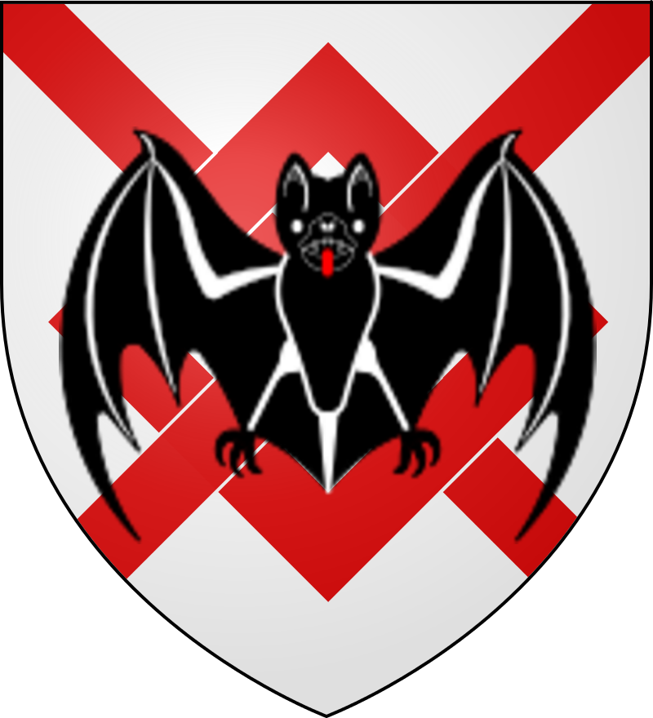 |  | 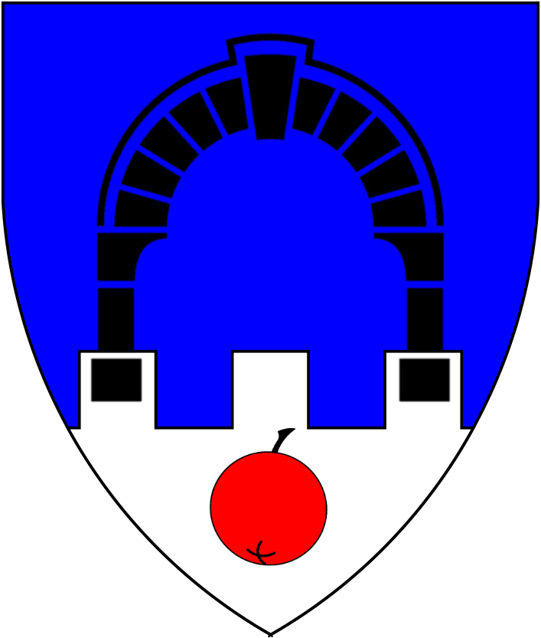 | 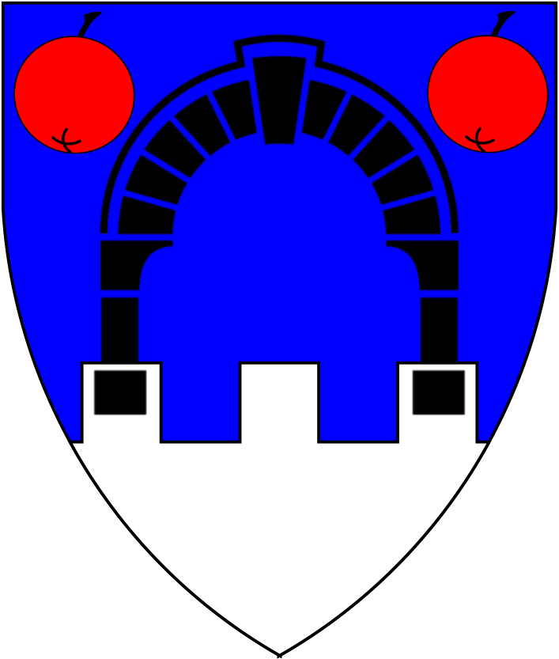 | 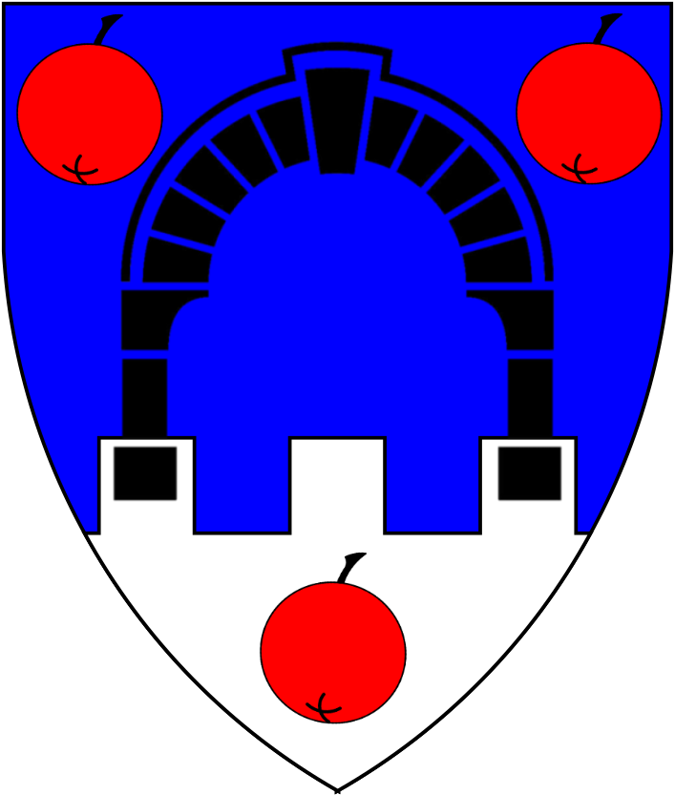
Sir Xanthos Archapfel | Sir Quintius Archapfel | Sir Temdaren of Verrau | Sir Abelaard Escar | Sir Devon Hyraksos
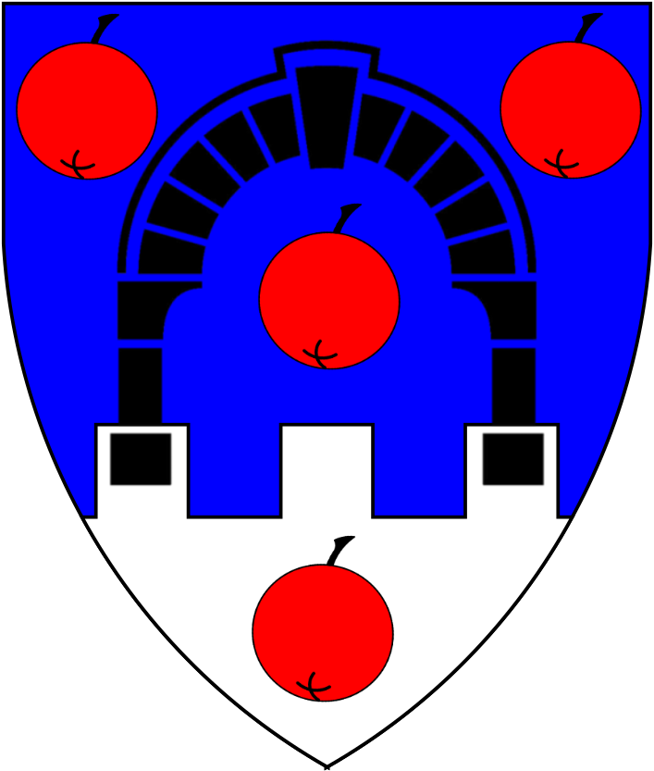 | 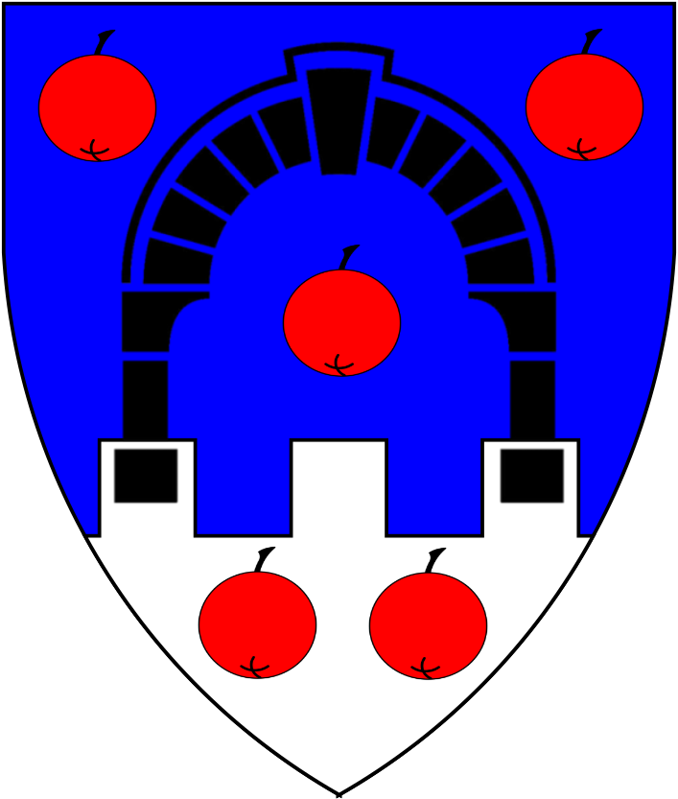 | 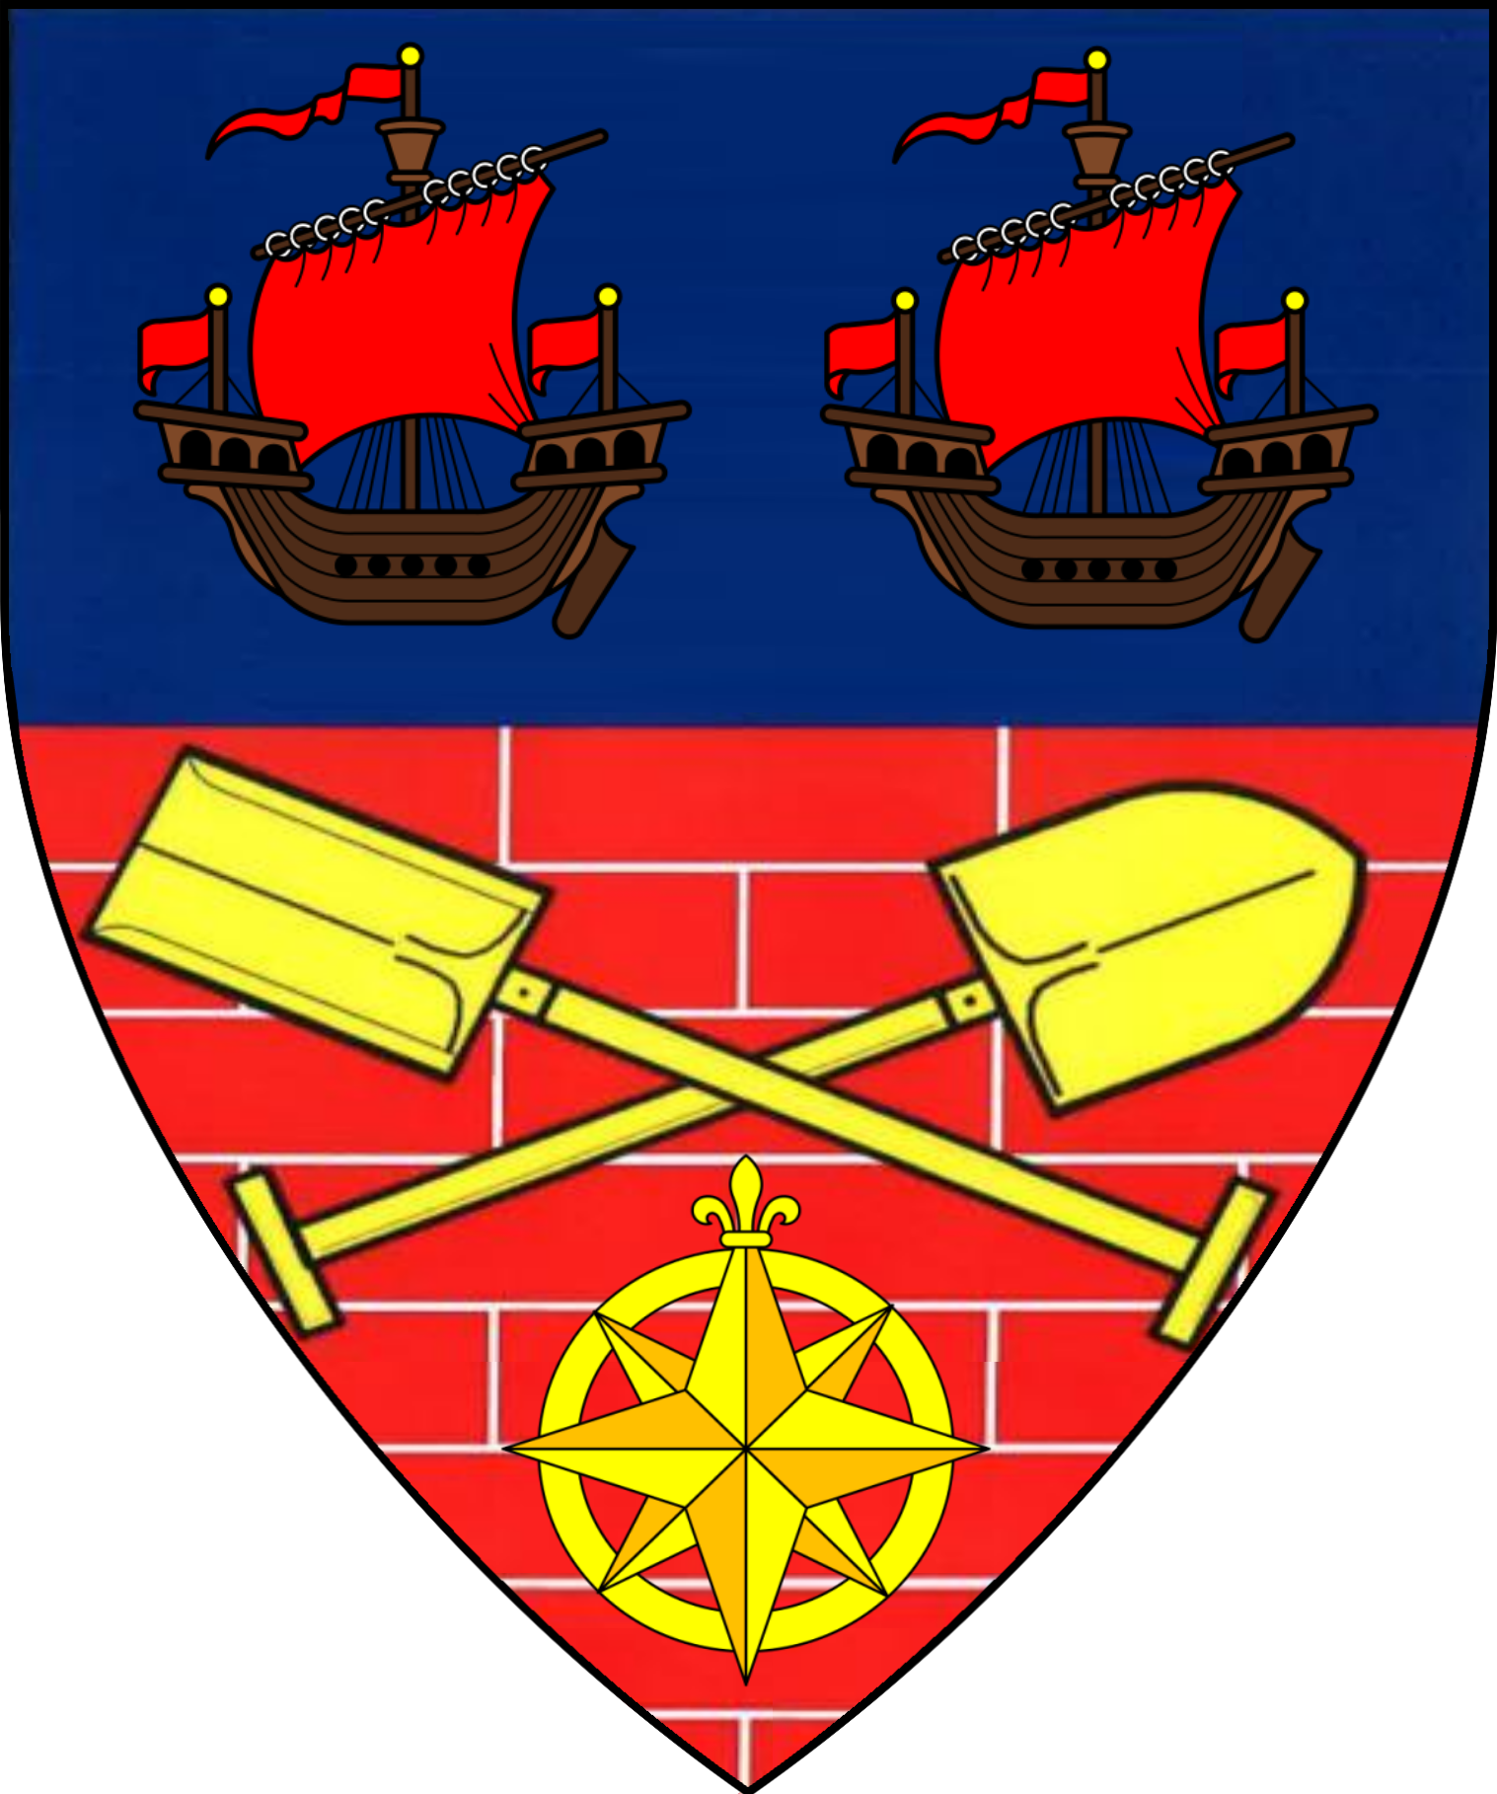 | 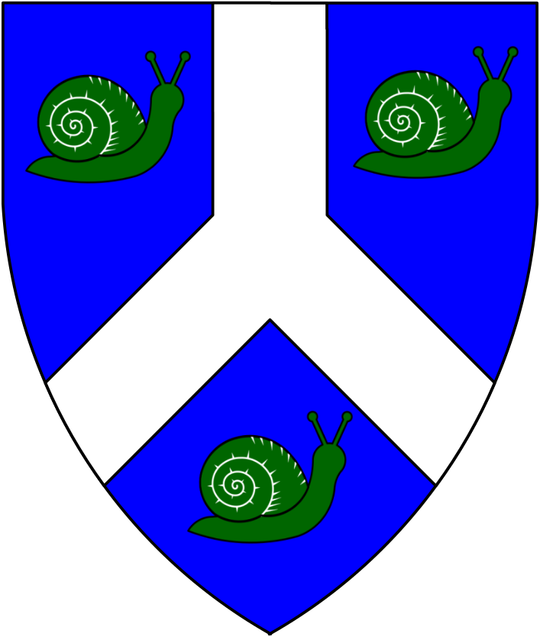

Church of Karameikos | Holy Symbol | Patriarch Jowett | Order of the Griffon
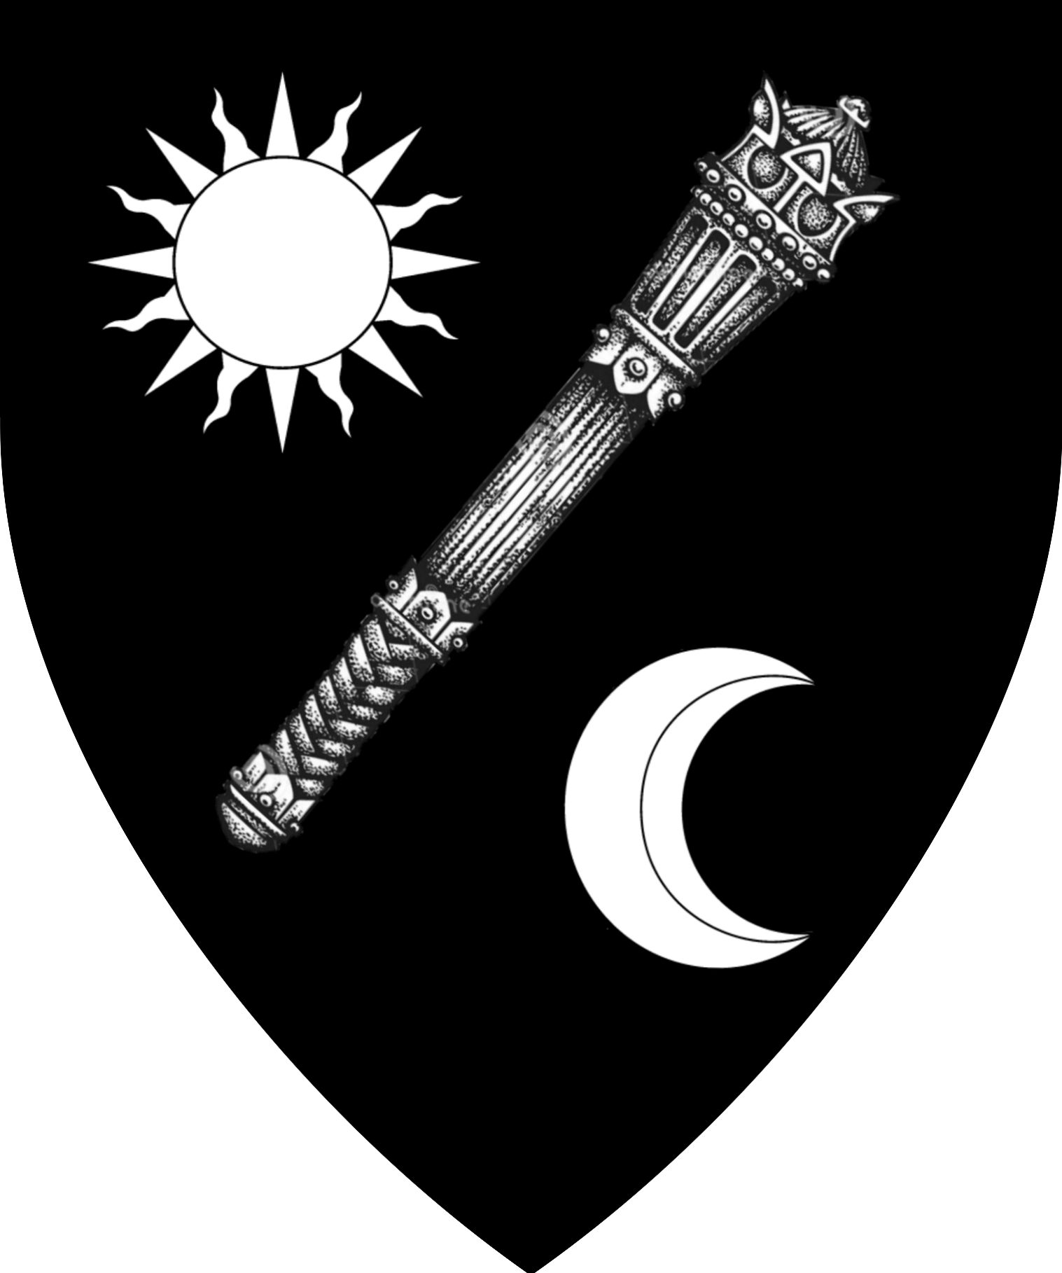 | 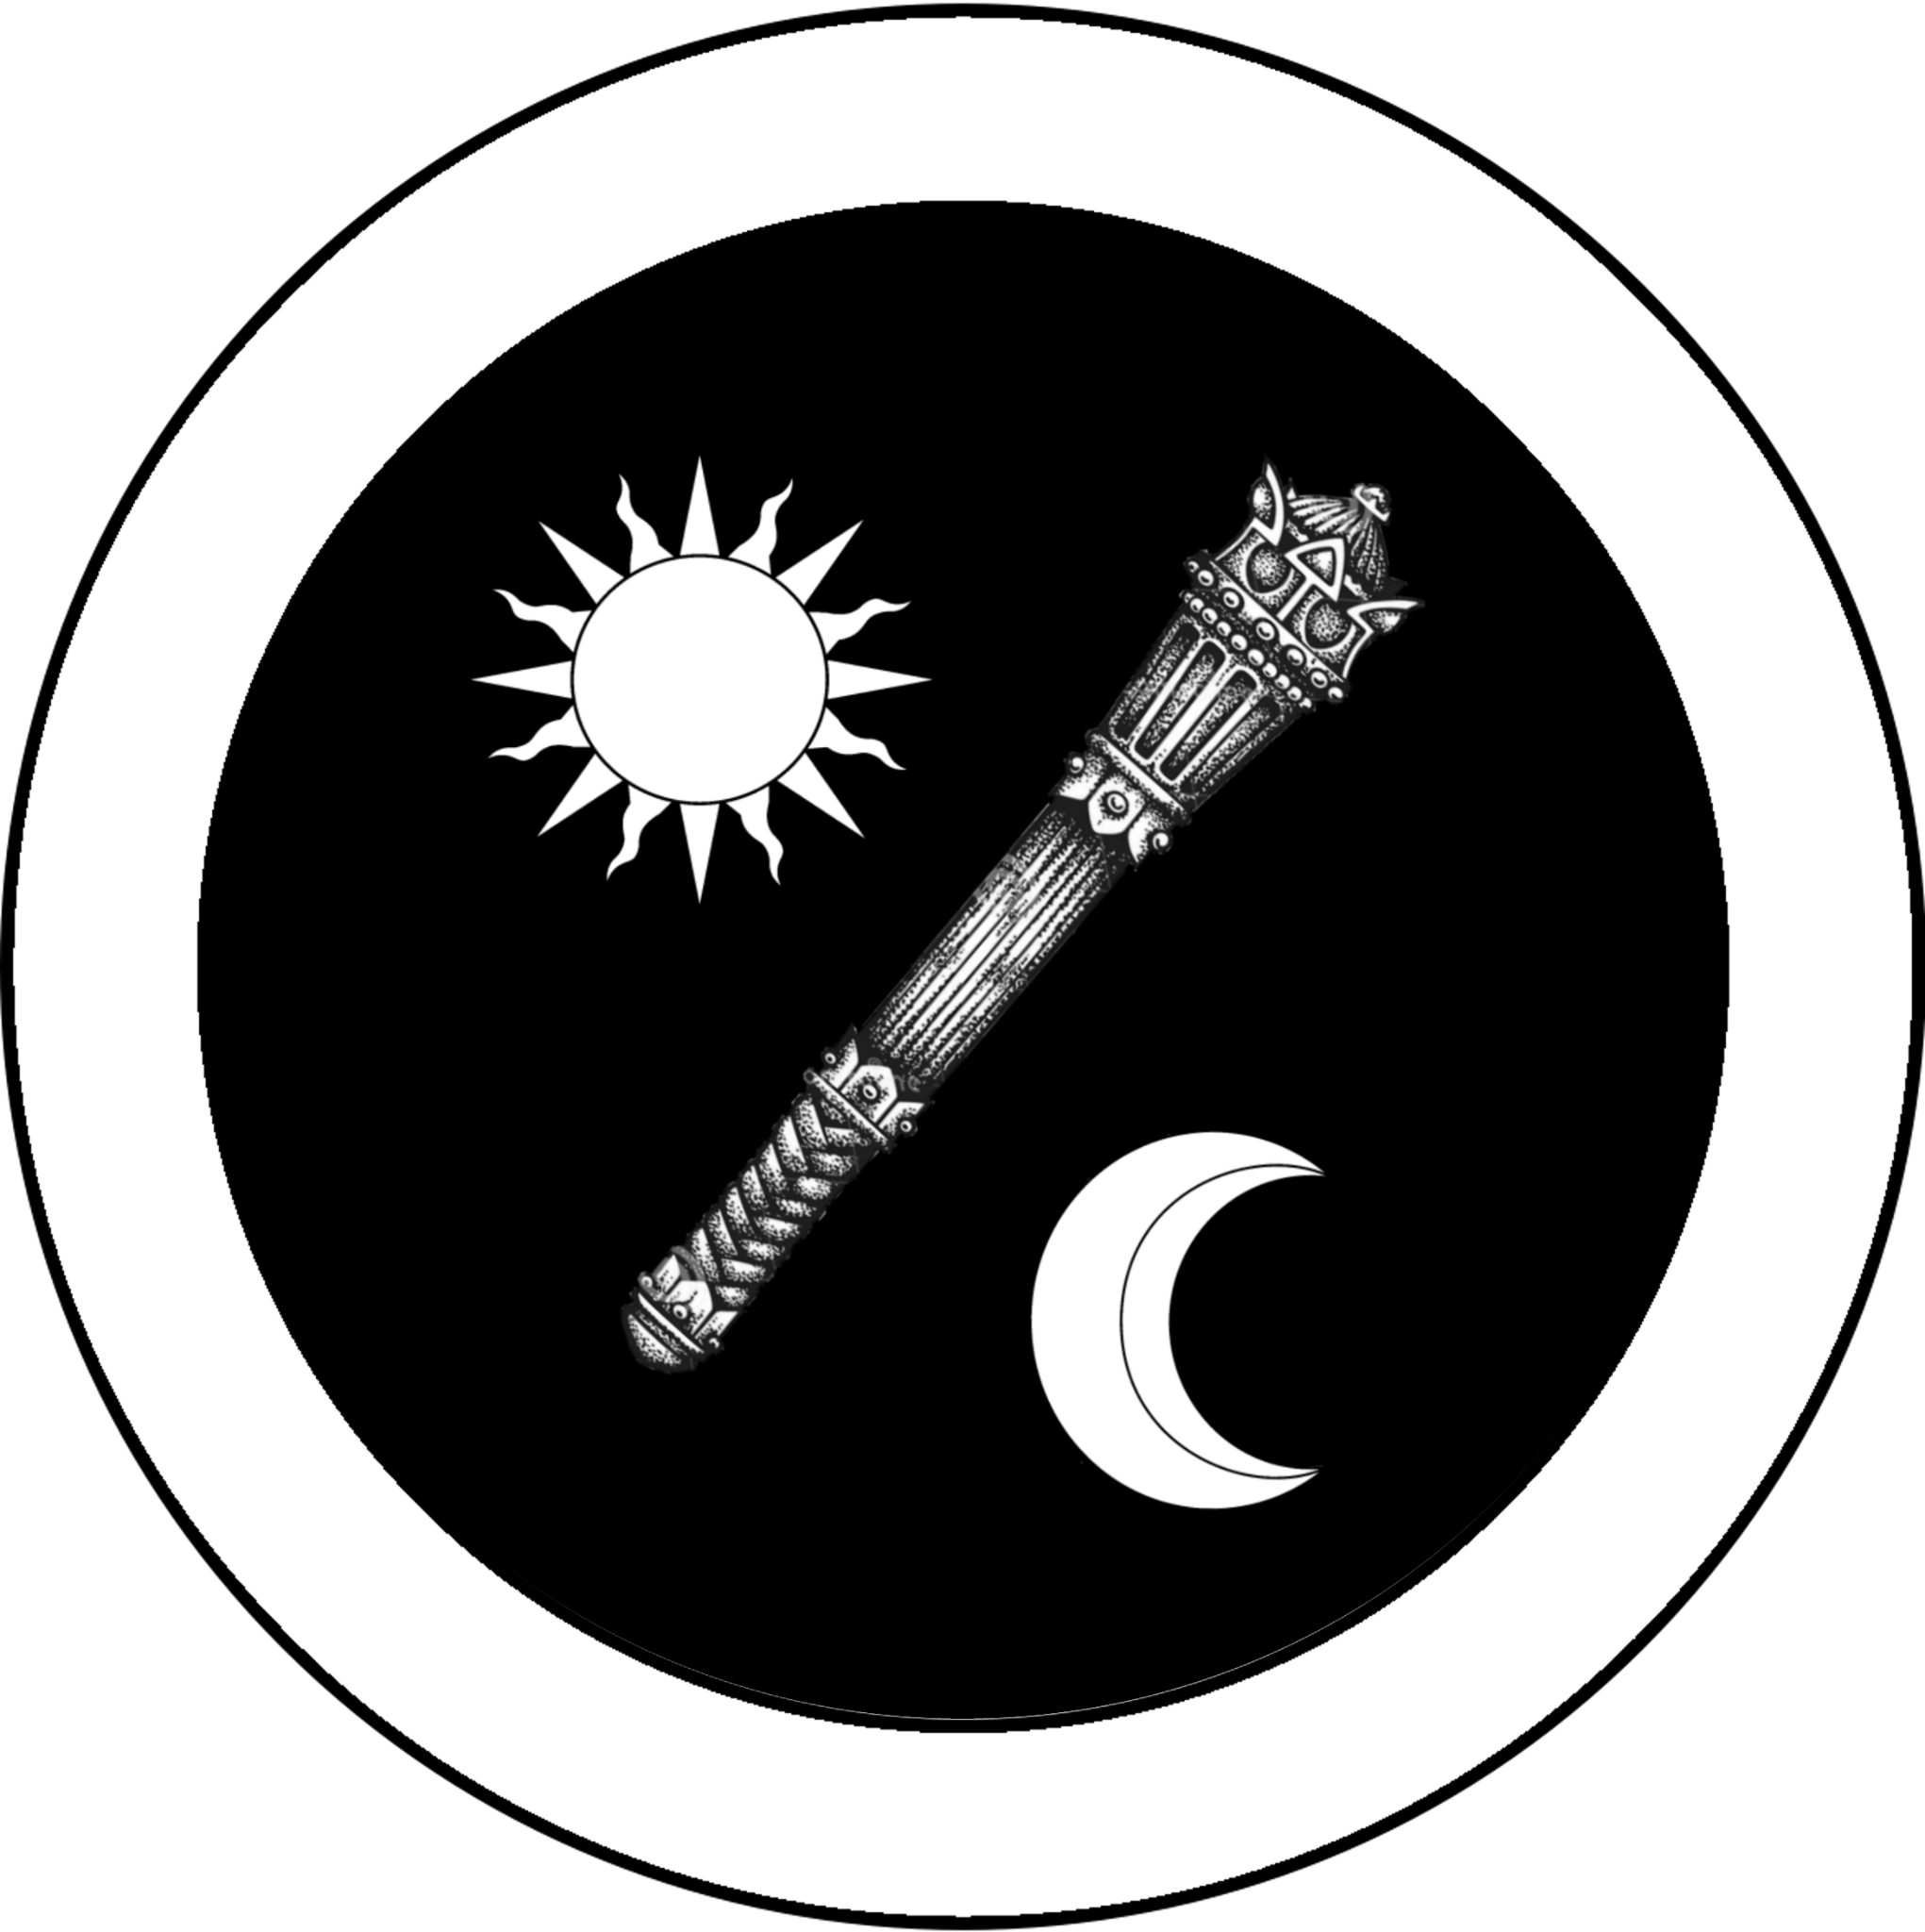 | 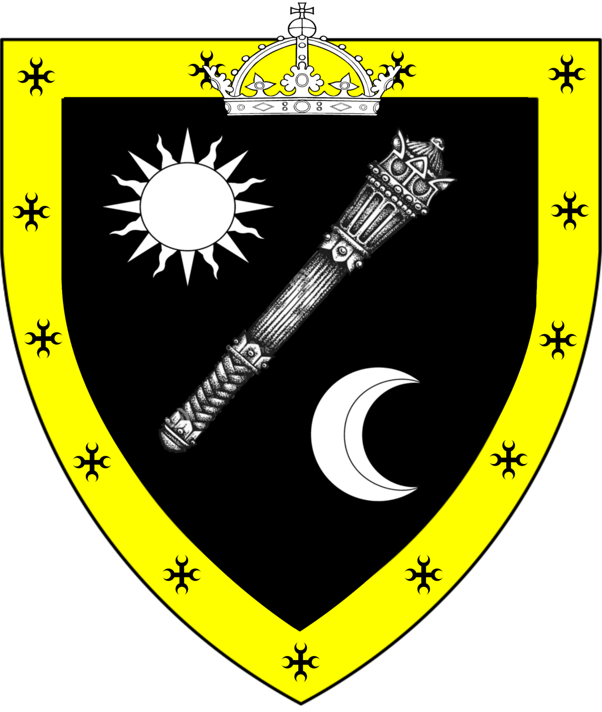
Church of Traladara | Holy Symbol | Patriarch Aleksyev Nikelnevich
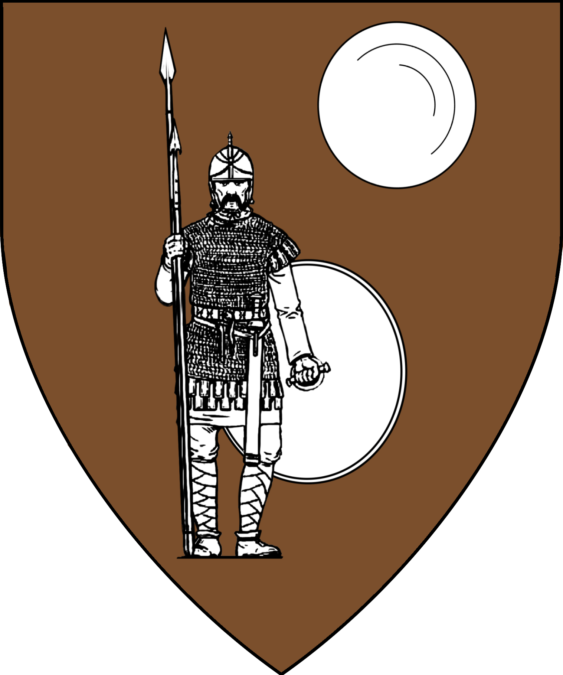 | 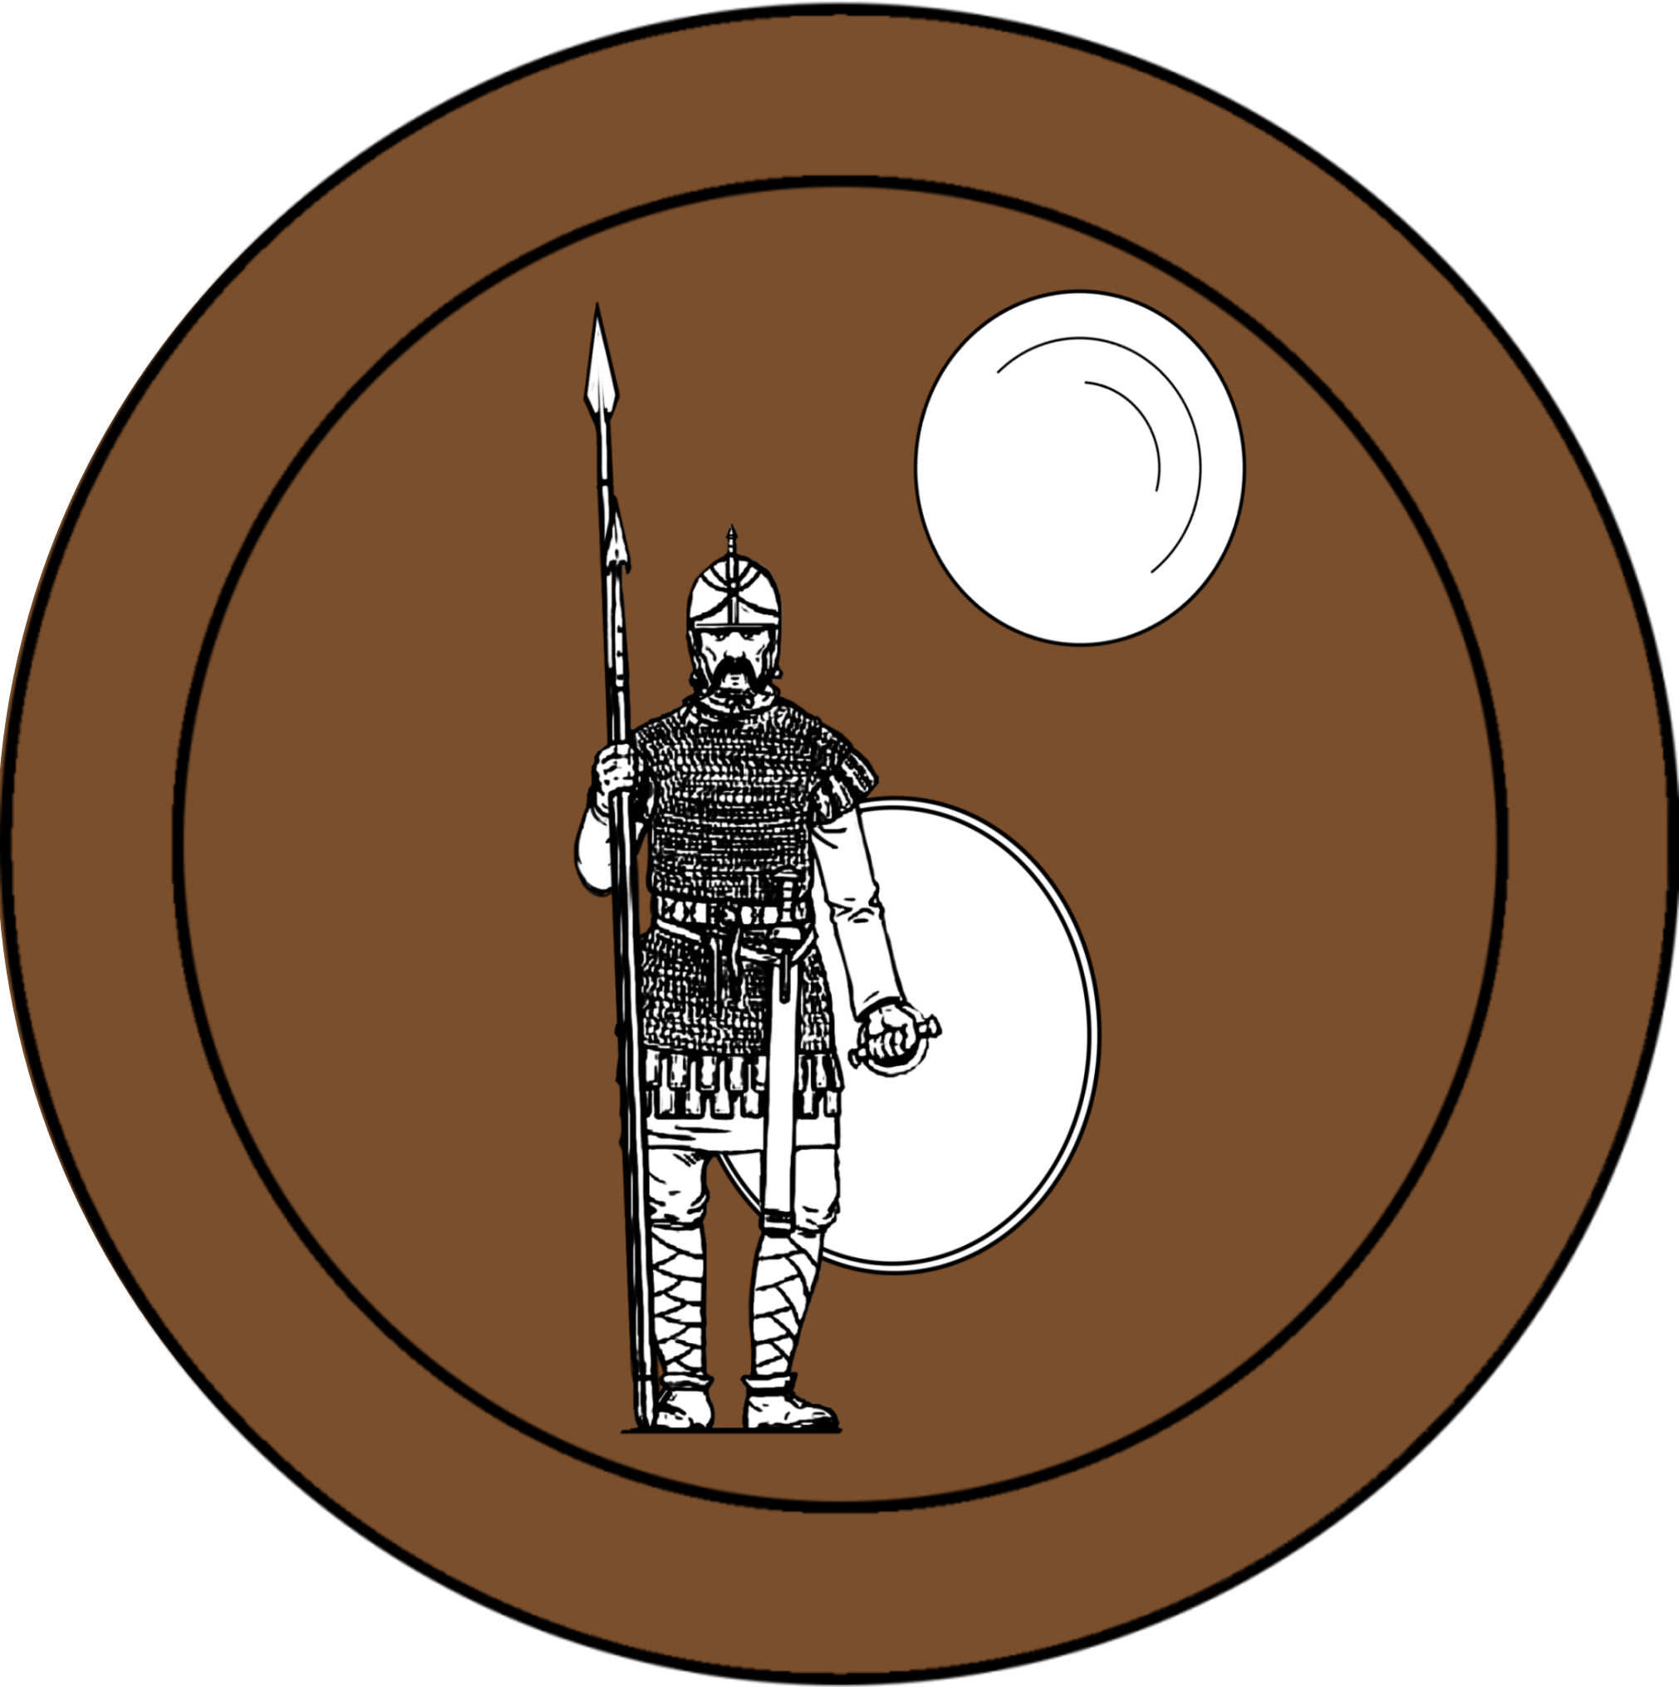 | 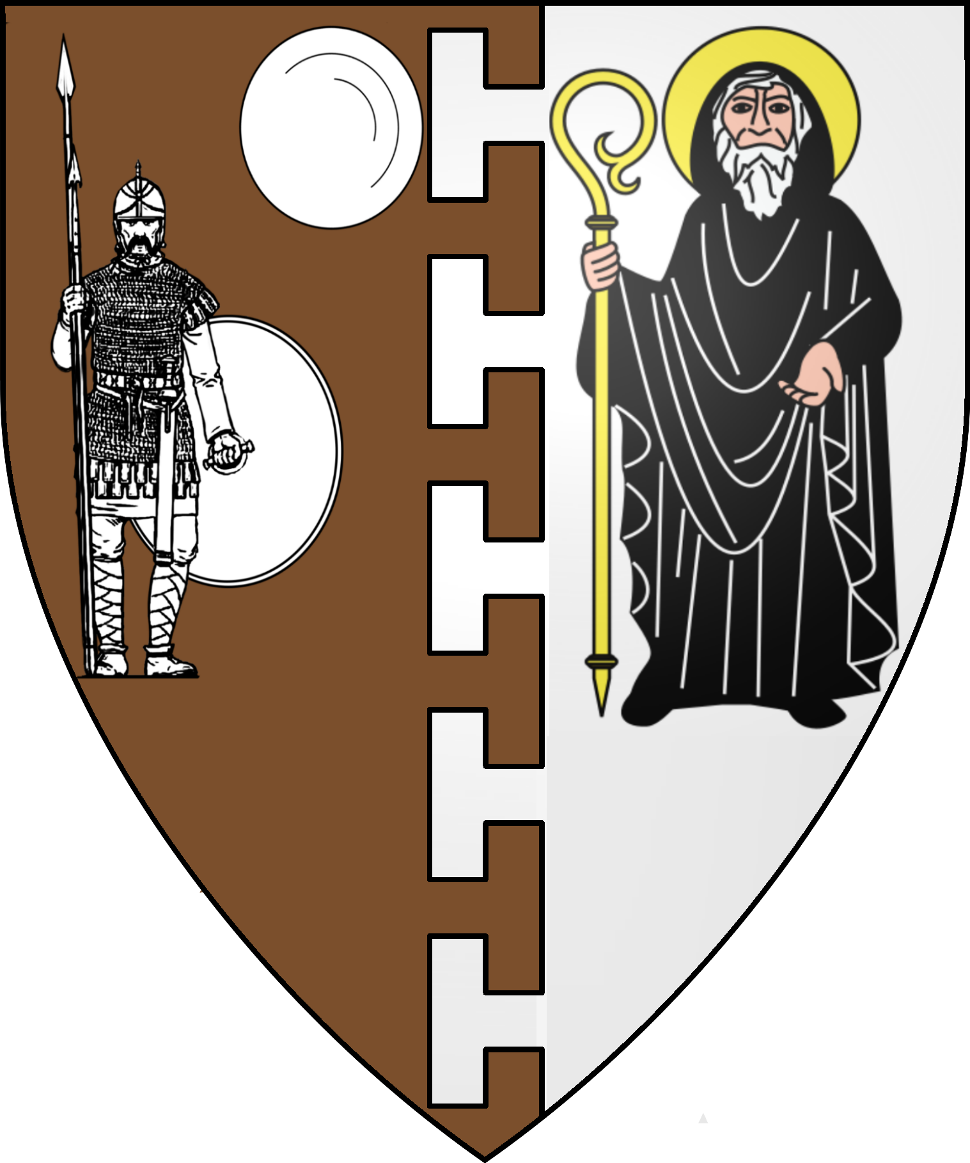
Cult of Halav Incarnate | Holy Symbol
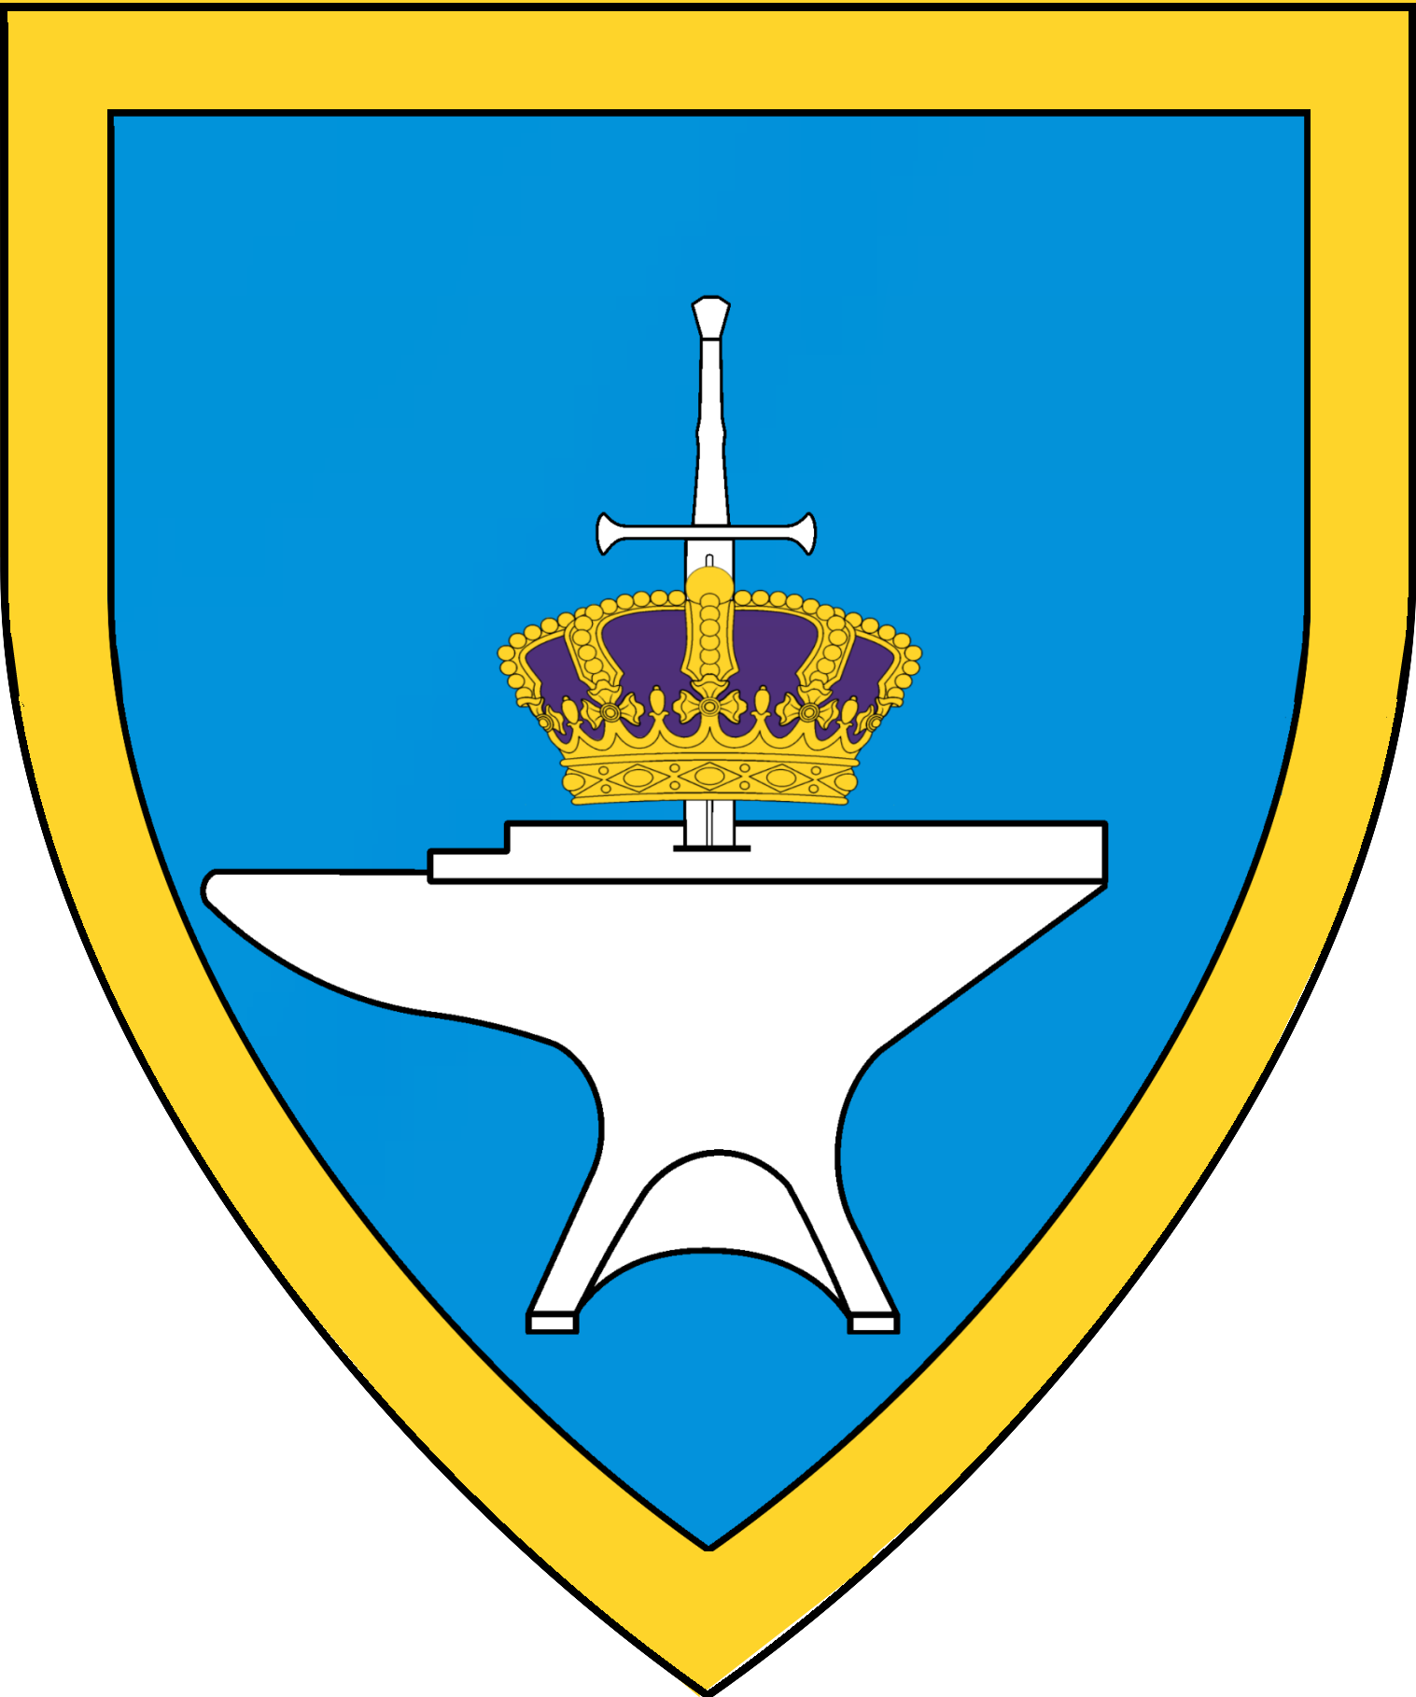 | 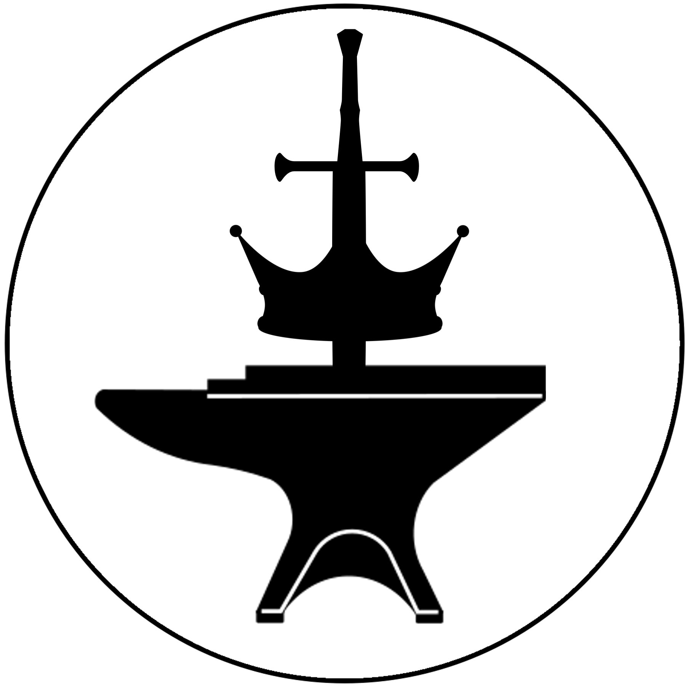
Specularum City Districts
Hill District | Bricktop District | North End | Merchant District | Old Quarter
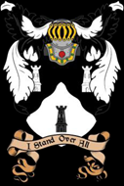 | 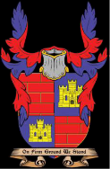 | 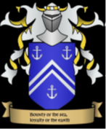 | 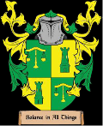 | 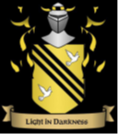
South End | Church District | Stronghold District
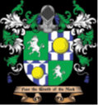 | 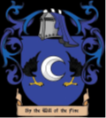 | 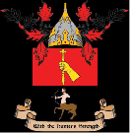
Lord Alexius Korrigan  Lord Seneschal of the Ducal Estates | Lord Zogrev Yarol  Minister of State | Admiral Lucius Hyraksos  Minister of War | Lord Bartran Cordelius  Minister of Trade | Lord Valdo Tisza  Minister of Finance
 | 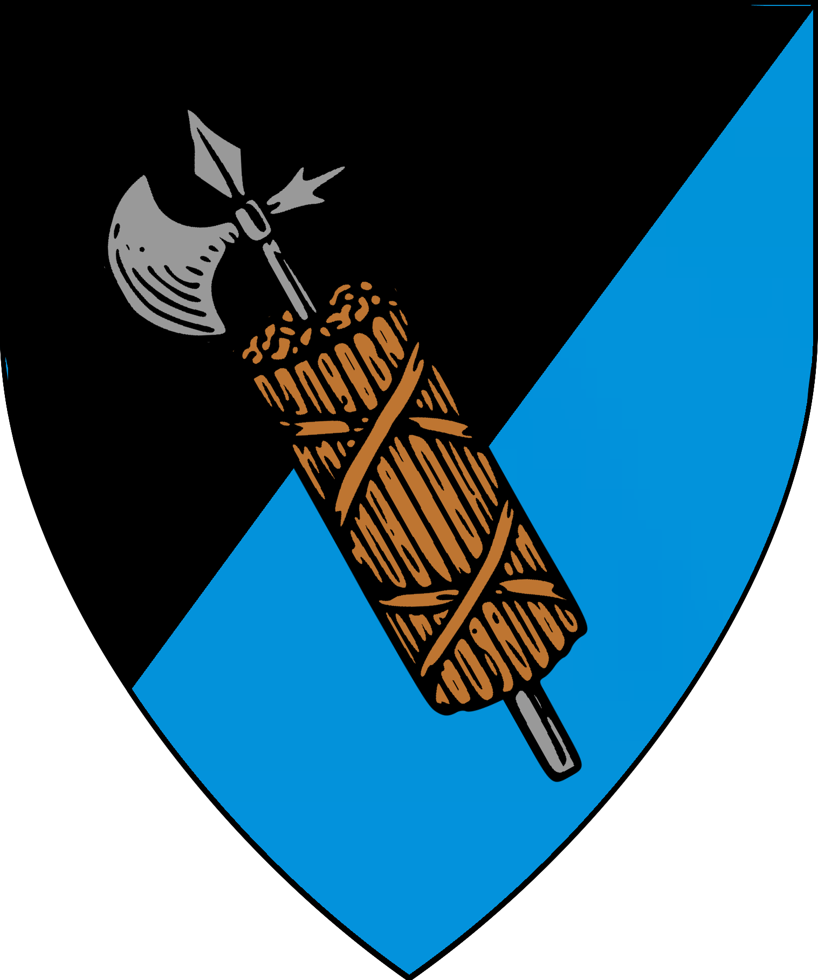 |  |  | 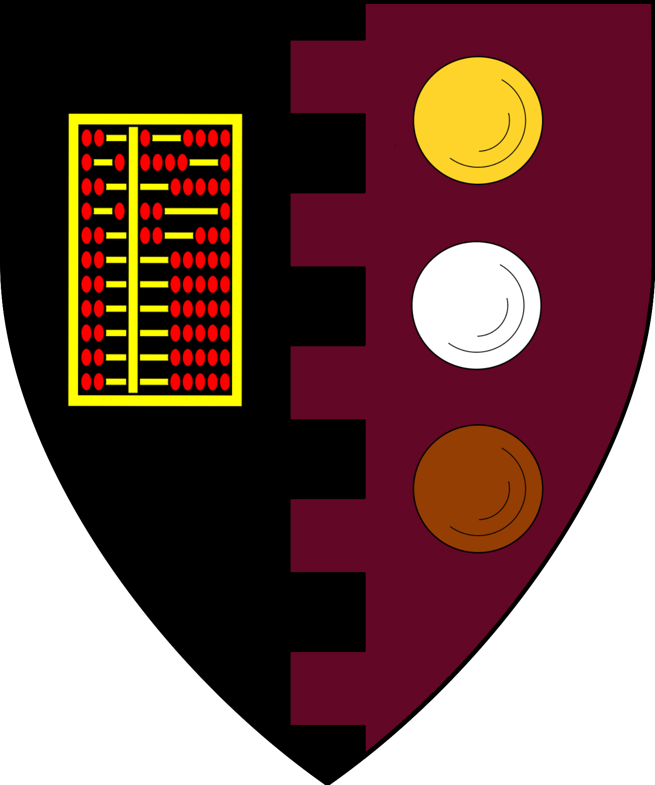
House Torenescu  Lord Pavel Torenescu | House Radu  Lord Theodoscius Radu | House Brightmane  Lord Ubi Amuru | House Moubotka  Lord Petr Moubotka | Lord Captain Robin Gadleaf
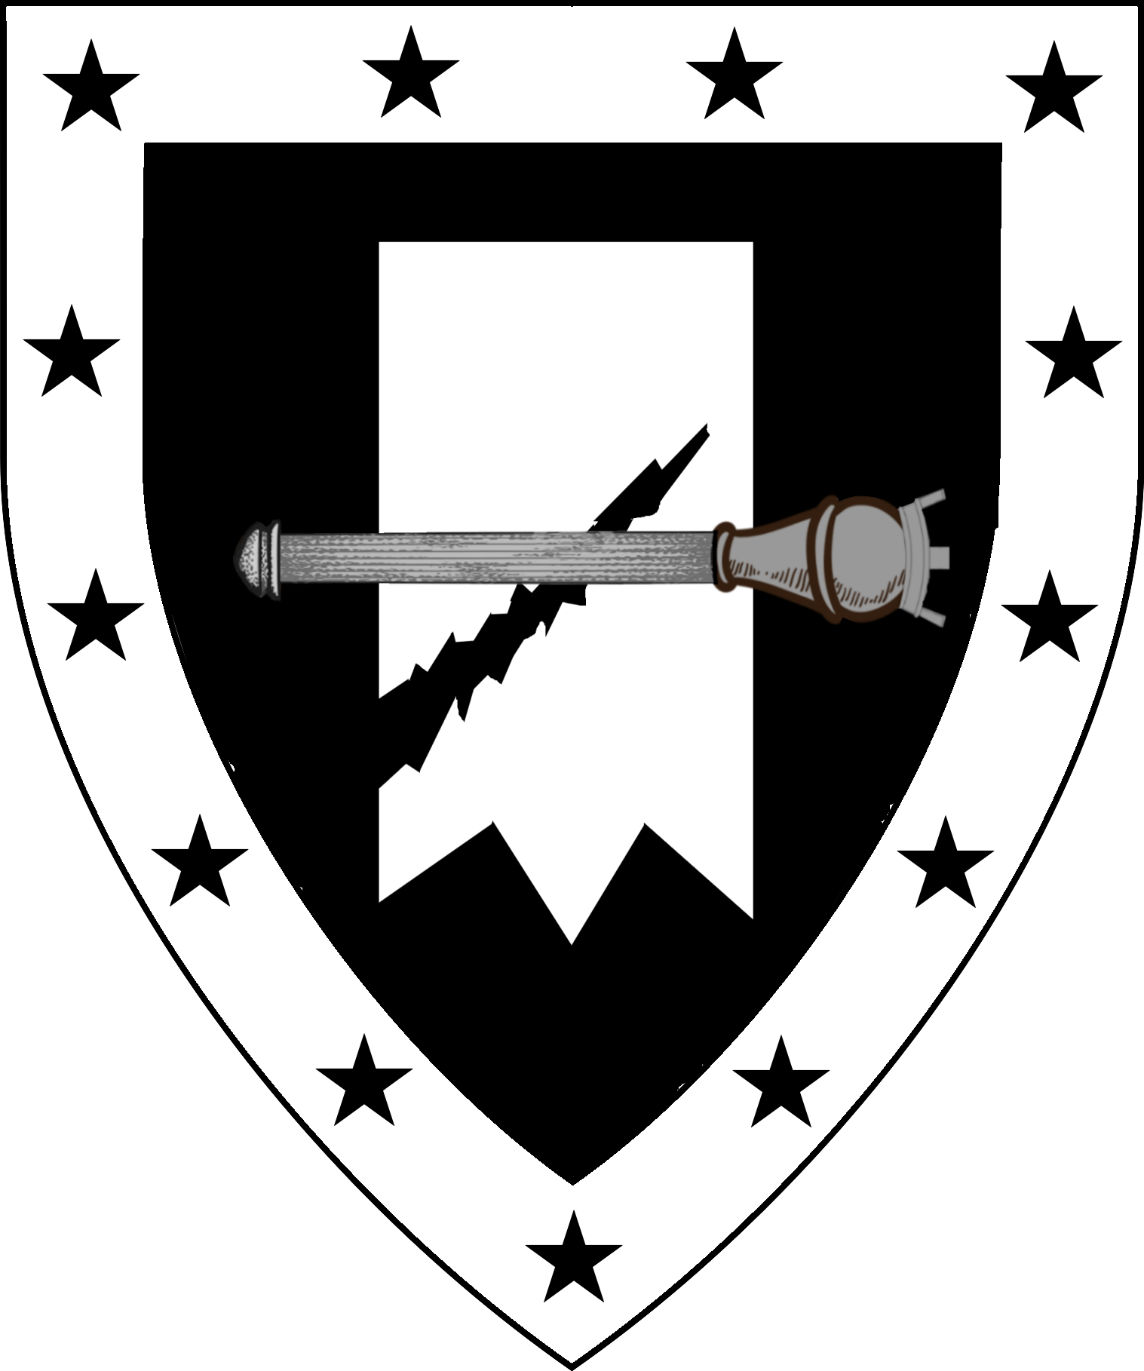 | 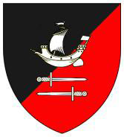 |  | 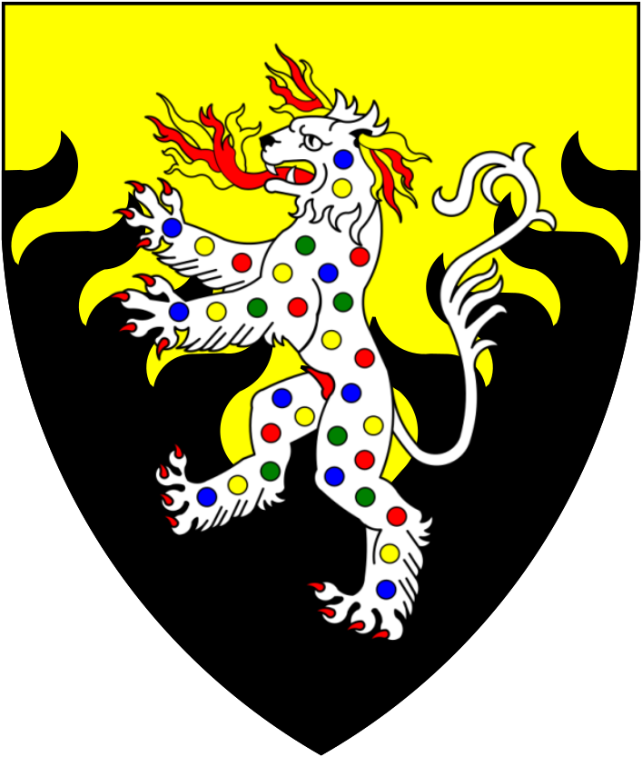 | 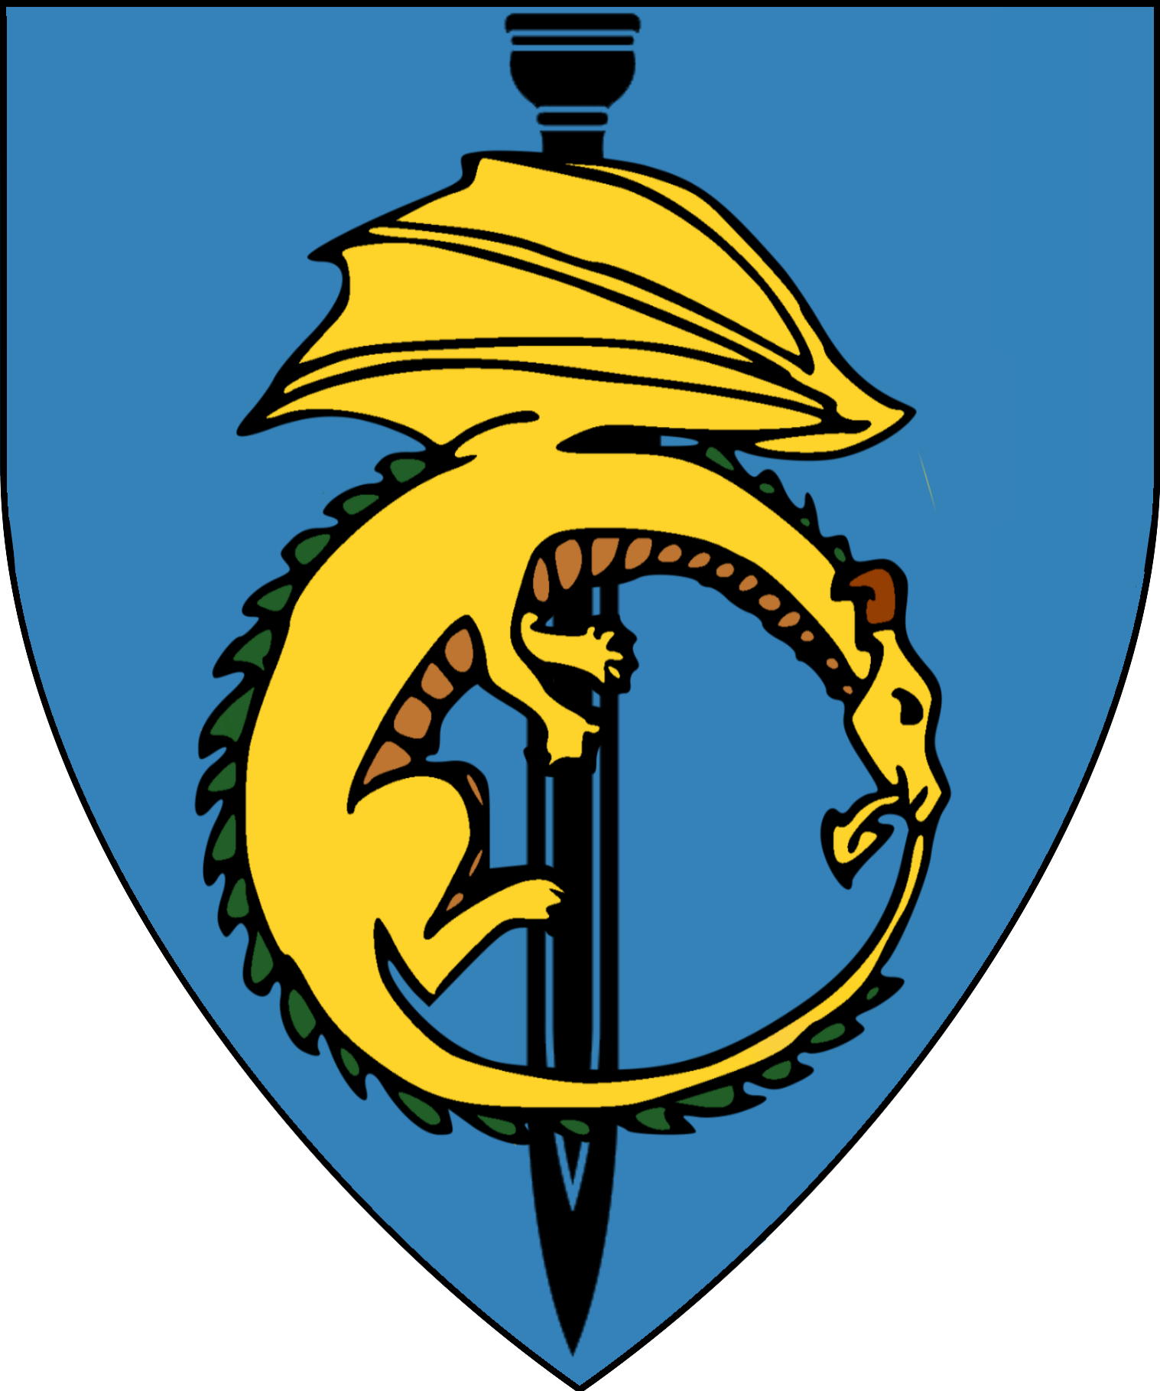
Magicians’ Guild | Merchant’s Guild | Moneychangers’ Guild | Goldsmith’s Guild | Scrivener's Guild
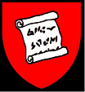 | 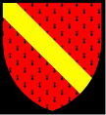 | 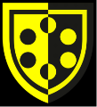 | 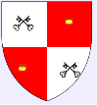 | 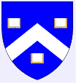
Apothecaries' Guild | Armorers | Bakers | Blacksmiths | Bowyer
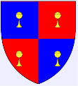 | 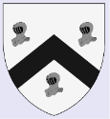 | 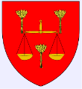 | 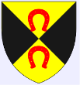 | 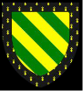
Brewers | Bricklayers | Butchers | Carpenters | Cutlers
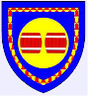 | 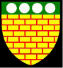 | 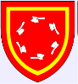 | 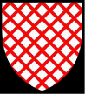 | 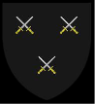
Dyers | Fishmongers | Grocers | Hunters | Innholders
 | 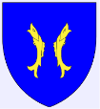 | 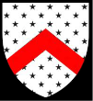 | 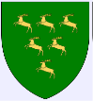 | 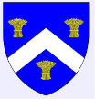
Leathersellers | Loggers | Mariners | Skinners | Tailors
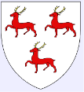 | 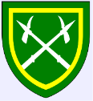 | 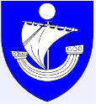 | 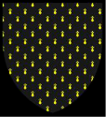 | 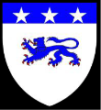
Vintners
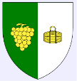
Organizations Operating in Karameikos
Ambassador’s Men | Ancient and Honorable Beggars Guild of Kelvin | Brotherhood  of the Woods | Iron Ring | Kingdom of Thieves
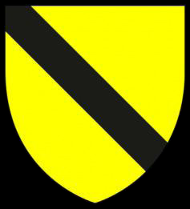 | 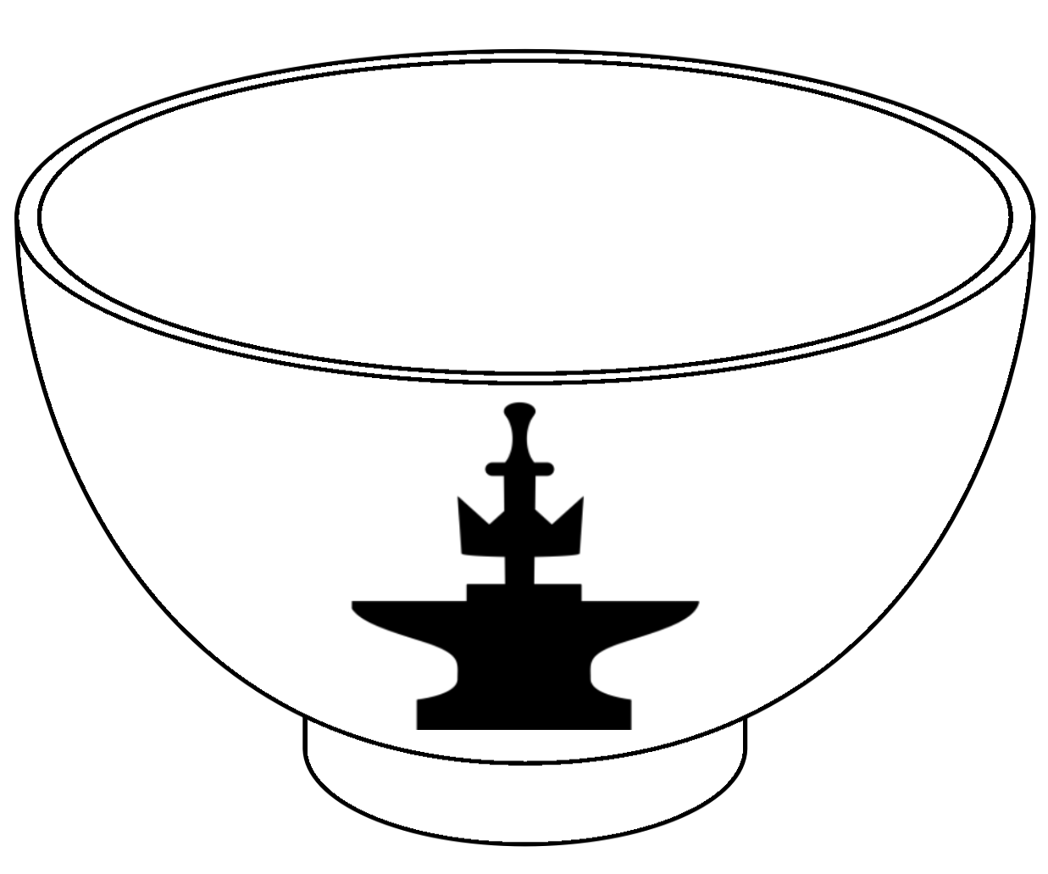 | 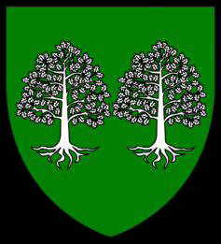 |  | 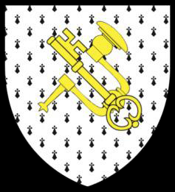
Secret Order  of the  Silver Chain | Shadow Mask Syndicate | Veiled Society
 | 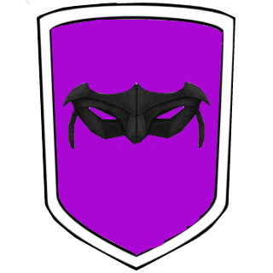 | 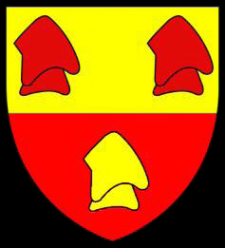
Demi-Human Domains in Karameikos
Kingdom of Hillforge | Callarii Elves | Vyalia Elves
King Dorfus Hilltopper | Chief Trader Prestelle, Rifllian | Count Yldysyl Greenheight | Lord Knight Cormac Sylvoril
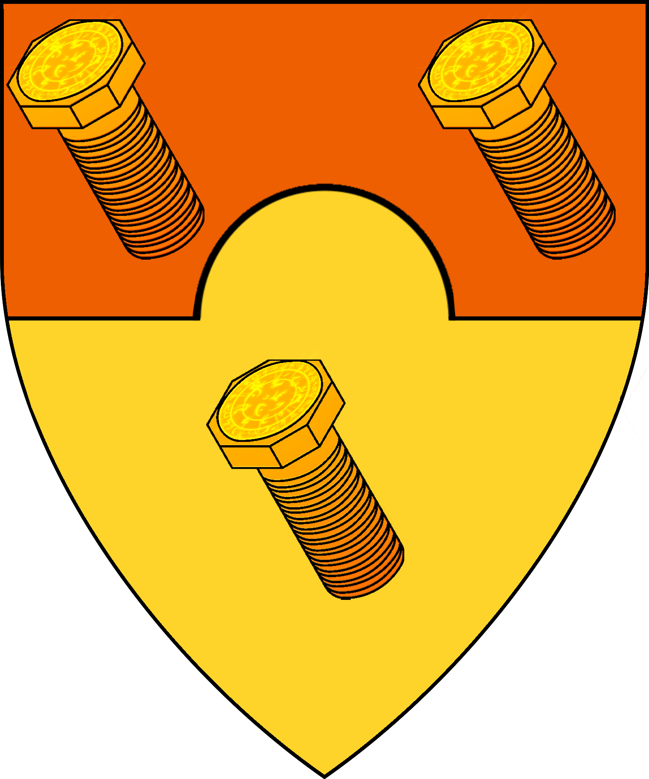 | 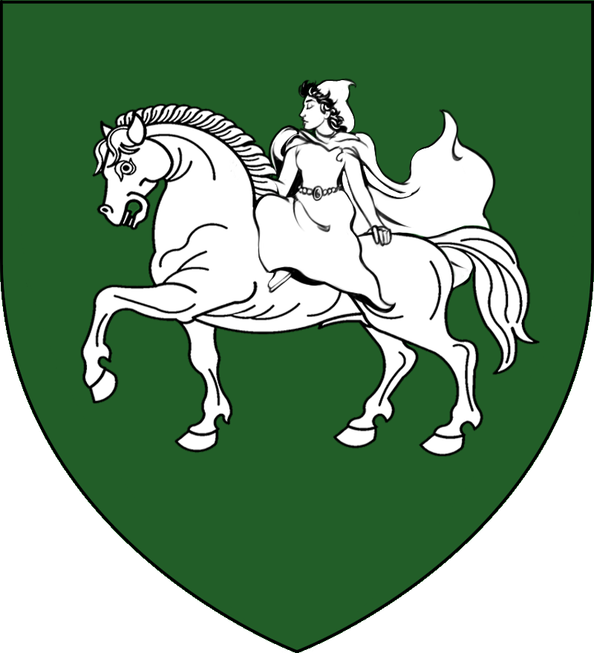 | 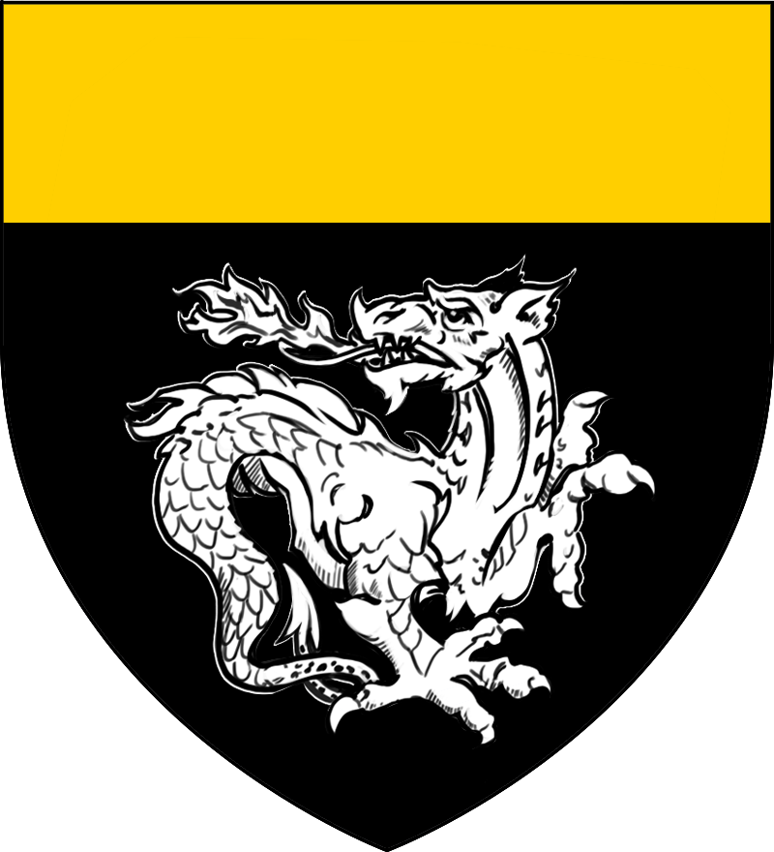 | 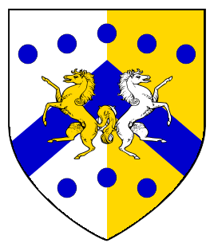

Humanoid tribes of the Grand Duchy of Karameikos circa 1000AC.
Heraldry based on the article Goblin Tribes of Karameikos by Giampaolo Agosta
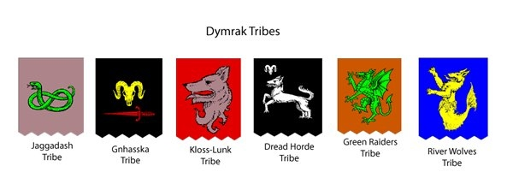
Blazonry
Jaggadash Tribe: Murrey, a serpent nowed vert
Gnhasska Tribe: Sable, a ram's skull caboshed Or and sword Gules palewise
Kloss-Lunk Tribe: Gules, a wolf's head erased Murrey
Dread Horde Tribe: Sable, a wolf rampant, and ram's skull caboshed in chief Argent
Green Raiders Tribe: Tenne, a dragon rampant Vert
River Wolves Tribe: Azure, a sea wolf Or

