The Old Mill
Originally by: Hayley Hummerston
Modified for Pathfinder by: Kenneth Kumle

An encounter for low-level Pathfinder party. This is set in Threshold, Karameikos, as it is based on a seed idea in the Basic Player's Guide, but should fit into any town which has an old crowded mercantile area. Originally written by Hayley Hummerston for the BECMI rule set, I ported it into Patherfinder for the game I am running. In my adventure the dungeon was being used by goblins to sneak into town and kidnap young girls (see TC1) and preform stealth raids into Threshold! The tunnel connecting the Old Mill to the brush hut outside of town was carved by kobold miners (currently based in castle Mistamere with Bargle). And the whole mini adventure was adapted as a lead in for the TC1 adventure.
The PC's are wandering in the rough area on Fogor's Isle when they hear a man scream. They head towards the scream and see a man being attacked by a Giant Centipede. There is rubble nearby if they wish to attack it with rocks. The man is a merchant, Carst (2nd-level human commoner), who complains of centipedes and rats raiding his warehouse. Carst is impressed with the performance of the party and offers them 200gp plus cures (credit note issued on local chapel for no more than 4 potions of Cure Light Wounds) to clean out the Old Mill next door of the pests which are eating into his profits.
(1) Carst's Warehouse. Large double entrance doors to the north lead into a central area to load carts. The floor is well-swept packed earth. At the sides are stacked sacks of nuts and fruit. Bales of fur and smaller casks (brandy) sit on racks to the west. A trapdoor above with a movable ladder leads to (4) and a door on the north leads to (2)
(2) Carst's Clerks. There are two small desks near the door, covered with paper (invoices, bills, etc) at which Carst's two clerks (0-level men) sit on stools. A plain wardrobe (unlocked) against the north wall behind them (containing their cloaks and hats, paper, pens, ink and a petty cash box with 500cp, 100sp and 10gp) sits beside a large plain trunk (for ledger books, bills and invoices, etc). Door to west leads to (3)
(3) Carst's Office. In the northwest corner under a window, is a large uncluttered desk with a large chair behind it which belongs to Carst. A secret panel under the desk contains gems worth 1500gp and 973 gp in various coins. There are three more chairs in front for visitors. On the east wall is a well-carved wood cabinet. It is locked and trapped with a needle that stings for 1 HP damage and leaves an indelible purple dye. It contains private papers and two flasks (the blue one is Cure Light Wounds and the red is Neutralize Poison). Carst buys new potions at the local chapel when a flask is used up and keeps the only key around his neck. A door on the east wall leads to (2) and a barred window to the north overlooks the street.
(4) Warehouse Attic. This low-ceiling area is covered with more cloth bales and sacks of grain. A crane stands near the trapdoor leading down.
(5) The Old Mill. This is filthy, muddy and its roof and upper floor have mainly fallen down. A pack of normal rats live in a lair in the rubble in the northeast corner and will flee to g if startled or engaged. Rat swarm(1) – see below. A ledge around the east and south walls is all that is left of the upper floor. In the southwest corner is a large pile of fallen timber which surrounds a hole in the floor - it is visible from the ledge. There are some roof beams nearby - strong enough to support bodies descending on ropes for the 10 feet to the floor of (a) below.
(a) Underground Room. A muddy and damp stone room, with several holes in the stonework now in the east, south and northwest. A thin trickle of water leads east. A secret door panel (DC-15 perception check to locate) covers a storage area with a rope ladder, key to the gate in (g), 4 hooded cloaks and a disguise kit.
(b) Dire Rat Lair (4)-see below, beyond the matted mess that the rats use as a nest, there is nothing else of interest in this room.
(c) Giant Centipede Lair. Giant Centipedes (5) – see below. The thin trickle of water continues east.
(d) Pool. Dark and slimy, formed from runoff of rainwater, containing rusted key, old boot, animal bones, coins amounting to 22gp and a ruby (50gp) and quartz necklace (1100gp)
(e) Centipede Swarm (1) – see below. Once disturbed, the centipedes will swarm over any PC foolish enough to stand their ground. The unlabeled room just south of e contains a mass of centipede eggs (DC-10 survival/kn: Nature/kn: dungeoneering to identify) that if left undisturbed will repopulate the centipedes inside the year.
(f) Tunnel. This tunnel starts as a natural hole, but becomes a wide and straight new construction.
(g) Cave. This is the home of a rat swarm (1) – see below. IF the rats were startled or engaged earlier the swarm will be found here and will fight as though cornered, else the room is empty and reeks of rat dung and urine. The gate in northeast has a string alarm (DC-15 Perception and Disable Device) and is locked, use the key (if found) or a DC-20 disable device check to open.
(h) Tunnel. Dwarves will observe (DC-10 perception check for Dwarves, DC-15 kn:Engineering for all others) this is a new construction - the walls are wet but not slimy. There is a bucket with rancid meat near the gate to the west. Secret doors to south lead to (i) and (j), DC-20 perception check to spot one. The tunnel continues for about 2 miles, coming out in a well disguised brush hut outside of Threshold in the woods on the western side of the river.
(i) Conference Room. 7 goblin guards watch through a peep-hole if warned by the alarm in (g) They will not reveal themselves unless the party appears weak or the door is found, but will instead follow the party and report to their headquarters. If they are losing a battle, they will try to escape through (j). There is also a table, 6 chairs, wardrobe with two cloaks and some sacks. On the table are a map of Threshold, pens and paper. There is an open door to the east and a secret door to the north leads to (h).
(j) Guard Room. 7 bedrolls and 4 rough straw mattresses cover the floor. Personal possessions of the goblin guards in (i) are here - mainly poor quality clothing and spare weapons except for 44gp and 60sp in coins in a pouch under the bed and 2 disguise kits. A secret door to the north leads to (h).
(6) Brush Hut: This 30’ diameter round, well disguised hut, appears as little more than a large pile of brush from the wooded area around it. The exit door to is concealed from the outside and there is a trap door and ladder leading to the tunnel from h. If any goblins escape from the PCs in the Old Mill, they will be found here and will have warned the few goblins stationed here. If the goblins in the Brush Hut are not warned then they can be surprised by the party, else the goblin wolf rider will ride out to some nearby caves in order to get reinforcements and will return with two(2) additional wolf riders 4 rounds after combat is joined by the PCs and the remaining goblins at the Brush Hut. Stationed here are a goblin sniper (1), goblins (2), and a goblin wolf rider (1) – see below. Within the Brush Hut are two casks of ale (5gal each), a crate with small size short bows (4) and quivers of arrows (12), a crate with small size leather armor (4) and disguise kits (3), a crate with rancid meats, and a crate with small size cloaks (worthless) straw and other bedding. Throughout the Brush Hut there can be found several pouches of coins as well, containing a total of 200gp, 230sp, and 400cp.

Note: if the connection between the goblins, kobolds, and the missing girls is made then Baron Harlan will offer a 50gp bounty for every goblin and kobold slain by the PCs until the threat to Threshold’s population is ended (ie- the missing girls are recovered and Bargle is slain or forced to flee [see TC1]).

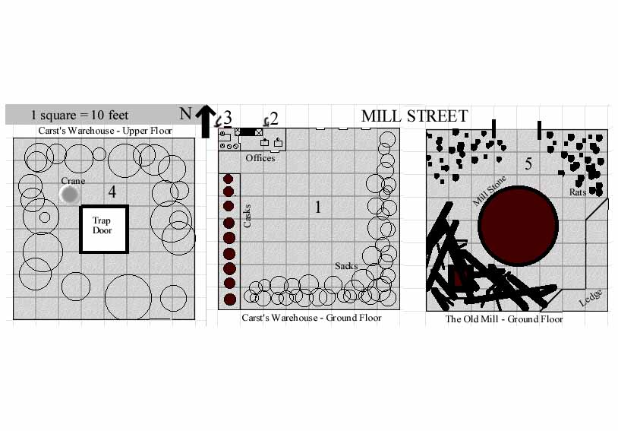
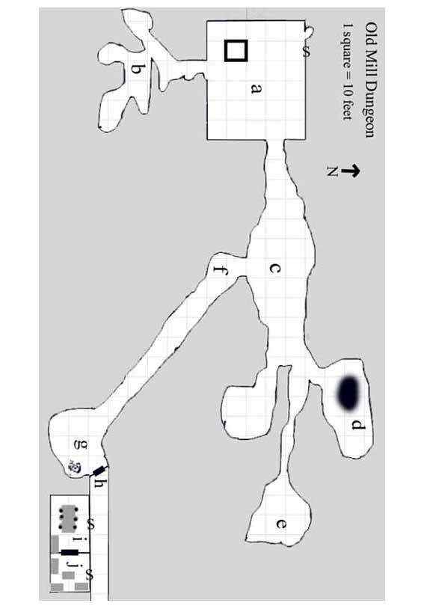
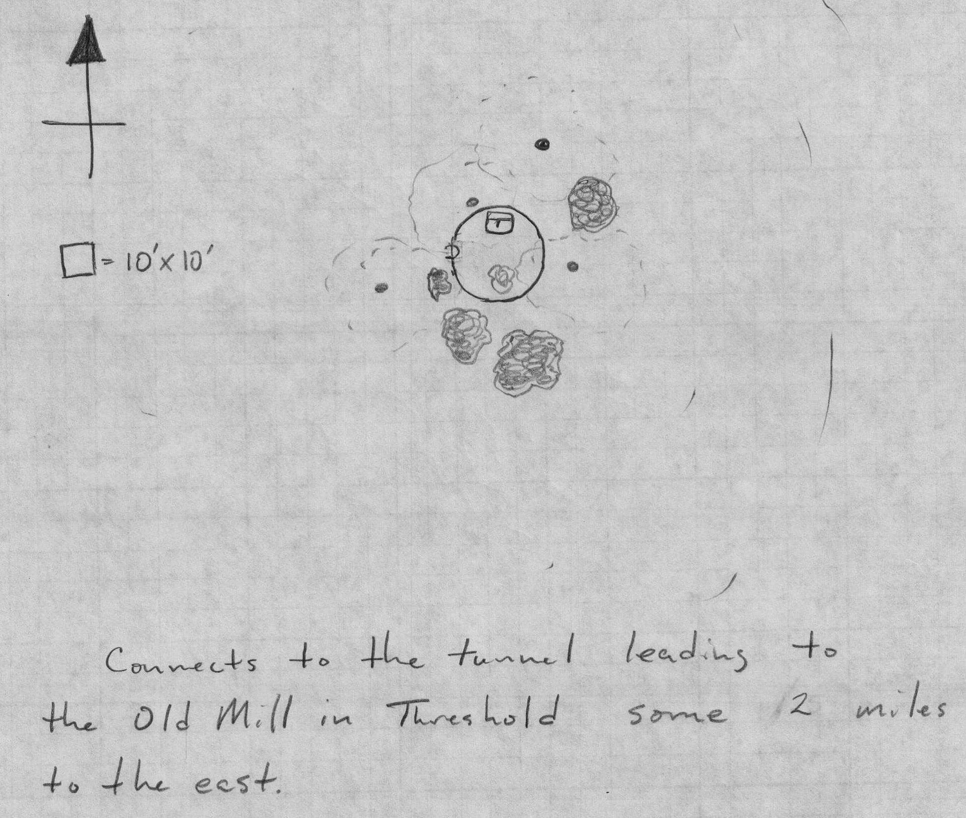

Centipede, Giant
CR 1/2; 200 XP
N Medium vermin
Init: +2; Senses darkvision 60 ft.; Perception +4
Defense: AC 14, touch 12, flat-footed 12 (+2 Dex, +2 natural); hp 5 (1d8+1); Fort +3, Ref +2, Will +0; Immune mind-affecting effects
Offense: Speed 40 ft., climb 40 ft.; Melee bite +2 (1d6–1 plus poison); Special Attacks poison
Statistics: Str: 9, Dex: 15, Con: 12, Int: —, Wis: 10, Cha: 2; Base Atk +0; CMB –1; CMD 11 (can’t be tripped); Feats Weapon Finesse ; Skills Climb +10, Perception +4, Stealth +10; Racial Modifiers+4 Perception, +8 Stealth
Ecology: Environment temperate or warm forest or underground; Organization solitary, pair, or colony (3–6)
Treasure none
Special Abilities: Poison (EX) Bite—injury; save Fort DC 13; frequency 1/round for 6 rounds; effect 1d3 Dex damage; cure 1 save. The save DC is Constitution-based and includes a +2 racial bonus.

Centipede Swarm
CR 4; 1,200 XP
N Diminutive vermin (swarm)
Init +4; Senses darkvision 60 ft., tremorsense 30 ft.; Perception +4
Defense: AC 18, touch 18, flat-footed 14 (+4 Dex, +4 size); hp 31 (9d8–9); Fort +5, Ref +7, Will +3; Defensive Abilities swarm traits, Immune weapon damage
Offense: Speed 30 ft., climb 30 ft.; Melee swarm (2d6 plus poison); Space 10 ft.; Reach 0 ft.; Special Attacks distraction (DC 13), poison
Statistics: Str 1, Dex 19, Con 8, Int —, Wis 10, Cha 2; Base Atk +6; CMB —; CMD —; Feats Weapon Finesse Skills Climb +12, Perception +4; Racial Modifiers +4 Perception
Ecology: Environment temperate or warm forest or underground; Organization solitary, pair, or tangle (3–6 swarms)
Treasure none
Special Abilities: Poison (Ex) Bite—injury; save Fort DC 13; frequency 1/round for 6 rounds; effect 1d4 Dex damage; cure 1 save. The save DC is Constitution-based and includes a +2 racial bonus.

Dire Rat
CR 1/3; 135 XP
N Small animal
Init +3; Senses low-light vision, scent; Perception +4
Defense: AC 14, touch 14, flat-footed 11 (+3 Dex, +1 size); hp 5 (1d8+1); Fort +3, Ref +5, Will +1
Offense: Speed 40 ft., climb 20 ft., swim 20 ft.; Melee bite +1 (1d4 plus disease); Special Attacks disease
Statistics: Str 10, Dex 17, Con 13, Int 2, Wis 13, Cha 4; Base Atk +0; CMB –1; CMD 12 (16 vs. trip); Feats Skill Focus (Perception); Skills Climb +11, Perception +4, Stealth +11, Swim +11; Racial Modifiers uses Dex to modify Climb and Swim
Ecology: Environment any urban; Organization solitary or pack (2–20)
Treasure none
Special Abilities: Disease (Ex) Filth fever: Bite—injury; save Fort DC 11; onset 1d3 days; frequency 1/day; effect 1d3 Dex damage and 1d3 Con damage; cure 2 consecutive saves. The save DC is Constitution-based.

Rat Swarm
CR 2; 600 XP
N Tiny animal (swarm)
Init +6; Senses low-light vision, scent; Perception +8
Defense: AC 14, touch 14, flat-footed 12 (+2 Dex, +2 size); hp 16 (3d8+3); Fort +4, Ref +5, Will +2; Defensive Abilities swarm traits
Offense: Speed 15 ft., climb 15 ft., swim 15 ft.; Melee swarm (1d6 plus disease); Space 10 ft.; Reach 0 ft.; Special Attacks disease, distraction (DC 12)
Statistics: Str 2, Dex 15, Con 13, Int 2, Wis 13, Cha 2; Base Atk +2; CMB —; CMD —; Feats Improved Initiative, Skill Focus (Perception); Skills Balance +6, Climb +10, Perception +8, Stealth +14, Swim +10; Racial Modifiers uses Dex to modify Climb and Swim
Ecology: Environment any; Organization solitary, pack (2–5 swarms), or infestation (6–12 swarms); Treasure none
Special Abilities: Disease (Ex) Filth fever: Swarm— injury; save Fort DC 12; onset 1d3 days; frequency 1/day; effect 1d3 Dex damage and 1d3 Con damage; cure 2 consecutive saves. The save DC is Constitution-based.

Goblin
CR 1/3; 135 XP
Goblin warrior 1; NE Small humanoid (goblinoid)
Init +6; Senses darkvision 60 ft.; Perception –1
Defense: AC 16, touch 13, flat-footed 14 (+2 armor, +2 Dex, +1 shield, +1 size); hp 6 (1d10+1); Fort +3, Ref +2, Will –1
Offense: Speed 30 ft.; Melee short sword +1 (1d4/19–20); Ranged shortbow +3 (1d4/×3)
Statistics: Str 11, Dex 15, Con 12, Int 10, Wis 9, Cha 6; Base Atk +1; CMB +0; CMD 12; Feats Improved Initiative; Skills Ride +9, Stealth +9; Racial Modifiers +4 Ride, +4 Stealth; Languages Goblin
Ecology: Environment temperate forest and plains (usually coastal regions); Treasure NPC gear (leather armor, light wooden shield, short sword, shortbow with 20 arrows, other treasure)

Goblin Sniper
CR 1/2; 200 XP
Goblin Fighter 1; NE Small humanoid (goblinoid)
Init +6; Senses darkvision 60 ft.; Perception –1
Defense: AC 17, touch 13, flat-footed 14 (+3 armor, +2 Dex, +1 shield, +1 size); hp 8 (1d10+3); Fort +3, Ref +2, Will –1
Offense: Speed 30 ft.; Melee short sword +2 (1d4+1/19–20x2); Ranged short bow +3 (1d4/x3)
Statistics: Str 12, Dex 15, Con 12, Int 10, Wis 9, Cha 6; Base Atk +1; CMB +0; CMD 12; Feats Improved Initiative, Point Blank shot; Skills Ride +9, Stealth +9; Racial Modifiers +4 Ride, +4 Stealth; Languages Goblin
Ecology: Environment temperate forest and plains (usually coastal regions); Treasure NPC gear (studded leather armor, light wooden shield, short sword, short bow with 20 arrows, other treasure)

Goblin Wolf Rider
CR 2; 600 XP
Goblin Fighter 3 (Rough Rider Template); NE Small humanoid (goblinoid)
Init +4; Senses darkvision 60 ft.; Perception –1
Defense: AC 21, touch 14, flat-footed 17 (+5 armor, +3 Dex, +2 shield, +1 size); hp 21 (3d10+3); Fort +4, Ref +5, Will +2
Offense: Speed 30 ft.; Melee short sword +5 (1d4+1/19–20x2); Ranged short bow +8 (1d4/x3); Mounted Melee lance +6 (1d6+1/x3)
Statistics: Str 13, Dex 18, Con 13, Int 10, Wis 12, Cha 6; Base Atk +3; CMB +3; CMD 17; Feats Mounted Combat, Ride by Attack, Mounted Archery, Weapon Focus: Lance; Skills Handle Animal +3, Ride +12, Stealth +10, Swim +4; Racial Modifiers +4 Ride, +4 Stealth; Languages Goblin
Ecology: Environment temperate forest and plains (usually coastal regions); Treasure NPC gear (scale mail armor, heavy steel shield, short sword, short bow with 20 arrows, lance, alchemist’s fire, other treasure)
Special Abilities: Steadfast Mount mount gains +1 dodge to AC and +1 moral to saves when rider is mounted or adjacent; Armored Charger no armor penalty to ride when mounted and mount does not suffer reduced speeds for med load or med barding while rider is mounted or adjacent; Wolf Mount combat trained

Wolf Mount
CR 1; 400 XP
N Medium animal
Init +2; Senses low-light vision, scent; Perception +8
Defense: AC 14, touch 12, flat-footed 12 (+2 Dex, +2 natural); hp 13 (2d8+4); Fort +5, Ref +5, Will +1
Offense: Speed 50 ft.; Melee bite +2 (1d6+1 plus trip)
Statistics: Str 13, Dex 15, Con 15, Int 2, Wis 12, Cha 6; Base Atk +1; CMB +2; CMD 14 (18 vs. trip); Feats Skill Focus (Perception); Skills Perception +8, Stealth +6, Survival +1 (+5 scent tracking); Racial Modifiers +4 Survival when tracking by scent
Ecology: Environment cold or temperate forests; Organization solitary, pair, or pack (3–12)
Treasure: riding saddle (will fit riding war dogs)
Special Abilities: Combat Trained is trained to bare a rider in combat and knows all the tricks of a combat trained mount

