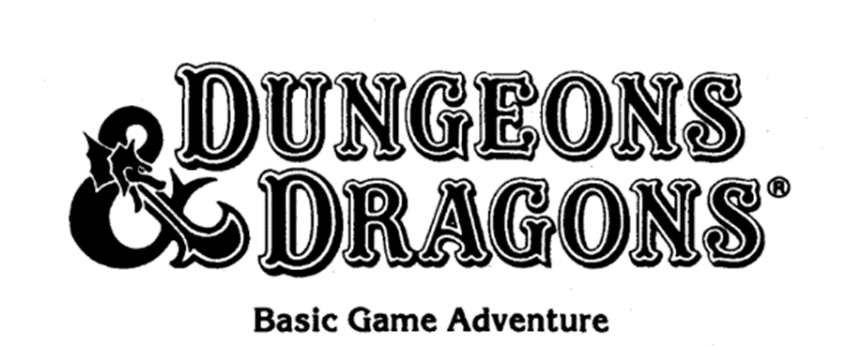

Castle Mistamere
By Christian Foote

Credits

Castle Mistamere (Gygar’s castle) Original concept and design
By Frank Mentzer, D&D Basic set, Dungeon Master manual page 4, 1983

Kill Bargle Expansion Adventure Design
By Jason Bulmahn, Dungeon Magazine issue #150, 2007
3e to BECMI Conversion
Demos Sachlas, Home brew adventure pdf

Cover Art
Three Doors
By Larry Elmore (In my opinion the best fantasy artist ever)
Please support his art at Larryelmore.com

All dungeon maps created with Dungeon Scrawl

Special Thanks to my adult D&D group, as we lovingly call ourselves “The Gutterpunks.”
Thanks for keeping the stories going.

Special Thanks also to the BECMI Berserker, for inspiring me to jump back into Basic D&D
Also inspiring me to actually do this module. You should really check out his YouTube Channel.

DUNGEONS & DRAGONS, D&D, Wizards of the Coast, TSR, the dragon ampersand, Player's Handbook, Monster Manual, Dungeon Master's Guide, all other Wizards of the Coast product names, and their respective logos are trademarks of Wizards of the Coast in the USA and other countries. All characters and their distinctive likenesses are property of Wizards of the Coast. This material is protected under the copyright laws of the United States of America.
I started this passion project as a love letter to my 10-year-old self. Little did I know that one small moment in my life would be the beginning of a lifetime of wondrous adventure. The year was 1984, my best friend at the time, Ryan, was moving away. It was a Friday, in the middle of summer, and Ryan was leaving on Monday. I wanted to see him off, so I walked a couple miles up a backcountry road to his house. His family was in the last stages of packing, Ryan and I talked and walked through the sea of cardboard boxes. This was a sad moment for me, as at the time, I thought it would be the end of my world. I was kind of an introvert as a child and didn’t have many friends, and Ryan was my closest. We eventually found ourselves in Ryan’s older brother's room.

The weird thing is, I have such a vivid memory of that time and day, for some reason Ryan’s brother's name escapes me. I guess that’s what happened after nearly 40 years. Well anyway.

His Brother was packing up his room, carefully placing all his belongings in the several cardboard boxes on his bed. I recall him collecting a few narrow game boxes off his shelf and just before he placed them in the packing box, I saw the artwork on the face of one of the boxes. Almost compulsively I blurted out “What’s that?” pointing to the top box. “This?” he said with a wry smile, holding out the box. “That’s Dungeons and Dragons.” Without hesitation he said, “Do you want to see it?” Before I could even answer, he handed me the box. I stood there for what seemed like a lifetime, enthralled by the artwork I was viewing. The box was the Basic D&D set from 1981, with the Erol Otis artwork. It was nothing I had ever seen, until this time I had never heard of Dungeons and Dragons. I had no idea what I was holding, or what to do with it. Ryan’s brother, seeing my instant amazement said, “Open it up.” I sat down on the floor of his room and opened the box to see the contents. Almost like being an adventurer opening up a treasure chest to find all the glorious riches inside. I began to thumb through the manual inside and was instantly mesmerized. I almost forgot that Ryan and his brother were even in the room. After a short while, I sadly boxed it back up, and handed it back to his brother. I feel like he sensed my sadness, but I'm not sure, because what he did next completely surprised me. “Do you want to borrow it?” he said questioningly. Taken aback at this offer I quickly responded “YES!” He quickly retorted “But you have to bring it back to me by Sunday, we are leaving Monday morning.” I agreed to his stipulation, and he handed the box back to me. I said my goodbyes to Ryan and his brother, promising to be back Sunday to return the game.

I wanted to take a quick pause in the story to shout out Ryan’s brother (whatever his name was). Kudos to him. I often think back and wonder why he did that. We didn’t know each other; I had seen him a few times in passing while over Ryan’s house. He was quite a few years older than us. We were 10 years old, and he was more like 15 or 16. What 16-year-old would give a 10-year-old one of his prized possessions, and trust that 10-year-old to return it before a hard deadline? I mean really, the improbability of it all, but it happened, and I am so thankful for his generosity. Well back to the story.

I ran home, and straight up to my room. I lay there for hours on my bed, reading and wondering. Trying to make sense of what I was consuming. Elves, Dwarves, Clerics and Magic-users. It was all so foreign, but yet it felt like home. I spent the next two days reading every line in that book, multiple times, but as promised I returned to Ryan’s house on Sunday. What happened next will always be seared into my memory. As I handed the box back to his brother and said thank you. He said, “Did you like it?” I nodded. With a Cheshire cat smile he said, “You’re welcome.” He knew…... He knew what he had done, and quite possibly this was his motive all along, I was hooked. There was a budding D&D player standing in front of him. “You can get a box for yourself. In the Mall there is a toy store that has a section for D&D and there is a new box set out now.” My sadness had quickly turned to determination. I had a mission now, I had to get my hands on my own copy. I said my final goodbyes to Ryan and his family, and the next morning they were never to be seen again. In my adult years, and the advent of Facebook, I attempted to find Ryan and his brother. To thank his brother properly. Sadly, I had no success. Ryan Clouse and his family moved to Fort Ticonderoga NY, in the summer of 1984. Wherever you are, Thank you.

The next few weeks I did nothing but talk about Dungeons and Dragons, to my parents. I explained to them, like any 10-year-old would, I needed to have this game. They would listen and placate me, but I was relentless. One thing to note this all was taking place during the ramp up of the “Satanic Panic” of the 80’s, which hit its peak around 1985. Trying to talk to my parents about a game that is all over the news and headlines, about how it is warping the minds of children, and pushing them towards Satanism. I really had my work cut out for me. Not only that, but my family was not well off. My parents had me at a young age, and they were young struggling parents, just trying to keep food on the table. Toys and gifts were only given on birthdays and Christmas, and for me, they were both in December. I could not wait until December. Finally, one day my mother and I found ourselves at the mall, and I dragged her to the toy store. There it was the Frank Mentzer Red Box Basic D&D set. I held it in my hands while I begged my mom, please. The one thing I had going for me, which I did not think about at the time, was I was a good student in school. I was moving into 6th grade and the prior year I did so well on the year end standardized tests, that I was being placed into advanced classes in the upcoming year. As a reward for doing so well in school, my mom thought it was only right to let me pick out a gift at the toy store. Anything I want (within reason, of course). She knew before she took me there what I was getting. So, I left that day, with a huge smile on my face, and the Basic D&D box set in my arms. And the rest, as they say, is history.

The goal of this adventure module is to combine the original adventure found in the Basic Dungeons and Dragons set by Frank Mentzer with the expansion adventure from Dungeon Magazine #150, into one continuous module. My work only consisted of compiling and formatting the work.

To the best of my limited ability, I wanted to recreate the original (BECMI) module form and layout, while still keeping the adventure as it was intended, and tutorial for new dungeon masters. For the most part it will be a word for word reproduction. You may see some minor changes to the original work, as some spelling or grammar mistakes were corrected. You will also find some flavor text additions that I felt were needed to flesh out the rooms a little more.

I wanted to take one last moment to thank and give credit to a few people.

First and foremost, Frank Mentzer, for being the creative genius behind the original adventure. Thanks for being the inspiration to thousands of little kids, like me.

Secondly Jason Bulmahn, for picking up where Frank left off and designing the Kill Bargle adventure in the final printed issue of Dungeon Magazine.

Lastly Demos Sachlas, for converting Jason’s 3rd edition adventure to the BECMI rules set. A lot of hard work went on there, and I wanted to give full and proper credit.

The following adventure is designed for the beginning Dungeon Master. It will have shaded sections, called flavor text. These sections are to be read aloud to the players. The Flavor text is intended to describe the scene to the players, and to give them information to base their game decisions.
You will see other sections titled “DM:”, this will be information intended just for you, the Dungeon Master.
It would also be very helpful if you had a copy of the Basic Dungeons and Dragons (BECMI) rules printed in the 1980’s.

Begin by reading the text below to the players.
“Many years ago, this part of the Realm of Man was ruled by a Magic-User named Gygar, a man of great and mysterious powers. He ruled the lands from his mighty castle Mistamere, located at the foot of the mountains to the north.
“Gygar died after a long and peaceful rule, but no successor was named. Over the years, the unclaimed castle fell into ruins.
“Now centuries later, the outline of the broken towers can still be seen from the town, ever beckoning to seekers of danger, fame, and fortune.
“You have gathered around a dinner table in the Gold Dragon Inn, in the center of town, to discuss your plans.
“The Inn is busy, filled with ruddy-faced townsfolk and other adventurers, who are eating, drinking, laughing, and having a splendid time.
“You have all heard the tales told by others, tales of monsters lurking in the ruins and guarding rich treasures. None of you have been there, but after an evening of discussion, you decide to try your luck in the castle ruin, and plan to meet at dawn for the short journey.
“One Special note: The town rulers have offered a reward of 1000 gp for the capture of Bargle, the renegade Magic-user! The death of Aleena was the final straw.

DM: Stop a moment and make sure all your characters are ready to go. This will be their final opportunity to stock.
up on supplies before they set off. If they are ready, then continue.
“It’s morning, and you’re off to the castle. It lies only 3 miles from town, just a healthy walk past a local farmer’s fields. As you follow the dirt road past the farm, you greet the workers tending the crops. It’s a lovely summer day, and all seems peaceful.
“The Landowner himself sits atop a wagon, watching his mean, and chats with you before you continue onward. He mentions that he has had no problems with monsters, and if any lurk in the nearby ruins, they stay there ‘like respectable monsters should.’ Every night, however, he carefully locks up all his animals.
“After bidding him a good day, you continue toward the ruin. As you approach, you see that the once mighty walls are jagged and full of holes, and a few large stone blocks have tumbled to the earth, lying scattered around the ruins.
“A gateway in the center of the front wall stands empty, and the massive rotting outer doors now lay rotting nearby. This gateway seems to be the easiest entrance through the wall. A 10’ wide gaping hole is in the wall off to the left and could be another entrance.
“You do not see any other entrances; the rest of the wall is crumbling, but a few wide holes have opened. This outer area has no other interesting features. A sheer cliff, the face of a mountain rises at the north edge of the ruins.”

DM: Now read the section to yourself and then continue with #1

DM Information:

Find #1 on the map; that is the location of the characters at this point. They have approached from the south (from the bottom of the map), heading north (towards the top of the page).
Assume that the walk took about 1 hour, and that the time is now 8:00 a.m. Note this near the top of your adventure record sheet and keep track of the passage of time from now until the adventure ends.

Special note:

Time is a resource that will be important in the game. For those players who are familiar with modern editions of Dungeons and Dragons, this concept may be foreign to them. Be sure to emphasize; Natural healing takes time. You will not recover from serious wounds after a long rest. Players may recover 1hp for 24 hours of bedrest, so it may take several weeks to fully recover. The point of emphasis; Injuries are serious and difficult to recover from. You are dead when you reach zero hit points. No death saves. If you are low on health, you had better run, and there is no shame in it. The world is a dangerous, and uncaring place. They are weak when they start off, but they are ambitious, and rewards will come from creative and clever play. The treasure will always be there, sometimes it is more important to live and fight another day.

The Hit roll charts and Saving throws that you will need during the adventure are given here, for your convenience:
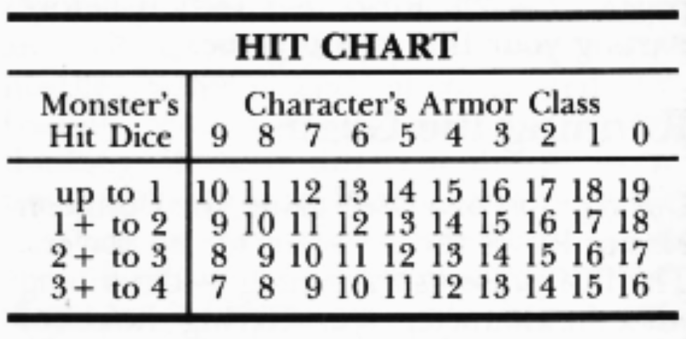

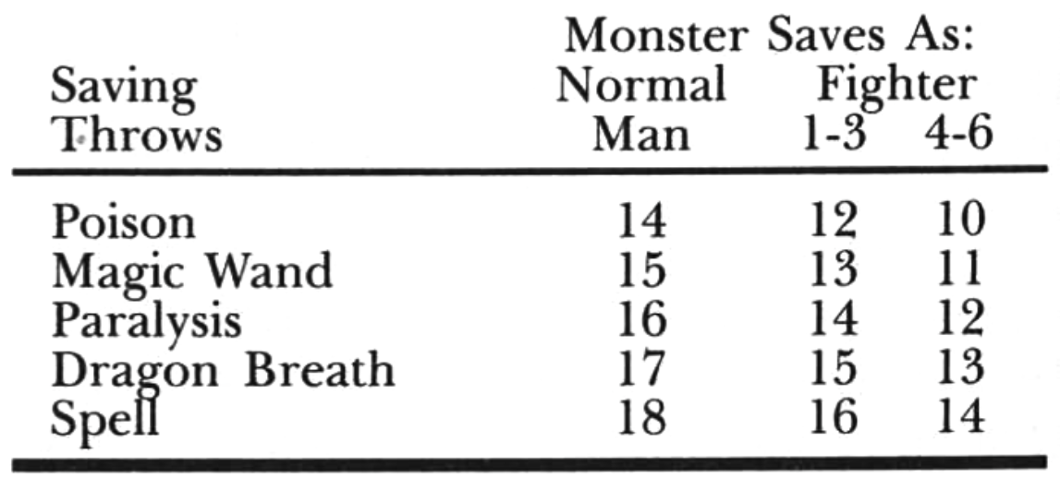

1 Read the Following

“The path through the rubble passes the fallen doors. As you cautiously approach, you notice some slight movement beneath it. You stop, wary of danger.

DM: Encourage the players to send someone forward to examine the door. They should do so, to be sure the path will be safe. If they don’t investigate now, a hidden monster could surprise the party as they pass by. The following encounter is a “warm-up” for both you and the players to practice.
Find out which players are examining, and which are keeping watch for other dangers.

Then read the following:

“Suddenly, the ground along one edge moves, and a hole appears. There’s something under the door!”

DM: If the characters closely examine the door, select a fighter or a dwarf (if possible), or randomly pick a character, to be the victim of the attack. Do not tell the players what you have done!
Ask the players one by one and starting with the victim you have chosen, what their characters play to do. Remember what they say and make notes if you wish. Then read the following:

“You see a large worm-like monster stick its head out of the hole under the door. It has eight long tentacles in a circle around its mouth. It doesn't come all the way out - Just far enough to attach (name the victim).

You will need the following details about the monster. Copy them onto your adventure Record Sheet:
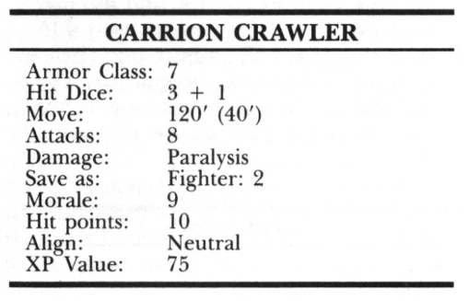

The carrion crawler will use all 8 of its tentacles to attack the single victim you have chosen. Tell the player to roll 1d6 for initiative, while you roll 1d6 for the monster. If your roll is higher, make 8 hit rolls for the carrion crawler. If the player’s roll is higher, allow the party to move back or attack first.
Be aware of the actions of the other characters, but do not allow any of them to attack in the first round unless they are next to the victim. If any missile fire attacks are desired, tell the players.
“You must move around to get a clear shot, to avoid hitting your friends. You may fire next round.”

If any of the carrion crawler’s attacks hit, the character must save vs. Paralysis (one per hit) or be paralyzed. If any Saving Throw fails, tell the victim “You fall over” Tell the rest of the players that they see the victim fall, but do not say whether the character is alive or dead.
After the first round of combat, ask each player for actions for the coming round. If the first victim is paralyzed, the monster will attack the next closest character. If no characters are nearby, it will crawl out of its hole and attack the nearest.
If more than one character moves in to attack the monster, the 8 attacks will be divided among the two closest opponents. Anyone hit must make a Saving Throw or fall over, paralyzed.
Continue running the battle as long as necessary. The party should be able to kill the carrion crawler easily. Any paralyzed characters will recover in 3 turns (1/2 hour), unharmed. The party may wait in the outer ruins (this area) while their friends are recovering or may drag them out to the edge of the fields (an even safer move). Whichever they choose, be sure to keep track of the passage of game time, counting the battle as 1 full turn.

If the monster is put to sleep by a Sleep spell, read #2. If the monster is killed, read #3

2
The carrion crawler is put to sleep by a magic-user or elf spell. When it goes to sleep, it merely stops moving, and its tentacles slump to the ground. Any character with a sword or dagger can kill the monster with one blow, and without waking it up.

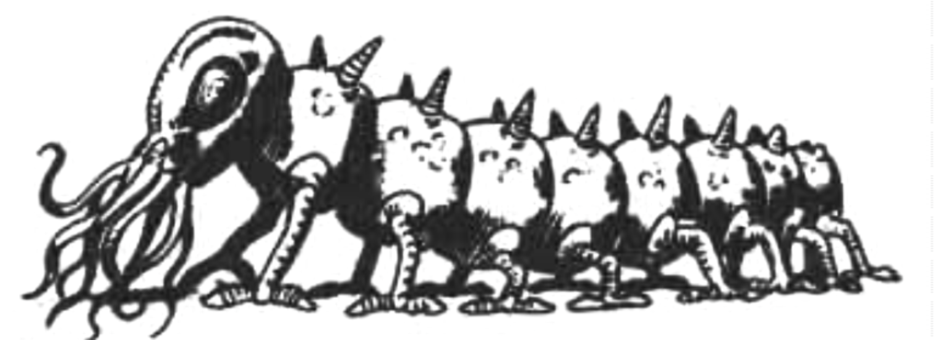

When the monster is killed, read #3.
3
The carrion crawler is killed. It slumps to the ground, motionless.

Read the following:
"Looking at the dead creature, you see that it is about 9' long and has many small legs, like a centipede. You have heard talk of such a creature, hack in town. They called it a carrion crawler. You peer into its hole under the door, to see if any others are still hiding there.”

DM: If the monster climbed out to attack the party, skip to #4. Otherwise, continue:
''You don't see anything moving, but the glint of treasure lies below! However, the body of the monster blocks the opening. Do you want to pull it out of the way?"

DM: The huge door is too heavy to be moved, and it would take hours to dig another hole through the rubble. • If the characters cooperate, they can grasp the body of the monster and pull it out of the hole. Its tentacles are not dangerous after death, and the creature may easily be pulled out of the hole. Read #4
4 Read the Following:
"With the body out of the way, you can clearly see a pile of coins at the bottom of the hole, about 8' down. Do you want to just go in and get it, or does anyone want to search for traps first?

DM: In the future, you should not remind the players about traps. But in this "warm-up encounter," try to help them decide what to do. There are no traps or other unusual features to be found, but the characters should always be checked. A skeleton will be found at the bottom of the hole, mostly covered by the treasure. Close inspection will reveal that it is the skeleton of a short man-like creature whose head is like a dog's. It does not move, being merely an old skeleton of one of the carrion crawler's past victims.

Read the following:
"This looks like the remains of another creature you've heard about, called a kobold. Kobold’s act and live much like goblins but are a different race. ''You carefully gather the treasure, putting it into sacks and dividing it among yourselves to balance the load. The coins are all copper and silver, about a thousand each, and two gems, garnets are uncovered near the bottom of the pile. You also find a small leather bag, almost rotted away. It may have belonged to the dead kobold.

DM: The garnets are worth 100 gp each. If a dwarf examines them, the value will be discovered; otherwise, they must be identified in town. The bag contains 15 cp and a brass key. On your Adventure record, under the carrion crawler information, make a note of all the treasure found. Anyone may take part of the carrion crawler or kobold skeleton if they wish, but they are useless and have no value. When the players are ready to continue the ad- venture, read #5.
5 Read the following.
"As you gather the treasure, you hear a loud THUMP. You see that the main gateway is closed! Although the huge outer doors lie here, rotting, a pair of inner doors remain. They have been closed; the only entrance is now the 10’ wide hole in the wall off to the left.
“Start mapping. Each square on the graph paper represents an area of 10’ long. The gateway, now closed, is 40’ wide; put that near the bottom of your map, in the center. The wall to the right of the gateway is 130’ long. The wall to the left of the gateway goes 100’, then there is a 10’ wide hole, then it continues west another 20’. The entire south wall, including the gate, is 300’ long.
“The wall is about 50’ high, and very shaky. Any climbing might pull some blocks loose, and they could kill you if they hit you.”

DM: Make sure the mapper has an accurate picture of the area. You may add the path leading up to the front gate and the fallen doors if you wish. Offer the players the following choices of action. If they pick one, turn to the entry number given. If they insist on actions not given in the list, do the best you can.

Examine fallen blocks 6
Peek into holes in wall 7
Go to the closed gateway 8
Enter the gaping hole 9
6 Read the following:
"As you prowl around the rubble, you find several large blocks of stone, apparently fallen from the decaying walls. Another Kobold skeleton lies under one of the blocks, but no treasure is visible, and the block is too heavy to move."

DM: Allow the players to choose from the list of options given in #5. Mark off 1 turn of time for examining the fallen blocks.

7 Read the following:
You carefully move up to the wall, looking for holes to look through, hoping to discover some clue about what lies on the other side. But all the holes are too high to reach. You cautiously explore a bit more, and find some other holes along the east wall, to the right. Some are near ground level, and you carefully peer through. "You see a large courtyard inside the wall, and the remains of a castle. The castle ruins are old and cracked, but not as badly as the outer wall, where you are now. Only one story of the castle still stands: the upper parts have crumbled, and the rubble is scattered throughout the courtyard.
"You see a group of creatures hiding in the shadows of the wall, avoiding the open sunlight, they are Kobolds!' There seems to be about 10 of them, but you cannot clearly see enough to determine their exact numbers, or their equipment carried.”

DM: Mark off 1 turn of time for finding the holes and looking through them. Encourage the players to talk about what to do next.
As they talk, tell the mapper to draw the area inside the outer walls.

Read the Following:

"The outer wall is 10' thick. A pathway leads through the rubble, starting at the gateway and leading 90’ north to a pair of doors in the middle of the south wall of the castle ruins. Those doors are 20’ wide. The castle wall extends 80’ to each side of the door, east and west. The side walls of the castle are each 100’ long, reaching north to the face of the mountain’s rugged cliff.
DM: If the party decides to enter the hole in the wall, read #10. If they go to the closed gateway, read #8. Mark off another turn of time for discussion and some movement, back to the outer ruins in front of the wall.

8
DM: The party decides to go to the closed doors at the front gate. When they get there, they may try to open the doors, but will have no success. Give them the options listed in #5.

9
DM: If the characters did not look through the holes in the wall, roll Id6. If the result is 1-3, the kobolds gain surprise: In the coming battle, each kobold will get one free missile fire attack before the party can act. If the result is 4-6, no free attacks will occur, but the kobolds will attack anyway. Read #10

10
DM: The kobolds in the courtyard are guards. They have been ordered to not let anyone enter the ruin. Seeing the party, they have closed the front gate, and will hold it shut if the party tries to break in.
These kobold guards are the biggest in their tribe and have maximum hit points (4 each). They are armed with short bows, arrows, and short swords. Each kobold has 2 quivers of arrows (20 per quiver), so you will not need to keep track of their equipment. A hit from a kobold arrow will inflict 1-6 points of damage, but the short sword attack of these weak creatures causes only 1-4 points of damage. Using the "up to 1 Hit Die" line of the Hit roll as a chart, kobolds are merely 1/2 Hit Die creatures. Each kobold carries a small leather bag containing 3-18 cp, but no other treasure.
A Sleep spell cast at the kobolds will automatically put them all to sleep. If this occurs, stop (regardless of what is happening at the time) and read #16.

Read the following:
“As the kobolds start firing, some of you may take cover behind some boulders in the courtyard. What do you want to do - Fire back at them, move in, or what?

DM: Find the planned actions of each character, one by one. If they want to talk about the situation, rounds of time will pass, and the kobolds will keep firing. For each minute of real time the players spend talking, count off one round of game time, and make one round of Hit rolls for the kobolds! Treat any part of a minute as a full round. The characters should take cover before they start talking, and you may remind them of this.
Missile fire is featured in this encounter. The kobolds begin firing as the party enters through the hole in the wall. The battle could result in the following situations:

A. The characters respond with missile fire of their own, and do not approach the kobolds. Some characters may take cover behind boulders. If this occurs, read #12.

B. One or more characters move towards the monsters and are fired upon several times. If this occurs, read #13.
C. The characters move cautiously towards the kobolds, using boulders for cover. If this occurs, read #14.

D. One or more characters remain inside the hole entrance, keeping the attention of the kobolds while the others circle around. If this is done, the kobolds will be busy with missile fire, and the party may break in. If this occurs, read #15.

E. The characters all go back out, circling around to enter by the gateway. They will still not be able to get in and must return to the hole in the wall (or go home).
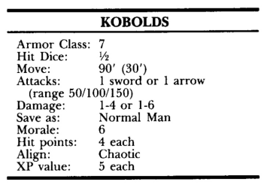

11
DM: The party attacks the kobolds hand-to-hand. If possible, each monster will attack a different character. You may choose opponents or pick targets randomly.
In each round of combat, remember to ask each player for actions, make an initiative roll, and then run the action.
When the first kobold is killed, roll 2d6 to check morale. If the result is 5 or less, the kobolds will try to run away, toward the castle ruin. They are slow creatures, however, and can be caught by anyone not wearing metal armor. If any kobold is caught, they will all stop and fight to the death.
If all the kobolds are dead or gone, the encounter ends. Stop keeping track of time in rounds. Count the entire battle as 1 turn of time and read #18.

12
DM: One or more characters start firing missiles at the kobolds. The range is 110'. If a character uses a long bow or crossbow, the range is medium, and no range adjustment is used. The range is long if a short bow is used, for a - 1 penalty to each Hit roll. The range is too great for a sling to be used, or if hand hurled weapons are thrown. Remind the players to keep track of the arrows or quarrels shot! If they run out of missiles, they cannot continue firing.
The kobolds are under cover, and the characters may also take cover. The kobolds will fire at those characters firing back at them. When firing at any target completely under cover, a — 4 penalty should be applied to all Hit rolls. Thus, the kobolds need a Hit roll of 20 to hit a character in plate mail armor (since a 20 always hits unless the range is too great). A character needs a Hit roll of 16 (instead of the 12 normally needed to hit AC 7), unless a range or Dexterity adjustment applies.
The kobolds will keep firing until most are dead. When only 3 (or less) kobolds are left alive, the survivors will run for the door to the inner castle ruin. Characters may fire for two rounds while they run. The running kobolds do not have cover and are AC:7. The characters are too far away to catch them. If any survivors get to the door, they will go inside, close and lock the door behind them, and go downstairs to Dungeon Level Two.

13
DM: Look at the range of the kobolds' short bows: 50/100/150. The distance between the kobolds and their targets is 101-150 feet, the range is long, and Hit rolls are penalized by -1 . At 50' range or less, the range is short, for a +1 bonus to Hit rolls. Any distance in between (51-100 feet) is medium range, with no adjustment.
You must carefully keep track of the exact position of each character during this encounter. As characters move, the missile fire range will change. Characters in metal armor move 20' per round; in leather armor, 30' per round; unarmored, 40' per round.
When the party first enters, the kobolds are hiding behind some rubble next to the path inside the gateway. They are 110' away from the party, so their first missile fire attacks are at long range (-1 penalty on each Hit roll). These attacks may be aimed at any characters, either selected or randomly determined.
During the first round of movement, the approaching characters move into medium range (no range adjustment). All the missile fire is aimed at the approaching characters. The kobolds ignore those characters taking cover.
Carefully keep track of both the positions of the characters and the passing of each round of game time. Remember to roll for initiative each round, to see if the characters move before or after the kobolds fire their arrows.
When any character gets within 20' of the kobolds, all the monsters will drop their bows and draw their swords. They will all attack immediately; read #11.

14 Read the Following:
"You see that the hail of arrows is dangerous, and approach with caution, taking cover behind boulders and moving from rock to rock."

DM: Using this strategy, the characters will have cover, but will move at half normal speed. Keep track of the positions of each character, from round to round. Apply a - 2 penalty to all the kobolds' Hit rolls when attacking the approaching characters that use this strategy. Read #13 to handle the missile fire, but remember to use

(a) half normal movement rate for characters, and

(b) a - 2 penalty to all kobolds Hit rolls for missile fire.

15 Read the Following:

"You decide to split up. Someone stays at the hole in the wall keeping the kobold's attention, while some of you go back out to circle around the front gate.”

DM: Other than using a Sleep spell on the kobolds, this is the best possible strategy. The kobolds will keep firing at the characters by the hole in the wall.
Keep track of time! A character in metal armor (moving 20' per round) will take 6 rounds to get to the doors. During this time, the kobolds will all keep firing at their targets by the hole in the wall. If no characters are firing back at them or moving toward them, 3 kobolds will stop firing and hold the doors.
When characters try to break into the front gate, roll Id6. Modify the result as follows:
Subtract 1, because the doors are locked. Add the Strength adjustment of the strongest character forcing the door ( + 1 for 13-15 Strength, etc.).
Add 1 for each additional character helping to force the door, whatever their Strength scores (+1 for 2 characters forcing the doors, +2 for 3 characters, etc.).

Subtract 3 if kobolds are holding the doors closed.

If the adjusted total is 5 or 6, the doors are broken open. If the total is 4 or less, the doors hold fast. Characters may repeat the attempt once per round.
If the doors are broken open, the characters may move in while the kobolds draw their swords. No free attacks are gained by either side. Read #11 to run the hand-to-hand combat.

16 Read the Following:

"As you cast the Sleep spell, you see all the kobolds stop and fall over."

DM: Stop keeping track of time in rounds; the battle is over. The characters may approach the kobolds or do whatever they wish. The characters may kill all the sleeping kobolds easily. However, if they keep one or more as prisoners, binding them with ropes, read #17. Otherwise, read #18.

17 Read the Following:

'You tie the kobold securely; you have a prisoner. Do you want to wake him up and talk to him?"

DM: If the players do not wake the kobold, read #18. If they wake him, continue:
The kobold awakens and looks around in panic. He struggles a bit but finds himself securely tied. In a strange dog-like voice, he growls. “What do you want?”

DM: Play the role of the kobold prisoner. He will not say anything about the rest of the dungeon but will reveal that he is one of the guards, placed here to prevent anyone from entering the ruins.
The kobold will offer to give money if the party will let him (and any other surviving kobolds) go. He asks to be untied to show the party where the treasure is. If the party unties him, however, he will run for the door to the ruined castle and get away!
If the party insists on keeping a rope tied to him, he will lead them to a pile of rubble by the east tower ruin. After digging for a minute, he will pull out a small iron box, which is not locked. The box contains 100 gp and a black gem (onyx, worth 50 gp).
If the characters want to kill the kobold after getting the treasure, remind the lawful characters that they would keep their part of the bargain, and let the kobolds go. If released, the kobolds will all leave peacefully. After thanking the party, they leave by the front gate and run away to hide in the mountains. When all the kobolds are gone, read #18.

18 Read the Following:
"You gather the treasure from the kobolds and find a total of 80 cp in their sacks. You also get 8 quivers of arrows, with 10 in each quiver. Thar short swords are not well-made and are worthless.”

DM: Now stop the game. Tell the players about each of the possible strategies given in #10. You may either read each section to the players, or play each one, as if it actually happened! If you play them, treat them as practice only. Remember what the characters' hit points and equipment are now, so they can be returned to "normal" after the practice. When you are ready to continue the game, read #19.

19
DM: To run the rest of this adventure, use the following Encounter Key for descriptions of each area of the dungeon. Keep track of the location of the party on your map. When they approach a numbered location, find that number in the key, and read the description. Remember to keep track of time. The party's movement rate per turn is equal to the movement rate of their slowest character (probably 60' per turn). Use the Order of Events checklists to be sure you are running each turn and encounter properly. If you have any problems, remind the players that you are still learning, find the explanation of the situation in this booklet, and read it.

Encounter Key:
Dungeon Level 1
20 Entrance:
The path through the rubble leads from the main gate to the doors of the castle ruin. The walls of this castle are still firm, and this is the only entrance. The doors are not locked and will open easily.
If anyone climbs the walls outside, they will discover that the first floor of the castle remains intact, but the upper stories have fallen completely apart. The rubble in the area is all that remains.
When the doors open, the characters see the first room inside the castle.

Read the following to the players:
“The 20' wide doors open inward, and you see the remains of a bare 30' x 40' room. Empty doorways are in the middle of the east and west walls; the doors are missing. A normal door is in the middle of the north wall. The room contains some trash and rubble, but not enough to conceal a creature.”

DM: As the party enters the room, sunlight will brighten the area, but the rooms to the sides will remain dark. Ask the characters what their light sources are and make notes of which characters light torches or lanterns. Everyone does not have to have their own light source. The party should search this area before continuing, but nothing of interest remains. The party can choose to go north, to the next door, west to room 22, or east to room 23.

21 Wrong way
DM: You should not be reading this to the players. As the party approaches a numbered area on the map, find that number in this Encounter Key and use the information given. There is no #21 on the map. Look carefully at the map, find the party's location, and turn to that number.

22 West Hall
DM: This 30' x 30' room has doorways in the east and west walls. It contains the remains of 3 chairs and 2 small tables. A fireplace is in the middle of the north wall. If they search carefully, the characters will find 3 old silver teaspoons, worth 10 sp each, and a small bag of dried-up peas. If they search the fireplace, they will see that the chimney is clogged with old timbers. If they search the chimney, read the following:
"You look up the chimney, poking. around to see if anything of value might be hidden there. Suddenly, a shower of rubble comes down on you, and a large dark shape comes flying out!”

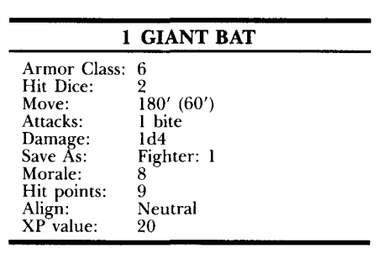

The movement rate given is only for flying. The bat flies out and attacks the character disturbing it. If the bat is hit, roll 2d6 to check morale; if the result is 7 or less, the bat will fly off through the west doorway, landing on a chest in room 28. If an 8 or more is rolled, the bat will fight to its death. One of the pieces of rubble shaken loose by the bat is an onyx gem, worth 50 gp. However, it will not be found unless char- acters examine the fresh rubble carefully.

23 Hallway
This 30' x 20' area has doorways (without doors) in the east and west walls. Normal wooden doors are in the north and south walls. The room contains some trash but nothing of interest.

24 East Hall
This 30' x 30' room has empty doorways in the east and west walls, and the doors are missing. A fireplace is in the north wall, and the room contains the remains of 4 chairs and one small table. An old pillow stuffed with feathers will be found if the characters search the room. There is also one loose brick inside the chimney of the fireplace. However, the chimney is filled with old fallen timbers. If a character searches the chimney, some timbers fall, and a Saving Throw vs. Wands must be made. If failed, the character takes 2-5 points of damage from falling timbers; if successful, 1 point of damage is still inflicted. The loose brick is automatically found while the chimney is searched. A finely made silver dagger is hidden in a niche behind the loose brick. It is not magical but may be sold in town for 75 gp.

25 Bedroom
This room is 30' x 40', with two empty doorways in the west wall and one in the east wall. The doors are missing. A large fireplace is on the south wall.
This area was once a fine bedroom, but its once-rich furnishings — the canopy bed, plush chairs, tables and rugs — are now tattered, moldy, and worthless.
Somehow, the moldy bed looks very comfortable. The first two characters to enter the room must each make a Saving Throw vs. Spells! If successful, nothing happens, but if failed, the victim(s) will walk over to the bed, lie down, and take a nap. The victim may sleep for years but will not age nor need food or drink.
A victim can only be awakened from this magical sleep in one of three ways:
A Dispel Magic spell will remove the enchantment (available in town for a price).
A normal pea placed under the mattress will cause the victim to awaken immediately, but with a sore back (— 2 on all Hit rolls until a good night's rest is had).
If placed on the bed in room 26, the victim will wake. Tickling the victim (with a feather, for example) has no effect. The room contains nothing else of interest.

26 Bedroom
This room looks exactly the same as room 25, but with two doorways in the east wall and one to the west. The bed is completely harmless, and even helpful. If a sleeping victim of the bed in room 25 is placed on this bed, the victim will wake in 3 minutes, completely unharmed by the experience and refreshed by the nap.
If the victim is tickled while on the bed (with a feather, for example), the entire bed will magically sneeze. This sneeze will cause the mold in the room to fly into the air, and everyone in the room must make a Saving Throw vs. Spells or start sneezing themselves, unable to do anything else! This sneezing lasts for 4 rounds, and at- tracts the monsters in room 35, which arrive 1 round after the sneezing starts. The monsters and the sleeping victim are not affected by the mold.
This bed may also be used to cure the deadly choking effect of yellow mold (see room 27).

27 Dining hall
Special Note: The doors to this room can only be opened by a character of 2nd Level or greater. You should read this entire encounter description before starting to run it. When you are ready, read the following to the players:
“This large 30’ x 60’ room has 5 doors, two to the east and west, and one in the center of the south wall. A large marble fireplace is in the center of the north wall.
A long wood table 10’ wide and 40’ long fills the center of the room. It is surrounded by 12 plain wooden chairs, 5 on each side and one on each end. The end chairs and two chairs on each side are occupied by skeletons, 6 in all. They are all dressed in rags, apparently the remains of fine dinner clothes, for both male and female. They are sitting up, but do not move.
“On the table in front of each chair sits a golden dinner plate, with a dusty glass goblet on each plate and dull silverware to either side. The table is bare wood, with no tablecloth.”

DM: From any doorway, the party cannot see into the fireplace. There, lurking in the shadows, are two harpies.
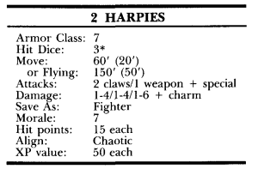

These horrible creatures are feared by the kobolds and all other creatures in the area and are avoided. They, in turn, stay in this room, feasting on the victims who wander in. The skeletons are all that remain of their past meals.
When any door is opened, the harpies start singing a duet. Every character must make a Saving Throw vs. Spells. The song of the harpies is enchanting; if the Saving Throw fails, the victim is Charmed (fully explained on page 23) and hears beautiful music.
If the door is closed immediately, the characters will be able to drag their Charmed comrades away from the room. The Charm may be removed by a Dispel Magic spell (available in town, for 100 gp), or by placing the victim on the bed in room 25 (causing sleep) and then on the bed in room 26 (waking the victim and removing the Charm).
If the door is not closed, the victim will walk into the room, circle the table, and continue toward the fireplace. If the Saving Throw is successful, the harpies' song is heard to be screeching noise, and has no effect. Only one Saving Throw must be made for the song of the two harpies.
If a cleric tries to Turn the skeletons, make the rolls normally, but there will be no effect. The skeletons are not animated monsters.
If any character attacks the harpies, the monsters will fly around the room and over the table, avoiding combat as much as possible. They will not land on or disturb the table, however. If cornered by two or more characters, a harpy will fight.
If any character touches a gold plate or climbs onto the table to attack the flying harpies, a terrible thing may occur. The "gold" plates are actually tin, covered with yellow mold!

These molds are smaller than normal. For each plate touched, roll Id6; if the result is 1-3, the mold releases a small cloud of spores, catching only the character disturb- ing the plate. The victim takes 1-4 points of damage and must make a Saving Throw vs. Poison or start choking, unable to do anything else. A choking victim will die in 6 rounds unless taken to, and placed in, the bed in room 26. Anyone climbing onto the table will disturb 2 plates, which may both produce clouds of spores (roll for each), inflicting 1-4 points for each cloud but only requiring a single Saving Throw. Yellow mold can only be harmed by fire. The touch of a torch will automatically destroy the mold on one plate, but a roll must be made for each such touch to determine whether a spore cloud is released.
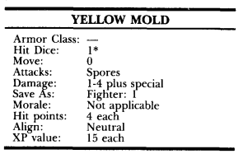

If one harpy is killed, roll 2d6 to check the morale of the other. If the total is 6 or less, it will surrender, offering to give all its treasure to the party in exchange for its freedom. If the party accepts, it will pull a long flat chest out from under the table.
The chest is locked, but the harpy has a key. It will open the lock and the chest, and then leave (if the characters permit) by the door in the south wall, continuing outside to flee into the mountains.
If questioned after it surrenders, the harpy will tell of a magic-user who came one day and took charge of the dungeon. This man lives below on a lower level of the dungeon, and the kobolds serve him. If the harpies are slain, a search of the room will reveal the harpies' chest.

The key found in the carrion crawler pit will fit the lock! The chest is not trapped. The harpies' treasure box contains: a few more dinner outfits, all moldy and ragged (worthless), 2,000 sp, 2 pairs of turquoise earrings (value 500 gp per pair), and two potions of healing. In addition, the 12 sets of silverware on the table are worth 5 gp per set. The goblets are only worth 1 gp for all 12 and will probably crack on the journey to town. The tin plates are corroded and worthless.

28 Storage
If the giant bat in room 22 flew away from the party, it would be found here. Read the following to the players:

“This room is 30’ x 30’ with doorways in the north and east wall, the doors are missing. The room is filled with boxes and crates of many shapes and sizes and looks like a storage area.”

DM: All the boxes are covered with a thick layer of dust and have not been disturbed for a long time. None of the boxes can be moved, opened, or damaged in any way! If the searching characters tap on any box, a deep voice will come from a larger one in a corner, saying: "Who's there?" Whatever the characters say, it will respond with "Is Bargle with you?" Again, whatever the characters say, it will finish with "Oh — well then, never mind!" It will not speak again.

29 Closet
This small 10' x 30' room has doorways in the south and east walls, but no doors. A dusty old round hatbox is lying on the floor in the northwest corner.
The hatbox is tied with a string. If the string is cut, the hatbox can be opened safely. But if the large bow knot on top of the box is untied, the character untying it must make a Saving Throw vs. Poison or take 1-6 points of damage, from poison placed on the string.
A woman's red hat, now faded and moldy, is in the box. The hat itself is worthless, but if removed from the box, a hatpin will be found beneath it. The hatpin is solid platinum, and worth 100 gp.

30 Stairs
This 20' x 30' room has doorways in the north and east walls, but no doors. A stairway by the south wall leads down to Dungeon Level 2. There is a fireplace in the northwest corner of the room. Lurking on the stairway are 4 kobolds, who are watching for intruders. They will only be encountered if the party starts down the steps.
When encountered, roll 2d6 to find the reactions of the monsters. If friendly, they will warn the characters not to proceed down the steps to the dangerous Second Level of the dungeon. If they Negotiate, they will want payment of at least 10 gp to reveal the same information. Each kobold has a bag containing 5 cp, and no other treasure or equipment except for their crude short swords.
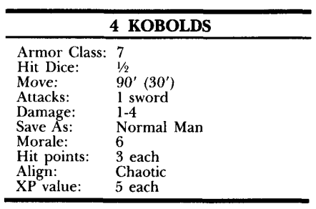

31 Trap Room
This room is 30' x 30', with doorways in the south and east walls (but no doors).
A large log is in the center of the room. One end is on the floor, but the other end is held up by a strong rope, which runs through hooks in the ceiling, wall, and floor. It is tied to a large chest, which is on the floor directly below the upraised log.
If the rope is cut, the log falls, smashing the chest and scattering its contents.
The lid of the chest is not held shut by the rope and can be opened easily. It is not trapped. Inside the chest are 500 sp, 50 gp, and one citrine gem (value 10 gp).
The kobolds and other monsters in the dungeon have avoided this area, believing it to be a deadly trap. It is harmless unless the rope is cut.

32 Statue Room
This room is 20' x 20', with a normal door in the east wall and a doorway (without door) in the west wall.
In the center of the room stands a statue of a short dog-headed man, clad in leather armor and apparently swinging a short sword (a kobold).
If the statue is touched, the center portion of the statue (from chin to waist) spins in a complete circle. The stone sword will hit the character touching the statue unless a Saving Throw vs. Wands is made, but with a penalty of - 2 to the roll. If failed, the character is hit for 2-8 points of damage; if successful, the character jumps out of the way in time.
This trap may be made harmless if a small button on the belt buckle of the statue is pushed. This button will not be found, however, except by a thief's search (normal Find Traps roll). Once the button is found, the thief may automatically "remove" the trap by pushing the button; no Remove Traps roll is made.

33 Closet
This small room is 10' x 20', and has only one entrance, the normal door on the east wall. The room contains piles of rags and trash. Hiding in the pile are 4 giant rats, which will attack if the room is entered.
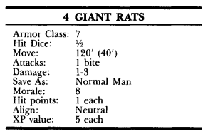

The rats will fight to the death, but there is nothing of value in the room.
34 Storage
This 30' x 30' room has doorways in the north and west walls, but no doors. It is identical to room 28, filled with boxes of all shapes and sizes. These boxes, however, can be moved and opened, but they are all empty. All, that is, except for one, a large box at the bottom of one pile. Inside the box is a zombie, which will stand and attack with a sword if the box is opened. It surprises the character opening the box on a roll of 1-4 (on Id6), gaining one free swing.
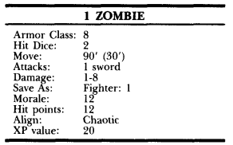

The zombie will climb out of the box as it attacks. If Turned by a cleric, it will either go to room 35 to join its comrades (if the Turning cleric enters by the west door) or to room 24 (if the cleric enters from the north).
There is nothing of value in this room.
35 Closet
This small 10' x 30' room has doorways in the south and west walls, but no doors. It is piled with trash and rubble. There are 4 zombies hiding in the room (5 if the zombie from room 34 joins them).

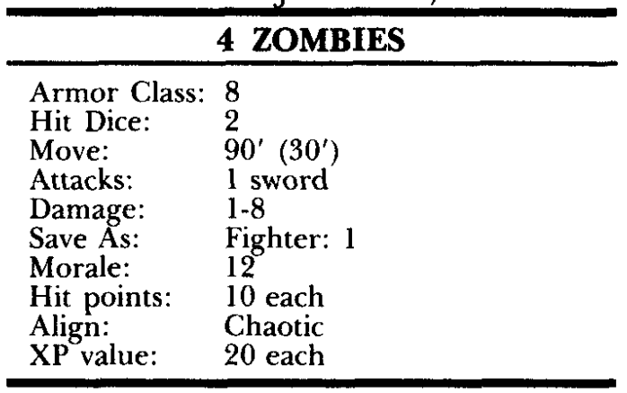

These monsters have been waiting for visitors for years. They cannot surprise anyone entering and will always lose initiative in combat (no roll needed).
If Turned by a cleric, the zombies will either go into room 36 to wait by the stairway (if the cleric Turning them is by the south door) or to room 34 (if the cleric enters by the west door).
If anyone starts sneezing in room 26, they will go there to attack the intruders. If then Turned, they retreat to this room.
A forgotten bracelet (worth 500 gp) lies under the trash in this room and will be found if the characters search carefully. The zombies' swords are rusty and worthless.
36 Stairs
This 20' x 30' room has doorways in the north and west walls, but no doors. A stairway leads down to Dungeon Level 2. Trash and rubble is scattered about the floor, but nothing of value or interest re- mains. (If the zombies in room 35 are Turned, they may be found here. If turned again, they will retreat to room 35 or room 37, depending on the location of the cleric Turning them.)

37 Kobolds
This room is 30' x 30', with doorways in the west and south walls (but no doors). The room contains some trash and rubble. Standing in the center of the room are 5 kobolds, who are looking around the dungeon to chase off intruders.
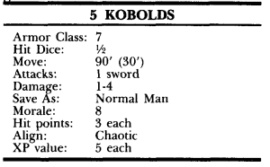

38 Statue room
This 20' x 20' room has an empty doorway in the east wall and a normal door in the west wall. In the center of the room stands a statue of a short dog-headed man, clad in leather armor and apparently swinging a short sword (a kobold). The statue is completely harmless.

39 Closet
This 10' x 30' room has one entrance, the door in the west wall. It contains some trash, but nothing of interest.

End of Dungeon Level 1

Before continuing deeper into the dungeon, If the players haven't already, you may want to recommend they return back to town. It would be a great opportunity to regroup, sell some treasure, and stock up for the deeper levels.
At the end of an adventure, you announce the total treasure found (and kept) by the party, so the players can divide it. The method of division should have been decided before the adventure began.
While the players are dividing treasure, you may spend the time calculating the Experience Points earned during the adventure.
You should have records of all the creatures defeated by the party on an adventure Record Sheet. If not, take a few minutes to remember the creatures encountered. If necessary, ask the players to remind you — and remember to keep a record next time. In each monster description, an "XP value" is given. This is the number of Experience Points to be awarded for each monster of that type. Multiply the XP value by the number of monsters defeated to find the total XP award for that encounter. Note that a captured monster is counted as "conquered" for XP awards, even if released. This does not occur often; the monster must usually surrender (as the result of a morale check) or be magically caught (by a Hold Person or Web spell, for example) for this situation to arise. Monsters that run away are not counted unless they are caught or defeated later. Add all the XP awards for all the encounters to find the total XP for the adventure. Find the number of shares in the party. NPC retainers count as Vi share for XP division: each character counts as a full share. Finally, divide the total XP by the number of snares to find the XP per share, and announce that total. A retainer will get l /2 the amount you announce. Remind the players to adjust that award for high or low Prime Requisites (+ 5%, +10%, or a penalty). They may ask you to help calculate it. You should also remind them that they get 1 XP for each 1 gp of treasure. As treasure is divided by the party, without your interference, they must make such calculations themselves. Their bonus or penalty (for high or low PR score) also applies.

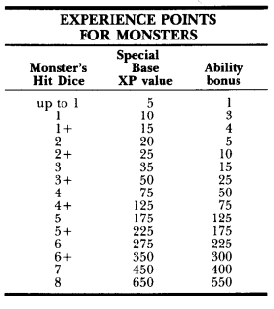

Encounter Key:
Dungeon Level 2

40 Gygar statue

“Standing along one wall of this room is an ancient stone statue covered in dust and cobwebs. Although its features are crumbling, it clearly depicts a powerful looking human wizard, his arms held forward as if to cradle an unseen gift.”

This 30’ x 30’ room contains a set of stairs leading up to area 30 above. If the kobolds on the stairway have not been dealt with, they charge down the steps to attack anyone in this room. Both of the doors leading out of this chamber are stuck but not locked.
The statue of Gygar hides a valuable treasure. At its base is a small inscription that reads, “The orb is the key.” Its arms and hands are perfectly weighted, so that if the stone sphere from room 60 is placed in its grasp, the arms lower, as does a section of its chest, revealing a hollow cavity. Inside this hole is an ancient sword +1 wrapped in oilcloth and a scroll with the 2nd level magic-user spell Invisibility.

41 Crypt
“Four stone pillars support the vaulted ceiling of this chamber. Thick sheets of cobwebs and dust hang between them to obscure the far side of the room. A faint crunching noise can be heard, echoing in the gloom.”

A pair of ghouls lair in this ancient crypt, eating an unlucky kobold. The ghouls attack any who disturbs their meal.
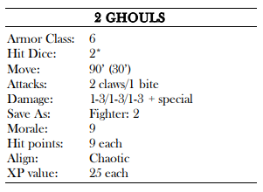

A search of the room will uncover a small silk bag containing 30 gp and a silver pin worth 50 gp.

42 Guard room
“A large table is turned on its side near the center of this squat chamber, with small piles of rubbish and debris scattered around it.”

This 30’ x 30’ chamber is one of a number of guard rooms manned by the kobolds to protect their lair and chieftain.

If the characters enter this chamber from the west, the kobolds hide behind the table and use it for cover while attacking with slings before engaging in melee. If the characters enter from the opposite direction (area 43), they can easily surprise the kobolds (who only watch the west).

43 Hallway
If the characters enter this room from the rat den, they will have the opportunity to surprise the Kobolds who wait in area 42.
If the characters, choose to listen at the door they will have a 50% chance to hear the kobolds. Roll a d6, success on a roll of (4-6). If they choose to carefully open the door, they will have the opportunity of a surprise round if they decide to attack.

44 Rat den:
“One corner of this small, unused chamber is a nest of torn bits of cloth, old bones, and broken weapons.”

A host of giant rats’ nest in this chamber, scavenging from the kobolds for food. They rush out from their nest to attack if disturbed in any way.
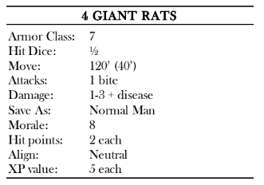

Hidden in the bottom of the giant rat nest is a finely crafted short sword.
45 Dead explorer:
“The skeleton of an elf lies sprawled across the floor in the far corner of the room.”

Eighteen years ago, an elf explorer fell victim to one of this dungeon’s numerous dangers, stumbling all the way to this chamber before he perished. Written in Elf on the wall above the adventurer is the phrase, “Beware yellow mold.”
While most of his gear has rotted away, his sword and spell book still remain.

The spell book contains the spells: Read Magic, Magic Missile, and Sleep.

46 Alcove:
“A crystal statue stands in this alcove, bearing a striking resemblance to Bargle. The statue glowers out at any who would pass beyond it to the stairs leading down.”

The statue is heavy and of little value. The stairs descend to room 73 below.

47 Beetle chamber:
“The set of stairs leading up to the ruins above is this room’s only notable feature.”

The stairs in this 30’ x 30’ room lead up to area 36 on Dungeon Level 1. A pair of oil beetles attacks any who enter. These 3-foot-long red-and-black beetles bear strange tubelike stalks on their backs and large, snapping mandibles.
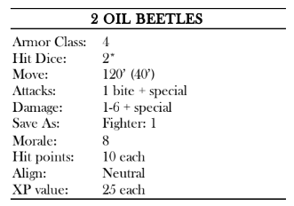

48 Pit trap:
This entire 20’ x 20’ room is one gigantic pit trap, placed here by the kobolds to keep the vermin to the north out of their area. Any creature walking through the center of the chamber sets off the trap and falls in, taking 2d6 points of damage from the fall, and another 1d4+2 points of damage from the spikes.
A kobold skeleton lies at the bottom of the pit with a small wooden shield +1 still strapped to its arm.

49 Stairs:
A single set of stairs descends from this chamber to Dungeon Level 3, ending just north of area 79. Scrawled on the wall in Kobold is the crude phrase “Use the other stairs! Bargle’s orders.”
Although there is nothing dangerous about these stairs, Bargle prefers that the kobolds come to meet him by using the stairs near area 46.
50 Gelatinous cube:

“Off to one corner of this room a number of glittering gold coins can be seen, apparently floating in the air.”

A gelatinous cube lairs in this room. The coins are actually suspended inside of it, and anyone who attempts to grab them without noticing the cube is engulfed.
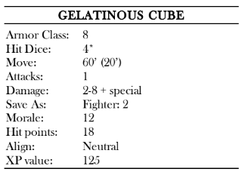

Once the cube is slain, the few coins inside it can be retrieved. There are a total of 18 gp and 12 sp inside it.

51 Hidden treasury: *
“With a low grinding noise, the ancient stone door slides open, revealing a passageway choked with dust and cobwebs, clearly unused for quite some time. Just inside the door, a number of musical notes are carved into the wall.”

The chamber at the end of the secret hallway contains one of Gygar’s hidden treasuries, left untouched all these years. His riches were not left unprotected, though. A statue of Gygar standing in the chamber is actually a magical trap that can be deactivated by playing the tune inscribed on the wall.
Alternatively, the singing urn from room 69 sings the same tune. If the correct tune is played, the statue is deactivated for 1-6 minutes.
If an incorrect tune is played, or no music is played at all, the statue attacks the closest intruder with fiery rays one round after they enter the room. The statue continues to fire one ray for 2-7 points of damage each round until the correct melody is played or the intruders finally leave the room.
Both of the iron chests in this room are locked and bolted to the floor. One chest contains ancient leather bags full of coins, one with 1000 cp, two with 100 sp, two with 100 gp, and one with 50 pp.
The other chest contains a halfling sized suit of chain mail +1, two potions of healing, a scroll with the 3rd level magic-user spell Fireball, and a scroll with the 1st level magic-user spell Protection from Evil.

*Note – access to the hallway leading to this chamber is blocked by a secret door, not indicted on the map in the rulebook

52 Spider den:

This room is home to a number of crab spiders. While they normally hunt kobolds and beetles, they are always on the lookout for a fresh meal. They attack anyone who enters this chamber and are drawn to investigate any disturbance in the hallway.
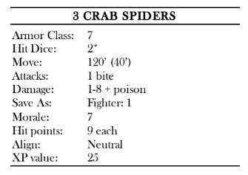

53 Spiderlings:
“Thick strands of webbing hang from the ceiling of this chamber, some of which support small cocoons of silk.”

There are two silken egg sacs, which are joined at the center.
54 Spider victims:
“Tattered armor, rotting flesh, and yellowed bones lie strewn across the floor of this small chamber.”

A search of the corpses here reveals a pair of small belt pouches. One pouch contains 22 cp, while the other contains 4 cp and a tiny green quartz worth 10 gp.

55 Gallery:
“A faded tapestry hangs on the south wall of this ruined chamber, depicting Castle Mistamere as it once was, a beacon of strength and order.”

Once cleaned, the tapestry is worth 200 gp and weighs 30 pounds.

56 Pillaged Statue:

“This ruined chamber has a cracked and broken statue that looks like a wizard.”

The statue in the southwest corner is similar to the one in room 40, but its contents were looted long ago when the statue crumbled.
The top half of the statue lies in ruins around its base. The stone orb used to open it is nowhere to be found.
A pair of oil beetles reside in this room and move to attack any who enter.
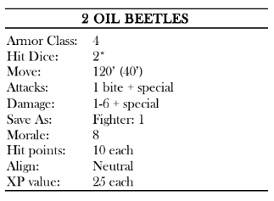
58 Warning:
“This small chamber is full of bones and other refuse. A message is written on the south wall.”

This room is used as a garbage pit for the kobolds. Any character who spends more than 1 round in this room must make a constitution check or be sickened for 1d4 minutes.
The writing on the south wall is in Kobold. It reads,
“Oil bugs this way – keep out!”
While the southern door is not locked, it leads only to a small chamber and another door, which is locked.
59 Trap room:
“Three doors lead out of this chamber to the north, east, and west. In front of the western door are the smeared remains of some gigantic bug, its pulverized carcass surrounded by a slippery stain of oil.”

Directly in front of the western door is a pressure plate that causes a stone piston to descend from the ceiling and crush anything underneath it, (2-12 points of damage, unless a Saving Throw vs. Wands is made).
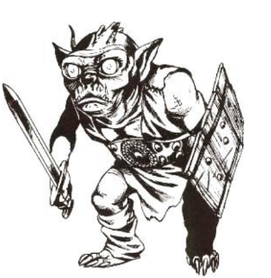
60 Beetle lair:
“Mounds of earth and stone are piled about this room, partially obscuring a stone chest in one corner.”

This is the primary lair of the oil beetles. Four of the dangerous vermin are in this chamber at all times, keeping watch over a cluster of eggs in the corner. They attack any who enters this room.

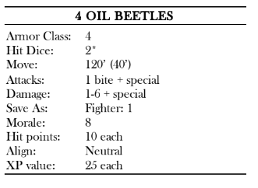

The stone chest in the corner must be unburied before it can be opened. This requires a total of 5 minutes’ worth of work without tools (half that time with them). Inside the chest is 500 gp, a stone orb (used to open the statue in room 40), and a pair of elven boots.

61 Trapped Hallway:
This T shaped hallway is normal in every way, except the south door is locked and trapped. A poison dart trap is in the keyhole. If the lock is picked before the trap is removed the player will have to make a poison saving throw or take 1d6 damage. If the door is instead forced open, then the kobold guards in room 62 will be alerted and have a surprise attack on the characters.

62 Stairs:

This is a set of stairs that descend to the bottom level of the dungeon, ending in area 81.
Two Kobold guards are posted on the stairs. By this time the presence of the characters is known, and the guards are on full alert. The characters will not be able to get the jump on them.

63 Kobold barracks:

This chamber is identical to room 66, except that there are only two bunk beds here instead of three.
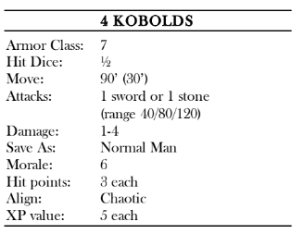
Two ordinary kobolds are resting in this room, along with a pair of kobold bodyguards, who are busy playing a game involving a rat, an apple core, and a pair of sticks.

The wager between the kobolds amounts to 27 gp and a piece of blue quartz worth 10 gp.

64 Mess Hall:
“Two long tables dominate this chamber, around which sit a dozen broken and battered chairs. Scraps of old meat, broken bones, and rotting leftovers litter the floor.”

This chamber is the mess hall, used by the kobolds to eat their meals. The floor in this room is covered in greasy, rotting leftovers.
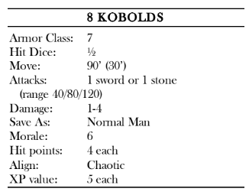
Eight kobolds are having a meal in this chamber when the PCs arrive. They start the combat by throwing their food platters at the intruders, before drawing spears to attack.

One of the tarnished sets of silverware in this room is actually made of pure silver and is worth 20 gp.

65 Audience chamber:
“Five doors enter this large chamber from various directions. In the center of one wall is a dais, atop which is a stone chair bedecked with tiny jewels.”

This is the audience chamber of the kobold chieftain. He rarely leaves this room, out of fear that Bargle might come to issue him orders and mistake one of his minions for the chieftain, thus dethroning him.
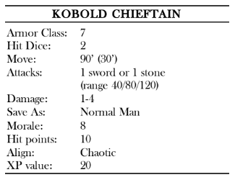

Sitting in this chair is a fierce kobold wearing a necklace of silver bones worth 150 gp. He also carries a potion of healing (2 doses) and a gold key worth 10 gp. The kobold chieftain is probably aware of the PCs by the time they reach this chamber, and thus unsurprised.
As such, he has four kobold bodyguards here to protect him. The kobolds attack the moment the PCs enter the room.
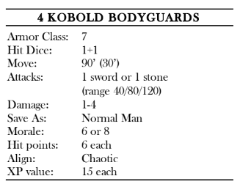

Aside from the gear carried by the kobolds, the throne is covered in what appear to be tiny jewels. While most of these are worthless bits of glass, two are actually topazes worth 500 gp each.

66 Kobold barracks:

“Three crude bunk beds are stacked into the corners of this room, while heaps of garbage, mainly old bones and ruined clothing, cover the floor.”

This room is one of the barracks for the kobold tribe. Since the kobolds sleep in shifts, this room is always occupied.
When the PCs enter, two of the kobolds in the room are playing dice in the middle, while the other four are sound asleep. With a shriek, the gaming kobolds draw their weapons and attack, waking the other four.

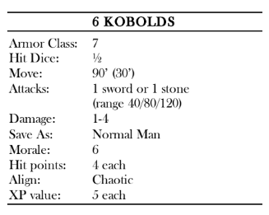

One of the kobolds has found a bag of
devouring during his exploration and mistaking it for a magical bag, has put all of his loot inside. Currently all that remains is 3 gp and a small amber gemstone worth 100 gp.

67 Well:

This chamber contains a stone well in one corner. The well extends for 20 feet before ending in a pool of clear water. A rope dangles into the well, tied to an iron spike driven into the wall and connected to a wooden bucket. The water in the well is safe to drink.

69 Closet:

The door to this chamber is not locked, but the edges are stuffed with bits of cloth. A successful listening check at the door reveals a faint singing noise coming from the other side.
Once the padding is removed, the singing is automatically heard. This chamber contains a magic urn that the kobold chieftain found too irritating to keep. Inside this small room is a silver urn that continuously sings an old elven lullaby. The urn is worth 200 gp, but anyone carrying it takes a -10 percent penalty on Move Silently checks. The urn has the ability to put the statue in room 51 to sleep. A Dispel Magic causes the urn to cease its singing for 1d4 rounds.

70 Chieftain’s bedroom:
The door to this room is locked, requiring a successful Open Lock check to open. The gold key possessed by the kobold chieftain in room 65 opens this door.
“This small chamber contains a simple
bed and a stout wooden chest. A reptilian scent hangs thick in the air.”

This is the bedchamber of the kobold chieftain. Although he rarely uses it for sleep, he does keep some valuable treasure in his chest, protected by a trap. A search of the room uncovers a copper key hidden under the bed.
This key opens the chest without setting off the trap. Anyone attempting to open the chest is attacked by a poisoned needle that springs out of the lid. 1d6 poison damage on a failed save.
Inside the chest is 800 sp, 150 gp, a small emerald-studded silver bracelet worth 500 gp, and a wand of magic detection (42 charges).
There is also a note from Bargle, ordering the kobold chieftain to be on the lookout for adventurers and to make sure not to allow them to proceed to the lower dungeon level.
71 Guard room:
This chamber is identical to room 42, except that one of the kobolds carries a potion of gaseous form. The kobold does not know the function of the potion and dares not drink it.
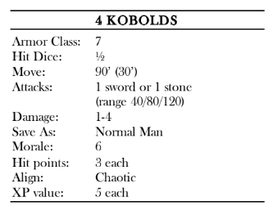72 Kitchen:
“A large fireplace stands in the north wall of this room, with a spit over the open flames. The carcass on the spit looks suspiciously like that of a dog.”

This is the kitchen for the tribe of kobolds.
There are few provisions here, with the tribe instead relying on what food their scouts on the surface can find. The rusted pots and pans in this chamber are of little value.
A pair of kobolds tends the fire in this chamber, preparing meals for the rest of the tribe. While one wields a long cooking knife instead of a spear (dealing 1d4-1 points of damage), the other grabs the hot spit off the fire and attacks with it (dealing 1d4-1 points of
damage plus 1d4 points of fire damage). They charge any intruders.

END OF DUNGEON LEVEL 2

Dungeon Level Three
Notes for the DM

Originally a small sub-basement of Castle Mistamere, this level has been greatly expanded by Bargle. All of the creatures on this level are loyal to him, recruited specially to guard him and his work. Unless otherwise noted, all of the walls, ceilings, and floors of this level are made from stone masonry and all of the doors are made of strong wood. None of these doors are stuck, and few are locked. Most of the chambers are lit by sputtering torches or simple lanterns hung from the ceiling.

Encounter Key:
Dungeon Level 3

73 Guard room:

“This small chamber bears a stone bench along the far wall. A single door exits this chamber, while a passageway leads to stairs going up.”
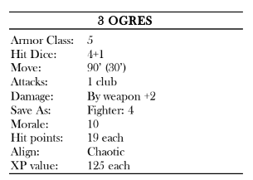
The stairs in this room rise up to the first level of the dungeon, ending in area 46.
A single ogre guards this room and is under orders to slay anyone other than the kobolds or Bargle himself. If he detects intruders, the ogre bellows a warning to the ogres in area 75 and attacks.
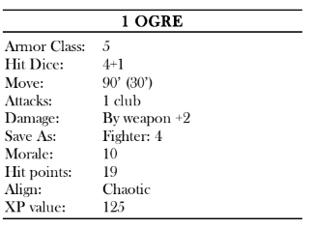

74 Ogre barracks:
“This chamber features a pair of gigantic beds, one of which is occupied by a large sleeping figure.”

Unless the alarm has been raised, this chamber contains a sleeping ogre whose loud snores prevent him from hearing most noises. If warned, he is instead only pretending to be asleep and springs up to attack the moment any character draws within reach.

75 Ogre den:
“A gigantic table sits in the middle of this room, with huge tree stumps around it for chairs. The carcass of a large boar rests in the center of the table, flies buzzing merrily around it.”

This room is the primary den for Bargle’s ogres. Three of the brutes are here most of the time, eating, drinking, or gambling. The table in this room is nearly 5 feet high and smaller characters can duck underneath it to gain cover from the ogres.
If warned of the PCs’ approach, the ogres are waiting for them in this chamber with weapons drawn. If not, the three are enjoying their meal and must stand up and draw their weapons in the first round of combat.

Aside from the 5 gp carried by each ogre, one of these ogres wears a silver amulet with a “B” inscribed on the front. The amulet is worth 25 gp, but more importantly anyone wearing it is not attacked by the statues in area 77 or area 83.

76 Storage:
“Large crates, sacks, and barrels are stacked in this small room. A wooden door in the southeast corner stands ajar.”

This chamber is used to store all of Bargle’s stolen provisions and contains a secret door. Behind it is a small chamber hiding another secret door. Inside this hidden chamber is a small sack containing 50 gp as a ruse to get intruders to turn back before finding the second door.

77 Tapestry room:
“A huge tapestry dominates the eastern wall of this room, all but obscuring a small passageway behind it. The tapestry depicts Bargle, looming like a giant over the ruins of Castle Mistamere with all the surrounding lands set ablaze.”

The tapestry hangs just a foot above the floor, making it nearly impossible to bypass it without disturbing it. The tapestry radiates magic.
Bargle set up this tapestry to stop would-be intruders. If the tapestry is touched without first saying “All Hail Bargle,” a 6-foot-tall crystal statue in the likeness of Bargle steps forth from
the tapestry and attacks while crying out, “Who dares invade my fortress?”
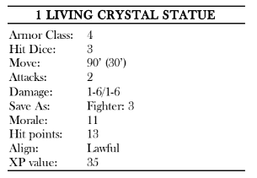

A living crystal statue is a life form made of crystal instead of flesh. Living statues are not affected by Sleep spells.
The tapestry weighs 150 pounds and is worth 500 gp.

78 Altar:
“In the center of the north wall of this room is a black altar lit by red candles. Above the altar is a painting of Bargle, and numerous trinkets and offerings are spread around the base.”

Bargle rarely has time to have an audience with all of his minions, instead allowing them to make offerings here for him to claim later.
The door leading south out of this chamber is locked.
Bargle’s minions leave a few things of true value here on the altar. Currently there is 28 cp, 15 sp, and 4 gp spread around the altar, along with a dead rat, two halfling fingers, and a potion of healing.

79 Guard room:
This room and its guardian are identical to area 73 save that the ogre possesses a tiny gold key used to disarm the trap in area 80.
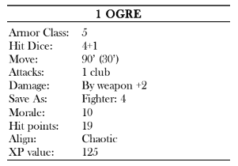

80 Blade trap:

“This small chamber contains a plain-
looking column at its center.”

This column hides large blades that spring out if anyone enters the room (1 blade per target for 1d8 each). Tiny keyholes on the wall of the north and south corridors both allow the trap to be disarmed. The trap can be disarmed by using the key from the ogre’s pouch in area 79.

81 Ruined study:
“Dust and mold cover two chairs arranged in front of a large fireplace on the south wall of this room. A faintly flickering torch is the only light source here, mounted on the north wall.”

This chamber was once one of Bargle’s studies, but since a pair of shadows moved in, he no longer uses it. As a result, the room has fallen into disrepair. The staircase to the west leads up, ending south of area 61.
While the shadows are on friendly terms with Bargle, they attack any other creatures who enter this room, pursuing them as far north as areas 79 or 82 if they flee.
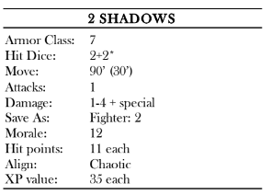

Shadows can only be harmed by magical weapons. They are hard to see and usually gain surprise (1-5 on 1d6). If a shadow scores a hit, it will drain 1 point of Strength in addition to doing normal damage. Shadows are not affected by Sleep or Charm spells, but they are not Undead and cannot be Turned by clerics.
On a table between the two chairs is an old book, forgotten here by Bargle. Titled The Flow of Fear and Flame, the tome covers all sorts of magical theories. It is worth 400 gp.

82 Pit trap:
“A large, stained rug covers the center of this otherwise empty chamber.”

The door on the north side of this room is locked. The one-way door in the west wall of this chamber cannot be opened from this side.
The center of this room contains a large pit trap, designed to open when more than 200 pounds of weight is applied to it. Anyone falling in takes 3d6 points of damage from the fall.
The rug is affixed to the trap door. Once sprung, the trap door closes one round later, trapping those in the pit inside.

83 Statue gallery:

“Six statues flank this long hallway, three to a side. Each one appears to be Bargle, his hands raised as if casting a spell.”

Four of the statues in this long hallway are living crystal statues. They move to attack only when a character reaches the middle pair of normal statues.
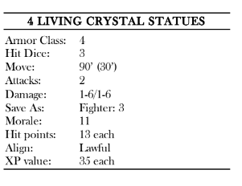

84 Chamber of doors:
“Four doors lead out of this rectangular chamber, two to the south and one each to the east and west. A booming voice calls out from the center of the room, “Fools, you have entered my inner sanctum. Guess correctly and you might live to face me.”

This chamber contains one of Bargle’s more dangerous traps. Three of the doors in this room are one-way, meaning they can be opened from inside the room, but not from the other side.
Behind the southern doors are identical empty rooms, large enough to hold a single creature. Nothing happens to these rooms until the doors leading into them are closed.
When the door to the east is closed, a secret door reveals itself and opens, leading to area 85, the lair of the doppelgangers. The door leading into this room cannot be opened until the secret door is closed. When the door to the southeastern room is closed, anyone inside this chamber is instantly.
teleported to the center of area 82, possibly causing them to fall into the pit. When the door to the western room is closed, a secret door reveals itself and opens, leading to area 87, the fake throne of Bargle.
The door leading into this room cannot be opened until the secret door is closed. In addition, a trap door in the ceiling opens the moment the secret door is closed, dropping a human skeleton into the small room and making it look like the unfortunate explorer was slain.
When the door to the southwestern room is closed, a trap door opens in the ceiling, dropping an ochre jelly into the room.
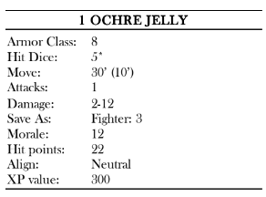

Attacks with weapons or lightning merely make 2-5 smaller (2 Hit Dice) ochre jellies. The smaller ochre jellies inflict only half damage.
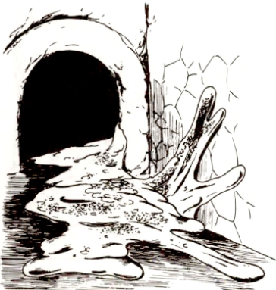

85 Doppelgangers lair:
“This small, well-appointed chamber holds two comfortable-looking beds, with small tables standing next to them.”

This room is the lair of a pair of doppelgangers. When the secret door from area 84 is opened, a small bell rings here, alerting them. They quickly go down the hall to investigate, both taking on Bargle’s form. Both speak in
intimidating and condescending tones as they battle intruders. If they manage to defeat any lone characters, they quickly assume their victim’s form and go to meet up with the rest of the PCs, only to betray them when facing the
real Bargle.
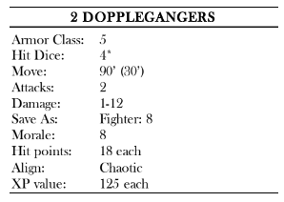

Underneath one of the beds is a small chest containing 200 gp and costume jewelry worth 100 gp (although it appears to be worth much more).

86 Fake bedroom:
“This small bedroom is richly decorated, with silk sheets atop a feather bed, a decorated oak chest, and a finely made table covered in books and maps.”

This chamber is made to appear like Bargle’s bedroom. Inside the chest, which is unlocked, are a number of robes sized for a human, an extra pair of leather boots, and a pair of potion vials. While both are labeled “extra healing” they in fact contain a deadly poison.
Atop the table are a number of rather
amateur tomes concerning gardening, skirmish warfare, and politics (none of which interest Bargle much). The maps are simple sketches of the region.
The only real thing of value in this room is the silk bedding, which is worth 50 gp.
87 Fake throne room:
“Unlike the other chamber in the dungeon, this one is richly decorated with marble and gold. To the north end is a raised dais.”

On the dais stands the imposing figure of Bargle, who glares at the party with contempt and asks, “Who dares disturb the mighty Bargle? You shall pay for your insolence.”
There is a locked secret door in the south wall of this room.
This is another doppelganger, taking Bargle’s guise. The doppelganger starts combat by pretending to cast a protective spell on himself before moving in to attack with his dagger. If the doppelganger manages to defeat one of the PCs alone, he assumes the corpse’s form and hides the body with the real Bargle in area 89.
If he is about to perish, the doppelganger drinks a potion of invisibility and flees the room, heading back out through area 84.
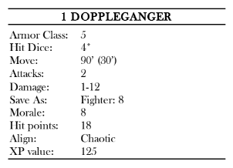

88 Fake treasury:
“Two iron chests sit on the floor of this small room, both of which are open, displaying dazzling wealth inside.”

Each chest contains 5,000 cp painted to look like gold coins. Close inspection of the loot reveals the fraud. Atop the piles of coins are a pair of crystal wands worth 10 gp each, a dozen glass vials containing colored water, and a gold-painted helm. Despite their appearance, none of these items are magical.

89 Bargle’s throne:
“The heavy stone door swings open to
reveal a chamber more opulent than the last. On the far side of the room across a placid pool sits a marble throne bedecked with glittering jewels atop a raised stone dais.”

This is the real throne room of Bargle. The pool in the center of the room is 10’ deep and quite cold. Bargle’s throne is carefully weighed on tracks that allow it to slide away with the touch of one gemstone on the throne’s left arm.
This reveals a long, dark, winding passageway that ends in the mountains behind castle Mistamere. Just inside this tunnel is a pressure plate that causes the throne to slide back into place immediately.
Sitting on the throne is Bargle the Infamous, his hand gently stroking his long black beard. By now, he has probably been warned multiple times of the PCs’ approach, and a small bell rings whenever the secret door leading into area 87 is opened, alerting him to prepare and cast all of the spells noted. When the PCs arrive, he says,
“I see you have finally pierced through all my ruses. I should have known fools such as you are not so easily tricked. The reward for your cleverness is death.”
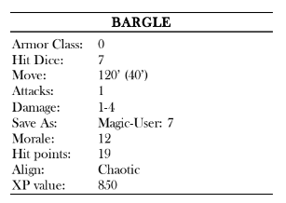

Strength 9, Intelligence 18, Wisdom 9,
Dexterity 17, Constitution 10, Charisma 15

His prepared spells are:
1st level:
Charm Person, Magic Missile, Shield*
2nd level:
Detect Invisibility*, Levitate*
3rd level:
Dispel Magic, Fireball
4th level:
Wall of Fire

*Already cast

Wearing bracers of defense AC 2, ring of regeneration
Carrying dagger +1, potion of healing, potion of gaseous form, scroll with the 5th level magic-user spell Conjure Elemental

In combat, Bargle uses his scroll to conjure a water elemental to the pool to protect him. He then casts his most powerful spells first, starting with Wall of Fire to divide the group and following it up with Fireball. He moves about on his dais, levitating once the PCs draw too close, but never moves away from his throne.
If dropped to 5 hit points or less, he presses the button on the throne’s left arm and steps into the tunnel (causing the throne to slide back into place). If prevented from doing so, he drinks his potion of gaseous form and seeps through a crack into the tunnel behind the throne.
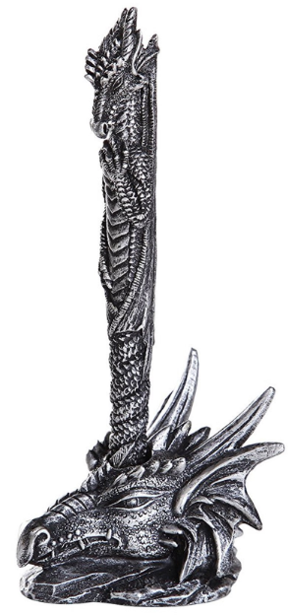
Should Bargle escape through the secret tunnel, the PCs might try to follow him. Finding the right gemstone to trigger the throne requires 2d6 minutes. The tunnel leads to the lair of a young red dragon named Venthavaxus that Bargle has befriended. The beaten magic-user might try to get the dragon to fight the PCs for him, or he might simply fly away, only to seek his vengeance another day, but further exploration is beyond the scope of this adventure.
Aside from Bargle’s gear, his throne is spotted with various small jewels, including 20 red quartzes worth 10 gp each, 10 pieces of onyx worth 50 gp each, 5 red garnets worth 100 gp each, and a single ruby worth 1,000 gp.

90 Bargle’s bedchamber:
“The feather bed in this room is covered in the finest silk sheets and pillows. Off to one side is a polished wood table bearing a single lit candle. On the other side is a stout iron chest.”

This chamber is Bargle’s personal bedroom. He spends much of his time here dreaming of future conquests and even greater power.
The furnishings in this chamber are quite fine and worth 300 gp. The chest contains the true treasures. It is locked and can be opened with a key hanging from Bargle’s belt. Inside is a small bag containing 200 pp, a larger bag with 500 gp, and a tiny coffer holding a trio of pearls worth 100 gp each. These sit atop spare robes, boots, and other clothes. The chest has a false bottom that can be found once the chest is empty. Inside is a pair of gauntlets of ogre power, a rope of climbing, a wand of paralyzation (22 charges), and two potions of healing.

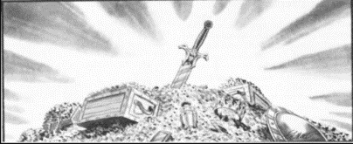

Conclusion
After the PCs handle Bargle, the council of the town of Threshold is much relieved. The group is paid the full bounty of 1,000 gp if they kill or capture Bargle, but only half that amount if they simply drive him away. Unless slain, Bargle soon escapes from his prison cell, only to plot his revenge on the PCs at a later date. Bargle is not a magic-user to be trifled with, and if allowed to live, he goes to no end to see his enemies punished.
Castle Mistamere Level 1

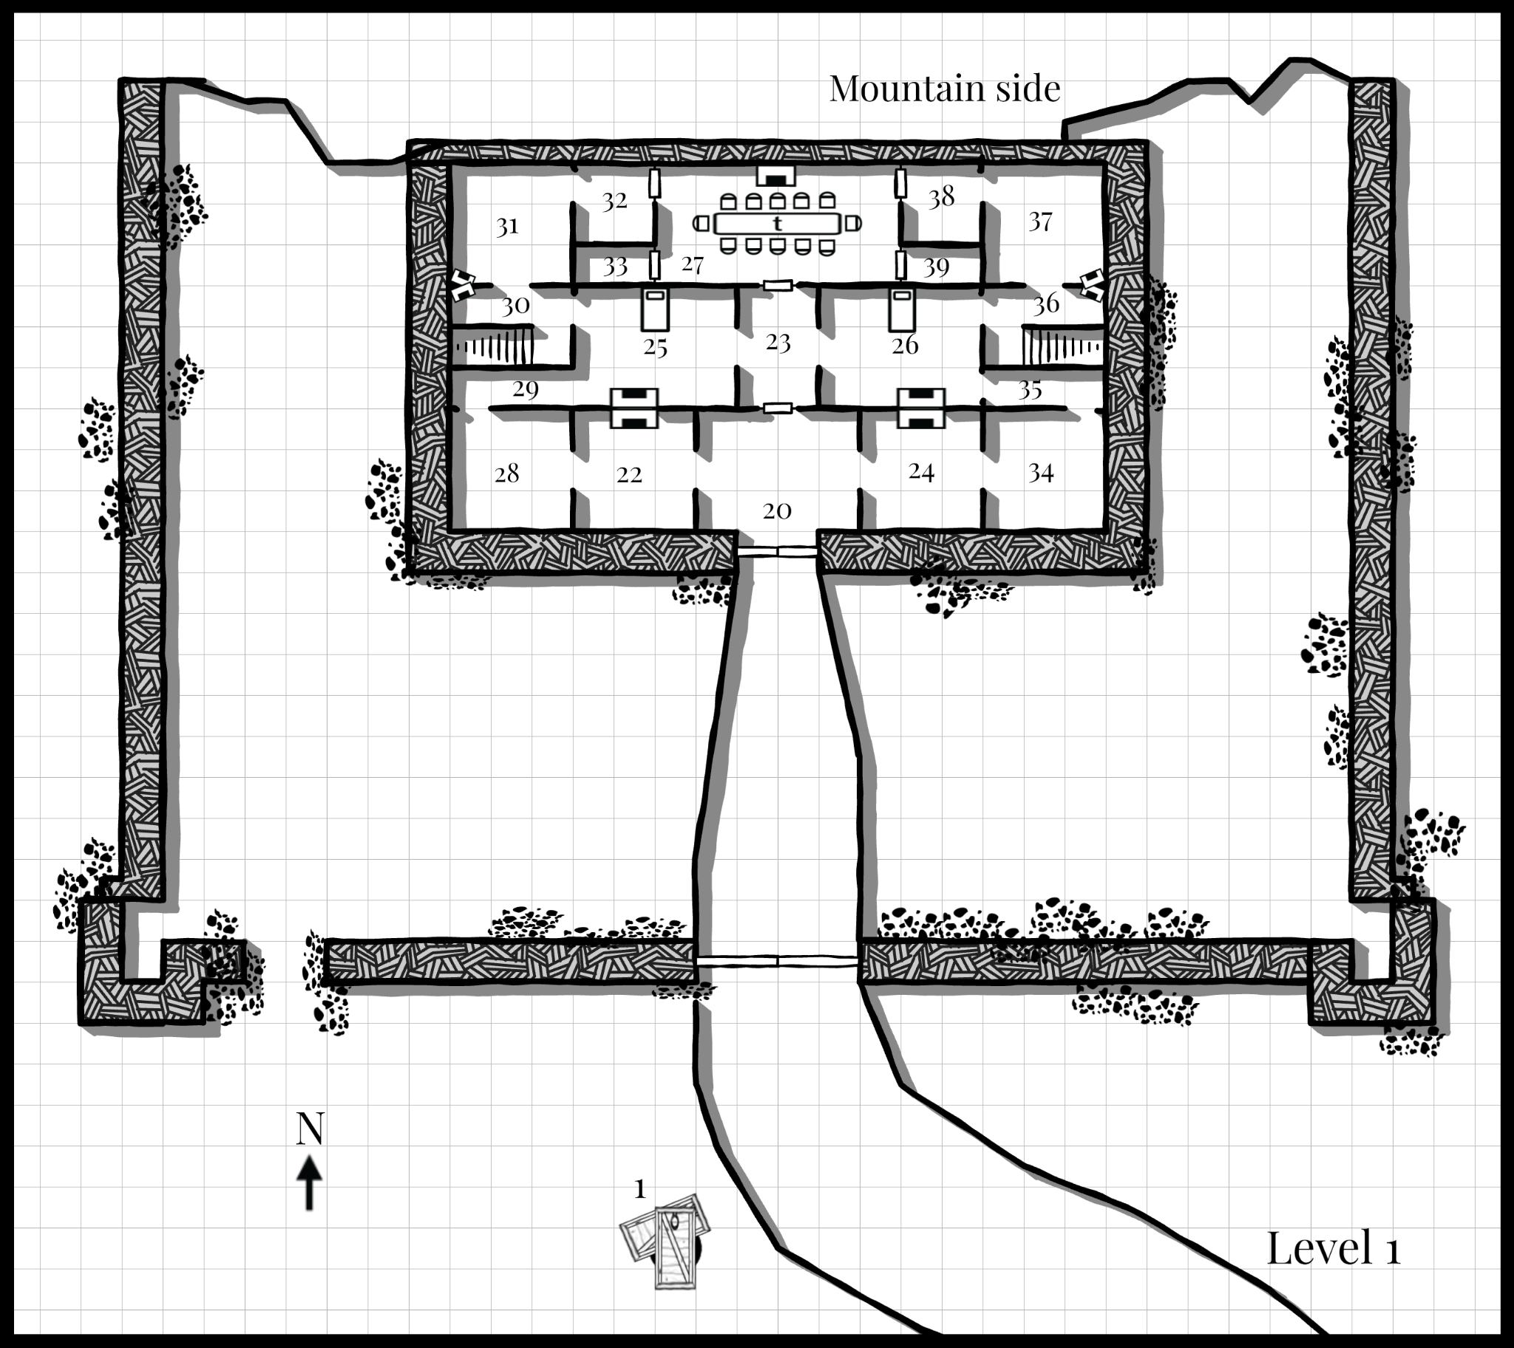

Key
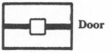
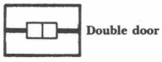

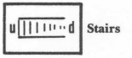
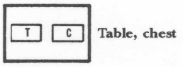

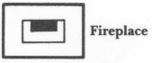

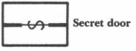
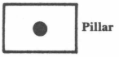

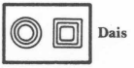
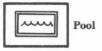

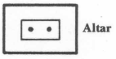
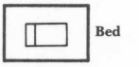

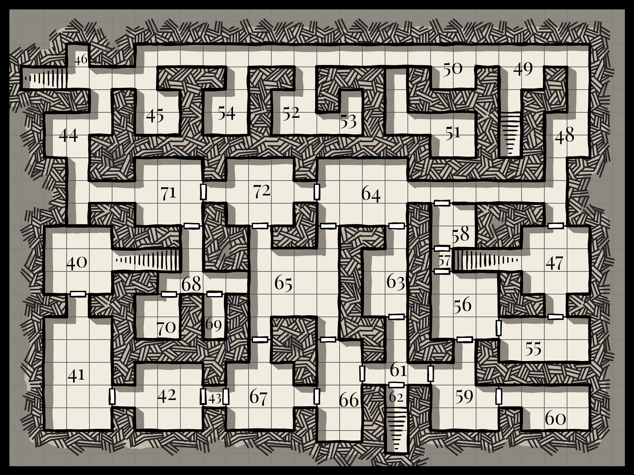
Castle Mistamere
Level 2

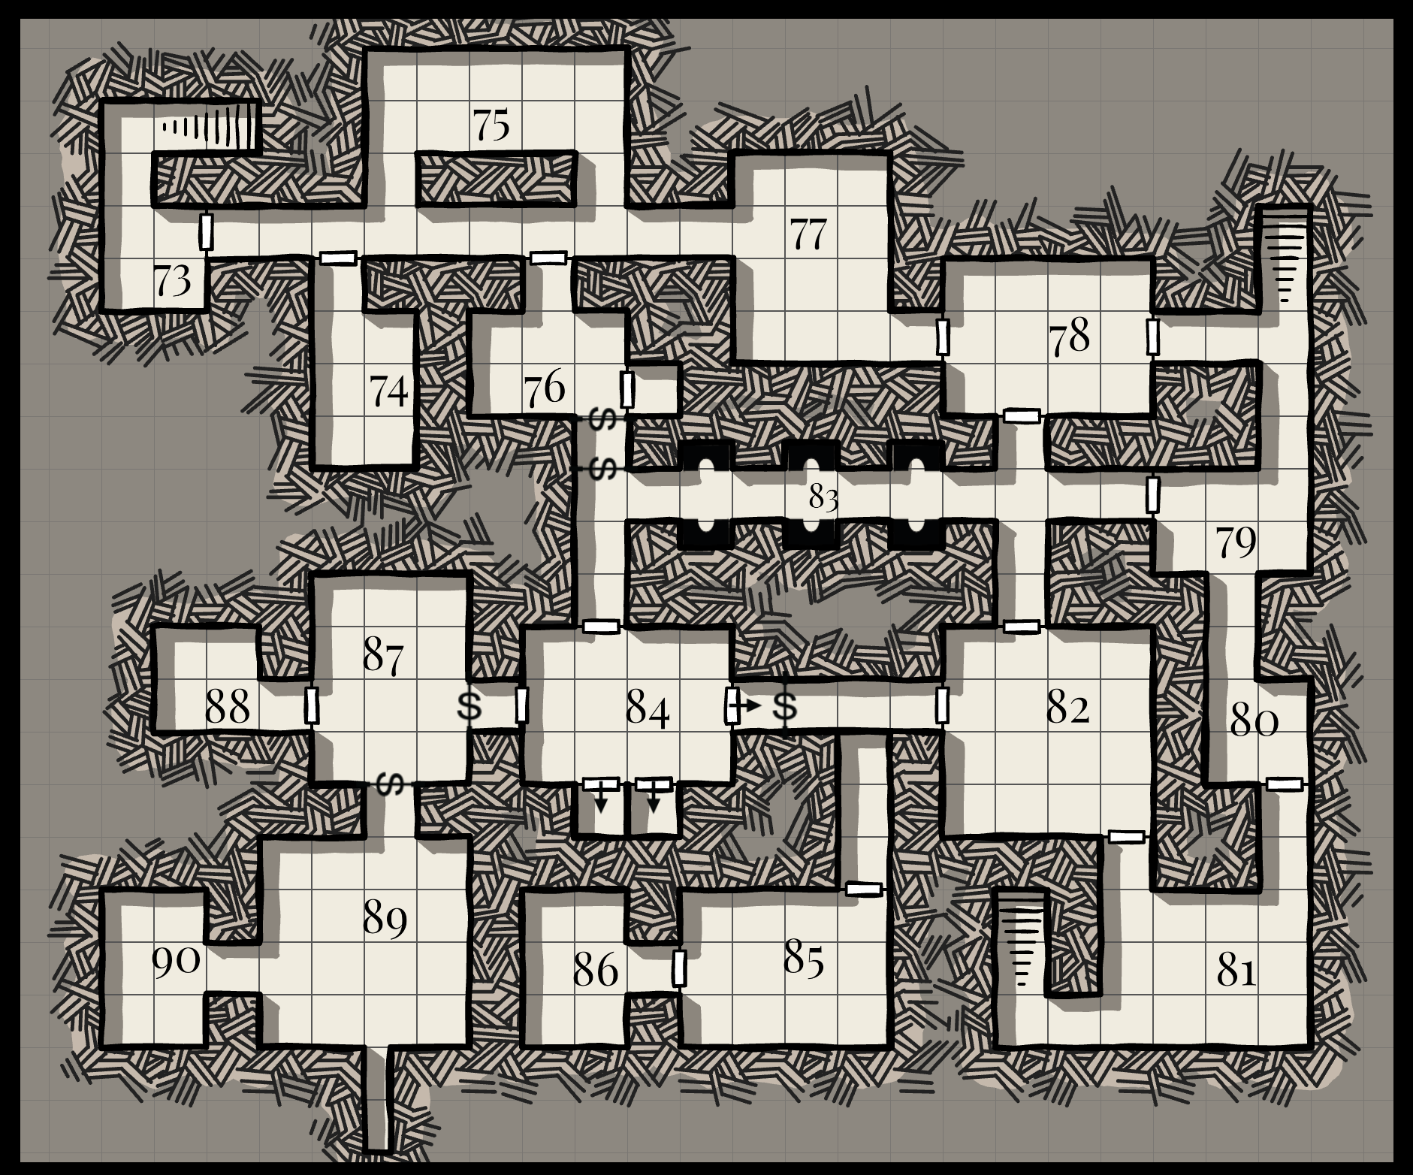
Castle Mistamere
Level 3

Threshold
