**V.E.S. Headquarters**

**A Section from Robin’s map to see original:** [**glantri_city_30feet_hex4_by_6inchnails_decp17i.jpg (8320×7390)**](https://www.pandius.com/glantri_city_30feet_hex4_by_6inchnails_decp17i.jpg)

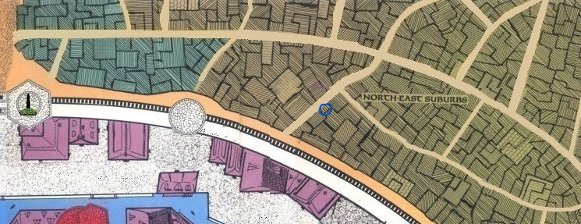

**Robin’s DM Note**: *Keep in mind that along the wall no Carts/Ladders/Wagons, horses(or other mounts) or magic use or walking at night is allowed without permit; City official Pass 32-B. Clause; Check-up control. Duration: 7 days. cost 2 SP. or residents pass ICW 8, cost 3 SP/Month only available if shopholder, or householder or a visitor Pass Duration ICW 9. Till next Sunrise, cost 4SP. At day no such pass is needed if just walking without mentioned conditions.*

**V.E.S. Headquarters**



